

Jurnal Teknik Sipil & Perencanaan vol (no) (year)

JURNAL TEKNIK SIPIL & PERENCANAAN

http://journal.unnes.ac.id/nju/index.php/jtsp/index

The Effect Of Lamong River Flow Diversion To Bed Surface Degradation
(Use the Microsoft Word template style: Paper Title)
Cahyono ikhsan¹
¹Civil Enginering Department, Faculty of Engineering, Universitas Sebelas Maret
Jl. Ir. Sutami 36.A Kentingan Surakarta, Jawa Tengah
Email: cahyonoikhsan@staff.uns.ac.id
Abstract Kali Lamong River with a trapezoidal channel shape has a bottom width of about 30 m, a top width of 40 m and a depth of 3.5 m. In one of the river segments, the basis is in the form of a fixed bed and it is assumed that there is no sediment transport in this section. On the downstream side after the fixed bed section, the river segment is a mobile bed with river bed material that has an average grain diameter of 1.5 mm, a relative mass density of 2.6, and porosity of 0.3. Flowrate with Q50 is 1000.00 m3/sec with a maximum flow speed of 15 m/sec. Riverbed degradation will occur initially at the upstream point in the fixed and mobile beds. Depth of riverbed degradation calculated by the Parabolic model of 80.00 cm / year based on the solution of the equation.
Keywords: degradation, parabolic model, river flow diversion

INTRODUCTION
Kali Lamong River has a watershed area of 720 km2 with a river length reaching ± 103 km which has river mouth into the Madura Strait. Kali Lamong River is included in the category of intermittent rivers with a relatively flat cross section of the river and there are 34 tributaries. Bankfull capacity of ± 250 m3/sec (annual Q), while the discharge during the rainy season can reach> 700 m3/sec. Subwatershed on Kali Among in FIGURE 1.
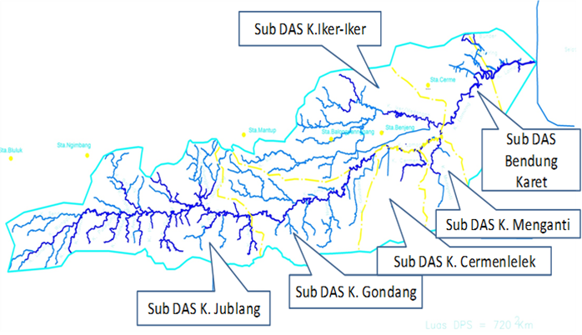
FIGURE 1. Subwatershed (SW) on the Kali Lamong Watershed

A watershed is an area defined by ridges of mountains where rain water falling in the area will flow towards the main river at a point or station under review [1]. Watershed is one of the parameters in the analysis of flood discharge in water reservoirs. The width of the watershed is also called the catchment area (A) in square kilometers or hectares. Determination of the area of ​​the catchment area is based on topographic maps or maps of the earth scale of 1: 25000 or scale of 1: 50000. The type of land use in the watershed will determine the magnitude of runoff coefficient (C) as determined in the planning standard used. The magnitude of the runoff coefficient will determine the magnitude of the planned flood discharge (Q) according to the flood discharge formula used. To obtain flood discharge using this approach, it is necessary to know in advance the maximum rainfall occurring in the observed area which is obtained from the calculation of the maximum rainfall. Due to the absence of recording flood data at the location of the study area, a direct flood discharge analysis was carried out, with an analysis of the annual maximum flood discharge frequency, using statistical methods (Frequency analysis of designed rainfall).
Frequency analysis of designed rainfall data can be conducted using several probability distributions, namely: Normal Distribution, Normal Log Distribution 2 Parameters, Normal Log Distribution 3 Parameters, Gumbel Distribution, Pearson III Distribution and Pearson III Log Distribution. Determination of the probability distribution used in hydrological analysis is carried out by testing the suitability of the frequency distribution [1].
In order to determine the goodness of fit of the empirical frequency distribution of data samples with the theoretical frequency distribution function that is expected to represent the empirical distribution, a statistical test is needed. There are two ways of testing, namely: Chi-Square Test and Kolmogorov-Smirnov Test.
Designed rainfall with a certain return period is usually analyzed by frequency analysis of statistical methods. Frequency analysis is an analysis to determine the relationship of extreme quantities with the likelihood (probability) of their occurrence, or often also displayed as the relationship between magnitude and its return. Frequency analysis is based on the statistical nature of the sample (data) available, to obtain the probability of a population (rain / discharge). The data used is the annual maximum rainfall data, which is the largest data that occurred during one year, measured over several years. Based on SNI 03 3424-1994 rain design for road surface drainage planning is based on maximum daily rainfall data from the rain observation stations that are closest to the project site, a minimum of 10 consecutive years.
The representative rainfall stations are combined rainfall stations consisting of Bunder, Cerme, Duduk Sampeyan and Benjeng stations, and the Sembung rain recording station located in the downstream area of Kali Lamong. The combined rainfall station rain data are shown in TABLE 1.

TABLE 1. Maximum daily rainfall data
Year | Combined Ranfall Station
1998 | 73
1999 | 101
2000 | 69
2001 | 105
2002 | 93
2003 | 34
2004 | 62
2005 | 35
2006 | 120
2007 | 51
2008 | 58
2009 | 81
2010 | 97
2011 | 71
2012 | 54
2013 | 70
Average | 73,34

Frequency analysis of designed rainfall data can be conducted using several probability distributions, namely: Normal Distribution, Normal Log Distribution 2 Parameters, Normal Log Distribution 3 Parameters, Gumbel Distribution, Pearson III Distribution and Pearson III Log Distribution. Determination of the probability distribution used in hydrological analysis is undertaken by testing the agreement of the frequency distribution.
The results of frequency analysis calculation of the maximum daily rainfall utilizing Normal Distribution, Normal Log Distribution 2 Parameters, Normal Log Distribution 3 Parameters, Gumbel Distribution, Pearson III Distribution and Pearson III Log Distribution for combined station rain data (Bunder, Mirror, Sitting Sampeyan and Benjeng) can seen in TABLE 2.

TABLE 2. Agreement of frequency distribution
No | Critical Value Difference 5%
 | Normal | Log Normal | Gumbel II | Pearson III | Log Pearson III
1 | 10,53 | 48,33 | -8,53 | 13,65 | 10,77
2 | 2,99 | 2,28 | -0,77 | -5,2 | -9,09
3 | -25,37 | 1,49 | 2,38 | -4,45 | -8,65
4 | -11,02 | 0,29 | 4,96 | -4,27 | -8,76
5 | -36,59 | -6,06 | 2,34 | -9,37 | -14,15
6 | -34,77 | -10,69 | 1,47 | -12,87 | -17,92
7 | -22 | -13,98 | 2,1 | -15,11 | -20,42
8 | -38,79 | -16,73 | 3,62 | -16,89 | -22,45
9 | -55,85 | -33,43 | -8,13 | -32,69 | -38,49
10 | 0 | -33,8 | -1,84 | -32,21 | -38,25
Maximum difference | 55,85 | 32,08 | 8,53 | 32,69 | 38,49
Agreement Test | declined | accepted | accepted | accepted | declined

The designed rainfall used for the base discharge analysis plan is the result of the frequency analysis of the Gumbel method as shown in TABLE 3.

TABLE 3. Designed Rainfall
Return Period | Frequency Analysis of Designed Rainfall (mm)
 | Normal | Log Normal | Gumbel II | Pearson III | Log Pearson III
2 | 73,34 | 69,5 | 69,76 | 72,7 | 71,59
5 | 94,16 | 91,78 | 96,99 | 84,99 | 94,69
10 | 105,06 | 105,88 | 115,01 | 105,49 | 107,57
25 | 113,98 | 122,15 | 137,79 | 113,29 | 121,6
50 | 124,14 | 136,46 | 154,69 | 126,29 | 130,61
100 | 131,08 | 149,24 | 171,46 | 130,63 | 138,83

In order to obtain flood discharge using this approach, it is necessary to know in advance the maximum rainfall that occurred in the review area obtained from the calculation of the maximum rainfall.
From each of the flood discharge calculation methods, there are limitations stipulated in the SNI-M-18-1989-F SK, The Flood Discharge Calculation Method, Ministry of Public Works, Republic of Indonesia.
The calculation of the Kali Lamong watershed flood discharge utilizing the Nakayasu Synthetic Unit Hydrograph (SUH) method is explained in TABLE 4.

TABEL 4. Nakayasu Synthetic Unit Hydrograph of the Lamong Watershed
No | Parameter | Symbol | Rate
1 | Watershed Area | A | 720 | km2
2 | Main River Length | L | 103 | km
3 | Parameter Alpha | a
- | for common watershed, a |  | 2,0
- | for the slow rising hydrograph section
 | & fast descending section, a |  | 1,5
- | for the fast rising hydrograph section
 | & slow descending section, a |  | 3,0
4 | Unit Rainfall | Ro | 1 | mm
5 | Time Concentration | tg
 | If L < 15 km, then tg = 0,21 * L^{0,7} |  | 5,40 | hours
 | If L > 15 km, then tg = 0,4 + (0,058 * L) |  | 6,39 | hours
6 | tr = 0,5 tg up to 1,0 tg | 1 | 6,39 | hours
7 | Time of Decline
 | from Tp to (Tp+30% time decline) | T _{0,3}
 | T _{0,3} = a * tg |  | 19,181 | hours
8 | Time to Peak | Tp
 | Tp = tg + 0,8 tr |  | 11,509 | hours
9 | Runoff Coefficient | C | 0,800
10 | Flood Peak Dischage | Qp
 | Qp = (C. A. Ro ) / (3,6 * ((0,3 Tp)+T _{0,3} )) |  | 7,069 | m3/s/mm
11 | Synthetic Unit Hydrograph
- | Qt When 0 < t < Tp | Qa | Qp * (( t / Tp )^2,4)
- | Qt When Tp < t < ( Tp+T_{0,3} ) | Qd1 | Qp * (0,3^((t-Tp)/(T_{0,3})))
- | Qt When ( Tp+T_{0,3} ) < t < ( Tp+T_{0,3}+1,5T_{0,3} ) | Qd2 | Qp * (0,3^((t-Tp+0,5T_{0,3})/(1,5T_{0,3})))
- | Qt When ( Tp+T_{0,3}+1,5T_{0,3} )< t < T decline | Qd3 | Qp * (0,3^((t-Tp+1,5T_{0,3})/(2,0T_{0,3})))

While the results of calculations with Nakayasu Synthetic Unit Hydrograph are shown in the flood discharge hydrograph in FIGURE 2.

FIGURE 2. Nakayasu Synthetic Unit Hydrograph

The comprehensive designed flood on the Nakayasu synthetic unit hydrograph which is occurred in Lamong River is presented in Table 5.

TABLE 5. Nakayasu Synthetic Unit Hydrograph
Method | Q (m³/s)
 | Tr 2 | Tr 5 | Tr 10 | Tr 20 | Tr 25 | Tr 50
Nakayasu Synthetic Hydrograph | 438,94 | 612,35 | 727,17 | 837,3 | 872,24 | 1000

METHODOLOGY
River flow with meander pattern, changes in river channel due to uncontrolled sediment transport will be faster than straight river flow due to horizontal and centrifugal pressure from the flow which will trigger the erosion of river banks on the outside of meander bends and sedimentation on the inside of meander bends [2].
Changes in river roughness result in changes in depth, hydraulic radius and flow velocity. Theoretical calculation of speed is done by the manning equation on the river before and after there is diversion. The magnitude of change is obtained by comparing the depth, hydraulic radius, and flow velocity [3].
The method which is utilized in this research is quantitative descriptive method. Flood analysis using the Nakayasu Synthetic Unit Hydrograph method is then calculated using HEC-RAS [4].

- Research Location
The research is located in the downstream of Kali Lamong, as depicted in FIGURE 3.
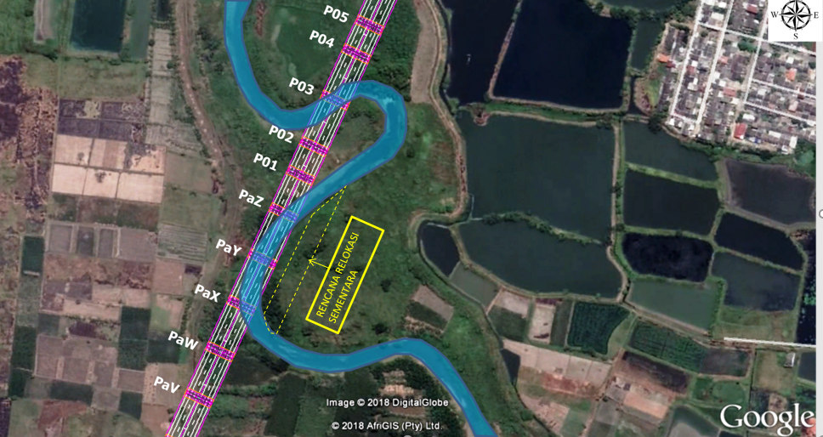
FIGURE 3. Location of river diversion at Kali Lamong River

- Calculation of Return Perion Flood Discharge
Calculation of flood discharge with a return period is as follows
- Prepare annual maximum daily area rainfall data.
- Perform rain distribution calculations using the Pearson Log Type III method.
- Test the suitability of rain data distribution by the Smirnov-Kolmogorov method.
- Perform rain return period calculations for periods 2, 5, 10, 20, 25 and 50 years using Microsoft Excel.
- Calculates the effective rain return period 2, 5, 10, 20, 25 and 50 by correcting the rain return period based on runoff coefficient.
- Calculate the rainfall concentration time with the Kirpich formula to estimate the duration of rain that occurs in the Kali Lamong watershed.
- Perform flood calculation for the planned return period of Q2, Q5, Q10, Q20, Q25 and Q50 using the Nakayasu HS method.

- Calculation of Riverbed Degradation
River bed stability is an important part to maintain the flow in a river. The riverbed will be stable, if the sediment grains are static (not moving). River bed stability will be disrupted if bottom sediment is transported so that the river bed structure is damaged, causing degradation and agradation along the river channel. [7]. Surface erosion and moving bedload accumulate continuously causing bottom degradation. The transported sediment capacity is affected by flowrate, average flow velocity, base slope and shear stress with a value of Froude < 0,6 [5]. Degradation occurs when the incoming flow rate is greater so that basic sediment is transported [6]. A river with a trapezoidal shape, based on a fixed bed and is considered to have no sediment transport in this section. On the downstream side after the fixed bed section, the river segment is a mobile bed. Riverbed degradation will occur, upstream at fixed and mobile beds.
Depth of riverbed degradation can be calculated by the Parabolic Model [7] based on the completion of the equation:

 | $$\frac{∂z}{∂t}-K\frac{∂^{2}z}{∂x^{2}}=0$$ | a)

where for degradation problems such as the problems above, the x-axis follows the initial river bed and is positive downstream, while the z-axis shows variations in the river bed and is positive downward.
Initial conditions and boundary conditions in Eq. (1) above is:

 | $$z\left(x,0\right)=0 ; \lim_{x→∞}{z\left(x.t\right)=0 ; z\left(0,t\right)=∆h(t)}$$ | b)

Resolving the equation (1) with initial terms and boundary conditions according to Eq. (2) is

 | $$z\left(x,t\right)=∆h erfc \left(\frac{x}{2\sqrt{K}t }\right)$$ | c)

The variation of riverbed elevation with respect to time at point x = L = 6Rh/Se is calculated by the following equation:

 | $$∆h\left(t\right)=\frac{q_{s}∆_{t}}{1.13(1-p)\sqrt{K∆t}}$$ | d)

RESULT AND DISCUSSION
- Pattern dan velocity of the flow
Flood Return Period (T) calculation of Kali Lamong flood discharge, which is determined by Q50, is 1000.00 m³/sec based on Nakayasu SUH analysis. It is used as a basis for hydraulic analysis with HEC-RAS [4]. The cross section of the Kali Lamong river in trapezoidal shape with a width of 30 m and a width of 40 m, FIGURE 4.

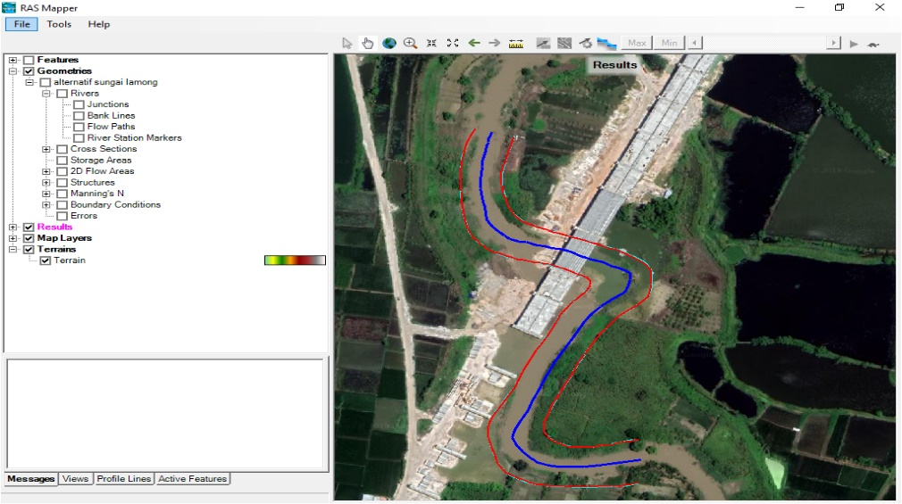
FIGURE 4. Location of river diversion at Kali Lamong River

At the channel location is provided cross section which then modeled as FIGURE 5, and then run according to the designed discharge.

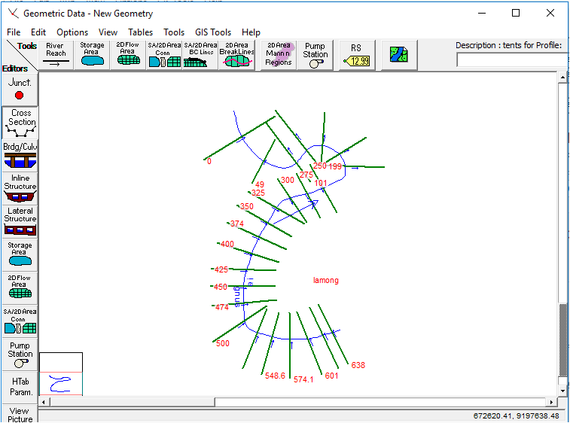
FIGURE 5. Cross Section Model of The Lamong River

The running results with HEC-RAS [4], the pattern and flow velocity in the Kali Lamong river channel are shown in FIGURE 6.

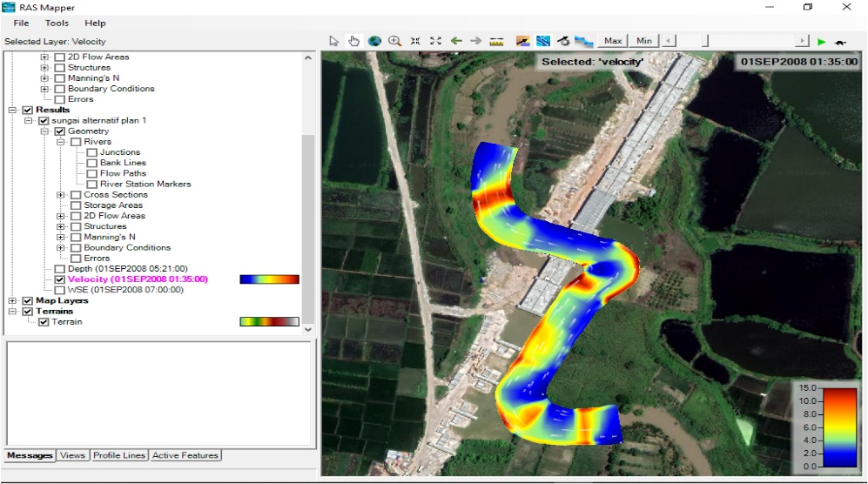
FIGURE 6. Pattern and flow velocity

The flow velocity at the bottom of the channel reaches 10 m/s to 15 m/s, then at that place scours occur which causes a fairly deep degradation or decrease in the bottom.

- Riverbed degradation
Kali Lamong River has a trapezoidal shape with a bottom width of B = 30 m. In one of the river segments, the riverbed is in the form of a fixed bed and it is assumed that there is no sediment transport in this section. On the downstream side after the fixed bed section, the river section is a mobile bed with river bed material that has an average diameter = 1.5 mm, relative mass density Ss = 2.6, and porosity p = 0.3. Flowrate is Q = 1000.00 m³/s with a depth of h = 3.0 m.

CONCLUSION
According to the results of the analysis and discussion, the following conclusions are obtained as follows:
- Design flood discharge due to raining period (QT) in the Kali Lamong River Basin is Q5 = 612.35 m³/second, Q10 = 727.17 m³/second, Q25 = 872.24 m³/second and Q50 = 1000.00 m³/second.
- Flow velocity that occurs in the diversion channel reaches 10 m/s to 15 m/s with a scour on the bottom and slope profile.
- Basic degradation reaches 0.8 m annually, which is analyzed by the parabolic method.

References

[1] | B. Triadmodjo, Hidraulika II, Yogyakarta: Betta Ofset, 2009.
[2] | S. Murniningsih, "Pengaruh Pergerakan Meander Terhadap," Indonesian Journal of Construction Engineering and Sustainable Development (Cesd), vol. 1, no. 2, pp. 45-52, 2018.
[3] | B. Barid and M. Yacob, "Perubahan Kecepatan Aliran Sungai," Jurnal Ilmiah Semesta Teknika, vol. 10, no. 1, pp. 14-20, 2007.
[4] | Hydrologic Engineering Center, HEC-RAS River Analysis System (Application Guide), Davis: US Army Corps of Engineering, 2010.
[5] | E. Setiawan, C. Ikhsan and R. R. Hadiani, "Caused shift voltage degradation and agradation on," in IOP Conf. Series: Earth and Environmental Science, Jember, 2019.
[6] | I. Suhardjo, "Degradasi Dasar Sungai," Journal Teodolita (Jurnal Fakultas Teknik), vol. 9, 2008.
[7] | Graf and Altinakar, Fluvial Hydraulics, Sussex: Wiley and Sons, 1998.
[8] | S. Fauziyah, C. Ihsan and S. Sobriyah, "Degradation and Aggradation Parabolic Model of Dengkeng Riverbed," in The Third International Conference on Civil Engineering Research (ICCER), Surabaya, 2017.

