Jurnal Teknik Sipil & Perencanaan vol (no) (year)
JURNAL TEKNIK SIPIL & PERENCANAAN
http://journal.unnes.ac.id/nju/index.php/jtsp/index
THE IMPACT OF MARKET RELOCATION TO ROADWAY AND SIDEWALK FUNCTIONS
(A Case Study at Patiunus Street Pekalongan)

Azhar Hasna Rany¹, R. Siti Rukayah², Suzanna Ratih Sari³

¹Architectural Engineering Master’s Students, Engineering Faculty, Diponegoro University
^{2&3}Architectural Engineering Master’s Lectures, Engineering Faculty, Diponegoro University hasnarany@gmail.com,

Abstract : The more advance the establishment of the country, the more developed the economic progress. The economic activities required a better supporting infrastructure. Besides it required a market location, it also needed a road to distribute the commodities in or out of the city. They were two supporting infrastructures that boost the economy in a country. The market relocation in the road space benefit and sidewalks can affect road functions and road user activities. Especially in the balancing interaction between the pedestrians and the vehicles, the safety factor of adequate space for pedestrians, the facilities offered a pleasurable experience on the sidewalk, the availability of public facilities unites and becomes supporting elements of the sidewalk. This research used the literature review method. It was conducted in Patiunus street, on the sidewalk that was used for Banjarsari relocation. The technique of collecting data used observation, documentation, and literature studies on standards. The conclusion of this study is to find out the existence of the Banjarsari Market relocation on Jalan Patiunus that affects the function of roads and sidewalks.

Keywords: market relocation, road functions, sidewalk

Abstrak : Semakin maju pembangunan negara, maka akan semakin tinggi pula kemajuan ekonomi. Kegiatan ekonomi membutuhkan banyak sarana prasarana penunjang yang lebih baik lagi. Selain membutuhkan sebuah lokasi pasar, kegiatan ekonomi membutuhkan sebuah jalan untuk akses keluar masuk barang ke dalam sebuah kota. Pasar dan jalan merupakan kedua prasarana yang saling mendukung untuk kemudahan laju ekonomi suatu negara. Relokasi pasar di ruang manfaat jalan dan trotoar dapat mempengaruhi fungsi jalan dan aktivitas pengguna jalan. Terutama pada faktor keseimbangan interaksi antara pejalan kaki dan kendaraan, faktor keamanan ruang yang cukup bagi pejalan kaki, fasilitas yang menawarkan kesenangan sepanjang area pedestrian dan tersedianya fasilitas publik yang menyatu menjadi elemen penunjang. Penelitian ini menggunakan metode literatur review. Penelitian ini dilakukan di Jalan Patiunus, khususnya ruas jalan yang ditempati relokasi pasar Banjarsari. Teknik pengumpulan data menggunakan observasi, dokumentasi dan studi kepustakaan mengenai standar. Kesimpulan dari penelitian ini untuk mengetahui keberadaan relokasi Pasar Banjarsari di Jalan Patiunus yang mempengaruhi fungsi jalan dan jalur pedestrian.

Kata kunci: relokasi pasar, fungsi jalan, jalur pedestrian.

INTRODUCTION
The more advance the establishment of the country, the more developed the economic progress. Economic activities need a good supporting infrastructure such as strategic market location and roadway to distribute the commodity in a city. Market and road became two main infrastructures that unite to support economic growth in a country.
On the twenty-fifths of February 2018, the fire of Banjarsari market caused all stands and buildings cannot be used. The government of Pekalongan relocated the Banjarsari market to some streets such as Patiunus, Belimbing, Rambutan, Manga, and Soerogenen parks. This relocation intruded the roadway and sidewalk function, and the pedestrians' needs were difficult to accommodate.
Habsara (1999) stated that the pedestrian facility consisted of three categories in general. 1) the main facility was a sidewalk that separated to the roadway, 2) crossing facilities such as zebra crossing and viaduct, 3) bus station facilities such as benches and bus stop.
Shirvani (1985) explained the sidewalk must be considered as one of the important elements in urban and regional planning. A right sidewalk system gives a positive impact on the trade city, like stimulating trade activities, decreasing vehicle dependence, and increasing environment and air quality. The fact is sidewalk can exist in the city. Commonly, it spread out in trade areas such as on the right or left roadway, and many shops offered their goods, and at the end of the street, there was a plaza as a social center (Rubenstein, 1987).
Uterman (1984) elaborated to get a good sidewalk, some important aspects must be considered such as safety, joy, comfort, and attractiveness. This elaboration was in line with Hamid Shirvani (1985), he explained that the sidewalk needs a deep consideration in several aspects. Those aspects consisted of 1) the balancing reciprocal between pedestrian and vehicle, 2) safety factor included adequate spaces for pedestrian, 3) the facilities that offered pleasure experience along the sidewalk, 4) public facilities that unite and support the sidewalk.
The crucial problem in urban planning was balancing between sidewalk and vehicle facilities. For example, the uptown pedestrian designed by the City of Charlotte, North Carolina, divided pedestrian zone problems into three categories: function and needs, psychological comfort, physical comfort. (Charlotte, 1978).
The Banjarsari relocation activities at Patiunus street caused pro and contra. The sellers who became a victim of Banjarsari market conflagration gave positive reactions since they can open their shops along Patiunus street. On the other hand, the pedestrian and the citizen who passed daily in that area felt annoyed with this relocation. Furthermore, the indigenous seller who had already set along the street objected to the relocation since it decreased their profit. This problem was interesting to be observed, how the impact of market relocation at Patiunus street toward roadway and sidewalk function. The research purpose and benefit of the study were some insights for the government in dealing with the Banjarsari market relocation.
RESEARCH METHODOLOGY
This research used qualitative methodology. This research was conducted in Patiunus street, at the sidewalk that was used for Banjarsari relocation place precisely. The data collecting technique used observation, documentation, and literature study on the standard.
RESEARCH SITES
Banjarsari market was located in Sultan Agung Street Pekalongan. The market was burned-out on the twenty-fifth of February 2018. All buildings were on-fire and cannot be used. The seller asked the government to relocate the Banjarsari market at Patiunus street as a temporary space (source: radarpekalongan.co.id).
Figure 1. Map of Banjarsari market before conflagration (red line) and Patiunus street (yellow line).
(Source: Google Maps)
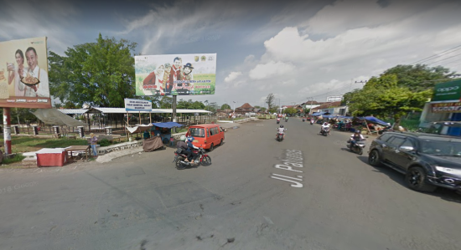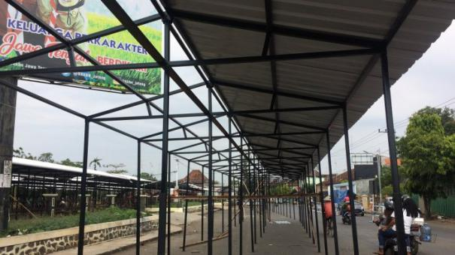
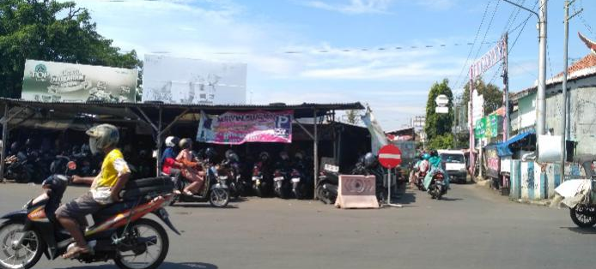
Figure 2. Patiunus street before Banjarsari market relocation
(Source: Google Maps and radarpekalongan.co.id)
Patiunus street was a primer-local street that was the center of local activities. There were street vendors who sold foods and fruits. Before conflagration was faced Banjarsari market, at Patiunus Street there was an adequate parking area for the visitors who come to the Banjarsari market or Patiunus street vendors. Furthermore, Patiunus street is connected to the districts. Many people and vendor street disagree with this relocation, but the government chose that area for the temporary market of Banjarsari. Many shops were placed at Belimbing street, Mangga street, and Soerogenen park. The effect of this relocation brought Patiunus street was fulled with 518 vendors. These vendors consisted of 474 clothing and accessorize vendors, 44 fruit, and vegetable vendors. Furthermore, Patiunus park was replaced by 295 vendors that consisted of 131 clothing and accessorize vendors, 188 fruits and groceries vendors, 20 household goods vendors, and 41 food vendors (source: radarpekalongan.co.id).

RESULT AND DISCUSSION
Result
Based on the street and road qualification, Patiunus categorized a premier local street. Furthermore, based on government low and administration, Patiunus street was classified as an urban road. Patiunus was included IIIC class based on axle load classification.
A primer-local street was defined as a connector among national, regency, district activities toward the center environment activities in each level (source: wikipedia.com). The characteristics of a primer-local street can be elaborated as follows, a. primer-local street was a street that connected to another city, b. primer-local street connected to the other primer street, c. primer local street was designed based on the speed design (no less than 20 km/h), d. freight transports and bushes were allowed to pass, e. the width of the standard road lane no less than 6 meters, f. commonly the average daily traffic was less in primer system.
During 2009-2029 in the sub-district of Pekalongan, Patiunus street served the public transportation route. This route can be elaborated as follows Sayun-Slamaran (round trips) as secondary taxi or van-stop. Patiunus was two-way road with medium categories (length 544 m; width 15 m; lane 11,4 m; left pavement 1,2 m; right pavement 2,1 m; left road tunnel 0,5 m; and 1,2 m of right road tunnel).
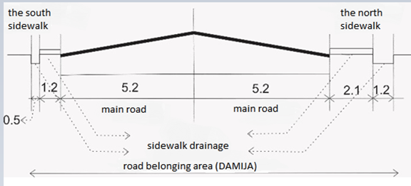
Figure 3. The Roadway Cross at Patiunus street
(Source: Researcher’s Analysis, 2019)
According to the sub-district of Pekalongan design in 2009-2029, Patiunus street will be built and renovated bus-stop to support the transportation system. Also, it will be applied hour restriction to public transportation in secondary bus-stop.
Schuluz in Surasetja (2007) explained that the function changed because of the functional frame. The functional frame was a physical aspect of human behavior that always need a space to accommodate their activities. It changed as long as humans changed their lifestyle. The functional frame must adapt to the complexity of the activities. The Banjarsari market relocation at Patiunus street and Patiunus Parking Areas caused transforming the road function as economic activities placed.

Discussion
The discussion of the research divided into two parts based on the characterization of primer local street and the change of sidewalk functions under the framework of Hamid Shirvani (1985)
Patiunust street included to a primer local street that connected to each center activities such as the central national activities, region activities, district activities, and local activities to the center of environment activities ( No. 101/t/BNKT/1990 The Guidelines for Determining Road Functional Classification in Urban Area)
The characteristics of Patiunus street as a primer-local street had been changed in some aspects. Wikipedia.com explained as follows.
a. A primer-local street in an urban area was a street that connected to another city,
b. A primer-local street connected to the other primer street
c. A primer-local street was designed based on the speed design (no less than 20 km/h)
d. A freight transports and bushes were allowed to pass
In the beginning, Patiunus street was passed by public transportation. However, this street cannot be passed by public transportation since the relocation of Banjarsari market was placed in there. This street was an important route that connected to the downtown of Pekalongan city. The street function diminished because of this relocation. Furthermore, the citizen who needs to go to the market and the downtown cannot access this street.

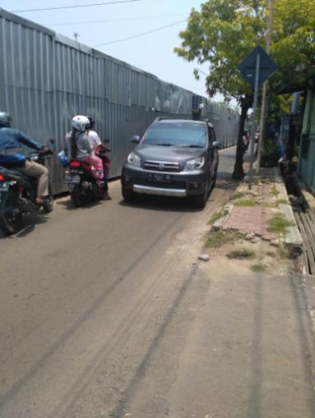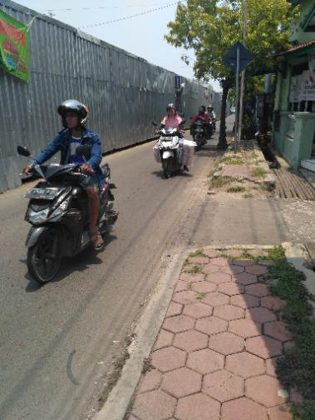
Figure 4. Patiunus Street was passed by vehicle
(Researcher Documentation, 2019)
Until 2020, Patiunus street was inaccessible to freight cars, and garbage trucks needed to turn around for picking the trash. Traffic Jammed became familiar to the people in passing this street, and the alley of Patiunus street transformed to be the shortcut route. The urban accessibility function tended to decrease and spent more time to pass this street because of Banjarsari market relocation.
e. the width of the standard road lane no less than 6 meters
The function of Patiunus street as a primer-local street did not optimize because of the nonstandard width of the road. Furthermore, the average daily traffics and the speed minimum (20km/h) cannot achieve. The citizen preferred to use another way and avoided Patiunus street except for the resident who lived there.
The road function tended to decrease since there only 3 m left to the vehicle passed the street. The problem arose when two cars came from the opposite way in Patiunus street. The cars needed to decrease their speed and must find an adequate space to pass. The researcher found that there was only space from a whole Patiunus street that possible to be passed for the two-car from the opposite side. It was applied too for cars and pedicabs which come from the opposite lane.
f. the average daily traffic levels are generally the lowest in the the primer system.
Patiunus street failed to fulfill a primer-local street standard. This failure embraced; the nonstandard width of the road (6m minimum), the average daily traffic, and the speed minimum (20km/h). The speed decrease tremendously, hence citizens preferred to use another way and avoided Patiunus street except for the resident who lived there.
The road function tended to decrease since there only 3 m left to the vehicle passed the street. The problem arose when two cars came from the opposite way in Patiunus street. The vehicles needed to decrease their speed and must find an adequate space to pass. The researcher found that there was only space from a whole Patiunus street that possible to pass for the two-car from the opposite side. It was applied too for cars and pedicabs which come from the opposite lane.
Road space benefit that should be used for pavement, median strips, sidewalk, road drainage, heap and excavation, main road, road equipment, and so forth can not be optimized at Patiunus street. Patiunus street was formerly planned for free space and the center of activities. Unfortunately, it cannot be done now.
The relocation of Banjarsari market placed more than half of the main road and the road space benefit. The illustration bellows showed the north sidewalk and Patiunus Parking area achieved the standard regulation of the sidewalk. Unfortunately, this part was used to relocate the Banjarsari market (left picture). The north sidewalk had 2 m of width, and the south sidewalk less than 1 m of width. Furthermore, there was a section of unavailable sidewalk near the market on the south sidewalk of Patiunus street.
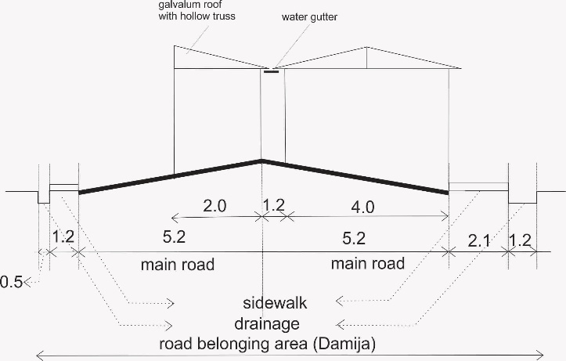

Figure 5. the illustration of Banjarsari market relocation at Patiunus street
(Source: Researcher’s Analysis, 2019)
Figure 5 showed the road part of Patiunus street according to Indonesian Ministry Regulation No 34, 2006. Then, add by the illustration of temporary stands for Banjarsari market relocation. The north side of Patiunus was covered by stands, while the south sidewalk was covered by many chuckholes and non-standard. It caused the pedestrians and visitors had to use the main road of Patiunus street.
The picture above was a road part based on Indonesian government regulation No 34, 2006.
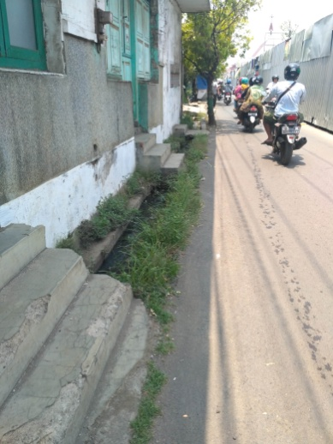
Figure 6. The North Sidewalk Condition at Patiunus Street
(Researcher Documentation, 2019)
The sidewalk of Patiunus street was covered by the Banjarsari market, and it was the south sidewalk remaining. This situation did not meet the sidewalk criteria proposed by Hamid Shirvani (1985)

  - The balancing interaction between the pedestrians and the vehicles. The Pedestrian preferred to use the main road to avoid the chuckhole and vendor street that utilized the sidewalk.

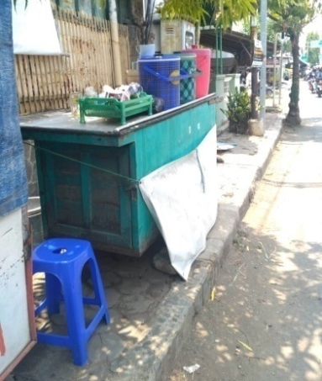
Figure 7. Vendor street at the south sidewalk of Patiunus street
(Researcher’s Documentation, 2019)
  - Safety factor, adequate space for pedestrians. The pedestrians at Patiunus street were not safe since there were many street vendors and potholes that need some improvements. The north sidewalk of Patiunus street had 2 m of width. On the other hand, the south sidewalk had 1 m of width, and some of the parts did not have a sidewalk. Most of the drainage at Patiunus street was broken, which caused a flood when the rainy season comes. Furthermore, the puddles will overflow and cover Patiunus street. This condition weakens the pavement structure and the safeness of visitors.

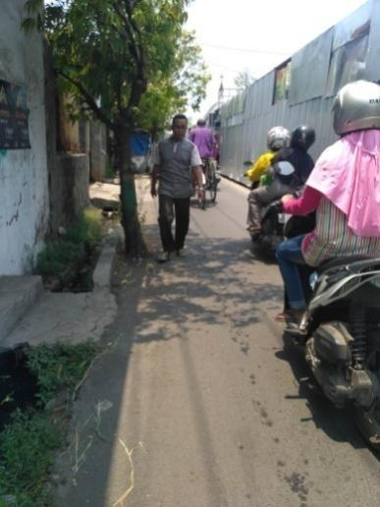
Figure 8. The Pedestrian looked uncomfortable when he had to use the road.
(Researcher’s Documentation 2019)

  - The facilities offered a pleasurable experience on the sidewalk. There were many trees on Patiunus street. Unfortunately, there was no enough street sign for the disabled person. Furthermore, the quality of the sidewalk needed some improvement.
  - The availability of public facilities unites and becomes supporting elements of the sidewalk. In the beginning, several facilities support Patiunus streets like parks and benches. However, those facilities cannot be used after the relocation of the Banjarsari market.

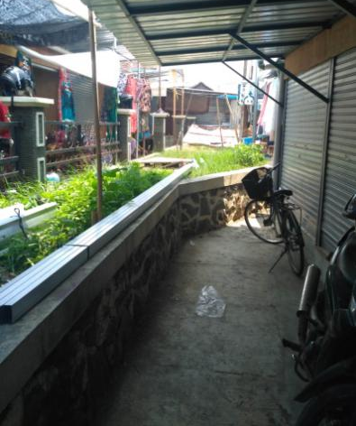
    - (b)
Figure 9. Patiunus Parking Area (a) before relocation, (b) After relocation Banjarsari market.
(Source Google Maps and Researcher’s Documentation, 2019)

The condition of Patiunus street that derived the function of primer local street was failed to achieve. Redesign the sidewalk and reorganized the vendor street were needed to employed the comfortable and safeness of visitors. It maintained pedestrians for not using the main road to walk. It brings safety and comfort to them and able to decrease the number of accidents in Patiunus street. The pavement structures became weakened because of puddles from poor drainage. It brought uncomfortable to pedestrians and vehicle users.
The government may change the road status from primer local street to secondary street if the market is overflow and crowded. It explained at PU NO.03/PRT/M/2012 regulation that stated several possible conditions to change the road function in an urban area; 1. The road status can be changed after another road function is applied, 2. The increasing traffic volume, 3. The decreasing of role road and or the width limit of the road used, 4. The changing status of the road can be proposed by the former committee to a new committee that will accept the new status of the road. The four factors can influence the road status of Patiunus street, from a primer local street to a secondary street. However, reconstruct and rebuild the Banjarsari market was needed to execute so that the principal function of Patiunus street will not be dis-sappier and inline with the 2009-2029 year plan of Pekalongan districts and sub-districts.

CONCLUSION
The relocation of Banjarsari market at Patiunus street changed the function of the sidewalk. The function changed and did not the same as the former design of primer local street. The pedestrians’ safety tends to decrease since one of the pavement sides was covered by vendors, while another side was worse and nonstandard.

SUGGESTION
The researcher proposed some recommendations as follows:
- The improvements of the sidewalk at the south park and re-design for the street vendor are needed. It aims to prevent visitors and pedestrians for not using the main road to walk. It brings safety and comfort to them and able to decrease the number of accidents in Patiunus street.
- The government may change the road status from primer local street to secondary street if the market is overflow and crowded.
- A right drainage system needs to be planned since the water overflowed and made many puddles. It is urgent to be solved since it disturbed the surface course of pavement structures.

BIBLIOGRAPHY
City of Charlotte. 1978. The Uptown Pedestrian. Charlotte: NC
Jacobs, J. 1961. "The Uses of Sidewalks : Safety" from The Death and Life of Great American Cities.
Indonesian Government Regulation No. 34 Year 2006, Road issued
The Ministry of Public Works Regulation Number 03 Year 2012 about the Guideline of Road Function and Road Status
Putro, Saptono. 2009. Pemodelan Tingkat Pelayanan (Level Of Service) Berbasis Sistem Informasi Geografis Untuk Mengurangi Kemacetan Lalu Lintas Kota Semarang. Jurnal Geografi 6(2).
Radar Pekalongan. 2018. https://radarpekalongan.co.id/26695/zonasi-pedagang-pasar-darurat-ditetapkan/. Access at July, 8 2019.
Rubenstein, Harvey M. 1987. Central City Malls. New York : John Wiley & Sons
Shirvani, H. 1985. The Urban Design Process. Van Nonstrand Reinhold.
Surasutedja. 2007. Fungsi, Ruang, Bentuk dan Ekspresi Dalam Arsitektur. Jakarta: UPI
Utterman, RK. 1984. Accomodating The Pedestrian. New York : Van Nostrad Reinhold Co.
Zanuardi, Arvian. 2012. Pengaruh Keberadaan Pedagang Kali Lima Pada Fungsi Ruang Manfaat Jalan Kawasan Jembatan Suramadu. Surabaya: Balai Litbang Sosial Ekonomi Lingkungan Bidang Jalan dan Jembatan
www.googlemaps.com
www.wikipedia.com

