Effect of Yoga Program on Competitive Anxiety in Semarang Badminton Athletes
Donny Wira Yudha Kusuma¹, Wang Bin²
¹Faculty of Sport Science, Universitas Negeri Semarang, Indonesia
²Central China Normal University, China
Email address:
donnywirayudhakusuma@mail.unnes.ac.id (D. Kusuma), bwang@mail.ccnu.edu.cn (Wang Bin)
Abstract:
The most obvious factor which really affects the capability of an athlete especially in Semarang badminton is psychological factors. When in a state of stress and anxiety wrap, some athletes have observed decreased performance, and anxiety that usually occurs in athletes is competitive anxiety. One technique is supposed to represent all the mental techniques are yoga. A total of 20 athletes (12 men & 8 women) from the badminton club in Semarang participated in this study. Quasi-experimental was used in study, two groups were selected according comes from the age group and the same class and is the candidate of the provincial team. Anxiety levels were measured with the CSAI-2R and sphygmomanometer. Data analysis using t-test and index gain. Cognitive anxiety item on the yoga group decreased (x=-2.10; -21.21%), and the control group also felt (x=-0.20; -2.19%). Somatic anxiety symptoms similar to yoga group (x=-3.50; -26.92%), but not for the control group, which increased (x=1.70; 17.71%). Whereas self-confidence has a negative correlation to other variables, the yoga group increased (x=2.00; 12.35%) and the control group decreased (x=-0.30; -1.99%). the last was badminton performance, yoga group increased (x=2.40; 14.67%) and the control group decreased (x=-3.283; -17.23%).
Keywords: Yoga; competitive-anxiety; badminton

Introduction:
The most obvious factor which really affects the capability of an athlete is psychological factors. One of the aspects that affect performance of athletes on the game is anxiety. Influence of anxiety in sports performance has been examined by many researchers (Cerin, Szabo, Hunt, & Williams, 2000; Craff, Magyar, Becker, & Feltz, 2003; Woodman & Hardy, 2003). In common, anxiety reported when athletes are not confident in dealing with the situation may be causing stress (Hardy, Jones, & Gould, 1996) and may affect the various types of sports (Weinberg & Gould, 1995). In addition, anxiety is often to be the interpretation of psychological arousal (Hardy, et al, 1996).
When in a state of stress and anxiety wrap, some athletes have observed decreased performance, even to the point of "choking". Therefore, the relationship between anxiety and performance sport as a topic of interest to researchers in the field of sport psychology. Sports psychologists began studying anxiety in an effort to develop appropriate interventions that can be useful in improving the negative experiences that sometimes detrimental for athletes, initially as an independent construct and lately as interdependent constructs (Andrew, 2009; Jones, 1995 ; Krane, 1992; Scanlan & Passer, 1978; Simon & Martens, 1977).
Anxiety that usually occurs in athletes is competitive anxiety. Competitive anxiety is a specific negative emotional response to competitive stressors (Fletcher et al., 2009). Research on the relationship of competitive anxiety and performance was originally based on an inverted-U hypothesis (Yerkes & Dodson, 1908). Basic assumptions or hypothesis put curvilinear relationship between performance and physiological arousal (Gould & Krane, 1992; Jones, 1995; Krane, 1992; Yerkes & Dodson, 1908). Moderate level of arousal is usually associated with better performance, while the arousal level that were too high or too low cause a very bad performance (Spielberger, 1966; Gould & Krane, 1992).
Others anxiety theorists have widened the dimensional approach of inverted-U to examine other potential dimensions of anxiety. Martens et al. (1990) sought to explain the multidimensional of sport anxiety. Their theory shows that anxiety was composed of both somatic and cognitive subcomponents. From this theory, cognitive anxiety is defined as "the mental component of anxiety and is the caused by negative expectations about success or by negative self-evaluation" (Martens et al., 1990). They convey a negative linear relationship between performance and cognitive anxiety. That is, if the cognitive anxiety was high that athletes have lower performance and vice versa.
There are two different views about anxiety, the first is the state anxiety and trait anxiety were made by Spielberger (1966), and the second is the somatic anxiety and cognitive anxiety conveyed by Martens et al (1990). Trait anxiety refers to anxiety in the aspect of personality. Martens et al. (1990) said when we are anxious we experience the physiological changes associated with high arousal, including increased heart rate and blood pressure, ‘butterflies’ in the stomach, faster breathing and flushed face. Anxiety increases heart rate and blood pressure. Increases metabolism and increased oxygen consumption. Would feel faster fatigue and reduce attention (Beauchamp, 2002). The dimensions of competitive anxiety tend influenced by sex, type of sport and level of ability. Concerning sex, female athletes are more prone to feel more anxious compared with male athletes (Martens, R., Vealey, R.S., & Burton, D, 1990). Competitive anxiety is a specific negative response to the competitive stressor. The negative response is substantially of cognitive anxiety and somatic anxiety. Somatic anxiety is a physiological changes response associated with high arousal, including increased heart rate and blood pressure, 'butterflies' in the stomach, faster breathing and flushed face. Anxiety increases heart rate and blood pressure, increases metabolism and increased oxygen consumption, experience fatigue more quickly intervening and reduce attention. While cognitive anxiety is a physiological changes response associated with the anxious thinking involves worries, self-doubts and images of losing and humiliation.
Next, studies has indicates that a reduction in anxiety may enhance athletic performance. There are a number of psychological techniques for regulating anxiety that can be applied to the sport psychology. The techniques to reduce anxiety such as Relaxation techniques, Cognitive-behavioral techniques, Imagery, Transcendental Meditation, and Diaphragmatic Breathing (Matt Jarvis, 1999. Walton et al, 2004. Gaines T., Barry L.M, 2008). Among these, the cognitive- behavioral approach is one of the most effective therapies (Borkovec & Costello, 1993; Walton et al, 2004. Gaines T., Barry L.M, 2008). Nevertheless, one technique is supposed to represent all that is offered, which is a yoga technique. Research on yoga that are associated with relaxation expressed by Caroline et.al (2007) argues that yoga is very effective for reducing anxiety, stress, and improving the health status as well as relaxation techniques. Then, meditation, cognitive behavioral, and imagery techniques can also be carried out by practicing yoga (Nurs Clin North Am, 2001. Sheng-Chia Chung, et, al 2012). Yoga breathing techniques called "pranayama" may affect anxiety, longevity, post-traumatic stress disorder, improve meditation and reduce depression (Shirley Archer, 2009).
Not a lot of research that examines the relationship between competitive anxiety against yoga exercises on the athlete, the results of Timmermans et al (2003) and Hala (2010) study may be a reference. They examined the practice of yoga on the athlete to determine the impact caused psychological, competitive anxiety which is the one. Yoga has a significant effect on the decline of competitive anxiety in the athlete. In general, yoga appropriate for athletes divided into four parts, it is stretching, postures (asana), breathing (pranayama), and meditation. Stretching serves to prepare the muscles for specific movements and helps the muscles to relax. Postures (asana) are almost equal to the stretching, the differences stretching are usually performed before and after exercise, while postures include balance and relaxation, strengthening and stretching. Yoga breathing helps oxygenate the system, improve the musculature of the spine, strengthen the diaphragm, and relieve pain. Meditation is a technique to rest your mind and achieve intrinsic awareness and different from normal consciousness. (Larry & Richard, 2002; Fabrizio & David, 2009).
Based on the results of study in badminton Semarang, Donny (2015) reported that many problems occur on psychological factors such as crucial match, first games, fear of losing, afraid for their parents, not ready, arena problems, people watching, strong enemy and it is a characteristic of anxiety athlete before or during a competition. Investigation continues into the problem-solving phase of the anxiety that occurs in athletes. Forty badminton athletes from different skill level, twenty parents, and ten badminton coaches served as subjects of the study. With the Revise Competitive State Anxiety Inventory-2 (CSAI-2R) and overview anxiety questionnaire as analyzing tools, data were further verified by applying descriptive statistics of SPSS 19. Study results could be concluded as followed: data presented here indicate that competitive anxiety in Semarang badminton athletes were high, and theoretically can affect the athlete's performance in the competition, the data recorded on each variable were cognitive anxiety and somatic anxiety experienced high anxiety (22.5% and 20%), and less self-confidence (17%). While, treatment has been done by the coach is not effective for reducing competitive anxiety on badminton athletes, because the treatment performed separately.
Connect statement above, yoga has multiple benefits, including; injury prevention, increased performance, body awareness, balance, core strength, breath awareness, mental focus, stress relief, recovery time, and endurance (Iyengar, B.K.S. 1996, Gleim GW, McHugh MP. 1997, LaMeaux,2011). With the many benefits derived from the practice of yoga, so it is important for badminton athlete to do yoga exercises. Yoga has a benefits, there are; Injury Prevention, Increased Performance, Body Awareness, Balance, Core strength, Breathe Awareness, Mental Focus, Stress Relief, Recovery Time, Endurance.
This study was conducted the effect of yoga programs on competitive anxiety in Semarang badminton athletes, the differences in age, sex, level and competitive experience were compared between yoga programs and cognitive behavioral practice.
Methods:
A total of 20 athletes (12 men & 8 women) from the badminton club in Semarang participated in this study. Two groups were selected according comes from the age group and the same class and is the candidate of the provincial team. Coincidentally, at the beginning of December to January Semarang Badminton Organization is holding badminton athletes’ selection to be a provincial team, from 20 athletes will be selected 6 athletes to be provincial teams (3 men and 3 women). Samples were 8 females and 12 males. The two groups were subsequently randomly assigned into the experimental group and the control group (10 athletes as experiment group and 10 athletes as control group).
Experiment group was considered as yoga model training group in which they underwent yoga model practices. Control group they are doing cognitive behavioral practice. The experimental group were given training for 3 days a week and for 6 weeks in total with 1 hour practice (at 09.00 pm -10.00 pm). After eight weeks, all participants (experiment and control group) followed the next competition. Same as in the pre-test, post-test execution is done one hour before the game to determine the level of anxiety after the use of the product (yoga exercises), and when tested using a Badminton Test Performance to find out the performance after the use of the product. Analysis of the data used to determine the reduction in anxiety and increase in performance knows the measurement results and performance anxiety before and after taking a yoga class. Data analysis using t-test is useful to know the difference or effect, t-test data analysis using SPSS -15 with a significance level of 5%.
Demographic information: The athletes were requested to provide information about sex, age, and badminton club, level of competition (local/province), and competitive experience. Test conducted ±30 minutes before the game (measuring anxiety) and during the match (measuring performance), anxiety levels were measured with the CSAI-2R and sphygmomanometer, this test takes about 15 minutes. Then performance used Badminton Performance Test during the game. Competitive anxiety: The athletes responded to an Indonesian version17 of the CSAI-2R (Cox, R. H., Martens, M. P., & Russell, W. D, 2003). For Physiological Measurement used sphygmomanometer to measure blood pressure. Then Badminton Performance Test was used to collecting data of badminton performance during competition. This instrument uses the calculation of the number of successes and failures in all badminton techniques that calculated the average of the match / competition. This instrument was independence made, therefore necessary to find validity and reliability. Calculated badminton technique is the number of successes and failures in Clear, Drop Shot, Service, Smash, Netting, and Drive (Grice, Tony, 2008; Mohamed, 1994)
Results:
In this study, we examined effects of “yoga for badminton” on competitive anxiety and badminton performance in Semarang badminton athletes. Symptoms of competitive anxiety and badminton performance in both groups were assessed and compared pre and post intervention between the experimental and control group. As study was done in Semarang badminton athletes, all subjects were provincial level. Experimental and control groups consisted of 10 athletes respectively. Competitive anxiety tests (systole, diastole, heart rate, cognitive anxiety, somatic anxiety, self-confidence) and badminton performance test were used during the pre-test and post-test with test respectively for all participants.
Data Analysis of Experimental Group
The hypothesis proposed in the data analysis in the experimental group was a difference between the mean value of competitive anxiety, blood pressure (systole, diastole, hear rate), and badminton performance before and after the yoga exercise. Paired sample t-test was used to determine whether or not the average differences between pre-test and post-test in the experimental group. The results of SPSS calculation can be described in the table below:

Table 1. Paired samples between pre-test and post-test in experimental group
Pair differences |  | Mean | Std. Deviation | T | Sig. (2-tailed) | % change
Pair 1 | S1 - S2 | 2.50000 | 10.80381 | .732 | .483 | -2.14
Pair 2 | D1 - D2 | .80000 | 10.47537 | .242 | .815 | -0.01
Pair 3 | HR1 - HR2 | -10.50000 | 18.80455 | -1.766 | .111 | 12.39
Pair 4 | CA1 - CA2 | 2.10000 | 2.23358 | 2.973 | .016 | -21.21
Pair 5 | SA1 - SA2 | 3.50000 | 2.54951 | 4.341 | .002 | -26.92
Pair 6 | SC1 - SC2 | -2.00000 | 2.49444 | -2.535 | .032 | 12.35
Pair 7 | BP1 - BP2 | -2.45000 | 2.66860 | -2.903 | .018 | 14.67
Note. t = t-statistics; s1 = systolic in pre-test; s2 = systolic on post-test; d1=diastolic on pre-test; d2=diastolic on post-test;hr1=heart rate on pre-test; hr2=heart rate on post-test; sa1=somatic anxiety on pre-test; sa2=somatic anxiety on post-test; sc1=self-confidence on pre-test; sc2=self-confidence on post-test; BP1=Badminton Performance on pre-test; BP2=Badminton Performance on post-test; %=percentage.
Based on the calculation of the t-test and significance of each variable, it was reported that the hypothesis is accepted if the "-T table ≤ T ≤ T value table" (T table = 2.262, p > 0.05). From table 4.24 shows the t-values ​​of systole, diastole, and heart rate were under 2,262 or sig. (2-tailed) was above 0.05 (p .> 0.05), which means that there is no difference between the mean value of systole, diastole, and heart rate, so that H0 was accepted. While the t-values ​​of cognitive anxiety, somatic anxiety, self-confidence, and badminton performance was above 2,262 or sig. (2-tailed) was below 0.05 (p < 0.05), which means that there is a difference between the mean value of systole, diastole, and heart rate, so that H0 was rejected.
Table 1 also shows the results of pre-test and post-test overall variable of the experiment group that includes the mean value of systole before and after yoga treatment were decreased (x=2.5; 2.14%). Mean of diastole decreased (x=8; 0.01%). Mean of heart rate increased (x=10.5; 12.39%). Mean of cognitive anxiety decreased (x=2.1; 21.21%). Mean of somatic anxiety experienced reduction (x=3.5; 26.92%). Self-confidence has increased (x=2.0; 12.35%). As for badminton performance increased of mean (x=2.45; 14.67%).
Data Analysis of Control Group
The hypothesis proposed in the data analysis in the control group was a difference between the mean value of competitive anxiety, blood pressure (systole, diastole, hear rate), and badminton performance before and after the yoga exercise. Paired sample t-test was used to determine whether or not the average differences between pre-test and post-test in the experimental group. The results of calculation of SPSS can be described in the table below:

Table 2. The paired samples between pre-test and post-test in control group
Paired Differences |  | Mean | Std. Deviation | t | Sig. (2-tailed) | % change
Pair 1 | S1 - S2 | -6,60000 | 15,67872 | -1,331 | ,216 | 5.83
Pair 2 | D1 - D2 | -6,30000 | 8,81980 | -2,259 | ,050 | 8.76
Pair 3 | HR1 - HR2 | -9,50000 | 21,13580 | -1,421 | ,189 | 11.20
Pair 4 | CA1 - CA2 | ,20000 | 2,04396 | ,309 | ,764 | -2.19
Pair 5 | SA1 - SA2 | -1,70000 | 2,35938 | -2,279 | ,049 | 17.71
Pair 6 | SC1 - SC2 | ,30000 | 4,05654 | ,234 | ,820 | -1.99
Pair 7 | BP1 - BP2 | 3,28300 | 4,08188 | 2,543 | ,032 | -17.23
Note. t = t-statistics; s1 = systolic in pre-test; s2 = systolic on post-test; d1=diastolic on pre-test; d2=diastolic on post-test;hr1=heart rate on pre-test; hr2=heart rate on post-test; sa1=somatic anxiety on pre-test; sa2=somatic anxiety on post-test; sc1=self-confidence on pre-test; sc2=self-confidence on post-test; BP1=Badminton Performance on pre-test; BP2=Badminton Performance on post-test; %=percentage.
Based on the calculation of the t-test and significance of each variable, it was reported that the hypothesis is accepted if the "-T table ≤ T ≤ T value table" (T table = 2,262) or "significance> 0.05". From table 4.25 shows the t-values ​​of systole, heart rate, cognitive anxiety, and self-confidence were under 2,262 or sig. (2-tailed) was above 0.05 (sig. > 0.05), which means that there is no difference between the mean value of systole, diastole, and heart rate, so that H0 was accepted. While the t-values ​​of diastole, somatic anxiety, and badminton performance is above 2,262 or sig. (2-tailed) was below 0.05 (sig. < 0.05), which means that there is a difference between the mean value of systole, diastole, and heart rate, so that H0 was rejected.
This table also shows the results of pre-test and post-test overall variable of the control group which includes the mean of systole before and after yoga treatment were rising (x=6.6; 5,83%). Diastole increased mean as much as 6,3 or by 8,76%. Mean of heart rate increased (x=9.5; 11.20%). Cognitive anxiety decreased mean (x=0.20; 2.19%). Somatic anxiety experienced a mean reduction (x=1.70; 17.71%). Self-confidence has increased (x=0.30; 1.99%). The mean value of badminton performance decreased (x=3.283; 17.23%).
Data Analysis of Index Gain
Analysis of the gain index was used to test the effectiveness of yoga for badminton in the experimental group and the comparison with the control group. Table below is the output from SPSS 19.00 which shows the interaction.
Table 3. Index gain between experiment and control groups
Item | Group | Mean differences | Std. Deviation | % Change
Systole | Yoga | -2.50 | 10.80381 | -2.14
 | Control | 6.60 | 15.67872 | 5.83
Diastole | Yoga | -.80 | 10.47537 | -0.01
 | Control | 6.30 | 8.81980 | 8.76
Heart rate | Yoga | 10.50 | 18.80455 | 12.39
 | Control | 9.50 | 21.13580 | 11.20
Cognitive Anxiety | Yoga | -2.10 | 2.23358 | -21.21
 | Control | -.20 | 2.04396 | -2.19
Somatic Anxiety | Yoga | -3.50 | 2.54951 | -26.92
 | Control | 1.70 | 2.35938 | 17.71
Self Confidence | Yoga | 2.00 | 2.49444 | 12.35
 | Control | -.30 | 4.05654 | -1.99
Badminton Performance | Yoga | 2.45 | 2.66860 | 14.67
Badminton Performance | Control | -3.28 | 4.08188 | -17.23
Table 3 shows the value of the index gain of experimental and control groups before and after treatment. In systole variables reported that the mean change in the yoga group (experimental group) (x=-2.50; -2.14%), while the control group experienced a change (x=6.60; 5.83%). It was means that after yoga treatment, the experimental group experienced a decrease that is not too big in systole of blood pressure, and inversely proportional to the control group who experienced an increase in systolic blood pressure at the time before the competition.
In diastolic blood pressure variables were not significant differences before and after treatment in the experimental group (x=-0.80; -0.01%). In the control group experienced an increase in the mean value (x=6.30; 8.76%). Negative sign indicates a decrease and a positive sign indicates an increase, so the yoga group was experience decreased and the control group was experience increased in diastolic and blood pressure variables.
There was significant improvement in both groups of heart rate, the yoga group increased (x=10.50; 12.39%), control group also increased (x=9.50; 11.19%). Cognitive anxiety item on the yoga group decreased (x=-2.10; -21.21%), and the control group also felt (x=-0.20; -2.19%). Somatic anxiety symptoms similar to yoga group (x=-3.50; -26.92%), but not for the control group, which increased (x=1.70; 17.71%). Whereas self-confidence has a negative correlation to other variables, the yoga group increased (x=2.00; 12.35%) and the control group decreased (x=-0.30; -1.99%). the last was badminton performance, yoga group increased (x=2.40; 14.67%) and the control group decreased (x=-3.283; -17.23%). The picture below is presented a graph of the above calculations.
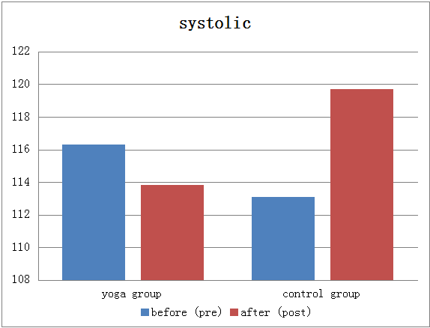  A | 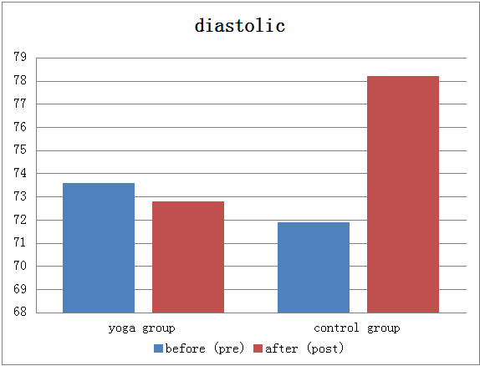  B
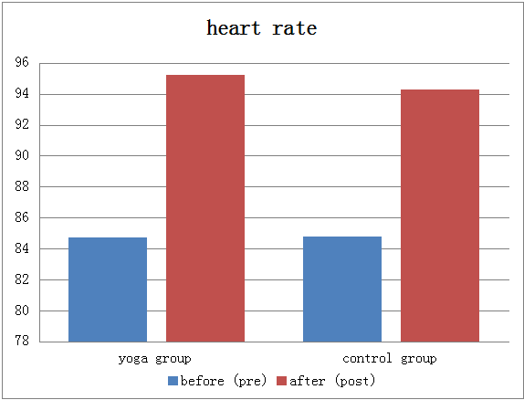  C | 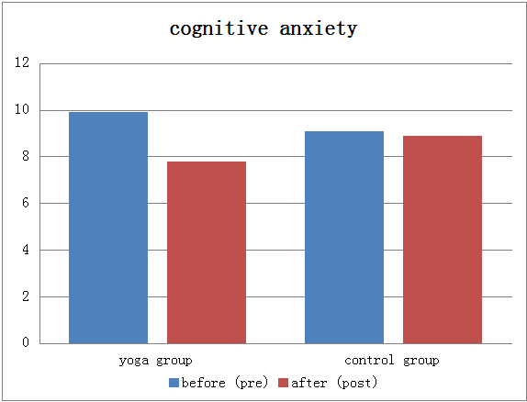  D
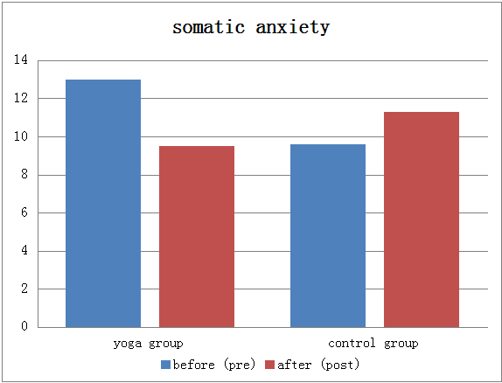  E | 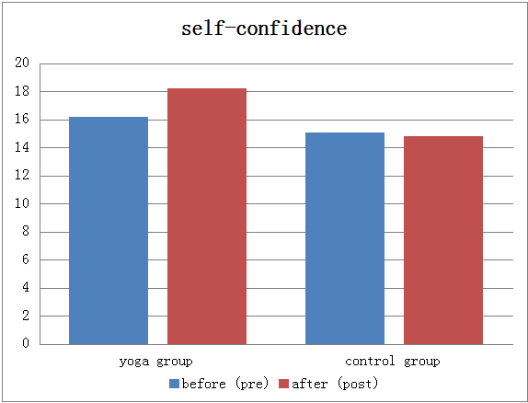  F
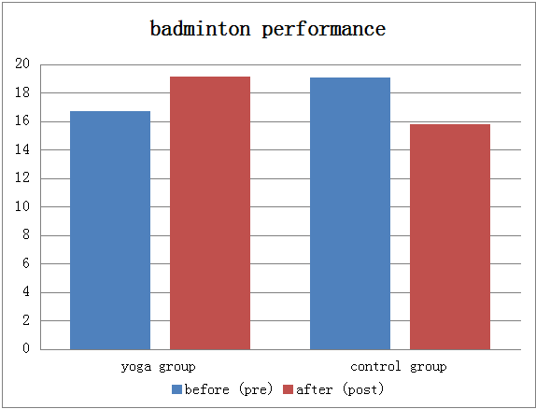
G

Figure 1: Different in scores (mean) of (A) systolic, (B) diastolic, (C) heart rate, (D) cognitive anxiety, (E) somatic anxiety, (F) self-confidence, and (G) badminton performance, before and after of experiment and control groups.
Figure 1 illustrates the effectiveness of comparison between experiment/yoga group before and after treatment with the control group. Yoga group experienced an increase in aspects: heart rate; self-confidence; and badminton performance, decreasing the aspect: systolic; diastolic; cognitive anxiety; and somatic anxiety. While in the control group experienced an increase in aspect: diastolic; heart rate; and somatic anxiety, and decrease the aspect: systolic; cognitive anxiety; self-confidence; and badminton performance. From the various kinds of data it can be concluded that the experimental group had a significant change compared with the control group, so treatment with yoga for badminton exercises managed to reduce anxiety and improve badminton athlete’s performance.
Discussion:
The testing phase is done yoga for competitive badminton in reducing anxiety in badminton athletes. Minimize threats to internal validity, some effort is made such as; make the same competition twice (pre-test and post-test), quasi-experimental with two groups (experimental and control groups), using the instrument competitive anxiety (CSAI-2R), blood pressure (systolic, diastolic, and heart rate) , and badminton performance test (Creswell, 2010).
The results of the research study reported that the mean of systole variables change in the yoga group (experimental group) (x=-2.50; -2.14%), while the control group experienced a change (x=6.60; 5.83%). It was means that after yoga treatment, the experimental group experienced a decrease that is not too big in systole of blood pressure, and inversely proportional to the control group who experienced an increase in systolic blood pressure at the time before the competition. In diastolic blood pressure variables were not significant differences before and after treatment in the experimental group (x=-0.80; -0.01%). In the control group experienced an increase in the mean value (x=6.30; 8.76%). Negative sign indicates a decrease and a positive sign indicates an increase, so the yoga group was experience decreased and the control group was experience increased in diastolic and blood pressure variables. There was significant improvement in both groups of heart rate, the yoga group increased (x=10.50; 12.39%), control group also increased (x=9.50; 11.19%).
Understanding blood pressure on a person's level of anxiety is very diverse, it has been argued if someone is experiencing anxiety, the blood pressure will rise (James et al., 1986), while Raglin et al. (1987) which states that blood pressure increases or decreases depends on what to eat, sleep, motion, and perceived stress. Increased heart rate is one of the contributors to the increase in blood pressure. When experiencing anxiety, heart rate will increase, it is possible to pump blood to the part of the body that need if fighting or fleeing when threatened. But the increase in cardiac output causes an increase in blood pressure which raises systolic heart rate, while diastolic is generally unaffected (Devereux et al., 1983; James et al., 1986; Raglin et al., 1987). From statement above concluded that blood pressure fluctuates randomly throughout the day because of power, diet, hydration, and more. Blood pressure is not constant even if a person does not have any anxiety. Heart rate and blood pressure have a tendency connected with anxiety. Adjust blood pressure with anxiety, which will eventually return to the base level. Changes in blood pressure have a tendency to be high in the short term, and usually occur in the early stages of anxiety or during a panic attack. One indicator of a person anxious is by increasing blood pressure of that person, but need another instrument which can indicate the level of anxiety a person.
Cognitive anxiety item on the yoga group decreased (x=-2.10; -21.21%), and the control group also felt (x=-0.20; -2.19%). Somatic anxiety symptoms similar to yoga group (x=-3.50; -26.92%), but not for the control group, which increased (x=1.70; 17.71%). Whereas self-confidence has a negative correlation to other variables, the yoga group increased (x=2.00; 12.35%) and the control group decreased (x=-0.30; -1.99%). the last was badminton performance, yoga group increased (x=2.40; 14.67%) and the control group decreased (x=-3.283; -17.23%).
Multidimensional theory states that it is necessary to distinguish between cognitive anxiety and somatic anxiety, so measurement must also be different (Martens, et al., 1990). The relationship between cognitive anxiety and somatic anxiety are positive, ie if the cognitive anxiety increases, somatic anxiety increased, and vice versa if the cognitive anxiety decreases the somatic anxiety also decreased. Another item that is self-confidence has a negative correlation with cognitive anxiety and somatic anxiety. The entire item (cognitive anxiety, somatic anxiety, self-confidence) was an indicator in determining an athlete's level of competitive anxiety (Martens et al, 1990; Cox et al., 1998, 2003).
The results of research in this study corroborate the theory of catastrophe models (Fazey & Hardy, 1988) about the relationship between anxiety and sporting performance. Instead they pointed out that when the athlete is experiencing high cognitive anxiety (i.e. they are worried), then a small increase in arousal beyond the optimum level can bring about a massive fall-off in performance. Under conditions of low cognitive anxiety, (i.e. when the athlete is not particularly worried), the inverted U hypothesis holds true. However, when cognitive anxiety is high then there comes a point just above the optimum level of arousal where performance drops off sharply. It is also associated with fluctuations of heart rate, that under conditions of low cognitive anxiety the results showed a weak inverted U, whereas under high cognitive anxiety performance peaked considerably higher but then dropped off quickly. This supports the catastrophe model.
The catastrophe model is more complex than the inverted U hypothesis and offers a more sophisticated understanding of the relationship between arousal and performance. The major practical application of the model is in showing that cognitive anxiety is not necessarily an enemy of performance, but under certain circumstances is beneficial (Hardy et all, 1996). This fits in with the results of interviews by Jones et al. (1993), which found that many athletes reported that they performed best when worried. However, been criticisms of the model. Gaines and barry (2008) proposed that it is essentially too complex to be entirely testable. Some researchers, such as Martens et al. (1990), have disputed the idea that cognitive anxiety, somatic anxiety and self-confidence can improve performance. Badminton performance testing between the yoga group and control group showed that the yoga group reported experiencing a significant increase in performance than the control group.
Conclusion:
Yoga for badminton has been made in this study done by badminton athletes very easily, because the movements and exercises offered are adapted to the athlete’s character and badminton themselves. Movement or yoga poses almost similar to the stretching and warming-up movement is athletes usually done, just add some more specific modifications movement for badminton. Yoga for badminton is also accompanied by a video and guidebook in doing so, what preparation, and what to do. With the book and the video will add discretion athletes in the practice of yoga, because it is not rooted by time, and can be done anywhere and anytime.
Badminton performance testing between the yoga group and control group showed that the yoga group reported experiencing a significant increase in performance than the control group. Yoga group experienced an increase in aspects: heart rate; self-confidence; and badminton performance, decreasing the aspect: systolic; diastolic; cognitive anxiety; and somatic anxiety. While in the control group experienced an increase in aspect: diastolic; heart rate; and somatic anxiety, and decrease the aspect: systolic; cognitive anxiety; self-confidence; and badminton performance. From the various kinds of data it can be concluded that the experimental group had a significant change compared with the control group, so treatment with yoga for badminton exercises managed to reduce anxiety and improve badminton athlete’s performance.
Acknowledgements:
We would like to thanks Universitas Negeri Semarang, Central China Normal University, Badminto Federation of Semarang (PBSI Semarang) for all support.
References:
Andrew Peden, (2009) Breathing to Manage Anxiety in Tennis. ITF Coaching and Sport Science Review 2009; 16 (49): 17 – 18.
Beauchamp, MR. Bary, SR. Albinson, JG (2002). Pre-competition imagery, self-efficacy and performance in collegiate golfer’s. J Sport Sci.20 (9):697-705
Borkovec, T & Costello, E. (1993). Efficacy of applied relaxation and cognitive behavioral therapy in the treatment of generalized anxiety disorder. Journal of consulting and clinical psychology, 61, 611-619, 1993.
Caroline Smith, Heather H, Jane Blake-M, Kerena E (2006) A randomised comparative trial of yoga and relaxation to reduce stress and anxiety. Elsevier Ltd . Complementary Therapies in Medicine (2007) 15, 77—83
Cerin, E., Szabo, A.. Hunt, N., & Williams,C. (2000) Temporal patterning of competitive emotions: a critical review, journal of Sports Sciences, 18, 605-626
Cox R (1998) Sport psychology, concepts and applications. Boston, McGraw-Hill.
Cox, R. H., Russell, W. D., Rob, Marshal (1998). Development of a CSAI-2 short form for assessing competitive state anxiety during and immediately prior to competition. Journal of Sport Behavior.
Cox, R. H., Martens, M. P., Matthew. P, & Russell, W. D. (2003). Measuring anxiety in athletics: The Revised Competitive State Anxiety Inventory-2. Journal of Sport and Exercise Psychology, 25, 519-533.
Craft, L., Magyar, T. M., Becker, B. J., & Feltz, D. L. (2003) The relationship between the Competitive State Anxiety Inventory-2 and sport performance: a meta analysis. journal of Sport & Exercise Psychology, 25, 44-65
Creswell J.W. (2010) Research Design: Qualitative, quantitative, and mix methods approaches. 3rd edition. @sage publication.
Devereux, Richard B., et al. (1983). Left ventricular hypertrophy in patients with hypertension: importance of blood pressure response to regularly recurring stress. Circulation 68.3 470-476.
Donny, W.Y.Kusuma., 2015. The development of techniques to reduce the level of anxiety based on yoga in Indonesian badminton athletes: research and development methods. Doctoral dissertation. Unpublishing. Central china normal university.
Donny. W.Y. Kusuma. (2015, September). The Study of Competitive Anxiety on Semarang Badminton Athletes. Taufik, Fahmi, Arif, Nadia, Lukman. Paper presented at Internatinal Conference ACPES 2015, UNNES Semarang (Indonesia). Semarang: UNNES Press
Fabrizio Coppola, David Spector, (2009) Natural Stress Relief Meditation As A Tool For Reducing Anxiety And Increasing Self-Actualization. Social Behavior And Personality, 2009, 37(3), 307-312
Fazey J and Hardy L (1988) The inverted U hypothesis: a catastrophe for sport psychology? British Association of Sport Sciences Monograph 1. Leeds, National Coaching Foundation.
Fletcher, D., Hanton, S., and Mellalieu, S. D. (2009) An organizational stress review: Conceptual and theoretical issues in competitive sport. In S. Hanton and S. D. Mellalieu (Eds.), Literature reviews in sport psychology. Hauppauge, NY: Nova Science.
Gaines T., Barry L.M. (2008) The effect of a self-monitored relaxation breathing exercise on male adolescent aggressive behavior. Adolescence, 43(170), 291-302.
Gould, D., & Krane, V. (1992). The arousal-performance relationship: Current status and future directions. In T. Horn (Ed.), Advances in sport psychology (pp. 119-141). Champaign, IL: Human Kinetics.
Gleim GW, McHugh MP, (1997) Flexibility and its effects on sports injury and performance. Sports Med. 1997 Nov;24(5):289-99.
Grice, Tony. (2008) Badminton : Steps to Success. Human Kinetics. United States of America 2nd ed.
Hala Nabil Yahiya (2010). Impact of hatha yoga exercise on some of the physiological, psychological variables and the level of performance in judo. Journal procedia social and behavioral sciences. Elsevier Ltd.5 (2010) 2355-2358.
Hardy, L., Jones, G., & Gould, D. (1996) Understanding psychological preparation in sport: theory and practice of elite performers. Chichester, UK: Wil
Iyengar, B.K.S. & Yehudi M. (1996). Light on Yoga. New York: Schocken Books.
James, Gary D., et al. (1986). The influence of happiness, anger, and anxiety on the blood pressure of borderline hypertensives. Psychosomatic Medicine 48.7: 502-508.
Jones, G. (1995). More than just a game: Research developments and issues in competitive anxiety in sport. British Journal of Psychology, 86, 449-478.
Krane, V. (1992). Conceptual and methodological considerations in sport anxiety research: From the inverted-U hypothesis to catastrophe theory. Quest, 44, 72-87.
LaMeaux (2011) How Does Yoga Help Athletes? Benefits and suggestions for incorporating yoga in your active lifestyle. http://life.gaiam.com/article/how-does-yoga-help-athletes
Larry P. & Richard U. (2002). Yoga RX. A step by step program to promote health, wellness, and healing for common ailments. 1st ed. Broadway. New York.
Marten R, Burton D, Rivkin, F, & Simon, J (1980) Reliability and Stability of Competitive State Anxiety Inventory (CSAI). In C.H.N adeau, W.C. Halliwell, K.M. Newell,G.C. Roberts (eds.) Psychology of Motor Behavior and Sport 1979. Human Kinetics, Campaign, IL, pp. 91-99.
Marten R, Burton D, Vealey RS, Bump LA and Smith D (1990) Development and Validation of the Competitive State Anxiety Inventory-2. In Marten R, Burton D, Vealey RS (eds) Competitive Anxiety in Sport. Champaign, Human Kinetics. 1990: 117-213.
Martens, R., Vealey, R.S., & Burton, D. (1990). Competitive anxiety in sport. Champaign, IL: Human Kinetics.
Matt Jarvis (1999). Sport Psychology. 1999 Routledge. London and Newyork
Mohamed, N. (1994).Tests of skill and mental sports field, Cairo, Dar ATF, 1:227-244.
Nurs Clin North Am. (2001) Meditation, yoga, and guided imagery. PubMed Mar;36(1):47-56
Raglin, John S., and William P. Morgan. (1987).Influence of exercise and quiet rest on state anxiety and blood pressure. Medicine & Science in Sports & Exercise.
Scanlan, T.K., & Passer, M.W. (1978). Factors related to competitive stress among male youth sport participants. Medicine and Science in Sport, 10, 103-108.
Sheng-Chia Chung, Maria M. Brooks, Madhur Rai, Judith L. Balk, and Sandeep Rai, (2012) Effect of Sahaja Yoga Meditation on Quality of Life, Anxiety, and Blood Pressure Control The journal of alternative and complementary medicine. Vol.18, Number 6, 2012, pp. 589–596
Shirley Archer, (2009) Benefits of Yoga Breathing. Annals of the New York Academy of Sciences 1172,54-62)
Simon, J.A., & Martens, R. (1977). SCAT as a predictor of A-states in varying competitive situations. In D.M. Landers & R.W. Christina (Eds.), Psychology of motor behavior and sport, Vol. 2 (pp. 146-156). Champaign, IL: Human Kinetics.
Spielberger CD (1966), Anxiety and behavior. New York, Academic Press.
Timmermans, C., Spittle, M., & Plaisted, V. (2003). The effect of yoga, the state anxiety and mood state of athletes. Proceedings of the 11th European Congress of Sport Psychology. Copenhagen, Denmark, July.
Walton, K.G., Schneider, R.H., & Nidich, S. (2004) Review of controlled research on the transcendental meditation program and cardiovascular disease. Risk factors, morbidity, and mortality. Cardiol Rev,; 12(5), 262-266.
Weinberg R and Gould D (1995) Foundations of sport and exercise psychology. Champaign, Human Kinetics.
Woodman, T., & Hardy, L. (2003) The relative impact of cognitive anxiety and self-confidence upon sport performance: a meta-analysis. Journal of Sports Sciences, 21,443-457.
Yerkes, R.M., & Dodson, J.D. (1908). The relation of strength of stimulus to rapidity of habit formation. Journal of Comparative Neurology of Psychology, 18, 459-482.

