ELING LAN WASPODO AS A LOCAL PERCEPTION FOR “MERAPI” VOLCANIC DISASTER PREPAREDNESS

Septian Aji Permana
Lecturer Universitas PGRI Yogyakarta/Indonesia¹

aji@upy.ac.id¹

ABSTRACT. Cangkringan community has a perception that the Merapi eruption is a gift not a threat or danger. This phenomenon can be understood as an attitude of wisdom of Merapi slopes to always be ready to live modestly with nature. This study aims to analyze the incidence of Merapi eruption in 2010 which has killed 347 peoples and found perceptions for readiness to face the threat of Merapi eruption in Cangkringan. This study used a qualitative approach for the perception of cangkringan peoples as preparedness to encounter the threat of Merapi eruption. Informant in this study were the Cangkringan peoples, caretaker of Mount Merapi, officials of Regional Disaster Management Agency (BPBD) in Sleman, Yogyakarta and data collected by observation and in-depth interviews. The collected data were then analyzed by using domain analysis, taxonomic, componential, and the theme of culture. The results showed that Perception built over the years was not to face the threat of Merapi eruption, but gratitude of Cangkringan community to the gift given by Merapi Volcano in the form of extraordinary natural wealth. Community's perception of preparedness to face the threat of Merapi eruption in the form of advice or messages that contain high phylosophy value is eling lan waspodo. The presence of disasters are not preventable, but casualties can be minimized by preparedness action in facing the threat of Merapi eruption.

KEYWORDS : Disaster Preparedness: Perception; Local Wisdom;

INTRODUCTION
Mount Merapi in Javanese community cosmology plays a very important role (Saso, 2001; Permana, 2016). In particular, Cangkringan community beliefs that mountain is a giver and also a taker. Volcanic eruption is a giver and a taker. Volcanic eruptions are useful as fertilizer for the soil fertility, as a livelihood, however the negative impact of the eruptions may affect the villages and sacrificed thousands of lives. Cangkringan community has a belief that mountain is "the big universe" of God's house as they symbolize the mountain as the house of the ancestral spirits in a puppet show.
For the Cangkringan community, Mount Merapi symbolizes as a tool that can provide benefits and threats. Mount Merapi plays an important role in people's lives on both economic and culture-social terms. Mount Merapi, environment and nature, as well as the culture of the Cangkringan community, are in a unity. Continuity and harmony of life among the four could be seen in each community activity. Appreciation and respect for Merapi and the surrounding nature were always be emphasized. According to the community belief, Mount Merapi and the surrounding nature were something that should be respected and appreciated (Walgito, 2004; Toha, 2003; Permana, 2016)
Mount Merapi is still regarded as the active and most dangerous Volcano in Indonesia, but on the other hand, the local citizens in Cangkringan have a different perception compared to the local citizens on other Merapi slope, such as community in Magelang, Klaten and Boyolali that they consider the eruption of Merapi is a threat or danger, in contrast to Cangkringan community who consider that Merapi eruption is gift rather than a threat or a danger (Sugihartono 2007; Siri, 2016).
According to Toha (2003), perception is one of the psychological aspects that is very important to humans in response to the presence of various aspects and symptoms in the surroundings. Walgito (2004) reveals that perception is a process of organizing, with the interpretation of the stimulus received by the organism or individual to be something meaningful, and is an activity that is integrated within the individual. The response as a result of the perception can be taken by individuals in various forms, which stimulus will get the response from the individual depends on the attention of the individual concerned. Based on this, the feelings, the ability to think, the experiences between individuals are not the same, then in perceiving something stimulus, the perception results may be different from one to another individual.
Rachmat (2007) suggests that the perception is the brain's ability to translate the stimulus or process for translating stimulus that goes into the human sensory organs. There are differences in sensing standpoint in Human perception. There are people who perceive something as good or bad, have positive or negative perceptions which will influence appeared or real human actions.
Sugihartono (2007), describes that everyone has a tendency to see the same object in different ways. Such differences may be influenced by many factors, including knowledge, experience and perspective. Perception is also interlocked with the perspective (How to look) of a person against a particular object by different ways by using sense organs they owned, then attempt to interpret it. Both positive and negative perceptions are like a file that is already stored neatly in the nature of our subconscious mind. The file will appear when there are stimuli that trigger it, or something happened that can open it.
The perception of Cangkringan community until now is still the same, that the presence of Mount Merapi is a gift. They still do not want to be moved or relocated, this is a clear evidence of the wisdom of the community to be prepared in a simple life with nature, although Cangkringan people are in a vulnerable position, but the daily activities of the people are still running (Rajib, 2001; Sebastian, 2001; Setyowati , 2014)
According to the opinion of Cangkringan people who were reluctant to leave the area, it can be understood as a fundamental fairness, this is because it involves their existence as Mount Merapi community which has environmental wisdom, which is able to coexist in harmony and in harmony with the natural environment of Mount Merapi. Local wisdom possessed by the people is quite difficult to be separated, because even if people are afraid of the eruption of Mount Merapi, but the community also expect that the eruption of Mount Merapi is a gift (Pyles, 2011; Permana, 2016).
This is reflected by the time of the eruption in 2010, although the Merapi eruption caused 196 died victims because of hot cloud burns, 151 died of non-burn wounds, 258 injured people and 410.338 people were relocated which occurred in Kinahrejo, Pelemsari hamlet, Umbulharjo village, Purwobinangun village, Turgo hamlet, Kepulharjo village, and Kaliadem hamlet, but the Cangkringan community remained refused to be relocated or moved (Permana, 2016).
This phenomenon can be understood, as an attitude of Cangkringan community to always be ready for unpretentious life together with nature and the environment they live in, even though the areas have been destroyed by fire by hot clouds and made as the restricted and uninhabitable areas. Cangkringan community considers that the slope of Mount Merapi is the homeland, so that Mount Merapi with all natural processes are perceived as something reasonable (Permana, 2016).
The government has a policy to relocate the slopes of Merapi by providing HUNTAP (permanent residences) but people are reluctant to move to HUNTAP. The public trusted the advice given by Merapi's caretaker more than the advice of the government to be relocated (Chen, 2006; Fatkhan, 2014). Eling lan waspodo can be used as an alternative middle ground policy because the community does not want to be relocated so that they are always ready to take an independent and spontaneous attitude (leadership).

RESEARCH METHODS AND DESIGN

This study used a qualitative approach with ethnophenomenology method. This study was conducted in Cangkringan Sub-District, Yogyakarta. Cangkringan was chosen was because Cangkringan area is geographically located in the south of Mount Merapi which make it vulnerable area for the eruption. Data collection instruments used here were observation, interviews, and documentation. Observations were participative, frank and subtle, and were not structured to know and make sure that the objects to be examined in this case were the informants in the location to be studied in order to obtain more accurate observation data. Once the researchers conducted an observation, then they conducted the process of documentation, archiving, and assembled a number of facts and information to the level of concepts and theories. Data were analyzed with analysis technique of domain, taxonomic, componential with the processes of organizing and reducing the data into patterns, categories and basic description unit so that the theme can be determined and conclusion can be formulated. Scene Analysis of Culture Theme was made during the data collection and after the completion of data collection. Analytical works carried out in this case were setting, sorting, coding and categorizing the data so that descriptions can be found in accordance with the aspects studied.

RESULTS AND DISCUSSION

- The Incidence of Merapi Eruptionin Cangkringan Community
Mount Merapi in Javanese community cosmology plays a very important role. In particular, Cangkringan community beliefs that mountain is a giver and also a taker. Volcanic eruption is a giver and a taker. Volcanic eruptions are useful as fertilizer for the soil fertility, as a livelihood, but the impact of the eruptions can destroy the villages and sacrificed thousands of lives (Koentjaraningrat, 1991; Permana, 2016)
Based on the record of BPBD Sleman, Yogyakarta, in average, Mount Merapi erupts in short cycle that occurs each between 2-5 years, while the intermediate cycle is every 5-7 years. The longest cycle has ever recorded after a break for >30 years, especially in the early days of its existence as a volcano. Entering the 19th century, the record of the Mount Merapi activities began continuous, and thus the people who are in the area of ​​Mount Merapi should be more prepared and alert (Permana, 2016).

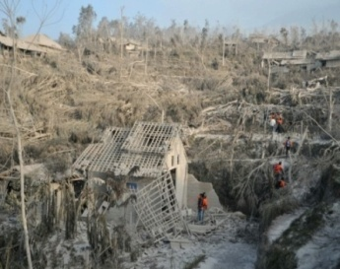
Figure 1.1The Impact of Merapi Eruption in 2010
(Source: Sachio, 2010)

Throughout history, the eruption of Mount Merapi has caused dead and injured victims as follows:

Table 1.1The number of Merapi Eruption victims

NO | The Year of Eruption | The number of dead victims | The number of injured victims
1. | 1822 | 100 people | none
2. | 1832 | 32 people | none
3. | 1872 | 200 people | none
4. | 1904 | 16 people | none
5. | 1920 | 35 people | none
6. | 1930 | 264 people | none
7. | 1954 | 64 people | 57 people
8. | 1961 | 6 people | none
9. | 1969 | 3 people | none
10. | 1976 | 29 people | 2 people
11. | 1994 | 66 people | 6 people
12. | 1997 | none | none
13. | 1998 | none | none
14. | 2001 | none | none
15. | 2006 | 2 people | none
16. | 2010 | 347 people | 258 people
(Document Source: BPBD Sleman, Yogyakarta, 2019)

Since the beginning of the history of the Mount Merapi eruption, it has been noted that the type of eruption is a lava dome growth then fall and produce hot clouds of rock fall known as Merapi Type. The incidence is growing lava dome at the peak at a time because the position is not stable or driven by magma from within and collapse followed by incandescent lava avalanches (Permana, 2016).
Merapi eruption in 2010 was the largest eruption of Merapi compared to the eruption of Merapi in 2001 and 2006. According to the experience of Mbah Harto et Merapi eruption in 2010, most of the local community though that the incidence would be in a small scale, because in the previous year, namely 2001 and 2006 Merapi only produce small eruption. In 2001 there was an eruption but only in a small scale so and the people were alert to go down to the evacuation place. However, in 2001 was a small scale which only destroyed the land so that people came back again to their residences even though people were encouraged by the government to be relocated but the people were reluctant because for them residence is homeland (Permana, 2016).

- Community Perception on the Incidence of Merapi Eruption

Mount Merapi is one of the elements of nature as the source of life must always be considered properly. This is necessary so that the relationship between community and nature is not exploitation. Otherwise, this relationship is mutually to keep each other so as to create harmony. The community has the perception that anyone who violates these interactions will be exposed to penalties (Saso, 2001; Permana, 2016).

menjagamaintain
MOUNT MERAPI
COMMUNITY

maintain

Figure 2.1 Community Perception on the Incidence of Merapi Eruption
(Source: Researcher Analysis, 2019)

Perception in the community towards volcanic eruption is hardly to be separated from the law of causation. The local community has a perception in which the preservation on Merapi mountain has to be made to ensure that the mountain gives benefit to the community, otherwise, the mountain will produce a huge threat. Mount Merapi is considered sacred by the Cangkringan community, this is because most people still adhere to the noble values ​​of Javanese culture, to the belief in the cosmology of Mount Merapi, palace ghosts of Mt. Merapi, and haunted places around Mount Merapi (Permana, 2016).
The local community believed that the Mount Merapi posed a threat or danger due to human activity which had been far from the values ​​of noble culture to always maintain the nature by not exploiting excessively, and vice versa if the community attitudes were filled with humility and unpretentious life by always care for and preserve the nature then the nature itself would bring benefits or grace (Permana, 2016).
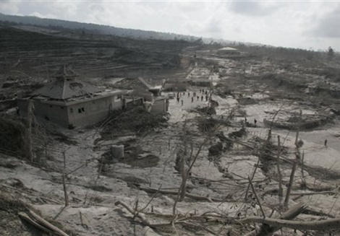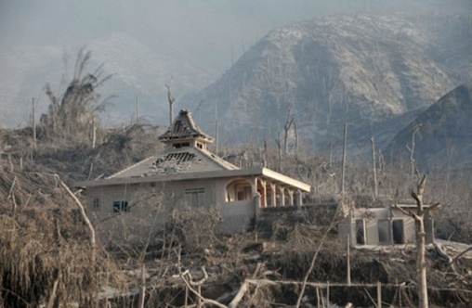
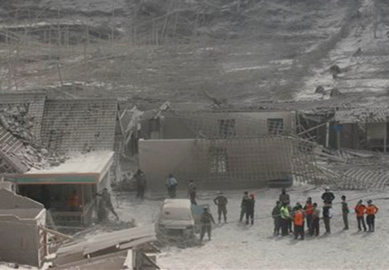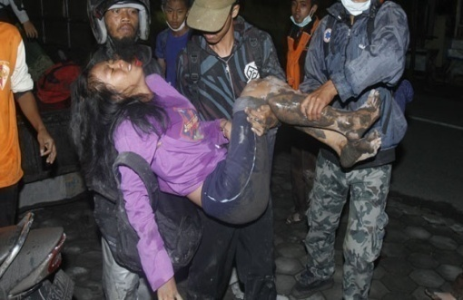
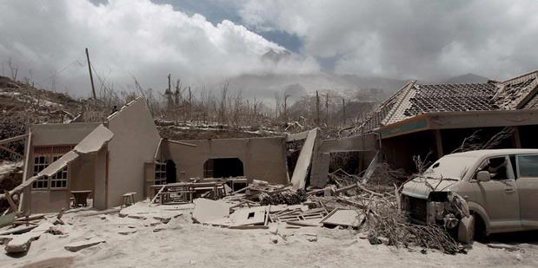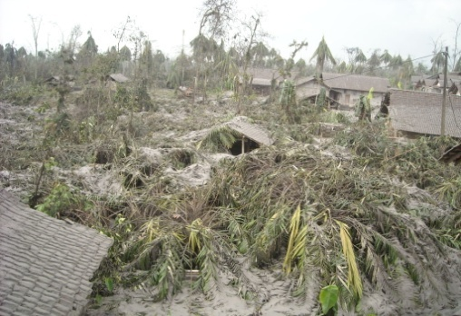
Figure 2.2 Community Perception on Merapi Eruption as a Threat
(Source: Permana, 2019)

Potential threats from Mount Merapi could lead to death, personal injury, property damage, social disruption, or environmental damage. For the people live in vulnerable areas (prone to disasters) there is a need to create preparedness for disaster.
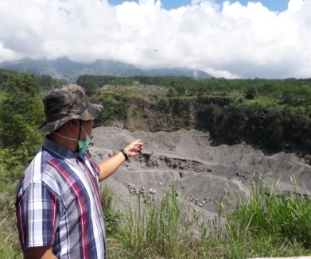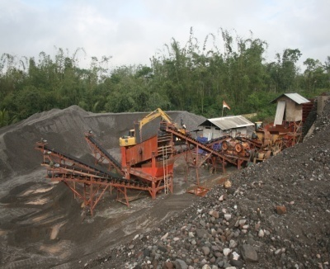
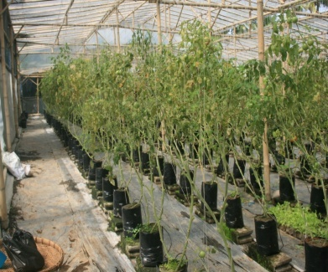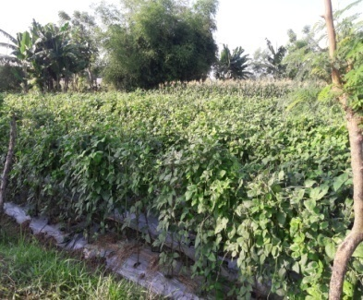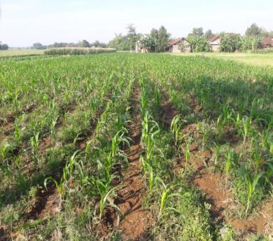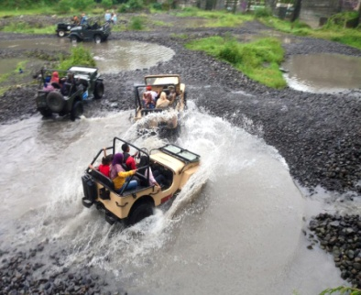
Picture 2.3 Community Perception on Merapi Eruption as a Gift
(Source: Permana, 2019)

The neighborhood around Merapi before the eruption was very beautiful and especially the land was very fertile, the interaction between people was also very good. One of the reasons that farmers did not want to move was because of the condition. Farmers believed that the wrath of Merapi was the will of God so that salvation as God's will is in line with the concept of community life of 'nerimo ing pandum' in which this concept illustrates a pattern surrendered life with all the decisions that have been determined by God (Saso, 2001; Koentjaraningrat, 1991; Permana, 2016).
Beside the concept of "nerimo ing pandum" above, community belief about the eruption of Merapi was that Merapi eruption brought grace. This perception has been entrenched so that the community believes that the eruption of Merapi is only part of the dynamic that ultimately will provide welfare for the community. The belief in the given welfare will be difficult to be torn down and becomes a part of the psycho-cultural aspects lives in the minds of the community (Sugihartono. 2007; Permana, 2016).
In logic-rational manner, long-term post-Merapi eruption, the land affected by the volcanic ash will improve soil fertility. Soil fertility means talking about the personification of the choice of 'source of life' phrase. Land is life which will contribute to the welfare that the fertility is 'guaranteed' by Merapi post Merapi eruption (Permana, 2016).
After the eruption of Merapi, tourism aspect became a major commodity; people have taken advantage of the erupted location to be used as the traveler journey route by using a rented jeep by the community. Locations around the major tourism attractions are used by the people to sell many things needed by both foreign and local tourists. That is why people are reluctant to be moved or relocated (Permana, 2016).
Perception owned by the people was that Merapi eruption could bring a threat, but on the other hand people were expecting an eruption of Merapi because for the community, the Merapi eruption could bring a gift of natural resources such as sand and stone. However, the community must remain be Eling lan Waspodo (mindful that even though Merapi brings grace, it will can pose a threat, so people should always be careful). This perception should always be embedded in the hearts of the people so that when there is a stimulus (the eruption of Merapi) community can respond positively so that they are more alert and ready against the threat of Merapi eruption (Permana, 2016).
CONCLUSION
The eruption of Merapi in 2010 for the community has a very important role in the life of the Cangkringan community both in terms of economic and social cultural aspects. Mount Merapi, the people and nature are an inseparable unity. The continuity and harmony of life between the three is seen when the community does not want to be relocated by the government.
Mount Merapi has given birth to its own perception for the community that living on the slopes of Mount Merapi actually feels protected, safe and comfortable even from the eruption of Mount Merapi can provide its own gifts in the form of natural resource wealth such as rocks and sand. Eling lan waspodo as a local perception for preparedness to face the threat of the eruption of Merapi which is full of symbolic meaning that even though we are in the midst of threats we must always ask God Almighty and always try really seriously.
Mount Merapi as a macrocosm of the universe that can affect the way of human life. The people in getting to know Merapi Mountain must have been very long because they were raised in Merapi since childhood, the people living on the slopes of Merapi have absorbed a lot of their parents' wisdom in dealing with Merapi's actions. During a long journey almost throughout his life people learned to recognize the natural phenomena associated with the activities of Mount Merapi. Oral traditions that are always spoken in prayers asking for safety "karepe ngono manungso kon podo eling lan waspodo” (human wants to be careful because remembering the threat of Merapi eruption can come at any time).

ACKNOWLEDGEMENTS
The authors thank the National Disaster Management Agency (BNPB) for granting permission to conduct research and thank the AJIB (Acceleration of International Reputation Journal) team for providing this article to be better.

DAFTAR PUSTAKA

Bhandari Kumar Rajendra. 2014. Disaster Education and Management A Joyride for Students, Teachers, and Disaster Managers. Jurnal: Springer New Delhi Heidelberg New York Dordrecht London 2014, DOI 10.1007/978-81-322-1566-0.
Chen Chun, Liu Yi-Chung, Chan Kuei-Chi. 2006. Integrated Community-Based Disaster Management Program in Taiwan: A Case Study of Shang-An Village. Jurnal: Springe- Verlag London 2006, DOI 10.1007/s11069-005-4669-5.
Cheney Shreve, Belinda Davis and Maureen Fordham. 2016. Integrating animal disease epidemics into disaster risk management. Jurnal : Disaster Prevention and Management: An International Journal, Vol. 25 Iss 4 pp. 478-491 http://dx.doi.org/10.1108/DPM-02-2016-0026.
Deeg Dorly, Huizink Anja, Comijs Hannie, and Smid Tjabe. 2005. Disaster and associated changes in physical and mental health in older residents. Jurnal: European Journal of Public Health, Vol. 15, No. 2, 170–174, All rights reserved, Doi:10.1093
Fatkhan Muhammad. 2014. Kearifan lingkungan masyarakat lereng Gunung Merapi dalam Menjaga alam. Jurnal: Penaggulangan Bencana, Volume 5, Nomer 1, Tahun 2014, ISSN 2087636X
Glenn Fernandez and Shaw Rajib. 2013. Youth Council Participation in Disaster Risk Reduction in Infanta and Makati, Philippines: A Policy Review. Jurnal: Disaster Risk Sci. 2013, 4 (3): 126–136, Doi:10.1007/s13753-013-0014-x.
Glik Deborah, David, Eisenman, Zhou Qiong. 2014. Using the Precaution Adoption Process model to describe a disaster preparedness intervention among low-income Latinos. Jurnal: Health Education Research, Vol.29 no.2 2014 Pages 272–283.
Hiryanto. 2013. Local Wisdom Identification on Understanding Natural Disaster Signs ByElders In DaerahIstimewa Yogyakarta. Jurnal: Penaggulangan Bencana, Volume 4, Nomer 1, Tahun 2013, ISSN 2087636X.
Kamp Van Irene, Velden Vander Peter ,Stellato Rebecca. 2005. Physical and mental health shortly after a disaster: first results from the Enschede
firework disaster study. Jurnal: European Journal of Public Health, Vol. 16, No. 3, 252–258, Doi:10.1093.
Kasdan Oliver David . 2016. Considering socio-cultural factors of disaster risk management. Jurnal : Disaster Prevention and Management: An International Journal, Vol. 25 Iss 4 pp. 492-505 http://dx.doi.org/10.1108/DPM-01-2016-0008.
Kessel Van Gisel, Gibbs Lisa, Dougall Mac Colin. 2014. Strategies to enhance reselience post-natural disaster: a qualitative study of experiences with Australian floods and fres. Jurnal: Journal of Public Health, pp. 1–9, Doi:10.1093/pubmed/fdu051.
Koentjaraningrat. 1991. ManusiadanKebudayaan di Indonesia. Yogyakarta: PustakaPelajar
Kolibri. 2012. Mendeteksitanda-tanda Tsunami berdasarkankearifanmasyarakat. Jurnal: PenaggulanganBencana, Volume 3, Nomer 1, Tahun 2012, ISSN 2087636X
Lebowitz Jon Adam. 2014. Community Collaboration as a Disaster Mental Health
Competency: A Systematic Literature Review. Jurnal: Jurnal Springer Science+Business Media New York 2014, DOI 10.1007/s10597-014-9751-6.
LuoXiaofeng and Levi Annette. 2013. Factors influencing willingness to participate in disaster reduction. Jurnal: Springer Science+Business Media Dordrecht 2013, DOI 10.1007/s11069-012-0546-1
Menghan, Tsai. 2014. Game-based education for disaster prevention. Jurnal : Springe DOI 10.1007/978-4-431-55090-7.
Mulligan Martin and Nadarajah Yaso. 2012. RebuldingComunity in the wake of disaster :lesons from the recovery from the 2004 tsunami Srilangka and India. Jurnal: Oxford University Press andCommunity Development Journal. 2011, Doi:10.1093/cdj/bsr025.
Oikawa Yukihikodan Shaw Rajib. 2014. Education for Sustainable
Development and Disaster Risk Reduction. Jurnal: Springer Tokyo Heidelberg New York Dordrecht London 2014, DOI 10.1007/978-4-431-55090-7.
Permana Septian Aji. 2016. Petuah Merapi Sebagai Kearifan Masyarakat untuk Kesiapsiagaan Menghadapi Ancaman Bencana Erupsi Gunung Merapi di Wilayah Cangkringan, Yogyakarta. Draf Disertasi; UNNES
Pohan. 2006. Kerangka Aksi Hyogo: Pengurangan Risiko Bencana 2005-2015 membangun Ketahanan Bangsa dan Komunitas Terhadap Bencana. Terjemahan oleh Wuryanti T. Jakarta: Masyarakat Penanggulangan Bencana Indonesia.
Prajanti, Sucihatiningsuh Dian Wisika. 2013. Evolution On Benefits And Development Of Information and Communication Technology (ICT) To Improve The Perfomance Of Agricultur Extension In Sentral Java. Internasional Journal. Organization Innovation (Online) 6.2 (Oct 2013) 243-253.
Pyles Loretta. 2011. Neoliberalism, INGO practices and sustainable disaster recovery: a post-Katrinacase study. Jurnal: Oxford University Press andCommunity Development Journal. 2011, Doi:10.1093/cdj/bsp058
Rajib Shaw and Takeuchi Yukiko. 2001. Sustainable Community Disaster Education in Saijo City and its Effectiveness in Landslide Risk Reduction. Jurnal: Springer Science+Business Media B.V. 2001, DOI 10.1007/s11069-012-0178-5.
Rakhmat, Jalaludin. 2007. Teori Persepsi dan Tindakan Sosial. Yogyakarta: Pustaka Pelajar.
Sasongko Lukas. 2001. Manusia Jawa dan Gunung Merapi, Presepsi Sistem Kepercayaan. Yogyakarta: Kanisius.
Sebastian, Heath E. 2001. Human and Pet-related Risk Factors for Household Evacuation Failure During a Natural Disaster. Jurnal: American Journal of Epidomology 2001, Vol.153, No. 7
Setyowati Dewi Liesnoor. 2014. Public Perception of Disaster Landslides and Efforts to Overcome in SubdistrictKaloran Central Java. Universal Journal of Geoscience.Vol 2 (7): 195-199, 2014.
Siri Hettige. 2016. An integrated social response to disasters: the case of the Indian Ocean tsunami in Sri Lanka. Jurnal. Disaster Prevention and Management: An International Journal, Vol. 25 Iss 5 pp. 628-648.
Sugihartono. 2007. Persepsi dan Kepercayaan. Yogyakarta: Kanisius
Suharti. 2008. PeranLansiaDalamPelestarianBudaya, LaporanPenelitian, Yogyakarta, LembagaPenelitian UNY
Suwarjo. 2009. PeranLansiaDalamPelestarianLingkunganHidup, LaporanPenelitian, Yogyakarta, LembagaPenelitian UNY
Swasono, Meutia Farida. 1995. Peranan dan Kontribusi Usia Lanjut, Laporan Penelitian, Jakarta, FISIP
Swasono, Meutia Farida. 1995. PeranandanKontribusiUsiaLanjut, LaporanPenelitian, Jakarta, FISIP
Toha Miftah. 2003. Sistem dan Mekanisme Persepsi Orang Jawa. Yogyakarta: Kanisius
Walgito Bimo. 2004. Persepsi Masyarakat Pedesaan. Yogyakarta: Pustaka Pelajar
Xi Zhang, Yi Lixin, Zhao Dong. 2013. Community-based disaster management:
a review of progress in China. Jurnal: Springer Science+Business Media Dordrecht 2013, DOI 10.1007/s11069-012-0471-3.
Yen lien Chin, Loh Siung Chin, Chen Chun Lian, Wei Liangyung, Lee Wencheng, and Ho Hsinya. 2006. Development and Implementation of Disaster Reduction Technology in Taiwan. Jurnal: Springe- Verlag London 2006, DOI 10.1007/s11069-005-4652-1.
Zermans Joris, Donker A Gé, Kerssens Jan. 2005. Health problems of victims before and after disaster: a longitudinal study in general practice. Jurnal: International Journal of Epidemiology 2005; 34:820–826, Doi:10.1093/ije/dyi096.

