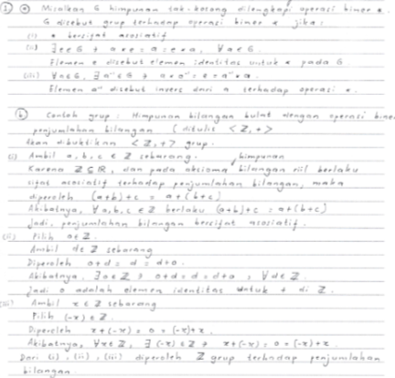
Figure 1 The Work of Problem 1 of the FI Subject

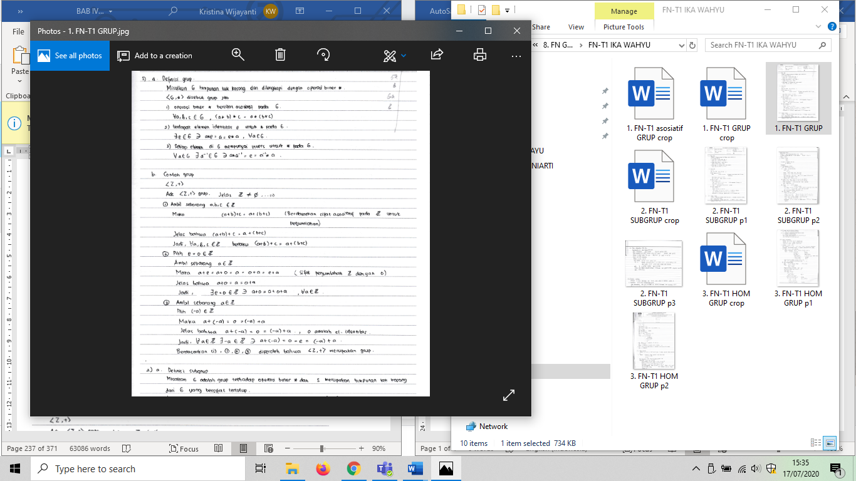
Figure 2 The Work of Problem 1 of the FN Subject

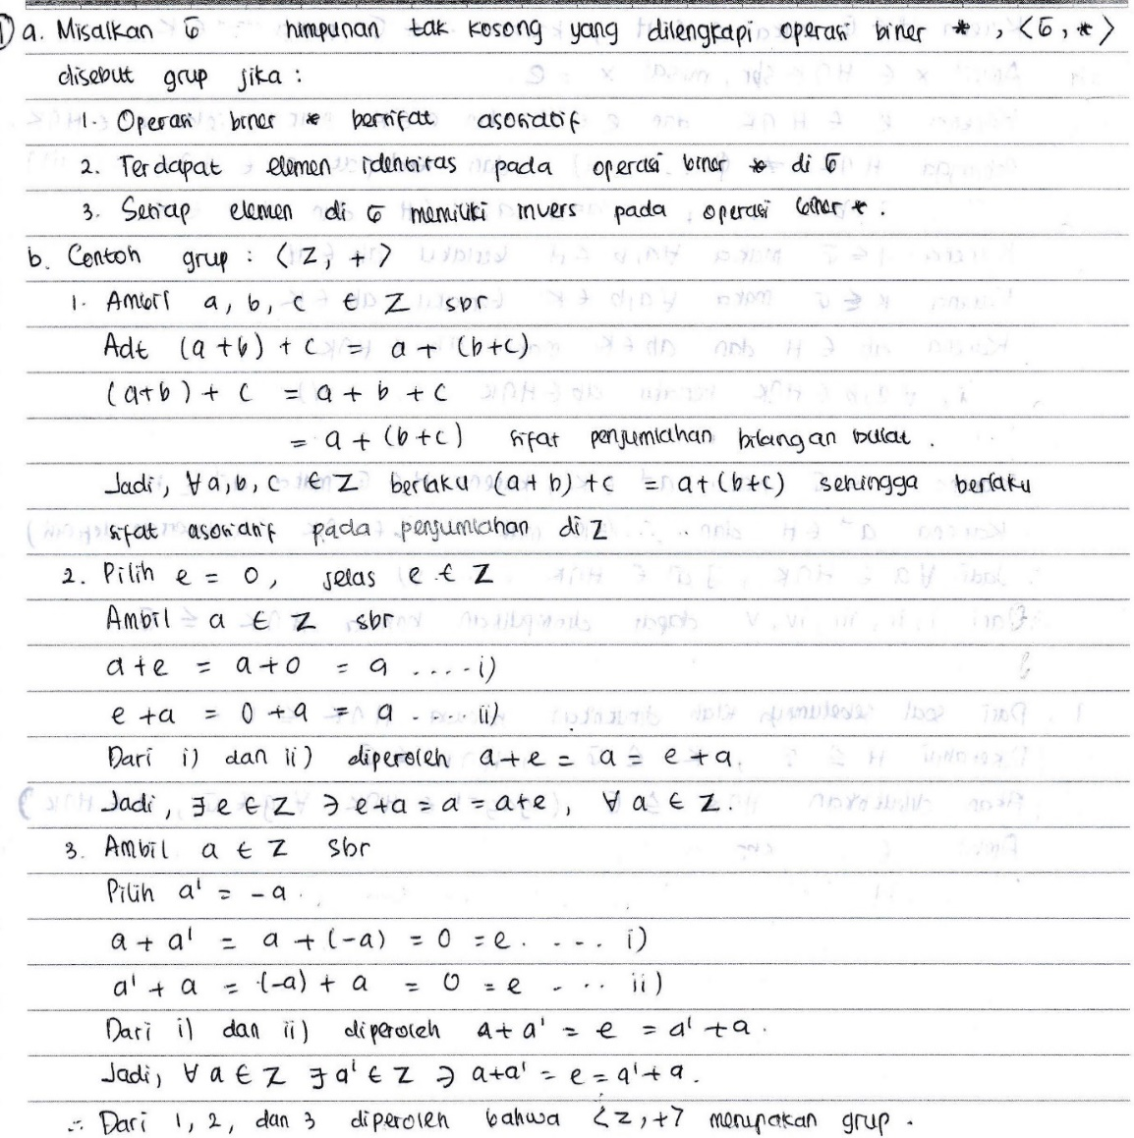
Figure 3 The Work of Problem 1 of the FD Subject

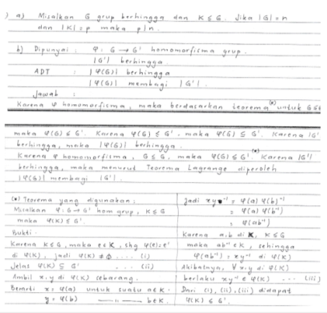
Figure 4 The Work of Problem 2 of the FI Subject

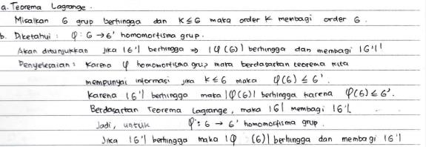
Figure 5 The Work of Problem 2 of the FN Subject

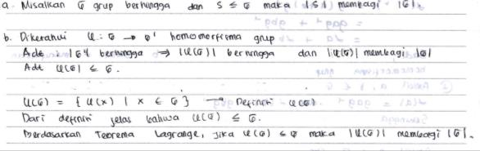
Figure 6 The Work of Problem 2 of the FD Subject

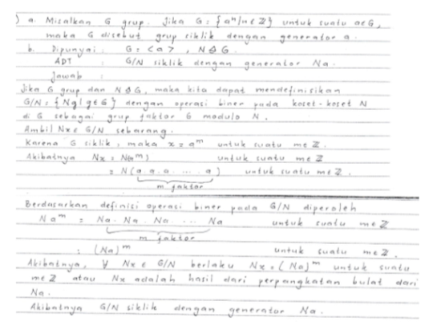
Figure 7 The Work of Problem 3 of the FI Subject

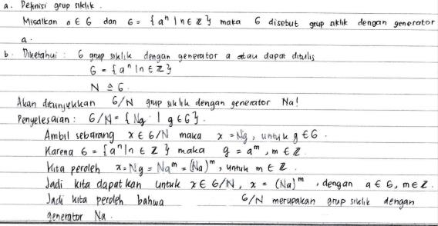
Figure 8 The Work of Problem 3 of the FN Subject

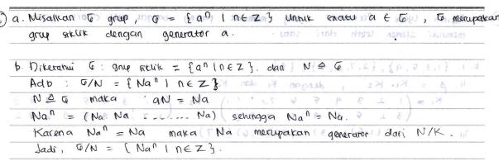
Figure 9 The Work of Problem 3 of the FD Subject

