USING USER-FRIENDLY DIGITAL MODE FOR ARABIC LANGUAGE TEACHERS, BANDUNG DISTRICT
Nalahuddin Saleh, Maman Abdurrahman, Hikmah Maulani, Shofa M khalid
Universitas Pendidikan Indonesia
nalahuddinsaleh@upi.edu, mamanabdurrahman@upi.edu, hikmahmaulani@upi.edu, shofelia@upi.edu
Abstract
Teaching foreign languages, such as Arabic in Indonesia, requires a very large effort from a teacher or lecturer and requires a variety of methods and media. Through this activity, teachers will be provided with various findings of innovative learning methodologies and guided by national Arabic language experts. The purpose of this service is that Arabic language teachers can be proficient in utilizing user-friendly digital modes in learning. The study used seminar and discussion methods, with the number of participants being 30 Arabic/PAI teachers in Bandung Regency. Each teacher will be trained and assisted to apply various theories presented by experts related to various digital modes of learning. The research findings show a high value in the assessment of teacher enthusiasm for training, as well as an assessment that the use of digital mode is a solution and an alternative method in teaching Arabic, especially during the pandemic. This service is expected to be the first step to continue developing user-friendly digital mode development workshops for teachers.
Keywords: Arabic, Digital, User Friendly
Abstrak
Mengajarkan bahasa asing, seperti halnya bahasa Arab di Indonesia diperlukan upaya yang sangat besar dari seorang guru maupun dosen dan dibutuhkan variasi cara dan media. Melalui kegiatan ini para guru akan dibekali berbagai temuan metodologi pembelajaran inovatif dan dibimbing oleh pakar nasional bahasa Arab. Tujuan pengabdian ini adalah guru bahasa Arab dapat mahir dalam memanfaatkan moda digital ramah pengguna dalam pembelajaran. Penelitian menggunakan metode seminar dan diskusi, dengan jumlah partisipan 30 guru Bahasa Arab/PAI Kabupaten Bandung. Setiap guru akan dilatih dan didampingi untuk menerapkan berbagai teori yang disampaikan para pakar terkait beragam moda digital dalam pembelajaran. Temuan penelitian menunjukkan nilai yang tinggi dalam penilaian antusiasme guru terhadap pelatihan, dan juga penilaian bahwa pemanfaatan moda digital menjadi solusi dan menjadi alternative metode dalam pengajaran bahasa Arab khususnya saat masa pandemi. Pengabdian ini diharapkan menjadi langkah awal untuk terus mengembangkan lokakarya pengembangan moda digital ramah pengguna bagi guru.
Kata kunci: Bahasa Arab, Digital, Ramah Pengguna

INTRODUCTION
Arabic in Indonesia is one of the foreign languages studied in formal educational institutions and non-formal education, starting from the MI/SD, MTS/SMP, MA/SMA levels, to the tertiary level. Learning Arabic in schools faces many obstacles in terms of methods, techniques, and learning media that seem monotonous and conventional (Rani, n.d.).
The conventional learning system in schools is increasingly believed to be an ineffective system. The concepts of brain capacity, intelligence, and creativity have developed rapidly and further strengthen the arguments that want to correct the weaknesses of conventional learning systems. The conventional learning system has characteristics such as closed classes in schools that are also closed from the surrounding environment; static and very formal room settings; the teacher becomes the only source of knowledge and knowledge for students and teaches linearly; using the whiteboard as the main means in the process of transfer of knowledge; strive for quiet learning situations and conditions to get maximum learning concentration; using compulsory textbooks which tend to be the only legitimate references in class; as well as an exam model with multiple choice questions, the results of which are a measure of students' abilities. All aspects of the learning process are now considered to contain many weaknesses that even aggregately become counterproductive to students' self and intellectual development (Suryadi, 2007).
With the development of technology, many changes occur at the level of conventional structures with technological structures. Technological developments cannot be avoided and denied from its existence. Due to the existence of technology, it has changed many aspects of human life. One of them is in the field of education which is often referred to as E-Learning (Aziz, 2020). Entering the era of the industrial revolution 4.0 or the fourth world industrial revolution, information technology has become the basis of human life, Information and Communication Technology (ICT) has become part of our daily lives, this is also included in the educational curriculum as one of the learning techniques. The world of education that wants to be more advanced and competitive must be supported by the use of Information and Communication Technology (ICT) as part of the teaching and learning process. English as an international language that unites communication globally cannot be separated from the integrated use of Information and Communication Technology (ICT) (Istiqoma Maria, 2020).
The concept of Information and Communication Technology-based learning has the effect of transforming conventional education into digital form, both in terms of content and system. In the world of education, the use of digital has its own advantages, namely in terms of effectiveness and flexibility of learning. The meaning of effectiveness is that learning becomes more effective/easier to understand with a large variety of sources that can be learned on its own, while flexibility means that it does not have limitations of space and time, can be anywhere and anytime (Sariakin, 2015). Various ICT applications are already available in the community and are ready to wait to be used optimally for educational purposes. Utilization of information and communication technology for education can be carried out in various forms according to its function in education (Unnes, 2009).
Many schools where the learning process is one-way, the dominance of teachers in teaching is still very strong. Thus, there is a need for alternative efforts that support the government's inservice training efforts, which can be directly determined in the field. These efforts are expected to improve the quality of the learning process which will ultimately have an impact on improving the quality of educational outcomes. One of the possible efforts to answer the above problems is an effort to improve the quality of the learning process through training in innovative methodologies and using digital. The learning process is certainly inseparable from various learning theories submitted by previous experts, because learning theory is one of the considerations in carrying out learning actions (Haryati & Erwin, 2019). The great potential of ICT to develop learning inputs, processes and outcomes has accelerated the use of ICT in learning in the last three decades (Tematik et al., 2017).
The application of information technology in education is a real and factual challenge. It is undeniable that advances in information technology have had a positive impact on the progress of today's world of education. Especially computer and internet technology, both in terms of hardware and software, provide many offers and options for the world of education to support the learning process. The advantages offered not only lie in the speed factor for obtaining information but also multimedia facilities that can make learning more interesting, audiovisual and interactive. In line with the development of internet technology, many learning activities can be done by utilizing this technology (Haniah, 2014).
Since 2020, the Covid-19 pandemic has immediately updated learning activities to be online and distanced, not optimizing face-to-face. Technological developments that occur so quickly have changed almost the entire order of social life, ranging from economic activities with the use of electric money, the use of online-based transportation, to the use of technology in education with the introduction of online learning or also called blended learning. In simple terms, blended learning is defined as combining learning in the classroom with e-learning. In Indonesia, the use of online-based learning is quite well known (El Fauziah et al., 2019). Information technology and technology (ICT) plays a key role in improving the quality of education. However, successful ICT implementation requires strategic planning. Technology integration is needed to create new forms of learning experiences and curriculum systems. Technology integration goes beyond simply introducing computers and other forms of technology into the classroom. Integration means combining two or more things to form a comprehensive whole (Teknologi & Dan, n.d.)
New teaching methods must be developed as part of the teaching and learning process. How to teach using information and communication technology (ICT/ICT) is one of them. Teachers must continue to develop or at least adapt their learning tactics, approaches, and technologies as professionals. Otherwise, these experts will forget the importance of attendance and learning (Kelas & Dasar, 2021). Relevant previous research on this research was conducted by (Sariakin, 2015) about the use of ICT in learning English, (Chodzirin, 2016) examine the use of ICT for suburban madrasa teachers, (Muhammad et al., 2011) also examines research at the university level in the UIN Alauddin Makassar area regarding the use of ICT in learning.
ICT or ICT includes two aspects, namely information technology and communication technology. Information technology includes everything related to the process, use as a tool, manipulation and management of information. Meanwhile, communication technology includes everything related to the use of tools to process and transfer data from one device to another (Wardani & Harwanto, 2020). ICT (Information and Communication Technology) is an information and communication technology system, which is one that can be used as a learning medium used in the teaching and learning process. Learning media using ICT is an innovative learning media (Sari, 2015). Education is an investment of civilization in the future. One indicator of a developed country is to have the quality of education. Improving the quality of education can be done by utilizing technology (Romadani & Prasetyo, 2020).
The research gap in this study is the use of ICT or digital mode with user-friendly nature for teachers in dealing with distance learning problems. The purpose of this study is to examine and elaborate on the implementation of the use of user-friendly digital modes for teachers that can be applied in distance learning Arabic programs during the Covid-19 pandemic.

METHOD
This study uses research and development methods (Research and Development). The orientation of this research and development is the implementation of the use of user-friendly applications in distance learning.

Participants
The participants in this study were Arabic and PAI teachers in Bandung Regency, with the practice location being the Al-Husaeni Ciparay Foundation, Bandung Regency.

Data collection technique
Techniques and instruments used to collect data in this study are Interview Techniques: this interview technique is used to collect information about various problems faced by lecturers in handling archives. Observation technique: this technique is used to find out various problems that arise in the management of archive administration in schools. Questionnaire Technique: This technique is used to collect expert and user opinions about the quality of the online-based lecturer archive database application program.

Data analysis technique
Data analysis was carried out through several stages, namely:
Data reduction: in data reduction the researcher discusses with friends or other people who are considered experts. Through this discussion, the researcher's insights will develop, so that they can reduce data that have significant findings and theory development values.
Data display: data display used by researchers is to present data with descriptive and narrative text descriptions.
Verification: Researchers verify as validation of data findings in the field. As explained that the third step in qualitative data analysis according to Miles Huberman is drawing conclusions and verification. The initial conclusions put forward are still temporary, and will change if no strong evidence is found to support the next stage of data collection.

RESULT AND DISCUSS
Human life today is greatly influenced by the development of science and technology. The rapid development of information technology in the current era of globalization can no longer avoid its influence on the world of education. Global demands require the world of education to always and constantly adapt technological developments to efforts in improving the quality of education, especially adjusting the use of information and communication technology for the world of education, including for strengthening digital-based learning..
Various ways are pursued by the government to increase skills and abilities through education. The structures that have been created over the last few years have not yet been able to bring about change and respond to national and overall demands. The act of harmonizing and improving education is the center of formation, which is still a problem that has not been able to be resolved in the field of education (Dasar, 2020).
(Paryanti, 2014) explained that the targets to be achieved through the implementation of technology and information systems are to answer the challenges faced in learning in the era of globalization, namely:
- student development;
- improving the quality of learning;
- efficiency and effectiveness of the teaching and learning process;
- human resources to achieve the desired target required an information system that can meet the following criteria: a. Reliability, Availability; b. Transparency, Accuracy; c. Scalability; d. Optimization; e. Flexibility; f. Best Practice; g. Knowledge Enhancement; h. Competency Match.
Behind the teacher's practice in using technology in the classroom, there are several factors that determine whether the teacher has integrated technology well or not. These factors can affect the practice of using technology by teachers, either being a benefit or an obstacle in its application (Indriani & Wirza, 2020).
Information and computer technology (ICT)-based second language learning can reduce students' psychological problems in expressing opinions and can improve critical thinking, problem solving and communication skills (Dewi et al., 2019).

Application Usage
Various user-friendly applications used in the training of Arabic language teachers in Bandung Regency, including:
Al Arabiyah ‘ala Internet
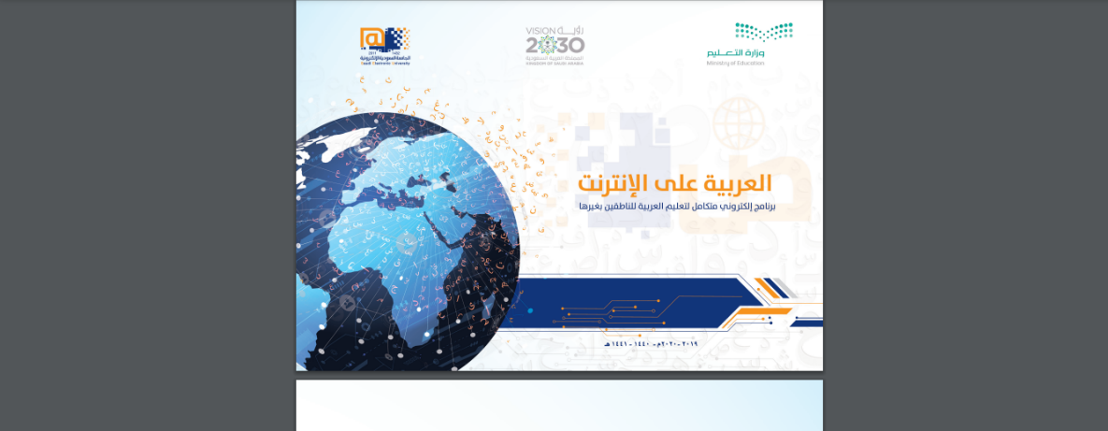
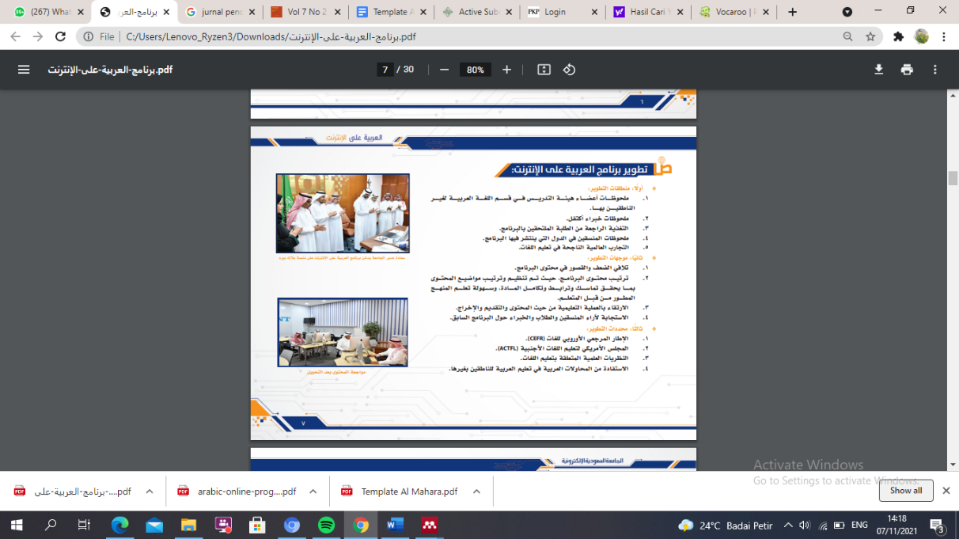

Arabic Online Program
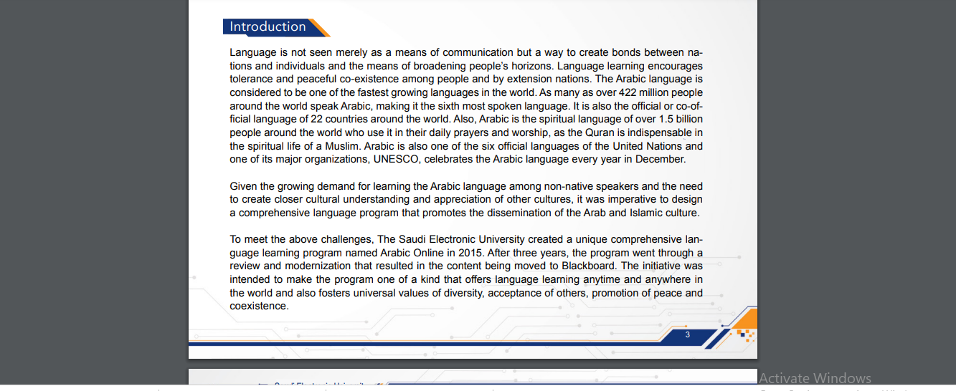
Using the Canva app
The use of this application is intended in the development of making presentation media such as power point, and graphic design. This application is said to be user-friendly because it is free of charge and friendly to internet data.
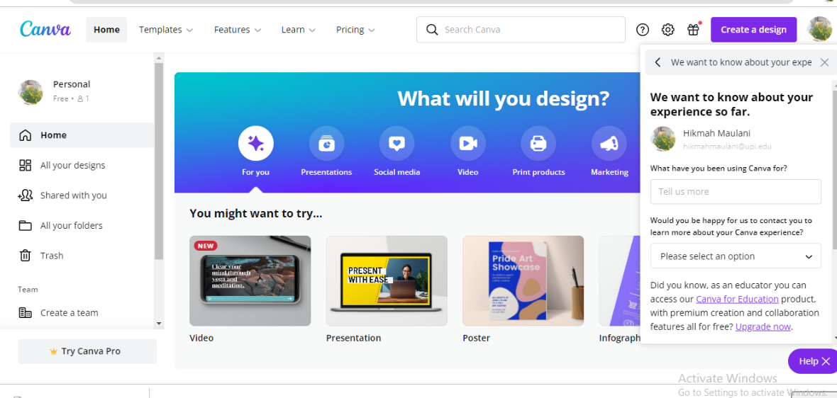
Using the Crossword Labs app
This application is an online crossword game, the same thing with Canva, this application is free and user-friendly. Crossworld Labs can be used in learning vocabulary, Nahwu, Sharaf or material that emphasizes grammatical theory.
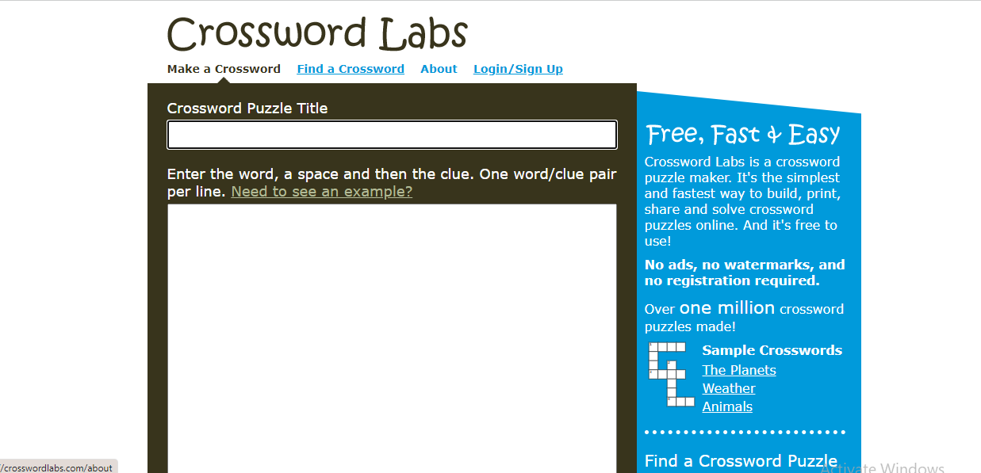
Vocabulary use
Vocaroo is a digital voice recording application that does not require excessive data or take up memory capacity of the device. This application is suitable for use with special skills or kalam.
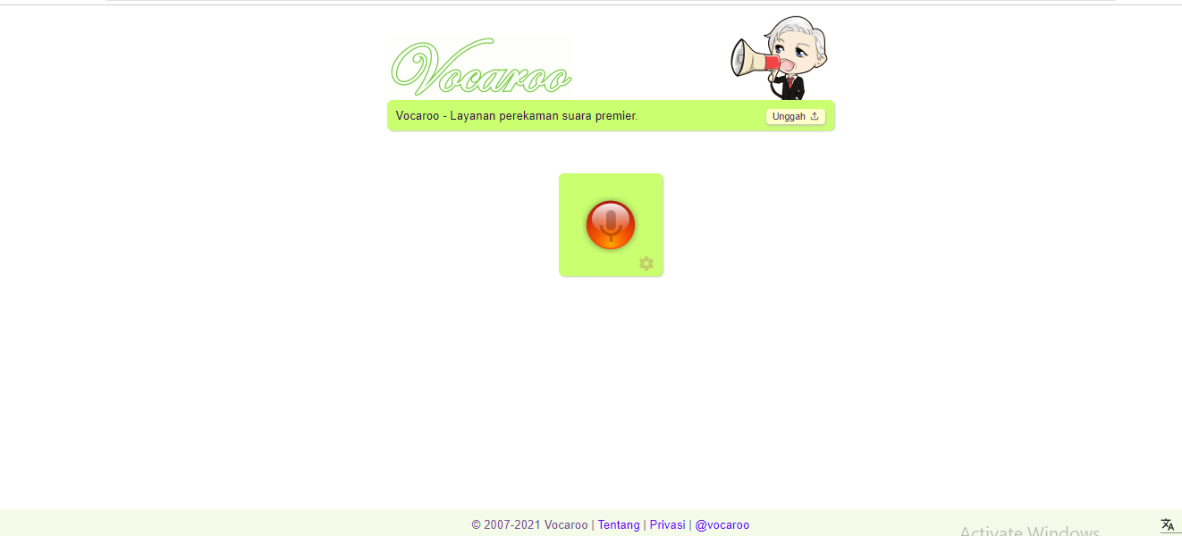

User Friendly Digital Usage Perception
In today's western countries, Arabic is getting quite a lot of interest. In America, for example, there is hardly a university that does not make Arabic as a subject, including Catholic or Christian colleges. For example, Harvard University, the world's most respected private university founded by Protestant "clerics," and Georgetown University, a private Catholic university, both have centers of Arabic studies that are more or less the Center for Contemporary Arab Studies. In Indonesia, Arabic is not only studied in Islamic education environments, such as: Islamic boarding schools, madrasas, Islamic schools and Islamic universities, but is also a subject in several general education institutions, such as UGM, UNJ, UPI, UNPAD, USU, UNHAS. , Academy of Tourism and Hospitality, ABA, and so on. The age of Arabic education in Indonesia is already at the age of the entry of Islam into the country, starting in the VII century AD. Arabic began to be taught along with the teaching of "read and write" the Koran. The main purpose of learning Arabic is to be able to read and understand the sources of Islamic teachings in Arabic properly and correctly. In the view of Muslims, Arabic is a "language that must be learned" in order to understand the verses of the Qur'an and the hadiths of the Prophet Muhammad. Both sources of Islamic teachings are in Arabic. Because, it is imperative for Muslims to study the Qur'an and the hadith of the Prophet SAW, basically it is also an obligation to study the language of the holy book.
In other words, the process of learning Arabic in Indonesia will always color and discourse the Islamic education curriculum as long as Muslims believe in the Qur'an and hadith as their life guide. The implementation of the objectives of the Arabic subjects mentioned above, among others, is supported by the emergence of various decisions of the Director General of Islamic Education relating to improving academic quality, both teachers at Madrasah Tsanawiyah, Aliyah and Lecturers at PTAI and PAI Lecturers at PTU in Indonesia. For example, in 2007, the Secretary General of the Ministry of Religion, Bahrul Hayat, Ph.D. explained that in order to improve the quality of religious education institutions, the Ministry of Religion provided undergraduate scholarships to 2,000 public and private madrasa teachers who teach Mathematics, Chemistry, Biology, Indonesian, Arabic, and English. The Master's Scholarship, which was held by the Ministry of Religion in 2007, is in collaboration with 14 state universities in Indonesia, including 7 public universities and 7 religious universities. And 60 of them are in the field of Arabic studies which are being discussed by UIN Jakarta and UIN Malang.
Furthermore, the Secretary General of the Ministry of Religion of the Republic of Indonesia explained that “this policy is to overcome the backwardness of education in madrasas. He admits the existence of madrasas has tended to be neglected. However, after the enactment of the National Education System Law, the existence of madrasas has shifted and its position is equal to other school educational institutions. In the 2006 budget, there were 675 teachers studying in 15 state universities and in the 2007-2008 budget, 1325 teachers were added. The total number of teachers studying at PTN with various majors is 2000 teachers.
Based on data from the Ministry of Religion of the Republic of Indonesia directory, the number of teachers of Madrasah Tsanawiyah, both public and private, in West Java with S1/D4 qualifications was recorded at 495 people; 4 and there are 664 public and private Madrasah Aliyah teachers throughout West Java; and the number of Arabic language teachers in vocational schools was recorded at 38 people and in SMAN and Private schools there were 72 people. Based on a pre-survey of MA/SMA Arabic teachers in 2009, it was found that Arabic teachers were "very minimal" in understanding and mastering innovative learning methods and utilizing multi-media-based DIGITAL in the form of CD/DVD in the Arabic language learning process in the classroom. Out of 100 teachers, more than half need information, training and assistance related to innovative research-based learning methodologies.
Based on the data from the respondent's questionnaire that has been processed, it is described in descriptive form as follows:

1 | Knowledge of digital-based learning media

Based on the questionnaire given to 30 participants, the results obtained were 21 participants or 70% assessed that participants had sufficient knowledge of digital learning media in learning Arabic and PAI learning, 9 participants or 30% considered that participants had knowledge of digital learning media good in learning Arabic and PAI.

2 | Knowledge of Arabic and PAI learning strategies

The results obtained from 30 participants, 5 participants or 16.6% considered that participants had insufficient knowledge of Arabic and PAI learning strategies, 15 participants or 50% considered that participants had sufficient knowledge of Arabic and PAI learning strategies, and 10 participants or 33.3% assessed that the participants had good knowledge of Arabic and PAI learning strategies.

3 | Easy access to Arabic and PAI learning media

The results obtained from 30 participants, 5 participants or 16.6% considered that participants felt less about the ease of access to Arabic and PAI learning media, 21 participants or 70% considered that participants felt enough about the ease of access to Arabic and PAI learning media, and 4 participants or 13.3% rate well about the ease of access to Arabic and PAI learning media.

4 | Student activity in using digital media

The results obtained from 30 participants, 5 participants or 16.6% considered that students tend to be less active in using DIGITAL media, 20 participants or 66.6% considered that students were quite active in using DIGITAL media, and 5 participants or 16.6% assess assessing that students use DIGITAL media well

5 | Teacher activity in using digital media

The results obtained from 30 participants, 20 participants or 66.6% considered that the teacher was quite active in using digital media, 10 participants or 33.3% considered that the teacher used digital media well

6 | Knowledge of Arabic and PAI Learning Management

The results obtained from 30 participants, 20 participants or 66.6% considered that participants had sufficient knowledge in Arabic and PAI learning management, 10 participants or 33.3% assessed that participants had good knowledge in Arabic and PAI learning management.

7 | Knowledge of digital media in Arabic KBM and PAI

The results obtained from 30 participants, 10 participants or 33.3% assessed that participants had a lack of knowledge about digital media in Arabic and Islamic teaching learning activities, 16 participants or 53.3% assessed that participants had sufficient knowledge about digital media in Arabic learning lessons. and PAI, 4 participants or 13.3% assessed that participants had good knowledge of digital media in Arabic and PAI.

8 | Learning in the Covid-19 Era makes it difficult for teachers
The results obtained from 30 participants, 5 participants or 16.6% considered that participants considered learning the Covid-19 era difficult for teachers, 25 participants or 83.3% assessed that learning in the Covid-19 era was very difficult for teachers.

9 | The need for digital media in learning in the Covid-19 era

The results obtained from 30 participants, 3 participants or 10% considered that participants felt the need for digital media in Covid-19 learning, 27 participants or 90% considered that participants really needed digital media in Covid-19 learning

10 | Difficulty using digital in teaching activities

The results obtained from 30 participants, 10 participants or 33.3% considered that participants found it difficult to use digital in teaching, 20 participants or 66.6% considered that participants felt very difficult in using digital in teaching

11 | Evaluation of KBM Arabic and PAI in the Covid-19 era

The results obtained from 30 participants, 10 participants or 33.3% considered that the evaluation of Arabic and PAI KBM in the Covid-19 era was considered sufficient, 5 participants or 16.6% considered that the evaluation of Arabic and PAI KBM in the Covid-19 era was considered sufficient. , 15 participants or 50% considered that the evaluation of Arabic and PAI KBM in the Covid-19 era was considered good

12 | Achievements of learning Arabic and PAI in the Covid-19 era

The results obtained from 30 participants, 2 participants or 6.6% considered that the achievement of learning Arabic and PAI in the Covid-19 era was considered sufficient, 5 participants or 16.6% considered that the achievement of learning Arabic and PAI in the Covid-19 era was assessed good, 20 participants or 66.6% considered that the evaluation of the Arabic and PAI KBM in the Covid-19 era was considered good, 3 participants or 10% considered that the evaluation of the Arabic and PAI KBM in the Covid-19 era was considered very good.

13 | Training and assistance in using digital in Arabic and PAI learning is beneficial for teachers

The results obtained from 30 participants, 2 participants or 6.6% of participants assessed that the training and assistance in using digital in Arabic and Islamic Education Learning was beneficial for teachers, 28 participants or 93.3% of participants assessed the training and assistance in using digital in Arabic learning and PAI is very useful for teachers.

CONCLUSION
The conclusion that can be drawn based on the explanation above is that the use of user-friendly digital modes can be a solution for teachers for learning at this time, especially during the current pandemic. So that learning can be more active, innovative and facilitate the implementation of Arabic learning. In supporting its success, of course there must be synergy from both teachers and students as well as teachers and policy makers. Because learning through user-friendly digital mode in its implementation cannot be one-way. So that quality education can be achieved, especially during the Covid-19 pandemic.

RECOMENDATION
This research can be carried out to the next stage by developing an independent and independent design related to the use of user-friendly digital learning modes for learning Arabic, especially in Indonesia.

REFERENCES
Aziz, A. (2020). Penggunaan E-Learning Sebagai Media Dalam Proses Belajar Bahasa Inggris Di Universitas Darwan Ali Sampit. Widya Wacana: Jurnal Ilmiah, 15(1), 11–17. https://doi.org/10.33061/j.w.wacana.v15i1.3514
Chodzirin, M. (2016). Pemanfaatan Information and Communication Technology bagi Pengembangan Guru Madrasah Sub Urban. Dimas: Jurnal Pemikiran Agama Untuk Pemberdayaan, 16(2), 309. https://doi.org/10.21580/dms.2016.162.1095
Dasar, D. I. S. (2020). Pemanfaatan Media Informasi Teknologi Dan. 7(2), 113–123.
Dewi, S. P., Abdillah, A. A., & Sofa, N. (2019). Persepsi Dosen Terhadap Penggunaan ICT Dalam Pembelajaran Bahasa Inggris. Epigram, 16(2), 169–174. https://doi.org/10.32722/epi.v16i2.2231
El Fauziah, U. N., Suryani, L., & Syahrizal, T. (2019). Penerapan Google Classroom Dalam Pembelajaran Bahasa Inggris Kepada Guru-Guru Bahasa Inggris Smp Di Subang. Abdimas Siliwangi, 2(2), 183. https://doi.org/10.22460/as.v2i2p183-191.3281
Haniah, H. (2014). Pemanfaatan Teknologi Informasi Dalam Mengatasi Masalah Belajar Bahasa Arab. Al-Ta’rib : Jurnal Ilmiah Program Studi Pendidikan Bahasa Arab IAIN Palangka Raya, 2(1), 1–19. https://doi.org/10.23971/altarib.v2i1.588
Haryati, & Erwin, Y. (2019). Pemanfaatan Information and Communications Technology ( Ict ). Prosiding Seminar Pendidikan Program Pascasarjana Universitas Palembang, 325–334.
Indriani, R., & Wirza, Y. (2020). Teachers’ practice in technology utilization in English language classrooms. Jurnal Penelitian Pendidikan, 20(1), 98–110. https://ejournal.upi.edu/index.php/JER/article/view/24560
Istiqoma Maria, P. T. N. (2020). ARSITEKTUR Bahasa Inggris sebagai bahasa internasional yang menyatukan komunikasi secara global tidak lepas dengan terintegrasinya penggunaan Teknologi Informasi dan Komunikasi ( ICT ). Begitu juga dikutip dari halaman Kemenristekdikti ( https://ristekdik. Penerapan Teknologi Informasi Dan Komunikasi (ICT) Untuk Pembelajaran Bahasa Inggris Di Prodi Arsitektur, IV, 101–116.
Kelas, D. I., & Dasar, V. S. (2021). SEJ (School Education Journal) Vol. 11 No. 1 Juni 2021. 11(1), 51–58.
Muhammad, H., Rahim, Y., Pendidikan, J., Islam, A., Tarbiyah, F., Uin, K., Makassar, A., Btn, A. :, & Makassar, A. (2011). Pemanfaatan Ict Sebagai Media Pembelajaran Dan Informasi Pada Uin Alauddin Makassar. 6(3), 127–135. http://yahoo.com
Paryanti, A. B. (2014). Makalah Penggunaan ICT Dalam Meningkatkan Mutu Pembelajaran. Jurnal Sistem Informasi Universitas Suryadarma, 1(1). https://doi.org/10.35968/jsi.v1i1.38
Rani, S. A. (n.d.). صلختسم ريوطت لىع ردقي ن � أ ةيبرعلا ةغللا ينسردم لىع بلطي لياصتإلاو تامولعلماو جيولونكتلا ريوطت عم ةيس � ارلدا ةدالماو ةييملعتلا فادهأ � ب ةبس � انلما ةقيرطلا سردلما مدختس � يو لةاعفلا ةيبرعلا ةغللا يملعت جذونم يرغتي يملعت جذونم نكا . لياصتإلاو تامولعلماو. 163–177.
Romadani, T. F., & Prasetyo, D. (2020). Pemanfaatan Teknologi Informasi Dan Komunikasi Dalam Mata Kuliah Bahasa Indonesia Di Perguruan Tinggi. Jurnal Edukasi Khatulistiwa, 3(2), 54. https://doi.org/10.26418/ekha.v3i2.42311
Sari, S. D. P. (2015). Manfaat Media Pembelajaran Berbasis ICT (Information and Communication Technology) dalam Pembelajaran Bahasa Indonesia. Pengembangan ICT Dalam Pembelajaran, November, 36–44.
Sariakin. (2015). Model Pengembangan Pembelajaran Bahasa Inggris Berbasis Ict (Information and Communication Technology) Dalam Meningkatkan Prestasi Belajar Siswa Sma. Visipena Journal, 6(2), 132–140. https://doi.org/10.46244/visipena.v6i2.370
Suryadi, A. (2007). Pemanfaatan ICT dalam Pembelajaran. Pendidikan Terbuka Dan Jarak Jauh, 8(1), 6.
Teknologi, I., & Dan, I. (n.d.). Pembelajaran Berbasis E-Learning Sebagai Bentuk. 165–174.
Tematik, P., Di, T., & Sd, M. I. (2017). Tentang Persepsi Guru Dan Siswa Terhadap. 13(15480080), 226–237. https://doi.org/10.33541/jdp.v12i3.1295
Unnes, F. B. S. (2009). Inovasi Pembelajaran Bahasa Inggris Berbasis Ict Dalam Rangka Meningkatkan Mutu Pendidikan. Lembaran Ilmu Kependidikan, 38(1), 59–67.
Wardani, M. A. P., & Harwanto, R. (2020). Penerapan Strategi Pembelajaran Berbasis ICT terhadap Pencapaian Hasil Belajar Sistem Komputer Siswa. Faktor Jurnal Ilmiah Kependidikan, 7(2), 99–106.

