LAMPIRAN LAMPIRAN
- Lampiran 1 Dokumentasi Penelitian
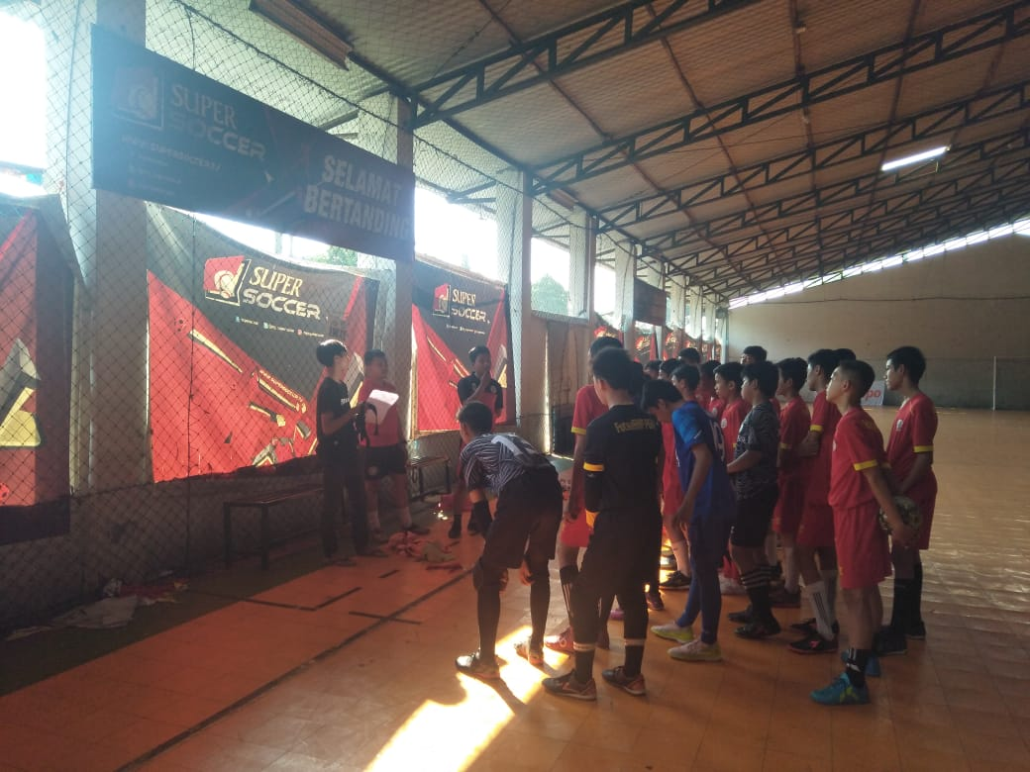
Gambar perkenalan peneliti sekaligus memberikan penjelasan teknis kepada sampel

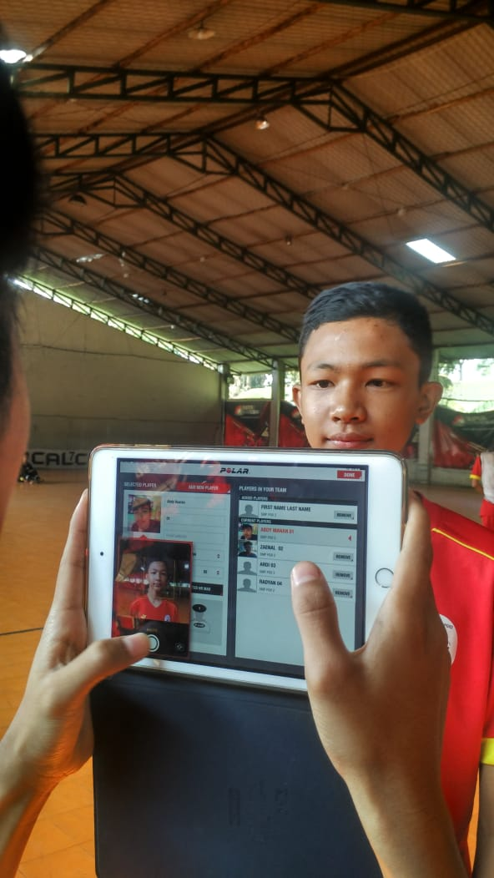
Gambar pemasukan data pribadi sampel
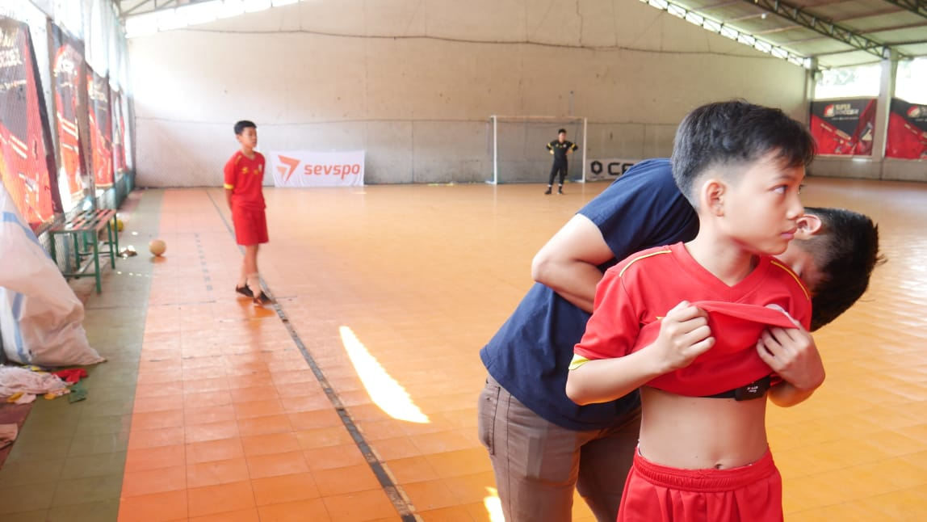
Gambar Pemasangan polar kepada sampel
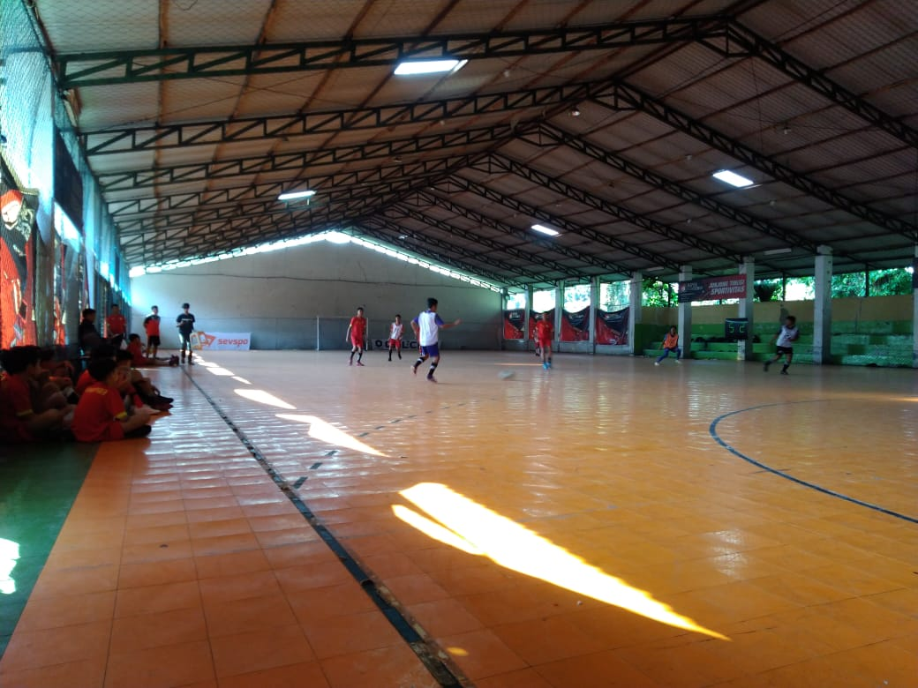
Gambar pelaksanaan game simulasi

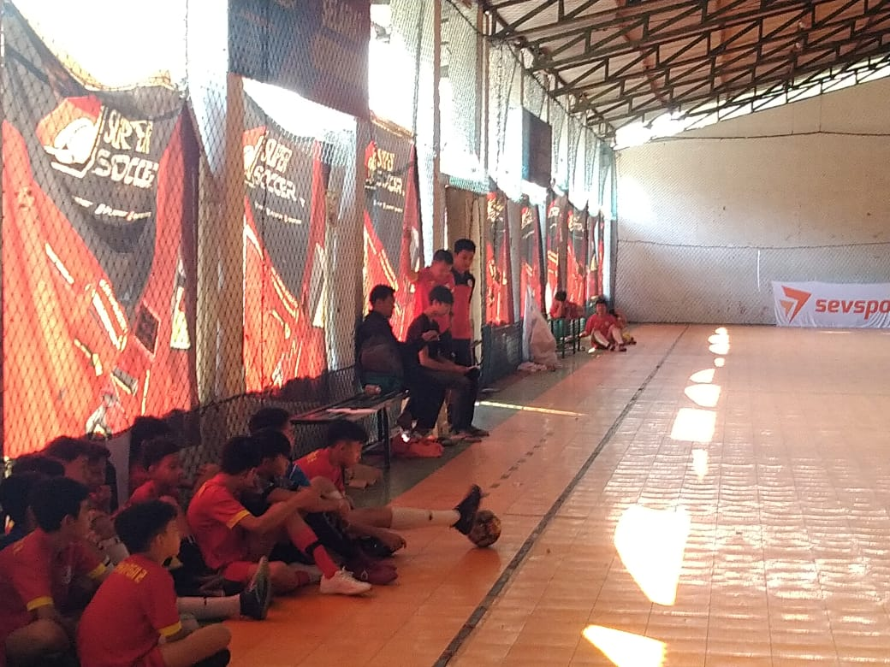
Gambar expert judgement menilai sampel dan pengecekan polar
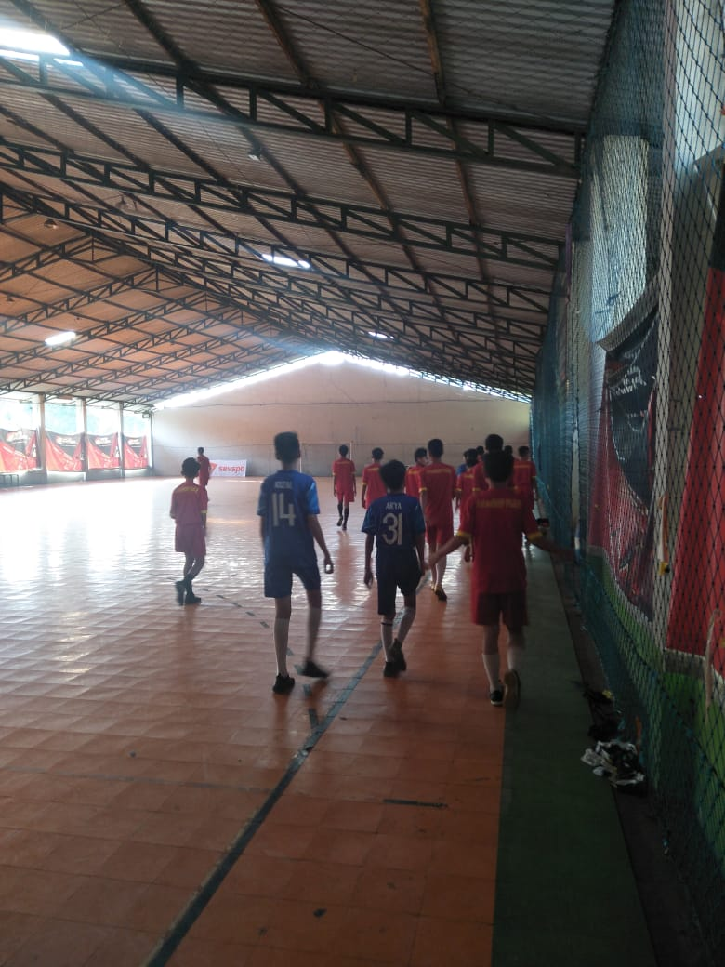
Gambar sampel sedang pemanasan sebelum melakukan RAST TEST

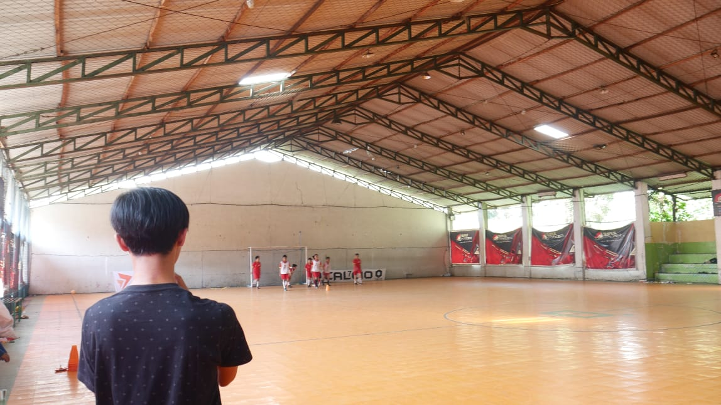
Gambar pelaksanaan RAST Test sekaligus memberikan kelelahan kepada sampel
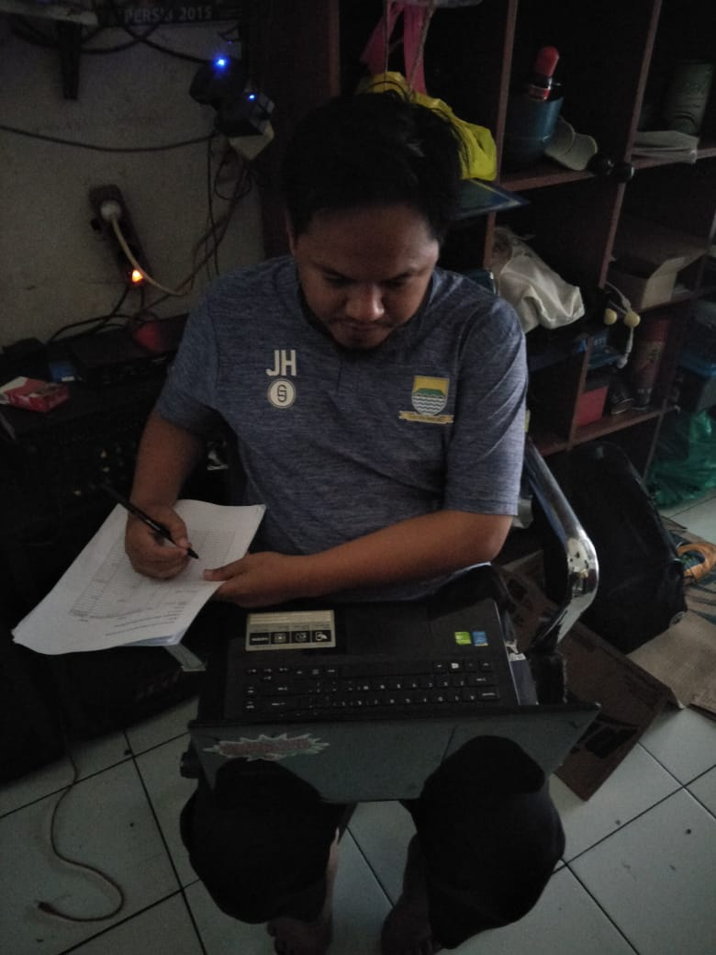
Gambar expert judgment sedang menilai kembali dengan melihat video yang sudah direkam peneliti

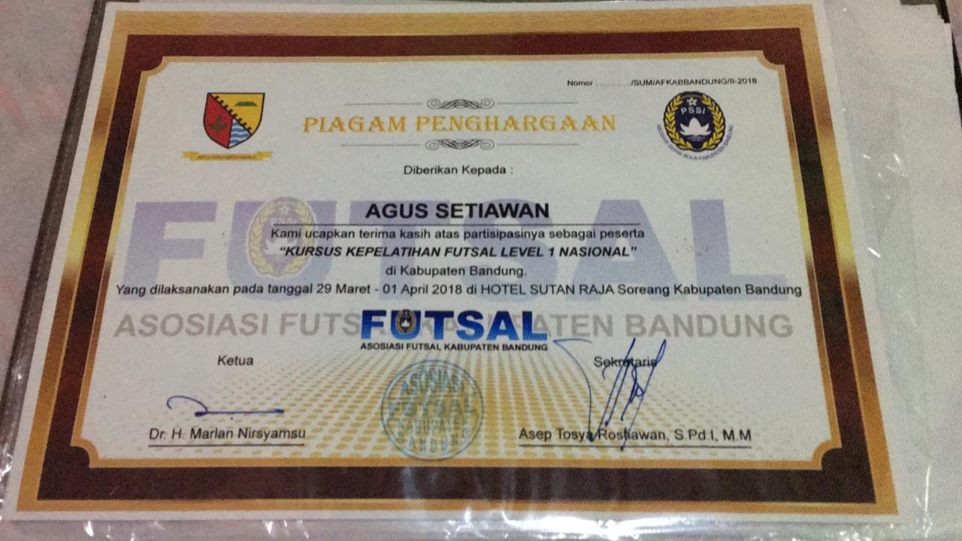
Gambar sertifikat expert judgment kepelatihan Level 1 Nasional

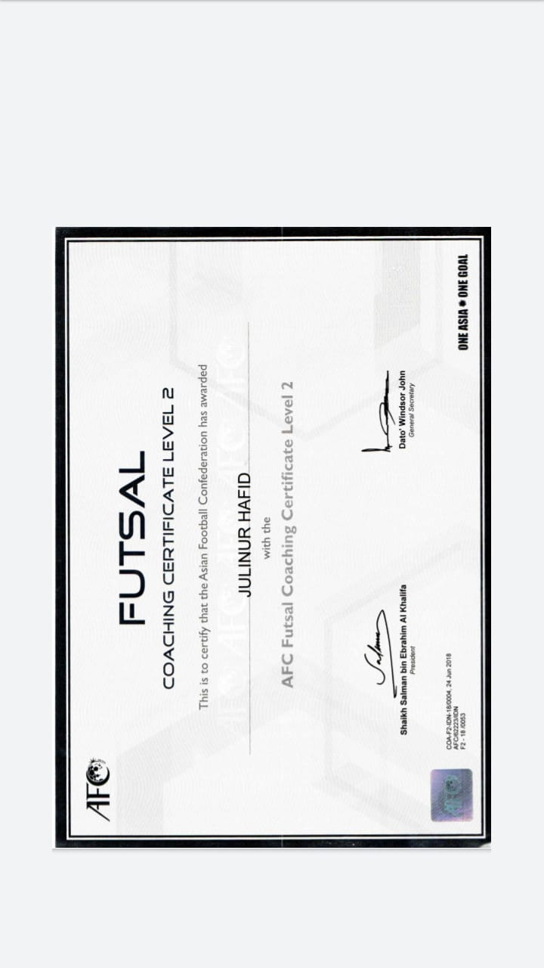
Gambar sertifikat expert judgment kepelatihan AFC Level 2

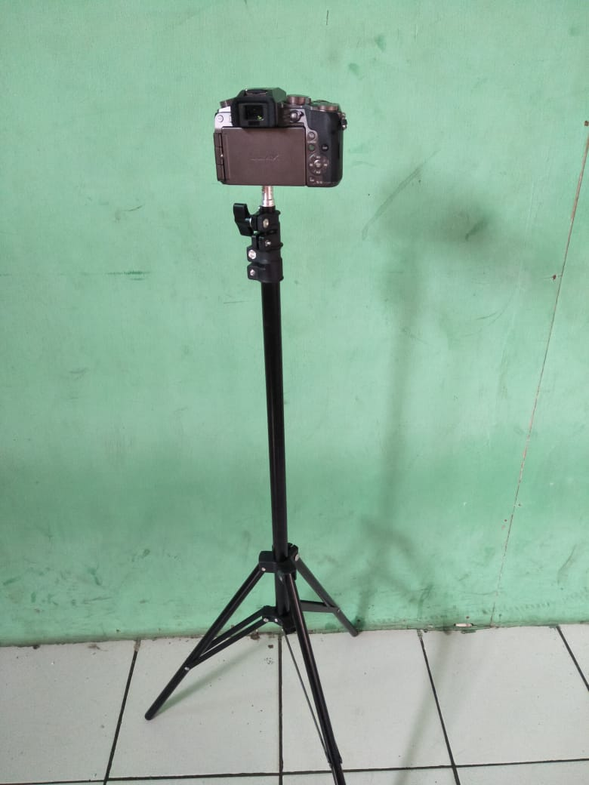
Gambar Kamera selama meneliti
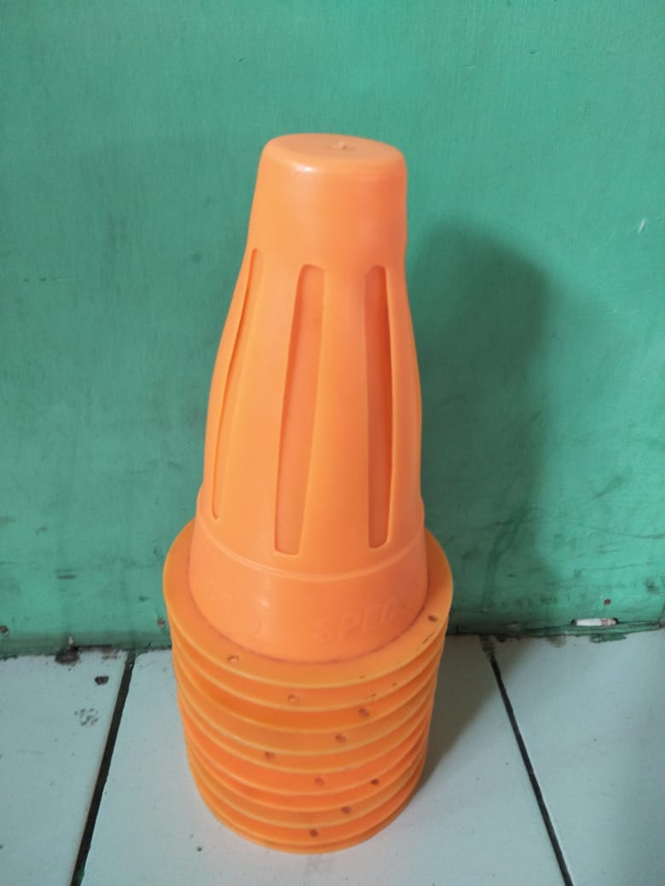
Gambar cones untuk RAST Test
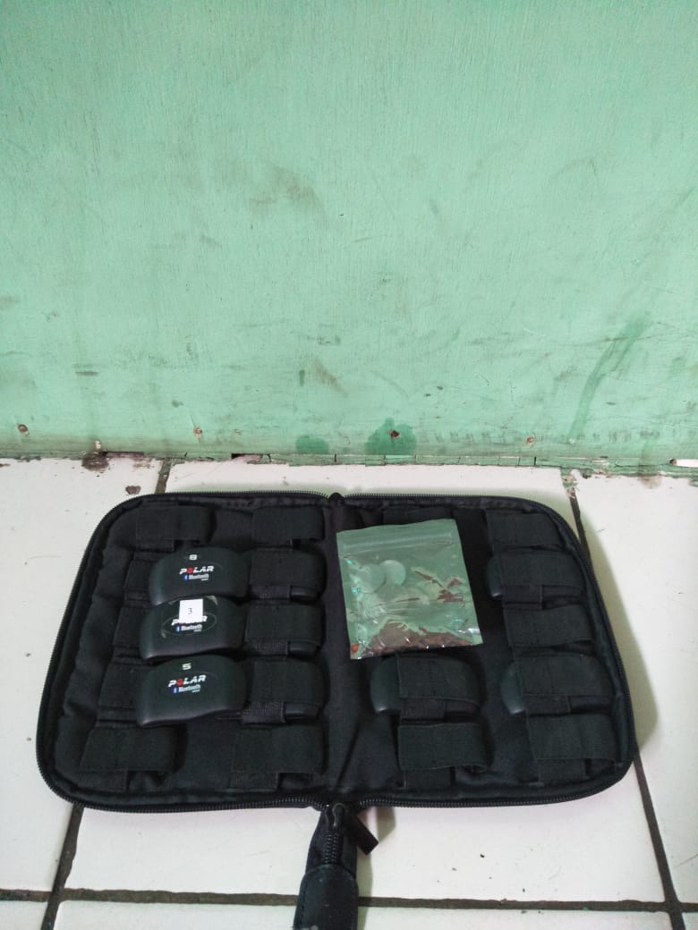
Gambar Polar Flow For Clubs
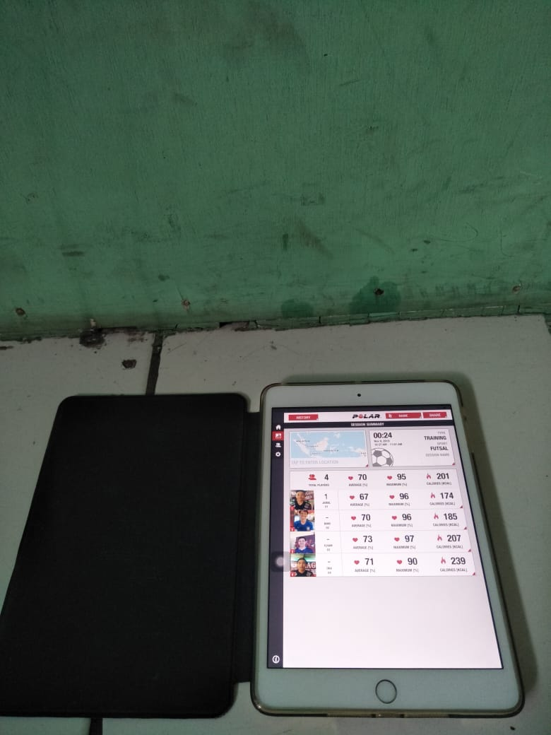
Gambar Tablet untuk melihat heart rate sampel
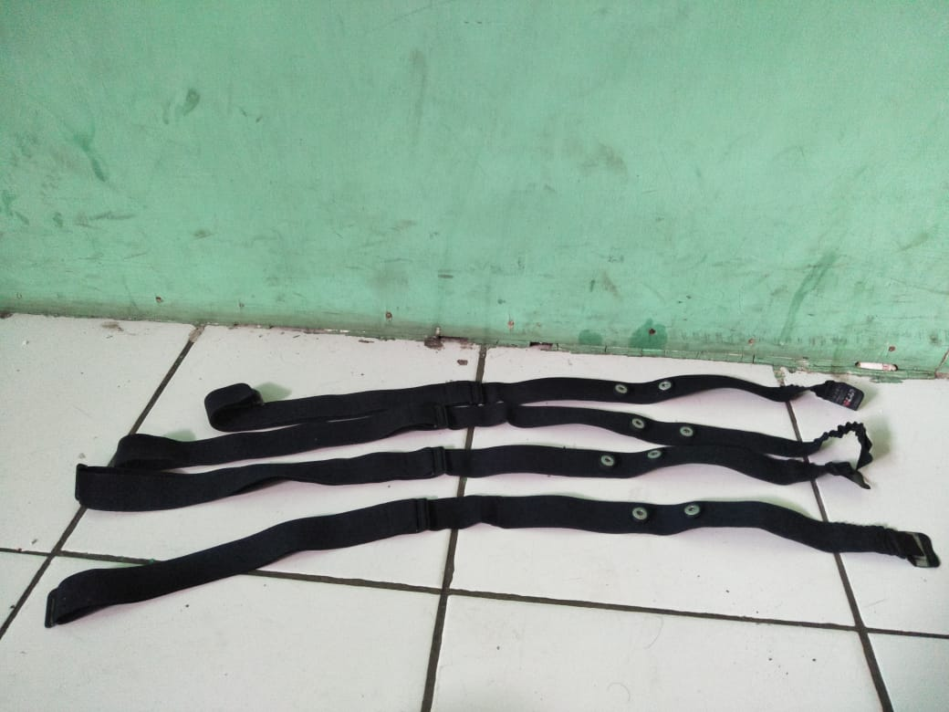
Gambar tali polar
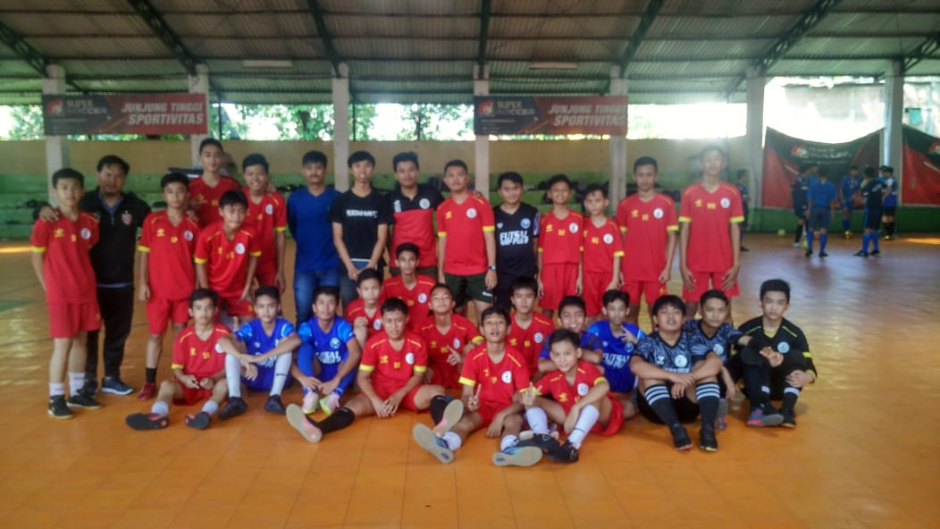
Gambar Foto bersama sampel dan expert judgment

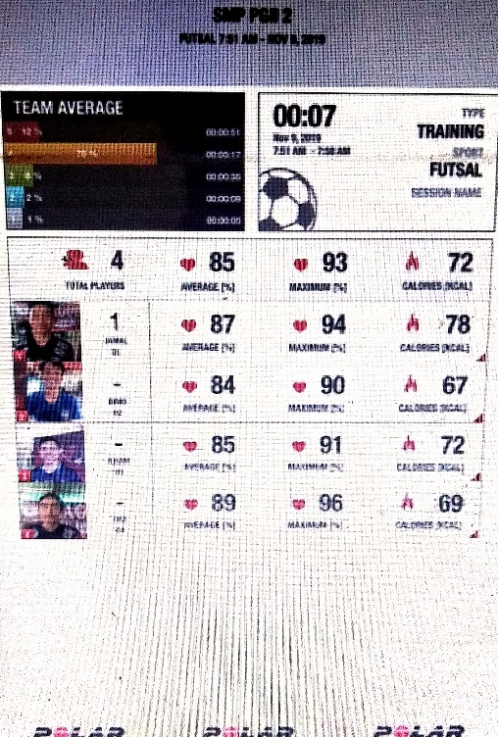
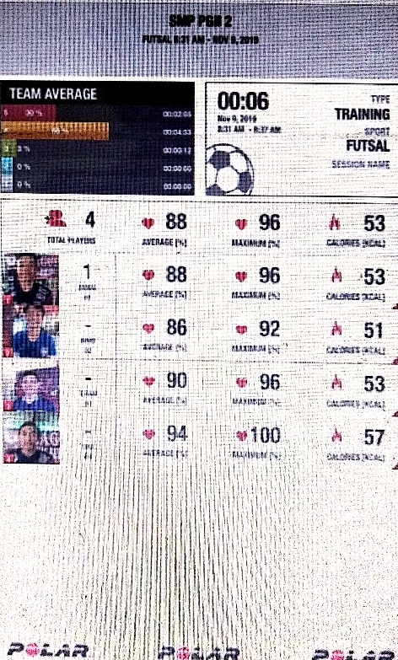
Gambar Heart Rate Polar Game Simulasi Pertama

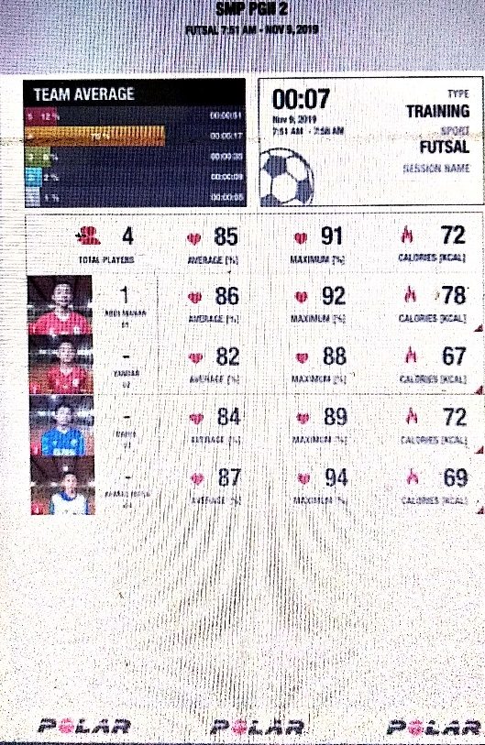
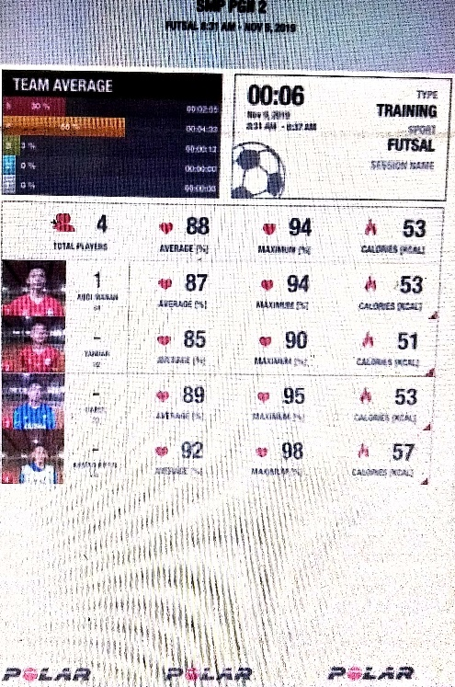
Gambar Heart Rate Polar Game Simulasi Kedua
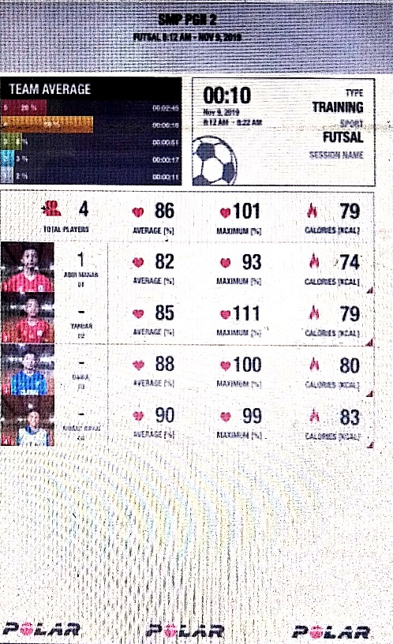
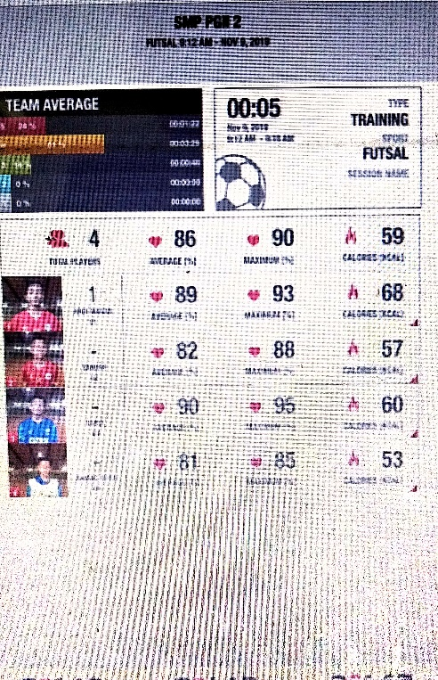
Gambar Heart Rate Polar Game Simulasi Ketiga
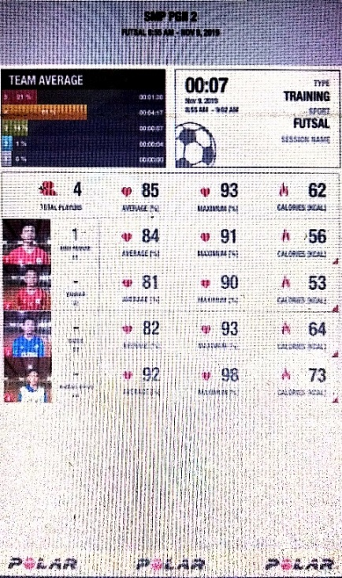
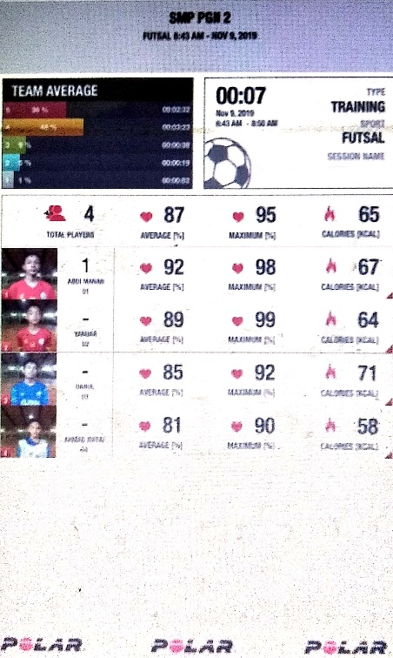

Gambar Heart Rate Polar Game Simulasi Keempat

- Lampiran 2 Hasil Data
Pengambilan Keputusan Sebelum Kelelahan
Nama | Offence-With the ball | Offence-Off the ball | Defence
AM | 5.00 | 3,00 | 4.00
AR | 5,00 | 0,00 | 3,00
YM | 1,00 | 1,00 | 3,00
D | 2,00 | 2,00 | 2,00
L | 4,00 | 4,00 | 1,00
S | 5,00 | 5,00 | 3,00
R | 1,00 | 1,00 | 0,00
T | 2,00 | 3,00 | 2,00
G | 0,00 | 3,00 | 3,00
M | 2,00 | 4,00 | 0,00
A | 4,00 | 1,00 | 3,00
R | 3,00 | 0,00 | 0,00
O | 5,00 | 3,00 | 3,00
J | 2,00 | 1,00 | 3,00
I | 2,00 | 4,00 | 1,00
B | 3,00 | 2,00 | 1,00

Pengambilan Keputusan Sesudah Kelelahan
Nama | Offence-With the ball | Offence-Off the ball | Defence
AM | 2.00 | 1.00 | 2.00
AR | 2.00 | 1.00 | 1.00
YM | 4.00 | 2.00 | .00
D | 2.00 | .00 | .00
L | 3.00 | 1.00 | 3.00
S | 3.00 | .00 | .00
R | 1.00 | 3.00 | .00
T | 3.00 | 1.00 | .00
G | 2.00 | 1.00 | 1.00
M | 2.00 | .00 | 1.00
A | 6.00 | 1.00 | 3.00
R | 1.00 | 2.00 | 3.00
O | 4.00 | 2.00 | .00
J | 1.00 | 1.00 | 3.00
I | 6.00 | 1.00 | .00
B | 6.00 | .00 | 2.00

- Lampiran 3 Hasil Output SPSS Versi 25
Deskripsi data sebelum kelelahan
Descriptive Statistics
 | N | Minimum | Maximum | Mean | Std. Deviation
Offence with the ball | 16 | 2,00 | 7,00 | 4,5000 | 1,54919
Offence off the ball | 16 | 1,00 | 7,00 | 3,2500 | 1,65328
Defence | 16 | 1,00 | 5,00 | 2,7500 | 1,12546

Deskripsi data setelah kelelahan
Descriptive Statistics
 | N | Minimum | Maximum | Mean | Std. Deviation
Offence with the ball | 16 | 2,00 | 7,00 | 4,2500 | 1,52753
Offence off the ball | 16 | 1,00 | 6,00 | 3,1250 | 1,36015
Defence | 16 | 1,00 | 6,00 | 3,3750 | 1,31022

Uji Normalitas data sebelum kelelahan
Tests of Normality
 | Kolmogorov-Smirnovª |  |  | Shapiro-Wilk
 | Statistic | Df | Sig. | Statistic | Df | Sig.
Offence with the ball | ,209 | 16 | ,061 | ,892 | 16 | ,061
Offence off the ball | ,213 | 16 | ,051 | ,891 | 16 | ,058
Defence | ,185 | 16 | ,146 | ,931 | 16 | ,255

Uji Normalitas data sesudah kelelahan
Tests of Normality
 | Kolmogorov-Smirnovª |  |  | Shapiro-Wilk
 | Statistic | Df | Sig. | Statistic | Df | Sig.
Offence with the ball | ,168 | 16 | ,200 | ,939 | 16 | ,334
Offence off the ball | ,162 | 16 | ,200 | ,947 | 16 | ,446
Defence | ,175 | 16 | ,200 | ,957 | 16 | ,602

Uji Homogenitas sebelum dan sesudah kelelahan

Test of Homogeneity of Variances
 | Levene Statistic | df1 | df2 | Sig.
OWB | 2,218 | 4 | 11 | ,134
OOB | ,091 | 2 | 12 | ,914
Defence | ,970 | 3 | 12 | ,439

Uji Hipotesis Paired Sample T-Test per Variabel

Paired Samples Test
 |  | Paired Differences |  |  |  |  | t | Df | Sig. (2-tailed)
 |  | Mean | Std. Deviation | Std. Error Mean | 95% Confidence Interval of the Difference |  | t | Df
 |  |  |  |  | Lower | Upper | t | Df
Pair 1 | Offence with the ball | -125000 | 2,18708 | ,54677 | -1,29041 | 14,39388 | -,299 | 15 | ,822
Pair 2 | Offence off the ball | 1,25000 | 2,08167 | ,52042 | -14076 | 2,3592 | 2,402 | 15 | ,030
Pair 3 | Defence | ,81250 | 1,86971 | ,46743 | -,18380 | 1,8088 | 1,738 | 15 | ,103

Uji Hipotesis Paired Sample T-Test keseluruhan

Paired Samples Test
 |  | Paired Differences |  |  |  |  | t | Df | Sig. (2-tailed)
 |  | Mean | Std. Deviation | Std. Error Mean | 95% Confidence Interval of the Difference |  | t | Df | Sig. (2-tailed)
 |  |  |  |  | Lower | Upper | t | Df | Sig. (2-tailed)
Pair 1 | sebelumlelah – setelahlelah | ,64583 | 2,08836 | ,30143 | ,03944 | 1,2522 | 2,143 | 47 | ,037

- Lampiran 4 Surat surat
Surat Keputusan
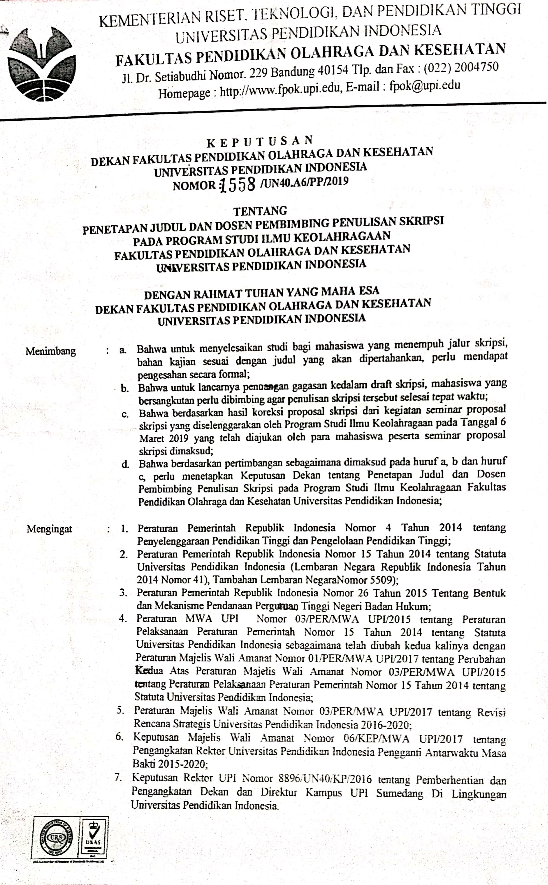
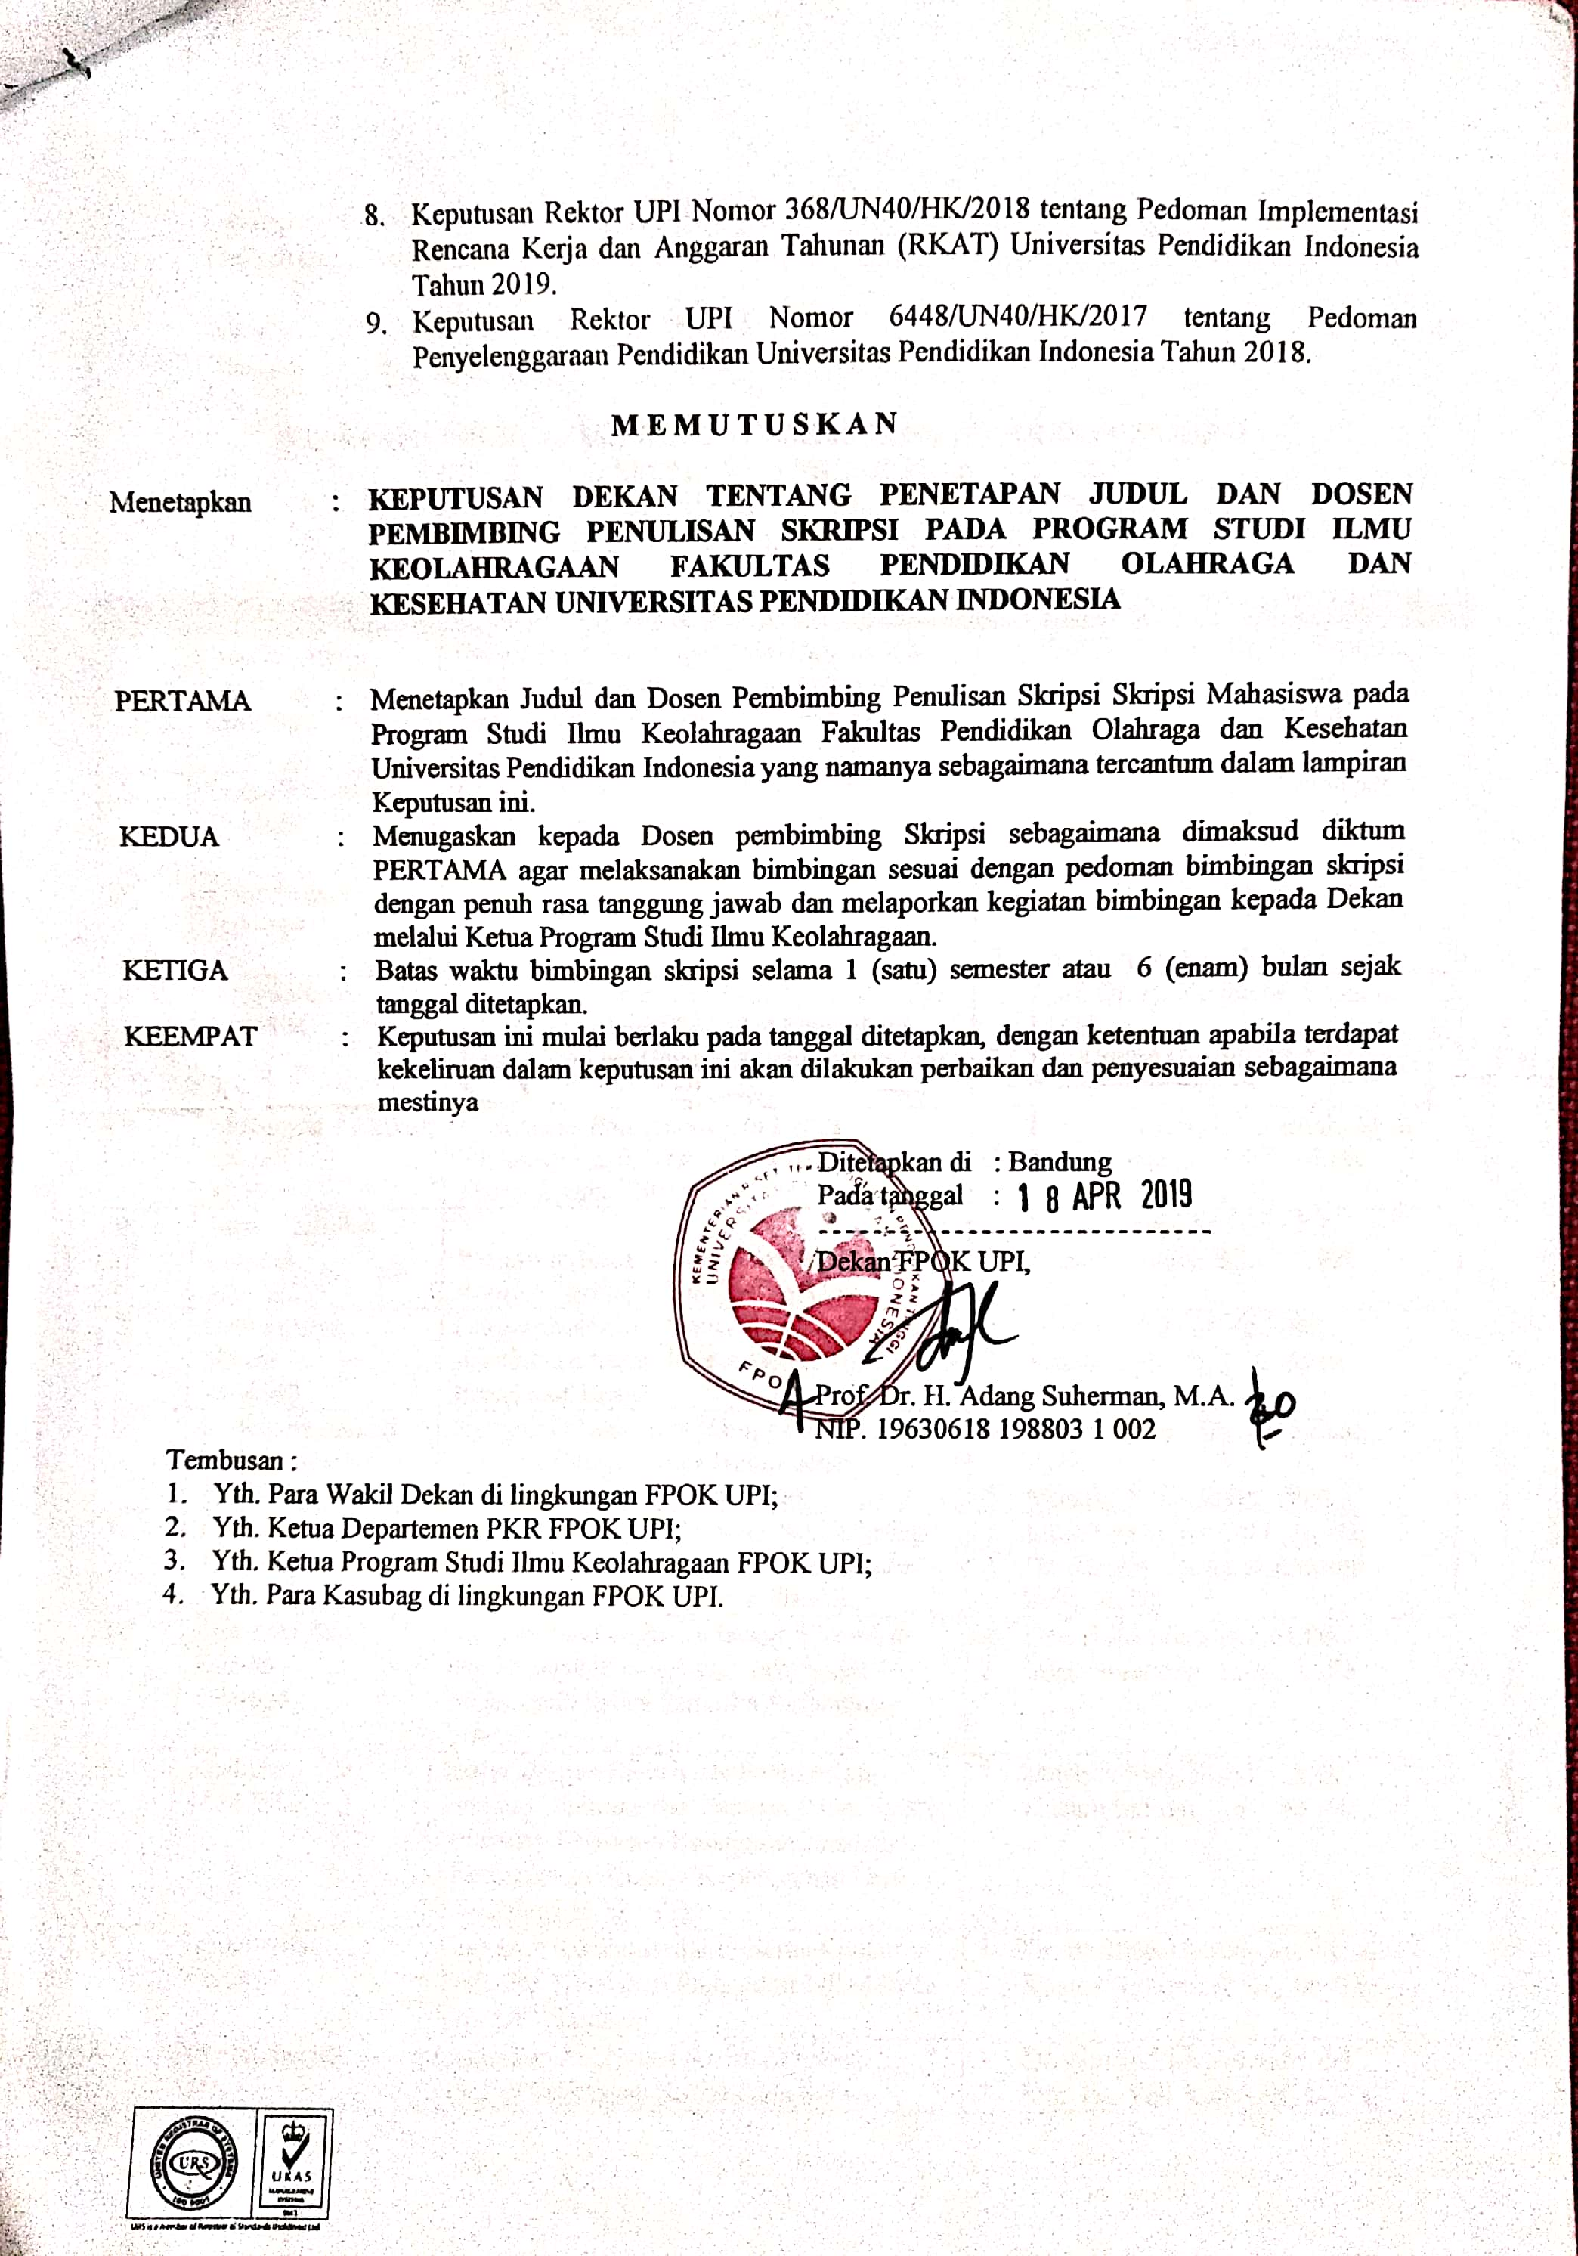
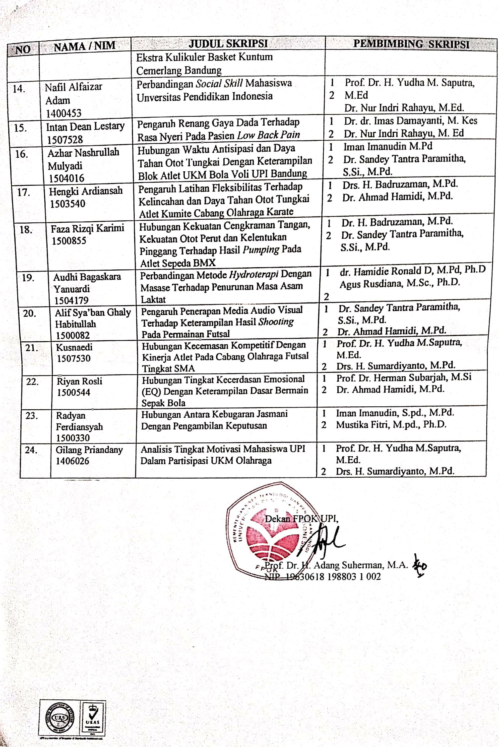
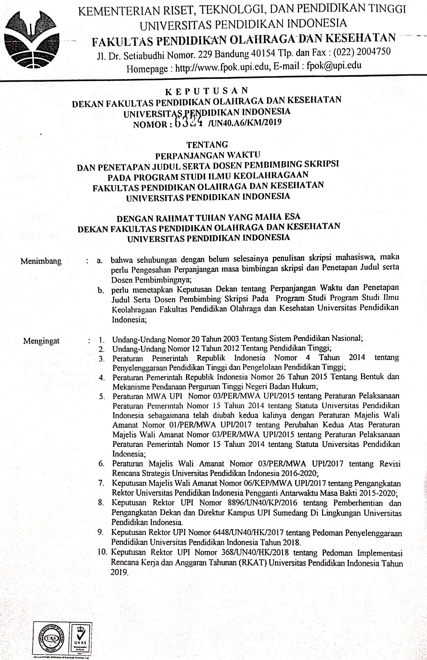
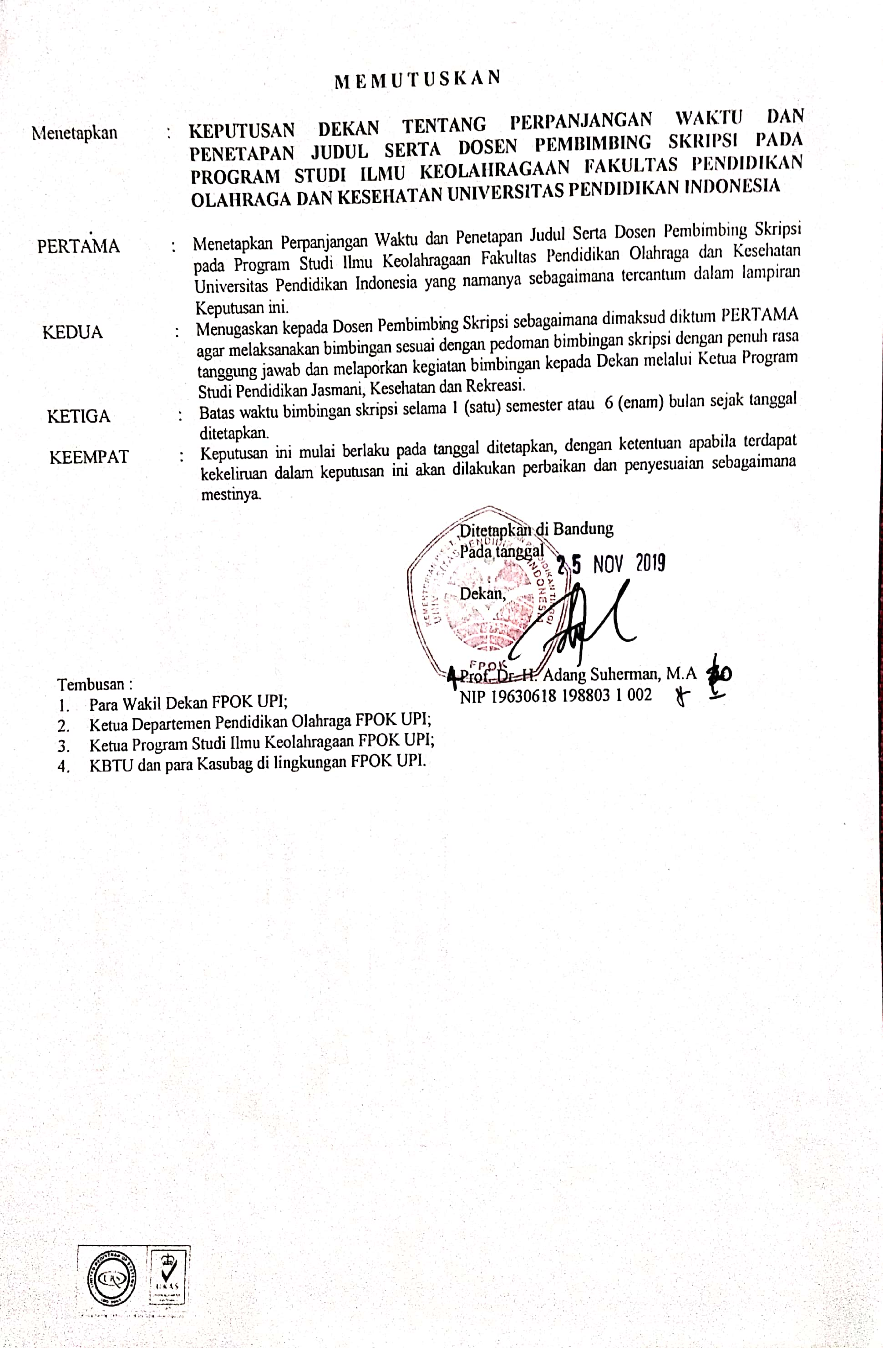
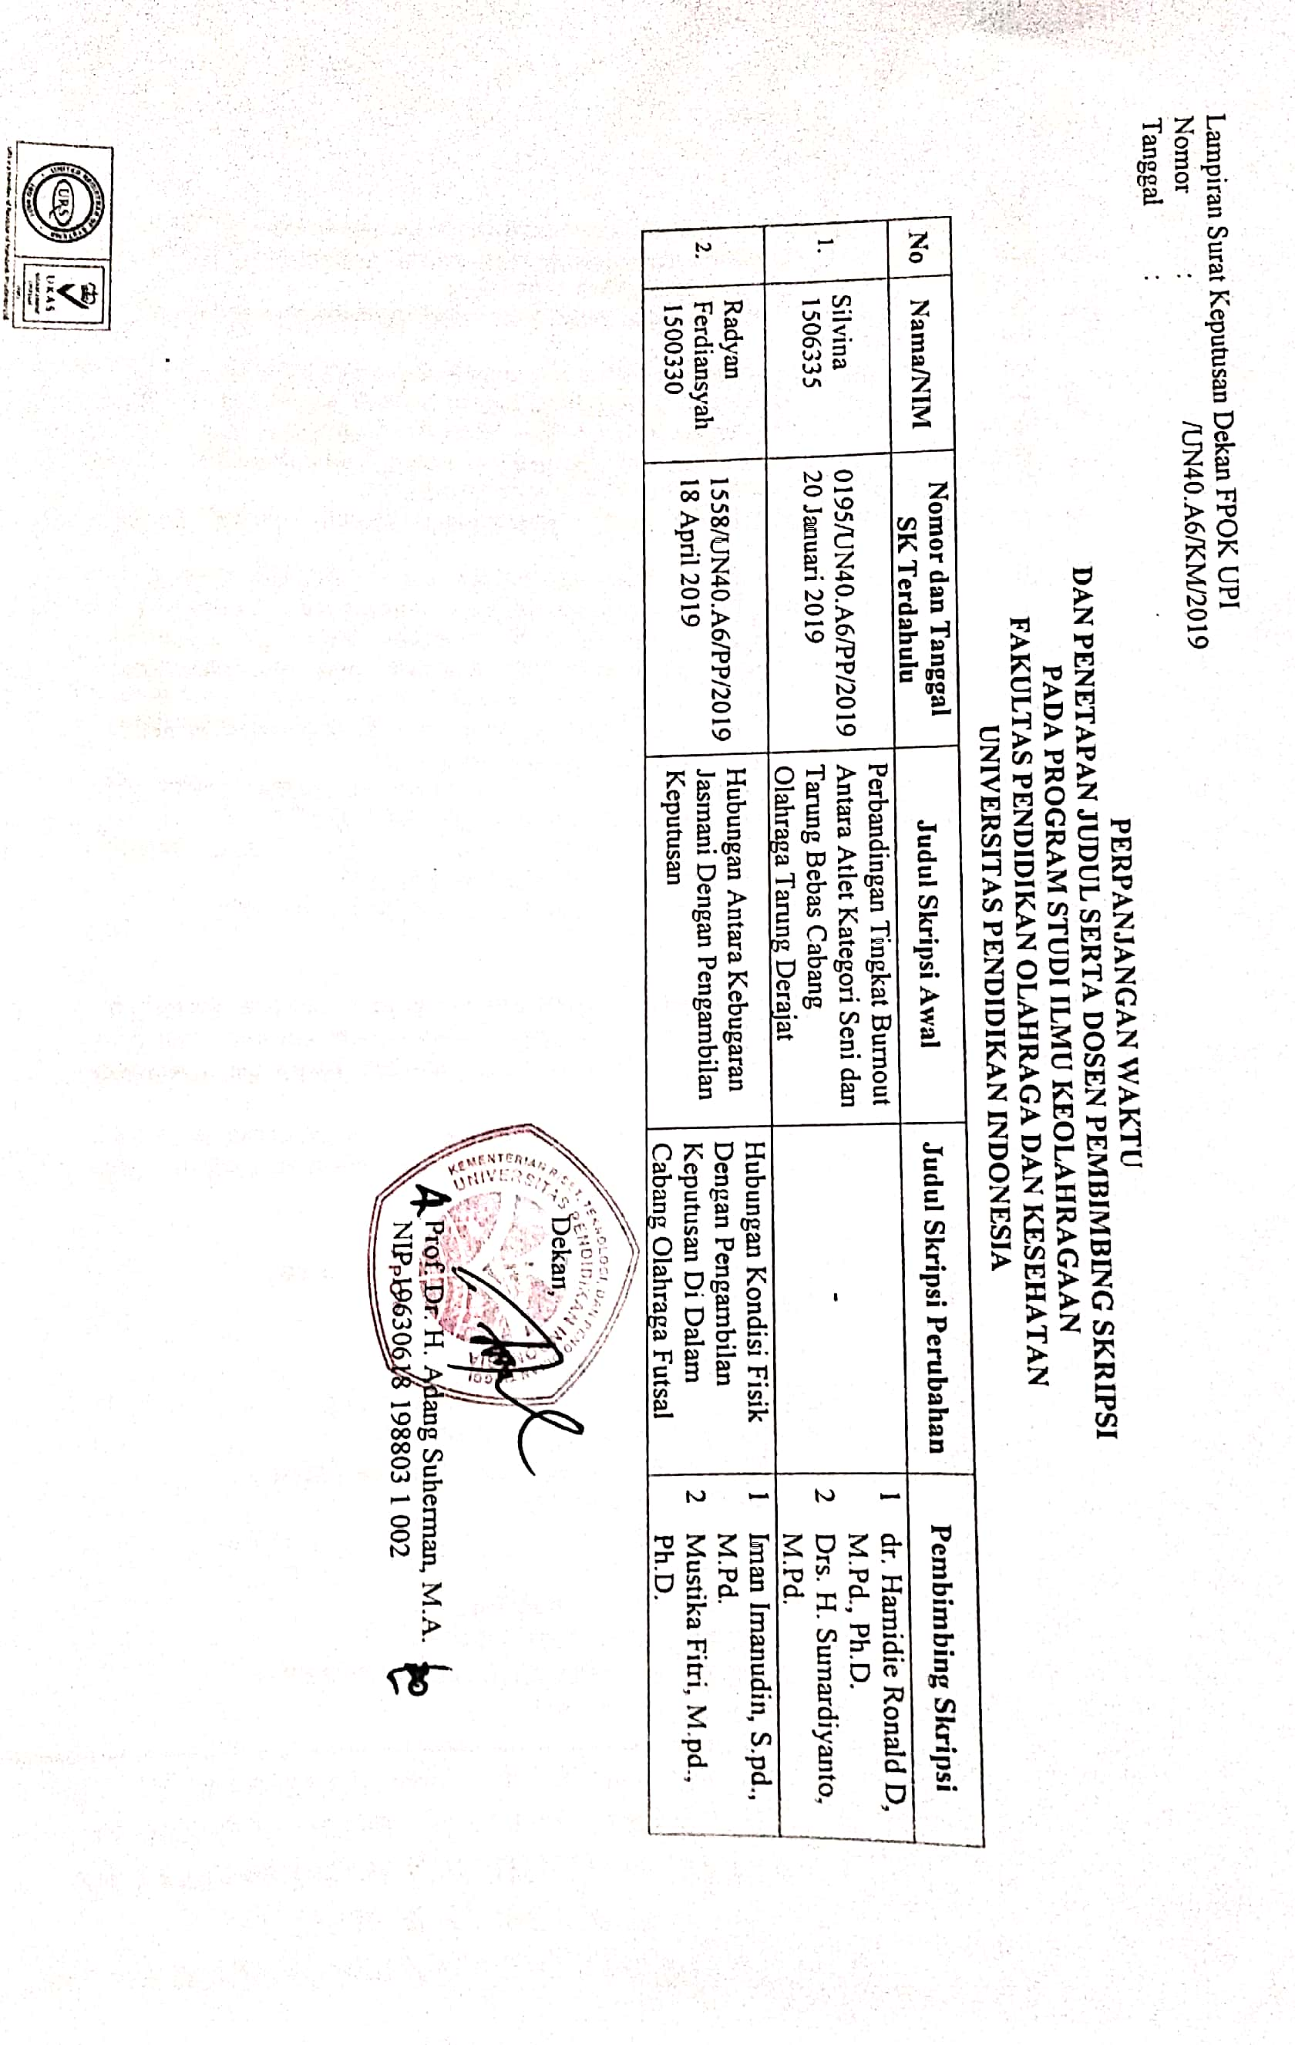
Kartu Bimbingan
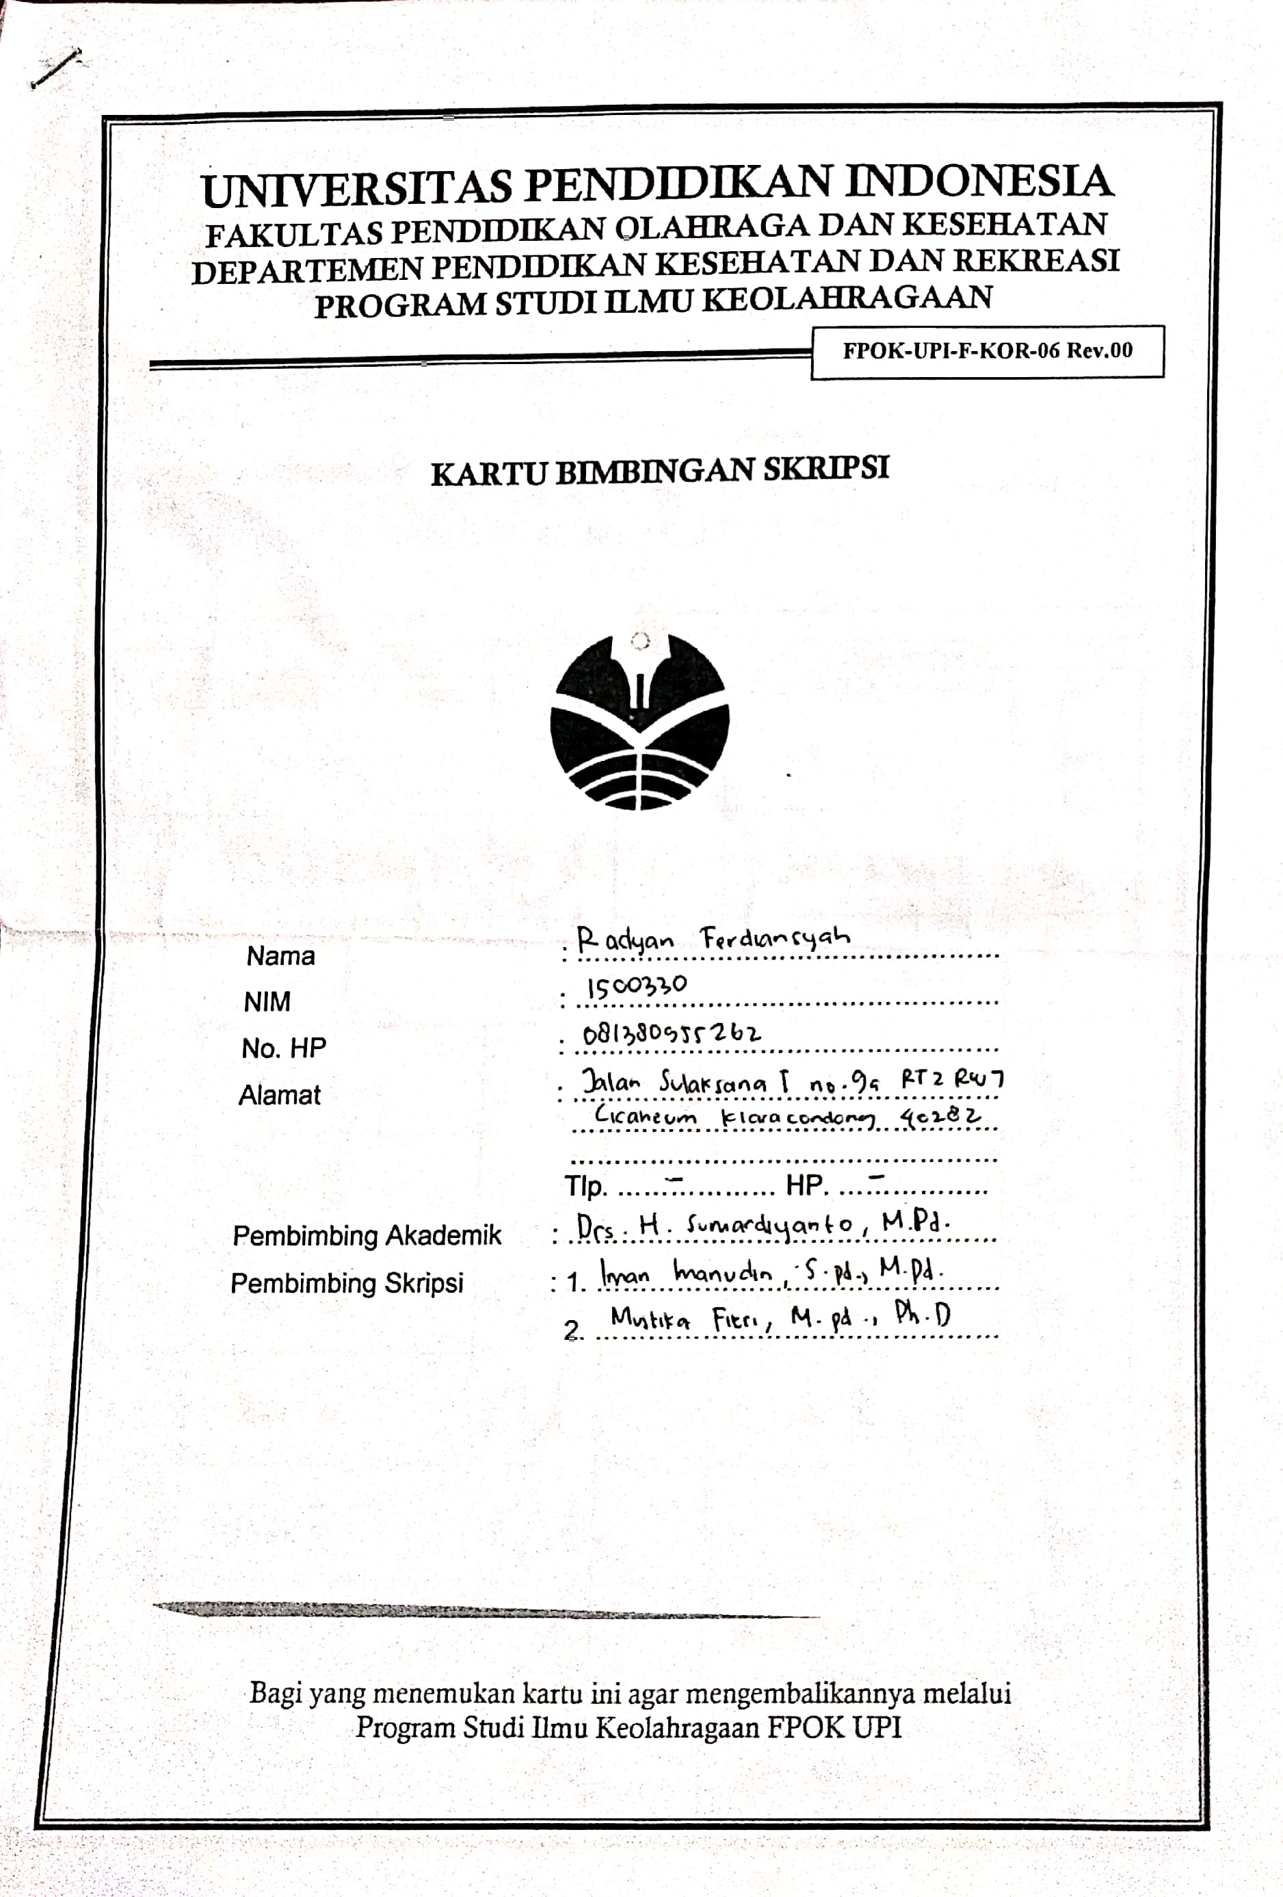

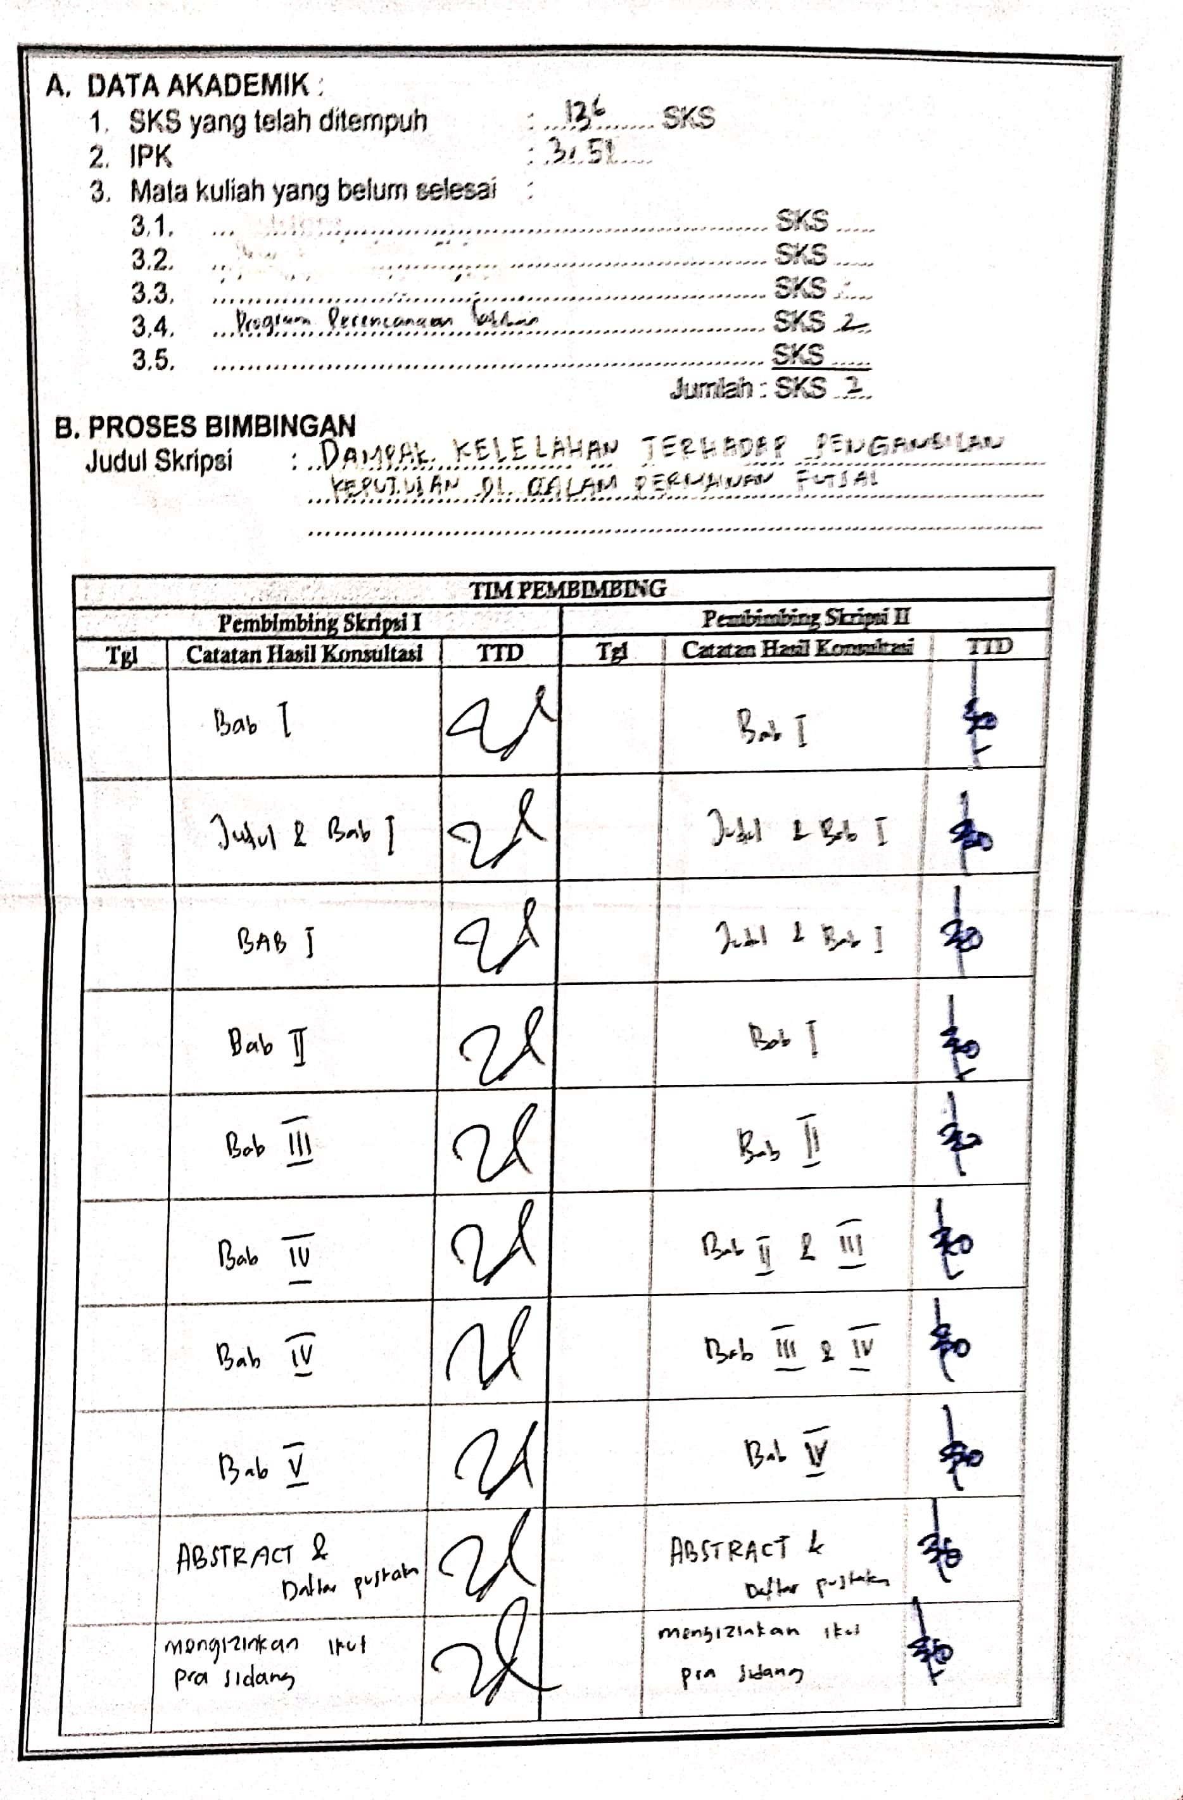
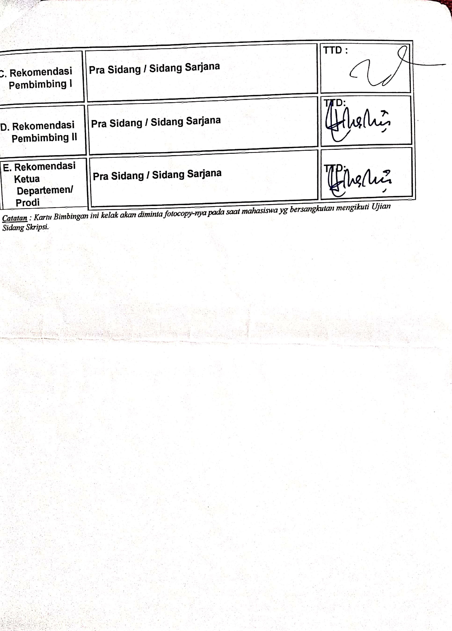

Surat Permohonan Izin Penelitian
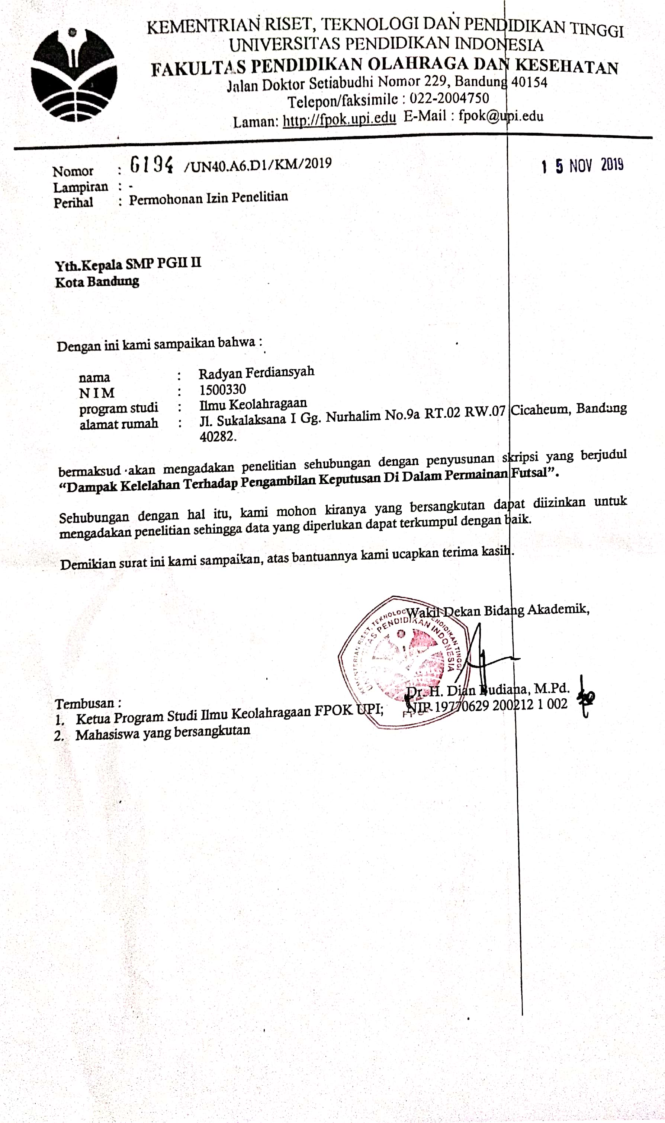

Surat Peminjaman Alat
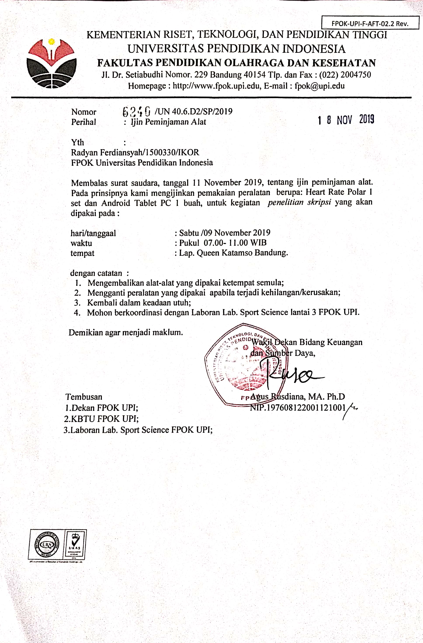

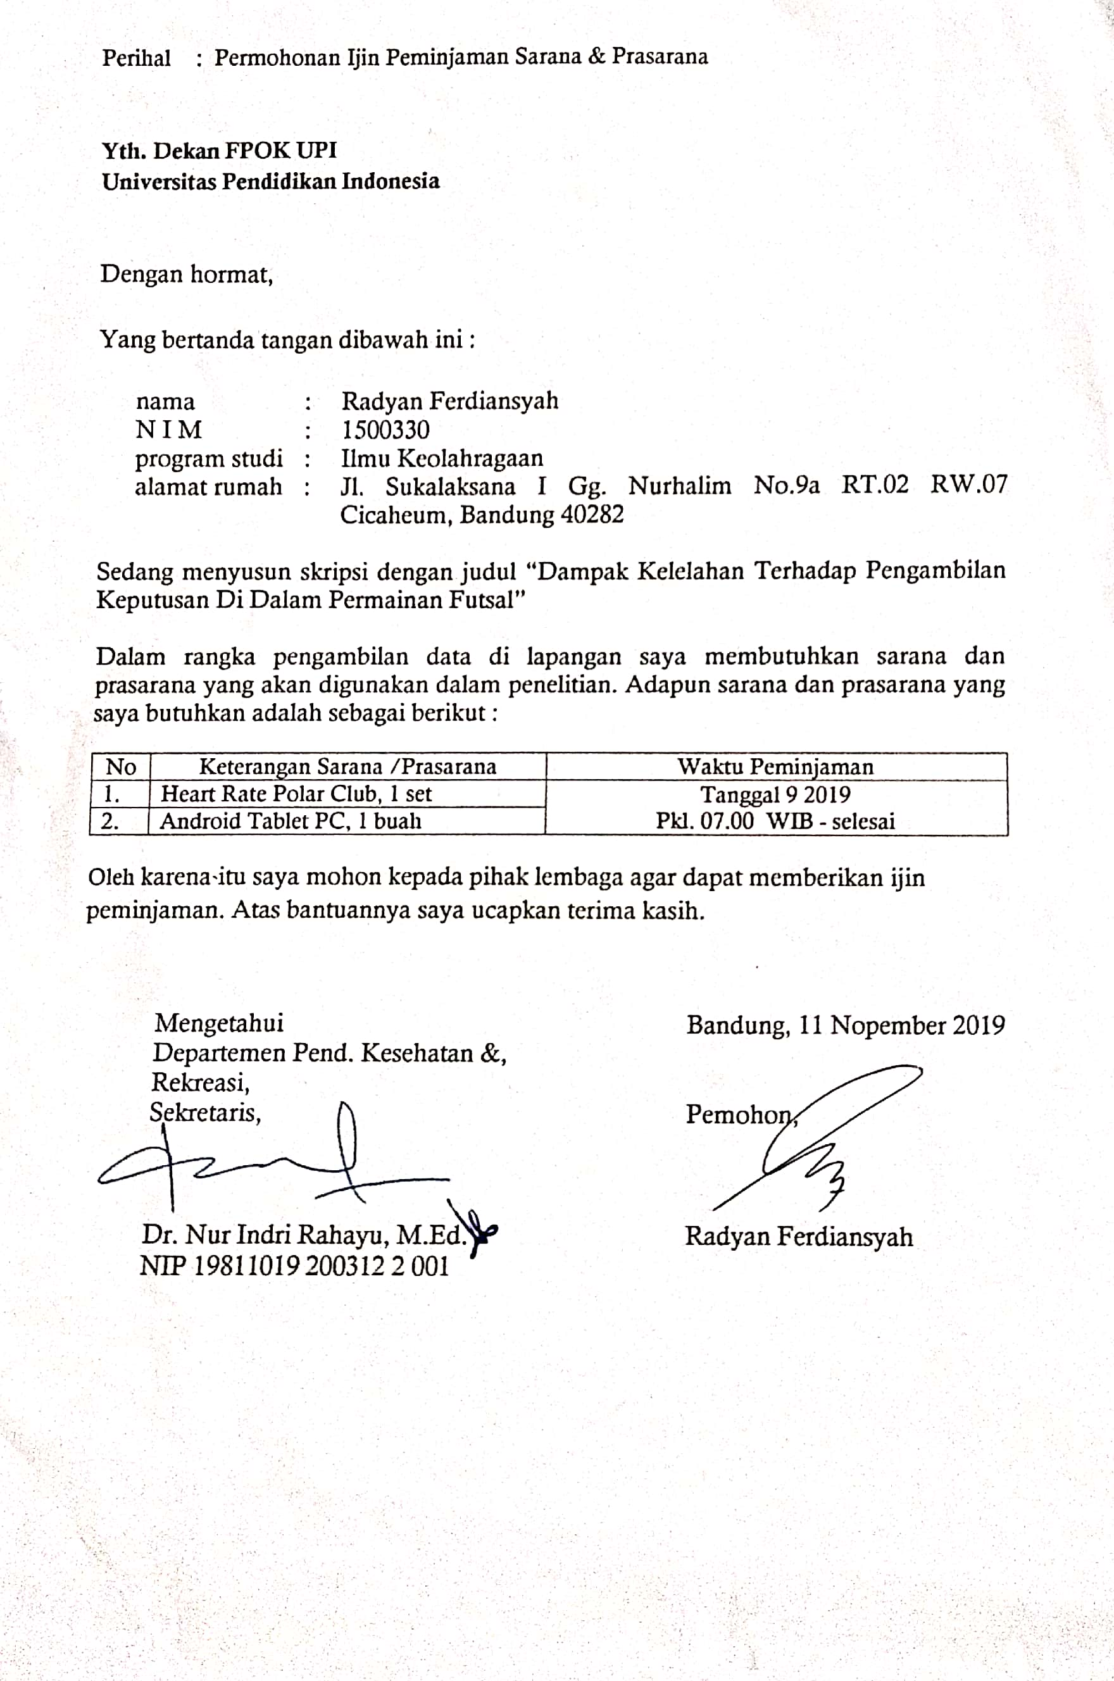
RIWAYAT HIDUP
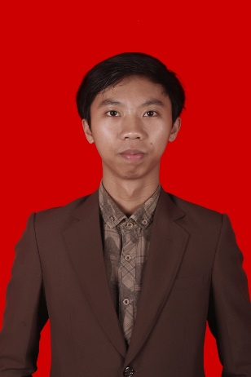
- Identitas Diri
- Nama : Radyan Ferdiansyah
- TTL : Bandung, 6 Januari 1997
- Jenis Kelamin : Laki-Laki
- Agama : Islam
- Status : Belum menikah
- Nama Ayah : Edy Boediarso
- Nama Ibu : Ratnasih
- Alamat : Jalan Sulaksana 1 Gang Nurhalim no.9a RT 02 RW 07 Cicaheum Kiaracondong 40282
- Nomor Hp : 081380955262
- Email : radyanferdiansyah@gmail.com
- Riwayat Pendidikan
      - TK : TK Al Ikhlas Bandung 2002-2003
      - SD : SDN Cicabe 2 Bandung 2003-2009
      - SMP : SMPN 27 Bandung 2009-2012
      - SMA : SMAN 16 Bandung 2012-2015
      - Perguruan Tinggi : Universitas Pendidikan Indonesia 2015-2019

- Prestasi dan Pengalaman Organisasi
- Juara 2 JF Sulfur Futsal National Championship 2012
- Juara 2 Kejurnas Tribun di Yogyakarta 2012
- Juara 2 Futsal Pocari Sweat Jawa Barat 2013-2014
- Juara 2 Kejurnas UC1000 di Jakarta 2014
- Peringkat 5 Hydro Coco Futsal Championship 2015
- Juara 3 liga bandung divisi utama 2015
- Juara 2 Brawijaya National Futsal Championship 2015
- HIMA Staff Divisi Intern Bidang Olahraga dan Kesehatan 2016-2017
- Relawan Ticketing PON 2016
- Juara 3 Liga Mahasiswa West Java Conference 2016
- Juara 3 liga bandung divisi utama 2016
- Juara 3 TUNFC 2016
- Relawan Bandung West Java Marathon 2017
- Juara 1 FFI Nasional Championship 2017
- Runner up FFI U-20 Nasional 2017
- POMNAS SULSEL Tahun 2017 Medali Perak
- PORDA XII JAWA BARAT Tahun 2018 Medali Perak
- UPI Student Achievement Award 2018
- Liga Profesional Futsal Indonesia 2018
- Gait Analysis Pocari Sweat 2018-2019
- Runner up Liga Bandung Futsal League Divisi 1 Tahun 2018
- Juara 1 Sema Championship Faperta UNIGAL 2019
- Seminar Young Enterprneur Festival 2019
- Juara 1 TUNFC 2019
- Runner Up Liga Mahasiswa West Java Conference 2019
- Liga Profesional Futsal Indonesia 2020

