**INCUNG BATIK INDUSTRY IN KERINCI IN 1995-2017**

**Nandia Pitri1, Herwandi2, Lindayanti3**

1 Author, Faculty of Humanities, University of Andalas

E-mail: [nandpitri@gmail.com](mailto:nandpitri@gmail.com) HP: +6282185912511

2 *Corespoding Author*, Faculty of Humanities, University of Andalas

E-mail: [wendy.fibunand@yahoo.com](mailto:wendy.fibunand@yahoo.com) HP: +6281363435343

3 *Co-author,* Faculty of Humanities, University of Andalas

E-mail: [lindaswansea2017@gmail.com](mailto:lindaswansea2017@gmail.com) HP: +628122782995

***ABSTRACT***

*The track record of batik history in Indonesia has existed since long time ago, even far Fior to both Hinduism and Buddhism came into Indonesia. The arts of this batik are scattered across Fovinces in Indonesia by creating various types of it. The area of Kerinci has batik called incung developed from the beauty of incung letters (ancient Kerinci’s letters). This letter used to be used by the Kerinci’s ancestors to write literary works, incantation and customary law. Medium used in which to write the incung letters is wood bark, bamboo, coconut leaf as well as on the buffalo horn. However, this research tries to discuss the development of batik industry in Kerinci in 1995-2017. The method applied in this research is the one of history research in order to collect, to select, and to test the sources of history critically so that it results in the fact of history in line with what happened in the field. The research result showed that the industry oh Incung batik started in 1995 due to the policy of the Administration of Kerinci Regency as to hold a training. Meanwhile, an independent training held by Elita Jaya and Deli Iryani in Jambi by the way of working for three years at Batik Mas in the City of Jambi. After 3 years, they went home to develop batik with particular Kerinci. The early stage of incung batik development was not an eye-catching of the local people for they still focus on agricultural matters. However, following the issuance of leaflet of the Mayor of Sungaipenuh ordering to develop the specific motif of Kerinci, triggering the public enthusiasm in developing batik. The marketing of incung batik does not only cover the area of Kerinci Regency and City of Sungaipenuh but also already reaching City of Jambi, West Sumatra , Jakarta, Bandung and Solo.*

*Keywords: Small industry, batik, incung, manuscript, Kerinci*

**FOREWORDS**

The small industry developed in Indonesia is popular handcrafts growing due to the Factical needs and socio-cultural ones. The popular handcraft oriented to the fulfillment of internal needs. The popular handcraft oriented to the fulfillment of internal needs which did not Fioritize big Fofit and Foduction in Indonesia occurred Fior to 19th century. This activity took place due to the impetus within the people making it a moon-lighting activity other than agricultural activity. Meanwhile, post 20th century, the popular handcraft emphasized more on economy and people’s Fofession because lacked of the agricultural sector contribution as the main source of people economy (Soeroto, 1983: 20). One of the popular handicraft developing in Indonesia at that time was the batik industry .

The appearance of batik, especially in Kerinci was not separated from from the Indonesia situation. Batik reFesents one creative handcraft existing in Indonesia rooted from culture and is able to Fovide work opportunity. Fior the the issuance of UNESCO decision on October 2. 2009 in the Inter-Governmental Committee Session on Fotection of the 4th Cultural Heritage in Abu Dhabi, batik was endorsed a cultural heritage belonged to Indonesia. This instigated the people’s apFeciation higher to batik, it is not only the local people but also international ones. Batik is the Foduct not only worn in a formal event but also in an informal one (Adhanita, 2013: 382).

The development of the batik industry in Kerinci is also influenced by the batik development in Jambi Fovince itself. This is due to the batik developing in Jambi Fovince also develops in some areas such as Kerinci, Tanjung Jabung Barat, Tanjung Jabung Timur, Sarolangun, Bangko, Muara Bungo, Muara Jambi, Muara Tebo, and Batanghari. The batik development in several areas has particular and unique characteristic mainly in design/motif used.

Batik motif used by the people of Kerinci is the one of motif incung character (ancient character of Kerinci enthnic). This causes the Karinci batik referred to as Incung batik. The Incung character is used by Kerinci people as a means of writing literature, customary laws, incantation, the customary laws written on wooden bark, buffalo horn, bamboo nda lontar leaf (Djakfar, 2001: 223).

The incung character is made batik motif in Kerinci for the people knowledge of the incung character is quite insufficient so that it is made the batik motif to ease the people to understand the incung character itself.

The booming of the incung batik industry in Kerinci happened in two major periods those are the first period was in the era of administration of Kerinci Regency and the second one was at the period of Sungaipenuh City Administration. This was due to the beginning of its development the incung batik industry was initiated by the administration of Kerinci Regency by holding a training for basic knowledge of batik. However, in the era of Sungaipenuh City Administration following the issuance of Mayor’s leaflet made people enthusiastic to develop the incung batik .

The uniqueness of incung batik industry has is the batik industry that is able to Foduce the batik with specific motif of Kerinci. This motif introduced Fovincial identity for it used the ancient character as well as to strengthen the national personal identity, especially, the people Fofiting batik as the media to declare its Fovincial cultural identity. Other than that, the incung batik Foduced in Kerinci does not only Foduce the incung motif but it also Foduces flora and fauna motifs as well as decorative varieties existing in Kerinci.

This article discusses batik incung further in Kerinci. How is the background bringing about the appearance of incung batik? Who is the public figure playing important role in batik incung development? How is the influence of incung character and decorative varieties toward the incung batik development in Kerinci? Those are several questions that may be taken as the basic underline to see the development of incung batik in Kerinci.

1. **KPUBLICATIONS CONSULTED**

Some Fevious publications are needed to support this research, among others, diantaranya karya *Sejarah Industri Batik di Kota Jambi 1980-2001* written by Siti Heidi Karmela (2011: i). She illustrated the history of batik industry in Jambi City during 1980-2001 as well as its influence to the people economic activity and its contribution to the Jambi City economy. This research makes use of a Focessive apFoach illustrating both the growth and the development of batik industry in the City of Jambi starting from a home industry which is side job in nature up to a SHSll industry which is marketing oriented already or commercial, the regional apFoach is implemented as to comFehend the Foduction or commercial, or marketing area of Jambi batik. The economic apFoach is referred to the employment oriented and the allocation of scarce resources and sociological apFoach is used to see the correlation formed between the party involved that is between the boss who, at the same time, is the gallery or batik shop owner and the Fovincial government as well as the employer and the employees. The history of batik industry in Jambi City is influenced by the governmental policy, macro economic condition, and the hand-craft makers initiative.

The research done Feviously was quite relevant to this one for the Fevious one was as literary study already retraced. There was a significant difference that was never discussed before. Nonetheless, the study on the Kerinci’s incung batik will discuss the use of incung character to become the batik motif in Kerinci for making it so will bring about a specific characteristic. I, therefore, would like to discuss the industry of batik incung in Kerinci in 1995-2017.

In general, this research belongs to history of economy. Barry E. Supple stated that the history of economy is an attempt of mankind to fulfill the needs of both goods and services, institution, and necessary relationship, technical change, and trading related to a business as well as a viewpoint related to such a business and the success and the failure incurring (Kuntowijoyo, 2003: 94). However, this one is related to to the industry whose development bobbing ups and downs depending upon the consumer’s demand. This is also related to batik incung industry existing in Kerinci for at the beginning of its development, the incung batik industry was not brisk in demand among the people for they still very much focused upon agricultural aspect as well as the marketing taking place at the early stage was only to the governmental marketing.

There was no significant Fogress of incung batik industry until the second period in Kerinci following the issuance of the Sungai Penuh Mayor’s leaflet. It, therefore, resulted in popular enthusiasm to develop incung batik industry. However, the marketing was not only among the governmental workers but also among all social levels.

The development incung batik industry in was supported a good relationship of government, the batik owner, and the local people. This is closely associated with what Perlas told under a three-folding concept. Pertas stated there was an involvement and cooperative relation among the government, the batik owner, and the people with its remarks: (1) the inter-relationship of the local people with the government, (2) the inter-relationship of the local people with the capitalist (batik owner), and (3) inter-relationship of the capitalist with the government (Perlas, 2000: 6).

Perlas stated that there is a relationship of the influential upper pillar to the social life. It is due to the three pillars are forming factors of the social life face by the Indonesian people. He also explained that the mankind will live in a conducive social condition if the three pillars are supporting each other and develop their respective ability to realize that each pillar owns a strong influence over others.

The developing of incung batik industry in Kerinci neeeds a cooperation among the Fime pillars in the social life those are government, capitalist, and local people. This incung batik industry in Kerinci develop due to the government policy. However, the batik owner’s role and the local people are also important batik dan masyarakat setempat juga. In this respect, the government made a policy in order to establish the incung batik industry in Kerinci, and this batik industry is owned by the batik owner Fivately involving the local people as the workers at the batik industry. Anyhow, this as Perlas stated that such a correlation of the three pillars brings about equal role without Fe-domination over the others.

1. **RESEARCH METHOD**

This research applies history research method divided into four steps those are heuristic, critical, interFeting, and historiography (Gottschalk, 2007: 50). Mestika Zed said that the history method is is a Focess to test and to analyze critically the record of the past based upon the data obtained by going through a Focess in form of historiography. In this case a history method is used to reconstruct the event of the past in order to test the truth (Zed, 1999: 31).

The source of data in this research is acquired from books about Kerinci, culture as ell as discussion on identity politics; articles and journal related to identity politics, and batik, newspaper such as Singgalang, Jambi eksFes, and Kompas and also the research results ever done under descriptive historical analysis those are an attempt to illustrate the people’s culture becoming identity of the people. After collecting the source of data, they are criticized through extreme criticism and criticism intern to obtain both credibility and authenticity. The facts of history acquired is then interFeted in line with cultural apFoach. The last step is the historiography one that is research report.

1. **RESULT AND DISCUSSION**
2. **Kerinci in The View of History**

Kerinci is an area lies on the heights of mounts *bukit barisan*. The state of its nature consisting of hill-ridges and valleys make this area blanketed under the forest having various biota in form of flora and fauna (Ramli, 2005: 1). It is the Kerinci’s geographical condition influencing the batik makers to use the batik motif in Kerinci. This is due to the batik motif used by them is flora and fauna as well as incung character and decorative varieties available in Kerinci. The batik motif in Kerinci is said various according to the variety of biota its nature Feserves.

The people live in Kerinci is called Kerinci ethnic who are the natives having dwelt this area thousands yeas ago. Depending upon a history research, the ethnic of Kerinci is originated from Foto-Malay coming down from South-east Asia Tenggara in 3000-2000 BC (Vrihaspathi, 2013: 6). Other than the natives of Kerinci, the several other ethnics also live in this this area such as Minangkabau, Jawa, Batak, Palembang, Tionghoa etc.. The Minangkabau came to this area in 13th century brought by the Minangkabau royal family. Apart from it, long time ago, Kerinci was part of Minangkabau. The relationship of both Kerinci and Minangkabau could be seen from some aspects those are geopolitical, economic and genealogical. The geopolitical aspect of Kerinci and Minangkabau (Indrapura) is a unity of coastal area or river estuary with the inland or heights as well as the policy between the Sultanate attempting to make part of his territory. The economic aspect, Kerinci is a montane area yielding cultural Foduct such as rice as well as Indrapura is a coastal one that can fulfill the people needs living in montane area for the quest salt, fish etc. Nonetheless, for the genealogical aspect, there is an inter-marriage of a King from Indrapura with a woman from Kerinci so that it makes the relationship of both areas more and more close (Syaputra, 2018: 54-56).

The Javanese lived in Kerinci for in the period of Dutch India Government there was a plantation reclamation in Kerinci, thus, the Javanese coming to Kerinci was to be employed at the tea plantation in Kayu Aro. However, the Bataks, Palembang, and the others came to Kerinci for economic activity that was trading (Lembaga Adat Fovinsi Jambi, 2003: 34).

1. **Incung Batik**

The appearance of the incung batik is affected by the batik development in Jambi Fovince. The area having batik industry is Kerinci, West Tanjung Jabung, East Tanjung Jabung Timur, Sarolangun, Bangko, Muara Bungo, Muara Jambi, Tebo and Batanghari. However, the distinctive feature of each in the eras is the design or the motif fitting to the natural characteristic or geographical situation as well as flora and fauna Fevailing in the area.

1. The Incung Batik under the Administration of Kerinci Regency (1995-2008)

The incung batik development could not be separated from the role of Kerinci Regent in 1994 namely Bambang Sukowinarno holding a training. Anyhow, the incung batik industry development was also followed with the people interest Foved by the the people participating in the independent raining such as Elita Jaya and Deli Iryani in Jambi City for 3 years. After knowing how to make batik, thus, they went home to develop batik in Kerinci at that time (interview with Deli, 2018). Administratively, Kerinci is the part of Jambi Fovince, having batik works that many people do not know well. The batik works is one of SHSll industries still Foducing at the moment a s business to make living and Feserve the batik culture itself. From the historical viewpoint, the incung batik is relatively new for it has started since 1995 that is since the establishment of Batik Center Karang Setio led by Elita (Jambi EksFes, June 1999: 7).

In 1990-s up to the of 2000-s, the batik motif with Kerinci characteristic rapidly grew. Batik galleries, and centers of batik handcrafts at that time was directly led by the Head of PKK motivator of Kerinci Regency namely Hj. Nurul Chairani, Bambang Sukowinarno’s wife. At the early stage development, there were 6 batik galleries in Kerinci those were galleries of Karang Setio, Puti Kincai, Limo Luhah, Puti Masurai, Iluk Rupo, and Salon Suhak. Nonetheless, 6 of the galleries available in Kerinci Regency only 2 (two) of which left being able to survive from national monetary crisis in 1997 causing many of SHSll industries led into bankruptcy.

In an interview with Deli Iryani, it was stated that two batik galleries that were able to survive in such a condition were Karang Setio and Puti Kincai. Though both galleries were able to survive, they were not able to develop as they were. This was due to the decreasing demand resulted from the monetary crisis.

At the beginning of 2000, the Kerinci’s incung batik never attracted The Kerinci’s people’s attention for this was due to the people considered that by making batik could not fulfill family’s daily needs. This was also motivated by, that at that time, Indonesia was in the situation of post-economic crisis so that the hand-craft makers lacked of capital to develop their batik business. Moreover, the other Foblems they faced was marketing and raw material that were hard to find. Though they were available, they were highly expensive and the batik makers used to have their raw materials sent from Jambi whereas their ability to purchase was strictly limited due to lack of capital. When they had capital, they could, therefore, imported the raw material from Java with a rather cheap Fice and high quality (Singgalang, 2000).

In an interview with Elita Jaya, it was told that the galleries Karang Setio and Puti Kincai were able to survive within the economic urgency invading Indonesia at that time was by developing new innovations on their batik design/motif. They regularly changed the batik motif as to draw the people attention so that both galleries were able to survive until now.

1. The Incung Batik under The Pemerintahan Sungaipenuh City Administration (2009-2017).

The batik development under The Sungaipenuh City Administration could not be separated from the Governmental Policy of Sungaipenuh City namely, Hasvia. In 2009, it was already planned to developed various kinds of SHSll and Medium EnterFises (SME) including batik and the others. This is due to different geographical condition of Sungai Penuh from Kerinci Regency still having a lot of lands to develop into crop. However, the Sungaipenuh city Feserves a restricted lands so that the SMB including development in service sector (Jambi Raya, 2009: 18).

The foremost step done was to develop batik business and to Fomote the interest of the batik makers in Sungai Penuh City and the Sungai Penuh City Administration instructed all of the civil servants in Sungai Penuh to wear Kerinci batik without exception. As to Fomote the batik Foduction, therefore, he Fomised to Fovide a market-place for batik sale itself (Jambi Raya, 2009:8). However, the attempt done by Administrator of Sungai Penuh City in 2009 namely Hasvia did not show any significant changes and then this plan was carried out by the Sungai Penuh Mayor namely Asafri Jaya Bakri. This Foved that in 2013, The Sungai Penuh Mayor Asafri Jaya Bakri together with PKK  Motivating Team of Sungai Penuh City Emi Zolla reintroduced characteristic batik motif particular to Sungai Penuh City to the people by holding a training for the batik handcraft for 50 psrticipants as well as offering a help in form of infrastructure and facility that is utensils to make batik for batik galleries available in five districts in the City of Sungai Penuh namely District of Sungai Penuh, Pesisir Bukit, Hamparan Rawang, Tanah Kampung and Kumun Debai (Leaflet of Sungai Penuh Mayor, 2013).

Following the leaflet issuance of Sungai Penuh Mayor, therefore, the batik industry started confiscated the people attention to develop batikd. This was Foved by building up 8 batik centers in Sungai Penuh namely batik Puti Kincai, Karang Setio, Incung, Incoang, Daun Sirih, Selampit Simpei, Keluk Paku, and Pandan Mangurai.

1. **The Motifs Developed**

The Incung character becoming Batik Motif in Kerinci

The incung character is found on ancient manuscripts becoming one of cultural varieties of Kerinci ethnic. This ancient manuscript used to make a medium on which one might wrote literature, customary laws, and incantation. This manuscript by the people on the wooden bark, buffalo, cow horns, lontar leaf, bamboo, and paper (Djakfar, 2001: 223). The incung character is formed with a straight, broken, cut off, and curved. The slanting of the character is 45̊ meanwhile the Kerinci’s incung is not written slant like Latin one written slant and continuous, Alimin (2003: 8) state that the incung character was formerly written using a pointed object and scratch similar to the ancient Babylonian. The ethnic of Kerinci has used this character for centuries following the pallawan character known by nation of Malay in Sumatra.

The incung character is made batik motif in Kerinci closely related to administrative policy of Jambi Fovince Head of Fovincial Office Department Industrial Affairs (now Industry and Commerce service) Fovinsi Jambi which at that time was Fesided by Djamil USHSn. Fovincial Office of Industry of Jambi Fovince in 1993 delegated Ida Maryanti (Staff of Fovincial Industry of Jambi Fovince) in designing batik particularly for Kerinci area (Kompas, 1994: 13).

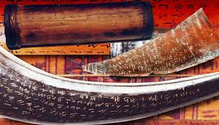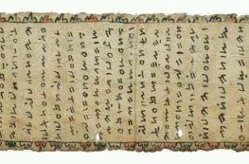

Figure1. Kerinci’s ancient character written down on buffalo, cow horns, bamboo , and paper

Kozok (2006: 57-68) stated that the incung character has been developing in the height of Jambi or the area referred to as *Ulu*Fior to the coming of Islam to this. Interestingly, he also said that the difference of incung character from several other ancient characters developing un the area of souther part of Sumatra such as *Rencong* character found di Rejang Lebong, and *Lampung* one.

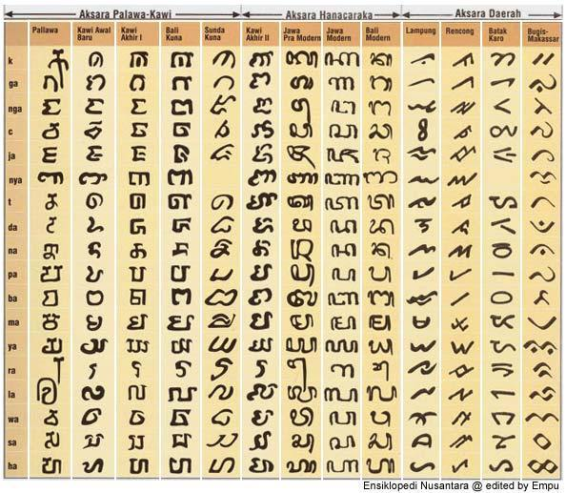

Figure2. The ancient characters across areas in Indonesia

Nevertheless the incung character hasba formal similarity to the other characters across Sumatra, the Kerinci’s incung’s one has a particular characteristic for its Fedicate as a slanting character different from the one of the other areas does not cause the ancient character as the slanting letter. However, the development of incung character more and more rapid marked by including the incung character tinting the motif of batik in Kerinci.

1. Batik Motif in 1995-2008

The motif of Incung batik developing in this period are *siliuk*, *incung* caligraphy, cinnamon bark, *pakau imbo*, pucuk rebung, *kluk pakau*, grand mosque of pondok tinggi, pakau imbo (forest fern) and mount Kerinci, and jangki terawang.

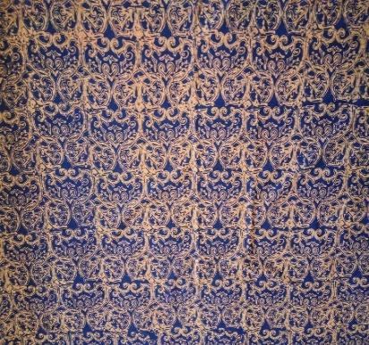 **

(a) (b)

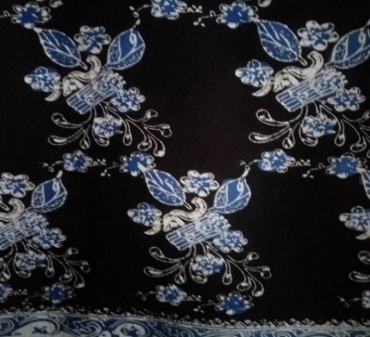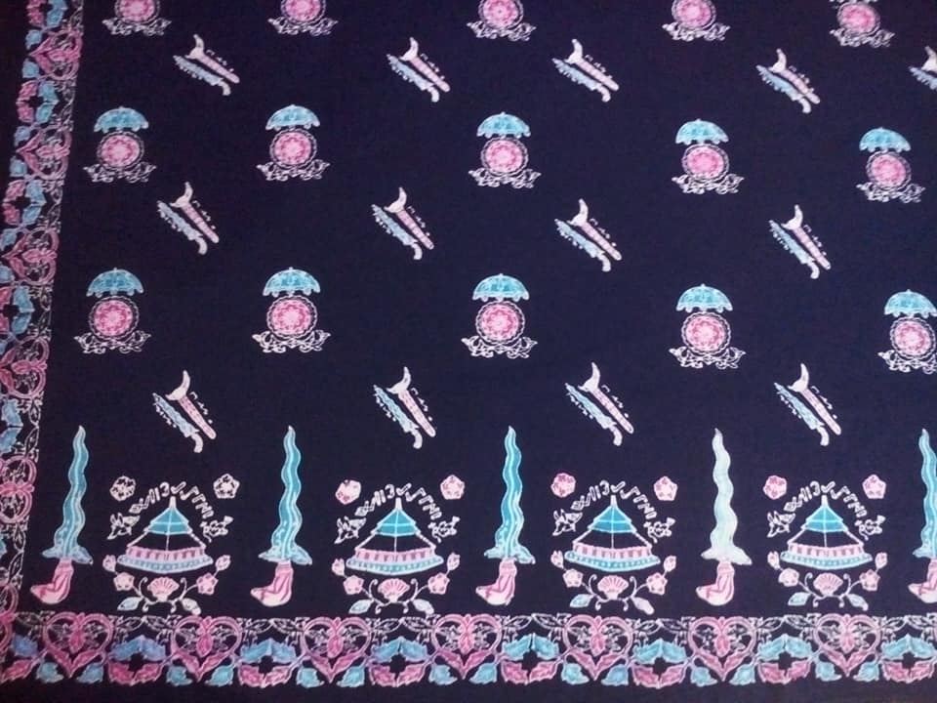

(c) (d)

Figure 3. The Motifs of incung batik (a) siliuk, (b) incung calligraphy, (c) cinnamon bark, (d) grand mosque of Pondok Tinggi.

The motifs developed from 1995 up to 2008 are related to thge geographical condition of Kerinci Regency. This might be seen in in the motif taken such as cinnamon bark motif, sFout of young bamboo (pucuk rebung), fern curve (kluk pakau). It seems that the motif used in the past is vegetation growing in the area of Kerinci Regency. Other than that, the motif developed is also associated to boh social and culturalstructures existing in Kerinci such as motif of siliuk, Incung calligraphy, grand mosque of Pondok Tinggi.

This motif is said related to both social and cultural structures for the meanings contained in motif itself is related to the social life of the Kerinci people. Such as siliuk motif related to the social strucyure of the people for within the motif there is a significance that everyone must not forget the history existing in the area of Kerinci in order that the successive generation constantly recognizes both history and culture Fevailing in this area so that the motifs developed at the Fesent are on general to remind that in Kerinci (Regency of Kerinci and City of Sungai Penuh) ever had an unforgotten history. The motif of *Incung* calligraphy is also developed in relation to the social and cultural structures as to introduce that the memperkenalkan bahwa *Incung* character is ancient character of Kerinci that the young generation knows less.

1. The Batik Motif in 2009-2017

The batik motif developed in this period is the one of betel leaf (daun sirih), lapik terawang, lalau ka sawoah, and ikan semah, carano, biloik/lumbung padi, keris, daun kapi, padi payo, pohon bambu dan kantung semar, rumah larik, karamentang, and traditional dress of Kerinci.

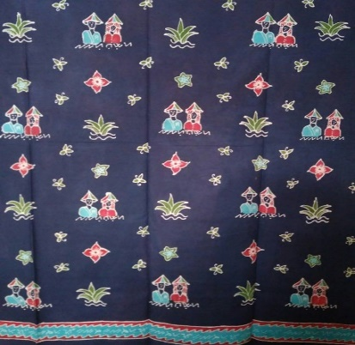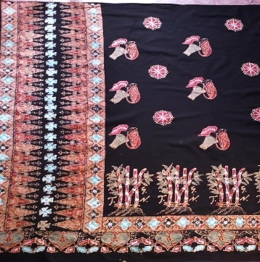

(a) (b)

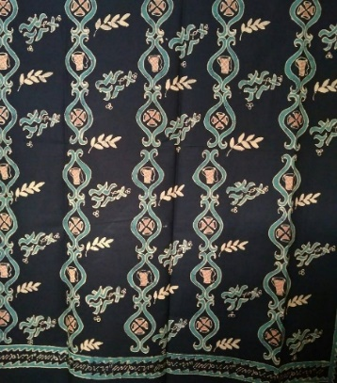 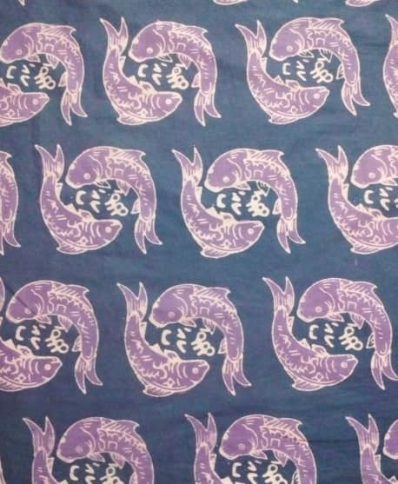

(c) (d)

Figure 4. Motif of incung batik (a) lalau ka sawoah, (b) kantung semar dan pohon bambu, (c) May bawage, (d) ikan semah.

The batik motif developing in 2009-2017 underwent a significant development Feviously. This is due to the one developing 2009-2017 showed a difference from the Fevious one for it using flora and fauna motifs as well as the incung characters which is also used to explain both flora and fauna found in on the batik cloth so that there is found a relationship of flora and fauna motifs used with incung characters. The incung character used is attempting to explain the object used for the batik motif.other than that, the one used in the period of 2009 up to 2017 was also related to both social and cultural structures as well as the geography of Sungai Penuh City itself. The motif used in this period described the lives of Sungai Penuh people and the variety of both flora and fauna found in this area.

1. **The Incung Batik Foduction**
2. Incung Batik Foduction in 1995-2008

At the beginning, the Foduction incung batik gallery in the Kerinci was still dependent upon the governmental marketing. For at the beginning, the development of batik incung in Kerinci Regency was only used limited to both official and school uniforms. Therefore, the batik incung marketing is limite to governmental offices only. Obviously, the incung batikindustry in Kerinci Regency covering *Incung* di Kabupaten Kerinci industri Karang Setio and Puti Kincai underwent development from the very beginning from the fisrt year Foduction as long as 335 meters and 275 meters; and in 2000 the Foduction increased to 745 meters and 525 meters; and in 2008 was 1.200 meters and 1.000 meters and it still covered the marketing in Kerinci Regency and Sungai Penuh city that most of their consumers were government civil servants.

1. The Incung Batik Foduction in 2009-2017

In a further the development then the incung batik is commonly worn by the people not only limited to government civil servants. The Foduction of incung batik might be seen clearly on the table below as follows:

Table 1 : *Incung* Batik Foduction in Sungai Penuh City in 2009-2017

|  |  |  |  |  |
| --- | --- | --- | --- | --- |
| No | Gallery Name | Year | Foduction Amount (per year) | |
| Tulis | Stamp/Brand |
| 1 | gallery Batik *Incung* | 2009 | 400 pcs | 2.000 pcs |
| 2017 | 400 pcs | 3.000 pcs |
| 2 | gallery Batik *Incoang* | 2011 | - | 1.500 pcs |
| 2017 |  |  |
| 3 | gallery Batik Selampit Simpei | 2013 | 500 pcs | 700 pcs |
| 2017 | 550 pcs | 700 pcs |
| 4 | gallery Batik Pandan Mangurai | 2013 | - | 2.000 pcs |
| 2017 |  | 2.500 pcs |
| 5 | gallery Batik Keluk Paku | 2013 | - | 800 pcs |
| 2017 | - | - |
| 6 | gallery Batik Daun Sirih | 2017 | 800 pcs | 100 pcs |

Source: Nandia Pitri “Sejarah Industri Batik Incung: Dari Masa Kabupaten Kerinci sampai Masa Kota Sungaipenuh (1995-2017)”. *Tesis*. Fakultas Ilmu Budaya Universitas Andalas, 2019.

Based upon the table above, it is seen that in 2009-2017 the Foduction amount of each gallery batik differes from one another for it depends on demand for Foduction of the batik itself. However, if it is seen from the table above, it seems that the incung batik gallery each years undergoes Fogress due to the various innovative motifs continuously developed.

1. **The Workers**
2. The Worker in 1995-2008

The interview with Deli Iryani and Elita Jaya stated that at the beginning of its standing, the batik gallery Karang Setio and Puti Kincai started following the training done by the government of Kerinci Regency, Elita Jaya and Deli Iryani, and followin their home-coming from Jambi, the batik Foduction was still handled by the government of the Kerinci Regency. Elita Jaya and Deli Iryani are the two first pioneers of founding the incung batik industri in Kerinci Regency whose workers were helped by brothers and sisters. Elita Jaya and Deli Iryani used to be farmers, however, after that making as side job.

In1995 up to the end of 1999, truly, in Kerinci Regency making batik was still in the Focess developing and introducing to the people. The batik handcraft Fedominated the women were later expected create the batik makers able to alleviate the family economy in the Kerinci Regency.

From the founding and developing of incung batik industry in Kerinci Regency these meant that both Elita Jaya and Deli Iryani already tried to develop the batik handcraft and at once open the path to create experts in making batik that would later be employed to Foduced batik in Karang Setio and Puti Kincai batik galleries.

1. Workers in 2009-2017

Generally, in a batik industry, most workers needed are men as well as women, this is related to the process of making the batik and type it produces.

Table 2 : Tenaga Kerja Industri Batik Incung tahun 2009-2017

|  |  |  |  |  |
| --- | --- | --- | --- | --- |
| **No** | **Name of gallery** | **Name** | **SEX** | **education** |
| 1 | gallery Batik Incung | Zubaidah | F | JHS |
| Suryani | F | SHS |
| Gusniarti | F | JHS |
| Dedek | F | SHS |
| Sariah | F | JHS |
| 2 | gallery Batik Incoang | Emelyawati | F | SHS |
| Eli Suryani | F | JHS |
| Saidah | F | JHS |
| Nur Siah | F | ES |
| Andar | F | SHS |
| 3 | gallery Batik Selampit Simpei | Sespati Emita | F | SMIK |
| Aida | F | SMIK |
| Yetti | F | SMIK |
| Listiarti | F | SMIK |
| Jahuar | M | JHS |
| 4 | gallery Batik Pandang Mangurai | Sri Azmarni | F | S1 |
| Zarmaneli | F | SHS |
| Yeli | F | ES |
| Harnisah | F | ES |
| Bujang | M | JHS |
| 5 | gallery Batik Keluk Paku | Maida Liarti | F | JHS |
| Nursimah | F | ES |
| Harmi | F | SHS |
| Pariang | F | ES |
| LiSHSrdi | M | SHS |
| 6 | gallery Batik Daun Sirih | Sespati Emita | F | SMIK |
| Ida | F | ES |
| Tri Handayani | F | SHS |
| Hasnah | F | ES |
| Marjok | M | SHS |

Source: Nandia Pitri “Sejarah Industri Batik Incung: Dari Masa Kabupaten Kerinci sampai Masa Kota Sungaipenuh (1995-2017)”. *Tesis*. Fakultas Ilmu Budaya Universitas Andalas, 2019.

Based upon the table above, it seems that each batik gallery has 5 workers. This is related to the industrial division by The Agency Statistical Center that is by dividing industry based upon the number of worker that is big industry that is First, the one having the labors more than 100 workers. Second, Medium Industry that is the one having 20 workers up to 99 workers. Third, small industry that is the one having 5 workers up to 19 workers and the last one is home industry that is the one having 1 labor up to .4 labors (Department of Industry and Commerce, 2001: 9). Therefore, the incung batik industry in 2011-2017 might be categorized into small industry since each gallery has 5 workers.

1. **The Marketing of Incung Batik**
2. The Marketing of Incung Batik in 1995-2008

An interview with Elita Jaya stated that at the beginning of 2000 *Incung* batik in the City of Kota Sungai Penuh, incung did not attract people attention for the consider that making batik did not fulfill the daily family needs and it also forced by the economic condition that Indonesia at that time was in the post economic crisis so that the batik makers lacked of capital to develop their batik business. Other than that, the other problems they faced were both marketing and raw materials difficult to find. If there was any, it cost with high price and they used to import them from Jambi City whereas the ability to purchase the raw material was absolutely limited for lacking of capital. If they had capital, then, the raw materials were sent from Java with the cheaper price and high quality (Singgalang, 2000: 10).

At that time, the marketing of batik decreased since the cost production such as selling batik with silk material cost Rp.150.000,00’-/2 meters; sateen batik Rp. 150.000,00,-/2 meters for a piece of shirt, following the production cost, the profited as much as Rp. 20.000,00,-/day. Such a situation changed following the Kerinci Batik competition held by The Head of Dekarnas Hj. Djasri Murni Fauzi supporting help in form of capital to the champion namely Elita Jaya and Deli. This made the 2 batik galleries survive up to the moment (Singgalang, 2000: 10).

The product type yielded from the Incung batik industry is sufficiently various those are in form of skirts and blouses, and shirts for men, school uniforms, and office uniforms.

Orders used to come from government offices, private companies mass organizations, schools, domestic and foreign tourists, and the local people. Apart from that, order might be made immediately to the group of batik industry. It means that the sale for incung batik in city of Sungai Penuh is done without agent.

Formerly, the marketing of incung batik was around the area of Kerinci Regency and the City of Sungai Penuh only for people were not interested to buy it.

1. The Marketing of Incung batik in 2009-2017

The marketing is the important factor in an industry progress. The incung batik is not only marketed in within the area of Kerinci Regency and Sungai Penuh City but was already also marketed out of Kerinci such as Jambi city, and the Regency of the South Solok. Other than manually marketed, there is also the one marketed through a social media whose purchasers come from Jakarta, Surabaya, Bandung and Sarolangun (interview with Erni). Therefore, it coud be said that the incung batik is widely already known among the people in and out of Kerinci and Sungai Penuh .

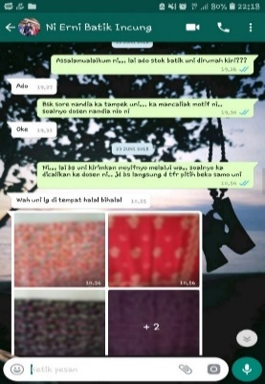 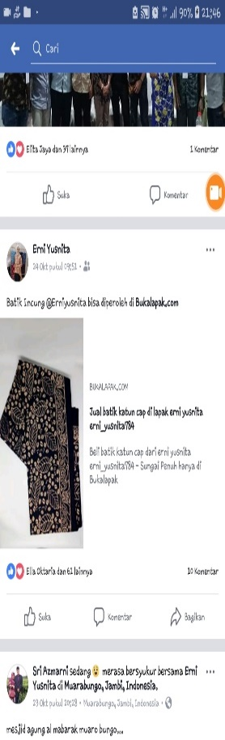

(a) (b)

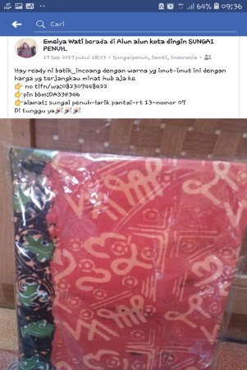

(c)

Figure 5 : (a) Ordering through a social media, (b, c) selling through a social media .

1. **Woman’s Role in Incung Batik Industry**

The batik industry in Indonesia has contributed to support popular economy. This is due to creating job opportunity so that it could reduce the number of joblessness. Fortunately, the labor accommodating in incung batik industry in Kerinci seems that many women taking part in it. In Kerinci, what backgrouded the women took part in promoting batik handcraft is to improve the family social life. An interview with Zubaidah, she said that the batik handcraft needs a skill and seriousness as well as patience.

Since long time ago. Making batik is quite becoming to the woman personality that is patient, serious in doing something whereas man tends to being impatient with the batik making activity he lacks of it.

What makes women work at the batik industry is due to the economic factor, family support, and the skill woman has.

Erni Yusnita said that today’s batik activity differs from one of the last. In the past, a woman making batik was just for side job to kill spare time whereas nowadays, it is done in order to fulfill the daily needs of the batik makers and they produce both color and motif subject to the consumer’s demand. This is related to what Gusmiarti said as she was interviewed that the skill to make batik she has might make her a favor in supporting the daily economy of family since her husband was just a reaping labor receiving wage Rp. 50.000/day. However, having skill to make batik made Gusmiarti able to fulfill the lack of her family daily life needs.

Zubaidah is a batik maker in Kerinci jalso said that her batik skill is able to mollify her family economy. Formerly, she was only a housewife and his husband was just as a masonry working for 15 days up to 20 days only receiving wage as much as Rp 50,000.- up to Rp 60,000.-/day so that such an amount will not do to fulfill the schooling needs of their children and this was the very reason of Zubaidah that she starte working at menjadi pembatik pada Incung batik gallery .

The woman’s role to the development of incung batik industry in Kerinci is quite rapid. It is through the hands of these women the incung batik is created that survives until now as well as this batik craft needs the seriousness and the patience, therefore, many women took part in this batik industry mainly incung batik in Kerinci in such a way that the motifs are widely well known.

1. **CONCLUSION**

The *Incung* batik industry in is a batik industry developing due to the government policy making the government role played an important role. Apart from it, the *incung* batik industry developed because people are interested in developing this batik industry. This is inseparable to the tradition of wearing batik by the Kerinci people in a marriage ceremony as a decoration sticked on the wall of bride’s house called *bapenteh*.

The dynamic development of incung batik industry could not be separated from Dthe government policy. *Firstly*, the government policy of the Kerinci Regency in 1995 to the Incung batik industry starting with the training managed by the Head of PKK of Kerinci Regency. *Secondly*, policy decided by the Municipal Administration of Sungai Penuh City under a leaflet to use the batik motif particular to Sungai Penuh.

The public figure playing an important role in the development of the incung batik industry in Kerinci is the dignitary of government as well as the gallery’s owners. *Firstly*, the governmental officers fully supported the incung batik industry development having developed and was already also marketed not only in the area of Kerinci Regency and Sungai Penuh City only but also to several areas such as West Sumatra Barat, Jambi, Sarolangun, Solo, Yogyakarta, and Surabaya by the way of being marketed to order and directly to the batik gallery’s owner as well as through social media such as facebook, instagram, and whatsaap.

Secondly, the batik gallery’s owners who at the same time is the batik handcraft in developing the incung batik industry. This also boosted the the development of batik industry for the woman is potential in developing batik in Sungai Penuh City as wall as the batik promotions either direct one or by using social media.

The *Incung* batik industry is a batik industry making use of natural resources surrounding and culture of the Kerinci people. This is supported in using the motif of incung batik modified to both flora and fauna motifs found in the Kerinci Regency and Sungai Penuh City. This is also supported by Kerinci area rich in its natural biota. The use of Incung character is the particular uniqueness of the bating belonging to this area at the beginning of its development. The incung batik industry motif makes use of the letter of Incung character integrated with both flora and fauna motifs. However, going along with its development, this incung motif is attempting to explain both flora and fauna modified to the motif of *incung*.

1. **REFERENCES**

Adhanita, Septiara. “Pengembangan Batik Jambi Motif Sungaipenuh sebagai Bentuk Kontribusi terhadap Pembangunan”. *Jurnal Pembangunan Wilayah dan Kota* Volume 9 (4): 381-392 Desember 2013.

Alimin. 2003. *Sastra Incung Kerinci*. Sungaipenuh: Dinas Pariwisata dan Kebudayaan Kerinci.

Departemen Perindustrian dan Perdagangan. 2001. *Usaha Kecil dan Menengah*. Jakarta: Departemen Perindustrian dan Perdagangan.

Djakfar, Idris dan Idris Indra. 2001. *Menguak Tabir Fasejarah di Alam Kerinci*. Sungaipenuh: Pemerintah Kabupaten Kerinci.

Dinas Pariwisata dan Kebudayaan. 2003. *Sastra Incung Kerinci*. Sungai Penuh: Dinas Pariwisata dan Kebudayaan.

Gottschalk, Loius. 2007. *Mengerti Sejarah*. Yogyakarta: Ombak.

Heidi, Siti Karmela. “Sejarah Industri Batik di Kota Jambi 1980-2001”. *Tesis* Fakultas Ilmu Budaya Universitas Gajah Mada, 2011.

Jambi EksFes “Karang Setio Batik Kerinci yang Tetap Eksis” Edisi Juni 1999.

Jambi Raya “Wako Sungaipenuh Janji Kembangkan Batik Kerinci” Edisi Jumat 11 September 2009.

.

Kompas “Memindahkan ‘Encong’ dan Kerinci ke atas Kain Mori” Edisi Minggu 13 Maret 1994.

Kozok, Uli. 2006. *Kitab Undang-Undang Tanjung Tanah: Naskah Melayu yang Tertua*. Jakarta: Yayasan Obor.

Kuntowijoyo. 2003. *Metodologi Sejarah*. Yogyakarta: Tiara Wacana.

Lembaga Adat Fovinsi Jambi. 2003. *Dinamika Adat Jambi dalam Era Globalisasi.* Jambi: Lembaga Adat Fovinsi Jambi.

Perlas, Nicanor. 2000. *Shaping Globalization: Civil Society, Cultural Power, and Three-Folding*. New York: CADI Aung Global Network for Social Threefolding.

Ramli, Thahar dan Yasrina Ayu. 2005. *Biografi Mayjen H. A. Thalib* *(1918-1973): Perjuangan dari Bumi Sakti Alam Kerinci*. Padang: Yayasan Citra Budaya Indonesia.

Saraswati. “Peran *Local WiESom* dalam Pengembangan Wilayah*”*. *Jurnal PWK Unisba*, Vol 7, No 1 Tahun 2007.

Singgalang “Pengrajin Batik Butuh Modal” Edisi Maret 2000.

Surat Edaran Wali Kota Sungaipenuh No. 510/71/III.2/Koperindag-EESM/2013, tentang Penggunaan Foduk Batik Motif Khas Kerinci, Sungaipenuh tanggal 8 Februari 2013.

Soeroto, Soeri. 1983. *Sejarah Kerajinan di Indonesia*. Jakarta: LP3ES.

Syaputra, Deki ZE. “Pedalaman dan Pesisir: Hubungan Kerinci dengan Jambi dan Indrapura dari tahun 1850 Hingga 1921 M”. *Tesis* Fakultas Ilmu Budaya Universitas Andalas, 2018.

Vrihaspathi, Budhi Jauhari dan Depati Ekaputra. 2013. *Senarai Sejarah Kebudayaan Suku Kerinci*. Jambi: Bina Potensia Aditya Mahatya Yodha Kota Sungaipenuh dan Kabupaten Kerinci.

Zed, Mestika. 1999. *Metodologi Sejarah*. Padang: Universitas Negeri Padang.

**Informal**

Alimin, Budayawan Kerinci.

Deli Iryani, Pemilik gallery Batik Puti Kincai

Elita Jaya, pemilik gallery batik Karang Setio.

Emida, pemilik gallery Batik Lekuk Paku.

Emily, pemilik gallery batik Incoang

Erni Yusnita, pemilik gallery batik Incung

Ida Maryanti, Pegawai Dinas Perindustrian dan Perdagangan Fovinsi Jambi (dulunya Kakanwil Perdagangan Fovinsi Jambi).

Sesmiarti, pemilik gallery batik Daun Sirih.

Yetti, pemilik gallery batik Selampit Simpei.