The Tomb of Teungku Di Anjong:
From History, Art Artifacts and Revitalization Motive for the Development of Aceh Creative Batik Design

By
Herwandi (Faculty of Humanities, University of Andalas)
Husaini Ibrahim (Univ. of Syiah Kuala)
Muhammad Yusdi (Faculty of Humanities, University of Andalas)

Abstract

Teungku Di Anjong is a great ‘pries’ who lived during his reign of Sultan Alaudin Mahmud Shah in the kingdom of Aceh Darussalam (1760 - 1781 AD). He came from Hedramawut but was very influential in Aceh at the time of his life, and had followers not only from the area around Aceh, but also from remote parts of Sumatra, Java, even from Peninsular Malaysia.

Teungku Di Anjong is buried in Gampong Peulanggahan, Kutaraja Sub-district, Banda Aceh City. His tomb is in an old mosque complex, which the people named by the Teungku Di Anjong Mosque. The tomb of Teungku Di Anjong along with his wife's grave named Syarifah, is in a construct (cungkub), has a jirat and two beautifully decorated tombstones. The decorations are generally in harmony with Islamic art, filled with Arabic flower and calligraphic ornaments. Currently the grave of Tengku Di Anjong becomes a tourist destination object that is unceasingly visited by travelers, both domestic and foreign.

Teungku Di Anjong Tomb is an art artifact, an art product of the creative industry in the 18th century ago in Aceh, which is a continuation of the tradition of decorating the tomb from earlier times. In this article will discuss the history of Teungku Di Anjong, in dynamics and its role in the development of history in the kingdom of Aceh Darussalam. Then will see the artifacts of the tomb of Tengku Di Anjong, which is associated with the revitalization of the ornament on the tomb, which can produce a new patented "motif" design that is registered to IPR (Intellectual Property Rights). The design of the new motif can be part of the enhancement of creativity for the development of batik motifs in Aceh Darussalam. Batik produced can have character of Aceh and islamic character.

Keywords: Teungku Di Anjong, history, Aceh Darussalam, archeology, art artifacts, revitalization, tomb decoration, creative batik design.

- Introduction
Acheh Darussalam preserves the rich cultural inheritance, mainly related to the Islamic one. It started from the intangible, customary rites up to the cultural ones in form of the living and visible cultural entity until now. Acheh is an endless cultural area to explore. Especially in the aspect of the intangible one, Acheh is rich in the inheritance with the remains of artistic artifact decorating the world art and creative industry in its era. Say, for example, the artistic artifact in form of the grave attribute such as tombstone. Thousand of artistic artifacts in form of tombstones scattered in almost every Gampong, the Achehtraditional villages.
In such away, the artistic artifacts and the grave attribute show how the tombstone inspire and grows the creative industry long time ago in the Nangroe Aceh Darussalam. In its historical discourse, the artistic artifacts were not only traded surrounding the Acheh area but traded to the other areas across Indonesia such as Malaysia (Yatim 1986, Ambary 1991).
The findings of such artistic artifacts are the evidence that the Nanggro Aceh Darussalam is a very potential area as the field and the object of research on creative industry for it is rich in artifact resources. However, among the resources could have undergone damage and even unusable for being worn-out that it is hard to be identified and made sources of study at the moment and later on. Let alone after Acheh was stormed by a civil war, and natural disaster of both earth quake and tsunami, deteriorating the condition that caused many sites seriously damage and they cannot be made the source of study anymore. Such artistic artifacts have recorded the artistic forms mainly the one of decorative variety of Acheh in the past time. If they are revitalized, thus the decorative pattern found on the artistic artifacts could be the main capital in developing both various art and creative industry in Acheh for the moment and the future.
This paper discusses the artistic artifact of Tengku Di Anjong as the products of arts, artistic artifact appearing at the end of 18th century AD. This paper will also relate to Tengku Di Anjong, great ulla buried in the grave. Who is Teungku Di Anjong and how do people appreciate him? What is the form of the artistic artifact of the grave of Teungku di Anjong ? How is the decorative formal pattern of the artistic artifact? What is the formal motif of revitalization result of Teungku Di Anjong’s grave? They are some number of questions basing this article.
B. History and Character of Teungku Di Anjong
Teungku Di Anjong’s real name was Sayid Abubakar Ibnu Husein Bil-Faqih coming from Hedramawut (Mursyidah, 2011), having pedigree related to immediate descendant of Prophet Muhammad PBOH. He was a great ulama living the authority of Sultan Alaudin Mahmud Syah in the Kingdom of Acheh Darussalam (1760 – 1781 AD). As an Ulama living for more than 60-s years next to Sheikh Abdurrauf as-Singqili, Tengku Di Anjong appeared as the substitute ulama, and was quite influential during his life time in Acheh Darussalam.
During his life, he ever married two wives. First he was married to an Achenese girl, a daughter of an ulee balang (RoyalAcheh). He lived a simple life with his this first wife though she was from the have family. It was not obvious what his first wife’s name was. However, next to the death of his first wife, Tengku Di Anjong went to the Middle East and got married to a woman from his home-town called Syarifah Fathimah binti Abdurrahman Aidit (Hurgronje, 1906: 219). Following the marriage, he came back to Acheh and permanently lived at Kampung Jawa with his wife to the end of his life (Mursyidah 2011).
He was a very influential Ulama in Acheh for he was the successor of the Ulama of Hadramawut networking spreading and strengthening Islam for some hundreds years before in the Archipelago. He played an important role at the end of 18th centuryin Aceh. Hurgronje stated that that he was a great Ulama and and absolutely honored in Acheh (Hurgronje, 1906). He had a special relationship to the Sultan of Acheh Darussalam. Even one of his student was Sultan Mahmudsyah, originated from Bugis and then appointed the Sultan of Acheh. This Sultan then offered Teungku Di Anjong parcels of land due to his honor to Tengku Di Anjong.
Teungku di Anjong also had a wide net-workingacross archipelago since his students were not only from the surrounding Acheh but a part of his disciples were also from some number of places such as Sumatera, Jawa, Celebes, and even from Brunei peninsular Malaysia (Nurdin 2017). Teungku Di Anjong played an important role in spreading Islam across the archipelago in 18th century. He was both a figure the tasawuf ulama and ulama of fiqih. He also played an important role to give an importantposition to Acheh as the “Chamber of Mecca” for previously people wanting to go for Hajj in the middle of 18th centuryhat to transit first in Ahceh (Mardira 2017). The Mecca goers were accommodated at Dayah Teungku Di Anjong. At that time it has been built in that Acheh was considered the Chamber of Mecca since before leaving for Mecca, the Mecca goershat to have a stop in Acheh beforehand (Nurdin 2017).
Teungku Di Anjong inherited a number of writing works, one out of which was known named as Book Eight (Kitab Lapan), a Malay book written in Arab character (Jawi), the collection of eight knowledge including fiqih, tasawuf, etc. This textbook is still studied by the Achenese in the villages (Mardira 2017).
AfterTeungku Di Anjong died, he was buried by the side of his wife’s graveat at the Mosque of Mesjid Teungku Di Anjong at Kampung Jawa (Hurgronje, 1906:73). His repute was honored and his grave was made place of main pilgrim in Acheh at the end of 19th century. Hourgronje stated that the grave of Tengku Di Anjong together with Syeh Kuala’s were the graves mostly frequented in Acheh (Hurgronje 1906). Even up to the moment both graves still become tourism destination for pilgrim in Banda Acheh.
Up to the moment, the cemetery complex and the Mosque of Teungku Dianjong are used for holding various religious festivals and haul by the people of Acheh.Such a number of religious celebrations already became a tradition held at the cemetery of Tengku di Anjong after he died. Almost every time there is an even celebration or kaulheld by the people such as the kaul by the people intended to thanks giving such as wedding party, ear-piercing of a little girl marking her adult. As a whole, there are three celebrations (Hurgronje called it annual kanduri) held festively at the complex of Teungku Di Anjong Cemetery (Hurgronje, 1906: 73).
The first one is kanduri Bu, is the one to pay an honor to Aja’ Eseutiri (wife of Tengku Di Anjong). On the Rajab18, one of three main annual kenduri is held in deah (woman’s prayer house) at the cemetery of the graet Ulama Besar Teungku Anjong. Such Kenduri is done to honor the wife of Teungku Di Anjong, whose grave is by the side of Teungku Di Anjong’shimself. His wife, usually is known as Aja’ Eseutiri namely" “the honored wife”, daughter of Sayyid from a clan of a well known family from Hedramawut called 'Aidid. His wife’s real name was Fatimah binti Abdurrahaman' Aidid. (Hurgronje, 1906: 219). The second one is the Birthday celebration of prophet Muhammad (mulud nabi), commonly called Mo’lot. This celebration is to commemorate the birthday of Prophet Muhammad PBUH. This celebration is also held festively every year at the complex of Teungku Di Anjong cemetery. As the celebration is on, one or more buffalo are slaughtered. Traditionally, the celebration is attended by many ulamas, and the other people. According to Hurgronje, the ulama was offered a part of some slices of the meat sent to them by the cemetery keeper. (Hurgronje, 1906: 213). The third one of the annual celebration is held atdeah Tengku Anjong in the night prior to14 of Ramadhan. This celebration is particularly dedicated to the honor of Teungku Di Anjong himself dying on 14 of Ramadhan 1196 (August 1782). Thus, the celebration was called the celebration (kanduri) of Teungku Anjong (Hurgronje, 1906:235).

C. The Grave of Tengku Di Anjong: Decoratively Artistic Artifact

At Peulanggahan, Banda Acheh, there is found a prayer house called the Mosque of Teungku Di Anjong. There is a main building in the complex in form of a mosqueand a cover of grave there were buried to bodies they are the grave of Teungku Di Ajong and his wife’s called Syarifah Fathimah binti Abdurrahman Aidit.
The Mosque of Teungku Di Anjong was built by Teungku Di Anjong himself in 18th century AD (Ibrahim 2006). The main building of the mosque was erected on the rectangular size 14,80 x 9.20 m (https://gpswisataindonesia.wordpress.com/). This mosque is not very much different from the old ones in Indonesia for generally the old mosques in Indonesia are commonlylayering roved(O'Neill, 1994).In1990, this mosque was refurbished and financed by the Municipal Government of Banda Acheh City. Since the enlargement of the new building on the side of the wall deviated from the previous form, then the reconstruction stopped, primarily, on the wall part having changed (https://gpswisataindonesia. wordpress.com). The mosque Teungku Di Anjong underwent a serious as the tsunami took place Acheh on December 24.2004. In the event, this mosque was totally damaged and then rebuilt with the same architectural style with the different material that was to build it with ferro-concrete, no more original building material (Dewi, 2015: 31-32). This appose to the regulation of Cultural Conservation of the Republic of Indonesia No. 11 2010. For there was a very significant change causing the mosque is not made an object of cultural conservation any longer (OCC) conserved and the maintenance is no longer financed by the government (Dewi, 2015: 272).
By the side of Teungku Di Anjong mosque, there is found a grave cover of Teungku Di Anjong and his wife. It is different from the mosque, the grave of is still considered original for it did not experience any considerable damaged as it was stormed by the tsunami in December 2004. Thus, the government still includes it into the protected cultural conservation and the government keeps financing its maintenance. This grave is considered authentic as there is damage or significant material change. (Dewi, 2015: 272).
Te grave attribute to Teungku Di Anjong is a tomb-stone. Like the other tomb-stones on the Achenese graves, they are usually decorated beautifully enough (in a literature discussing the Achenese tomb-stone, the product of Achenese tomb-stone is usually called batu Aceh (Achenese stone) that is not only popular in Indonesia but also in Peninsular Malaysia). The Achenese styled tomb-stone spread over North Sumatra, West Sumatra, Riau, Bengkulu, Lampung, Banten, Jakarta and some other places in Malaysia (Ambary, 1985, Yatim, 1986, Herwandi 2002, 2003).
The tomb stone of Di Anjong’s wife was made of mountain-stone. The size of Tengku Di Anjong’s tomb-stone is length 321Cm, width 50Cm, and height 50 Cm., whereas his wife’s is length 324 Cm, with 45Cm, and height 18Cm. These both graves have decorated tomb-stones, the raya is decorated with twisted ties (puta talou), young bamboo sprout (pucuk rebung), column cloud (awan meucanek), a stalk of cloud (awan setangke), a three layer ketab (keutab lhee lapeh) (Herwandi, Husaini Ibrahim, M Yusdi 2017). At the bottom of the tomb-stone, there is a decoration engraved in such a way in form of flowery pattern called beautiful flower(bungong aju-aju) in form of a triangle whereas on the top side of the tomb-stone is given a flowery and leafy decorations. On top it has a rather different decoration although it is different it is still the form of leafy pattern, too.
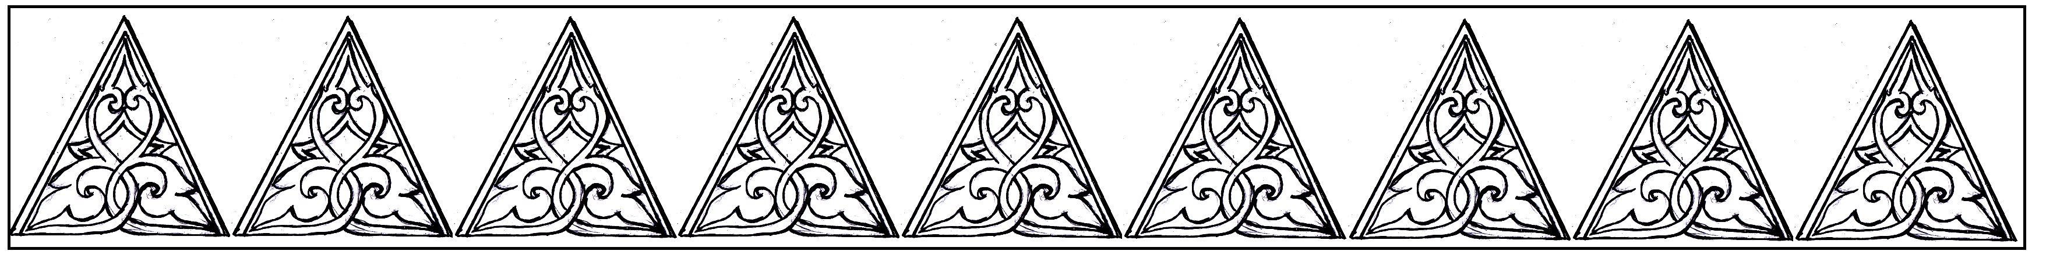
Figure 1. Decoration of bungong aju-aju (triangle cloud)
at the bottom of tomb-stone of Teungku Di Anjong’s grave

On the top side of Tengku Di Anjong’s grave decorated with with flowery pattern seulupo, on his wife’s decorated with betel leaf pattern(daun sireh)
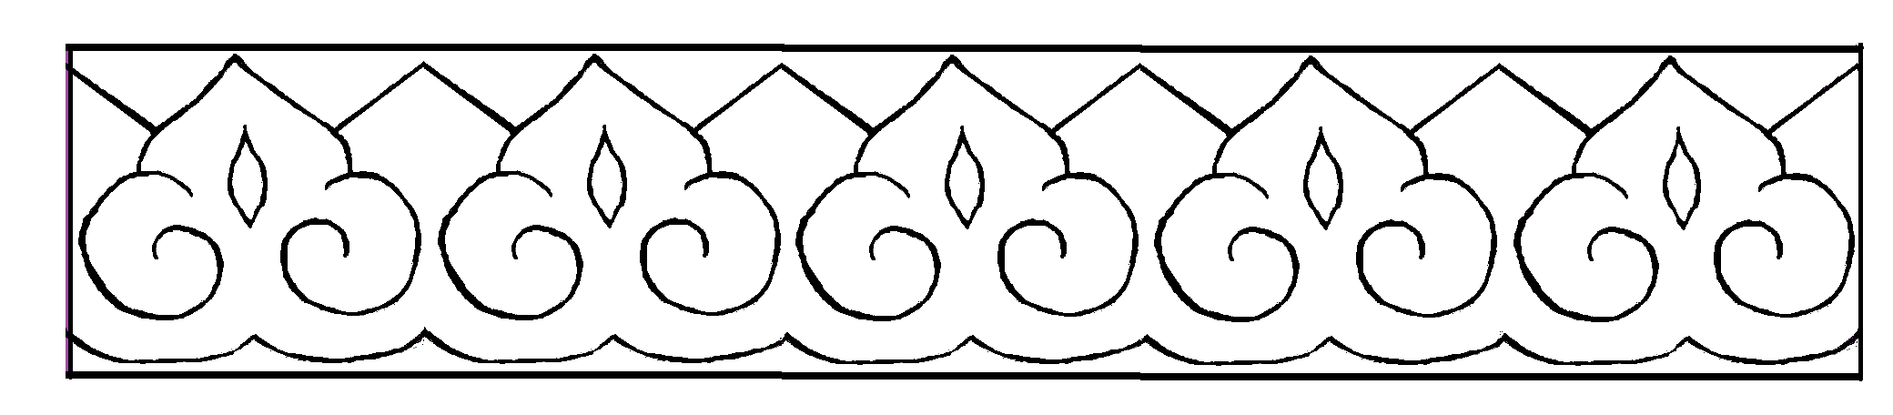
Figure 2. Decoration of daun Sireh on the top sideis
Teungku Di Anjong’s wife’s grave
Whereas on the top surface of Teungku Di Anjong’s grave was decorated with various decorative pattern such as figurative decoration of Arab calligraphy in form of kalimah shahadah La illaha Illa Allah, Muhammadal rasul Allah‘No God but Allah and Muhammad is the messenger of Allah each of which as many as 32 items (16 of which are on the left side and the other 16 item on the right one) on the top tomb-stone placed in the decorative pattern of two twisted ties (putar tali dua). The decoration of the same pattern is also found on the top tomb-stone of Tengku Di Anjong’s wife, however, the figurative decoration Arab calligraphy in form of Bi-sentential testimony ‘shahadatayn is only found as many as 31 items those are 16 items eastward, and15 westward.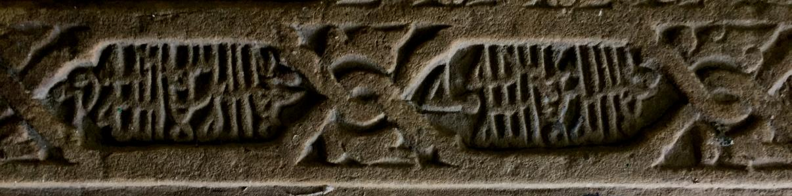
Figure 3. Bi-sentential testimony ‘shahadatayn on Tengku di Anjong’s and his wife’s (Herwandi, Husaini Ibrahim, M Yusdi, 2017)
On the top tomb-stone, on both graves, the decoration in form of flowery pattern awan mucanek,and neck lace of keutab lhe lapeh.
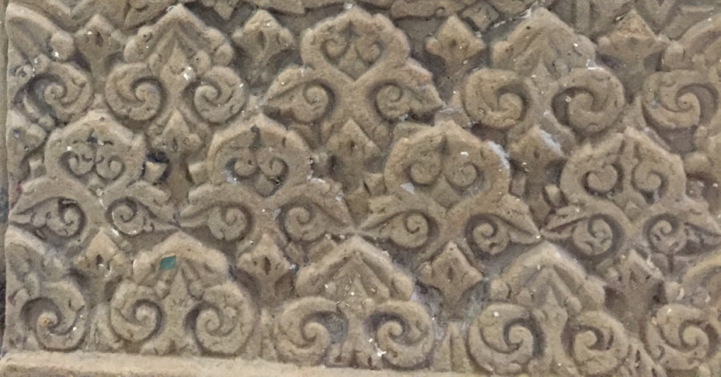
Figure 4. Decorative pattern motif of intermittent cloud (“awan meucanek”) on the grave of Tengku Di Anjong and his wife’s
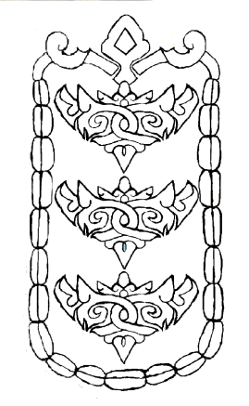
Figure 5. Decoration of necklace pattern of keutab lhee lapehon the top side of
Teungku Di Anjong’s grave
On the middle part of Teungku Di Anjong’s grave there was written in Arab character (tending to have the style of khat naskhi) engraved on the tomb-stone. A part of the character is readable, however, since it is written so closely and begins to gert worn out, major part of it is unreadable. The readable one is related to the name of a figure buried and the date of his death. The readable characters read as follows.
Wa wafat fi tuwfi al-Habib Abu Bakar ibnu Al-Husein…..Ibnu……‘Asyar fi Ramadhan…..
The sentences above obviously explained the death of Habib Abu Bakar Bin Husein later on well known and called Teungku Di Anjong. This paper also has similarity to the one found on the tomb-stone top of Teungku Di Anjong’s grave foot also explaining the figure buried in it.
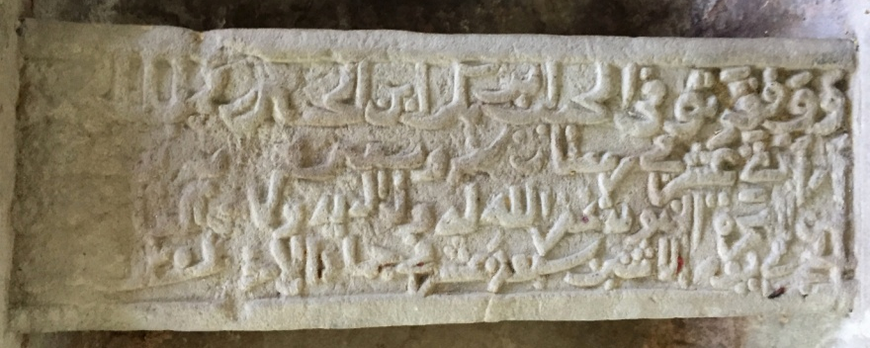
Figure 6. Arab character on the middle part of Teungku Di Anjong’s grave
Tomb-stone grave foot of Teungku Di Anjong is club round like sizing height 104 Cm. The tomb-stone base is square sizing 33 x 33 cm. The tomb-stone foot is decorated in flowery triangular decoration pattern whereas the tomb-stone body is formless, no decoration, however it was done finely. Even though the tomb stone body is formless, on the top part of the tomb-stone there found Arab character written red paint Malay in Arab character whose letter style tended to be naskhi. This writing contained information of time when the figure was buried in this grave died. The characters found were written circularly, starting from the middle, bit by bit to the edge.
In general, the character on the tomb-stone of the grave foot of Teungku Di Anjong could be said is not intact any more, it is already damaged, on the certain part, the character is not readable. Perhaps this is due to being old, let alone it was ever stormed by tsunami on December 26.2004, so that it is appropriate that on the certain part of it is not readable. The readable character on the tomb-stone top of the grave foot of Teungku Di Anjong, among others are as follows.
Tahun hijratan nabi shallahu alaihi wasallam seribu seratus sembilan puluh enam….empat belas hari bulan Ramadhan pada malam Jumat waktu Isya….pada tarik itulah ……

‘The hegira year of prophet Muhammad PBOH one hundred and ninety six ... The fourteenth of Ramadhan on the Thursday night the time Iesha ... It was on that date ...

It seems that this sentence runs together with the one found on the tomb-stone as it also explained the figure buried in it and the date on which he died namely the date on which Teungku Di Anjong passed away.
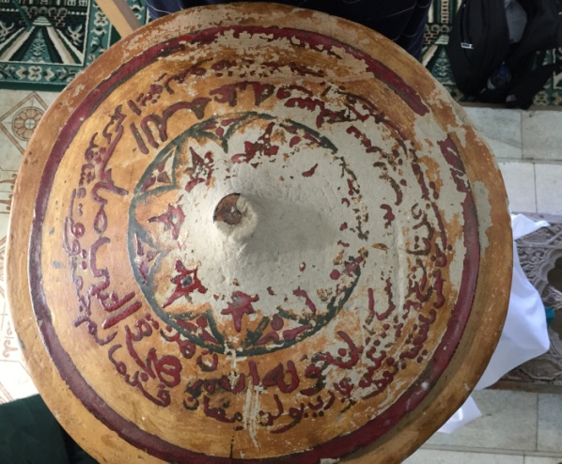
Figure7. Upper part of Tomb-stone the grave foot of Teungku Di Anjong
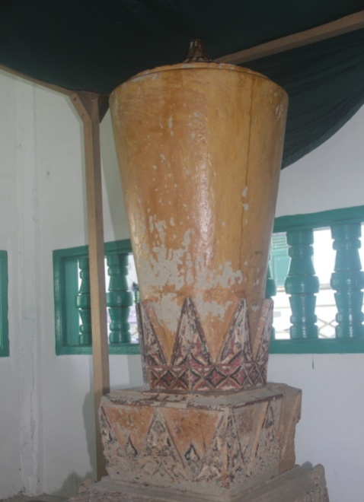
Figure 8. Grave Head Tomb-stone of Teungku Di Anjong
The head tomb-stone also takes the form club-round, sizing height 104 Cm. The tomb-stone base is square sizing 33x33 cm. This tomb-stone also has decorated base in form of flowery triangle. On the top of head tomb-stone there is found an engraved calligraphy in the form of round ordered figurative pattern of sunflower (bunga mata hari). In that solar pattern there is found a calligraphy written in Arab that is the bi sentential testimony, “Lã illaha illã Allah, Muhammad ar-Rasul Allah”, followed by the one“Ya Huw”, so that the sentence is more complete that is “Lã illaha illã Allah, Muhammad ar-Rasul Allah, Ya Huw”. Such a sentence is found as many as 16 items circularly ordered forming the sunflower motif.

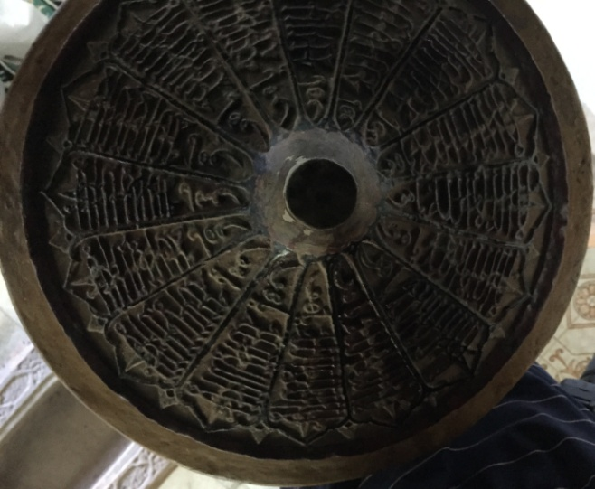
Figure 9. The Grave Head Tomb-stone of Teungku Di Anjong
(there found a sentence: “Lã illaha illã Allah, Muhammad ar-Rasul Allah, ya huw”
as many as 16 items)

Meanwhile, the grave of Fatimah Binti Aidid, the wife of Tengku Di Anjong has two tomb-stones flat-winged form. The tomb-stone foot, the base sizing 21x21 Cm. Tomb-stone height, 100 Cm. The base of head tomb-stone sizing 26x26 cm and the height is 110 cm. These tomb-stones are full of decoration such as bungong awan setangke, kalung keutab lhee lapeh, bunga matahari, bunga melu, etc.

D. The Revitalization of Grave Decoration for Development of Achenese Creative Batik Motif
The grave of Teungku Di Anjong and his wife’s have a very potential decoration to be revitalized, developed as the Achenese batik motif. Some attempts have been done such as to design the batik motifs produced by the revitalization of Tengku di Anjong grave decoration. Say for example, the motif ”kalimah awan berarak”, particularly designed using intermittent clouds found on the grave of Teungku di Anjong. The batik Motif “Kalimah Awan Berarak” has been “patented” as the property rights preserved to the Ministry of Justice and Human Rights Republic of Indonesia in 2017, and fortified under (No. Registration of Property Rights: EC00201704596, October 18.2017).
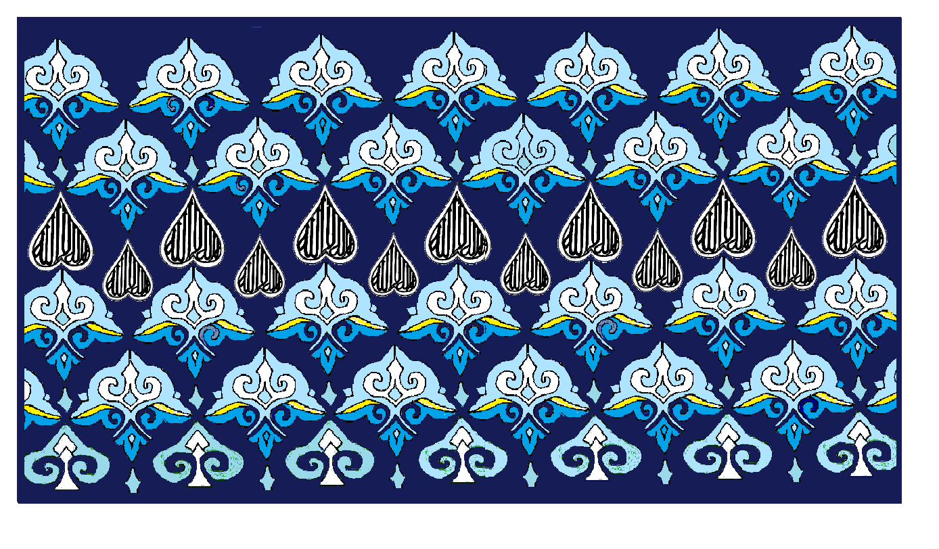
Figure 4. Batik Motif Kalimah Awan Berarak
(Herwandi Design , 2017)

The batik motif Sentence of Intermittent Clouds (Kalimah Awan Berarak) is to represent a very deep philosophy and is very religious. Literally, the naming of this motif is the combination of the words kalimah‘word’ awan ‘clouds’ and the one berarak‘intermittent’. Thus, the word kalimah connotes to bi-sentential testimony (La illaha illa Allah, Muhammadarrasullullah) (la illaha illa Allah;or Allah-Allah, or Huw Allah‘He is the God’). The word awan berarak‘intermittent clouds’, connote to constantly moving clouds decorating the sky, and freely this motif may be meant that the moving clouds is in the remembering of Allah “awan berarak yang berzikir”.

The motif of clouds is not something strange in the Achenese traditional decorative pattern. In the repertoire of the Achenese traditional decorative pattern, this motive is sometimes called clouds ‘awan-awan’. According to Dahlia (2014), the cloud motif is the continuity of Hinduism Java construction and is not separated from one another in its implementation with the mountaining as the completion to the nature of gods. Previously, perhaps the cloud motif was inspired by the real mount condition whose upper part is always covered with the clouds. Then, Dahlia also stated that the cloud is closely associated with water symbolizing fertility (Dahlia; 2014: 63-64).

The basic form of the intermittent clouds is dominated by bending lines forming construction pattern designed in such a way that conform a well ordered flowers close to one another like the intermittent clouds. This motif has a very deep philosophy. In the Achenese cultural repertoire, it is closely related to the Islamic teachings placing the clouds as something having sacred value. The motif of intermittent clouds is likened to the sky atmosphere that is in the view of Sufism it is signified that the power of Allah exceed the width the sky and the mankind is only as the clouds that will disappear and the human knowledge will not equalize the power of Allah (Dalia, 2014: 65).
Other than the motif of Kalimah Awan Berarak, nowadays, the other batik motifs are also already designed namely: 1) Batik Tengku di Anjong, 2) Batik Lhe Laphe all of which are developed from the decorations found on the grave of Tengku Di Anjong and his wife’s and the registration of the intellectual property rights is now in the process of issuance.
Under the same spirit, by revitalizing the Achenese grave decoration, a number of new batik motifs are also already designed and registered as well to The Ministry of Justice and Human Rights of Republic of Indonesia. The motifs are among others:
- Glass Framed Sentence (Kalimah Bingkai Kaca) Motif

This motif is the combination of the Achenese flower and framed up with the glass frame and sentence saying laillaha illa Allah, as the following figure below.

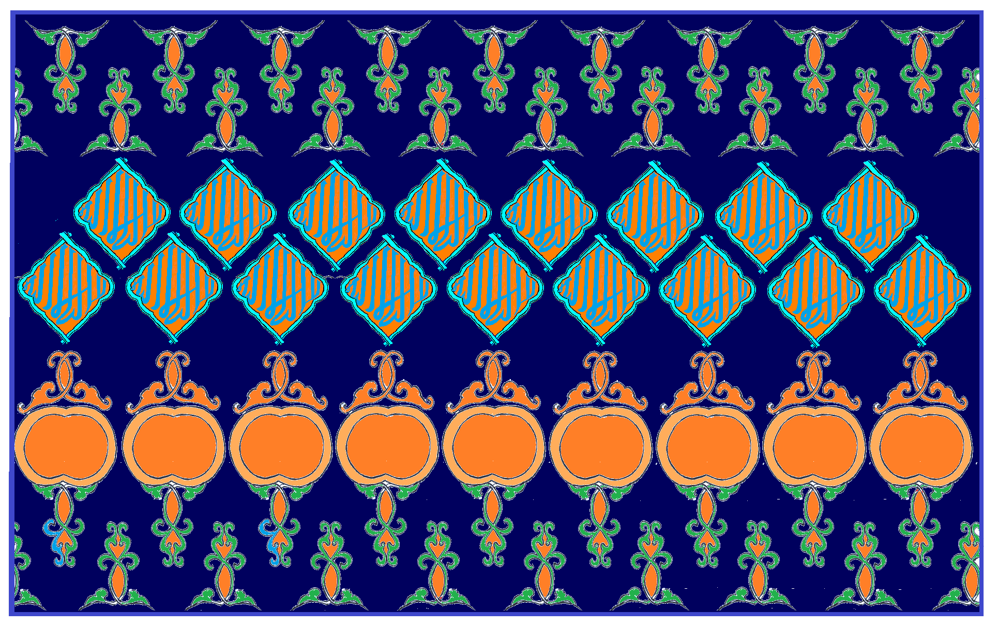
Figure1. Batik Motif of Glass Frame Kalimah
(Herwandi’s Design, 2017)
- Motif of Bungong Shahadah Flower

The batik motif of shahadah flower is also the combination of decorative motifs on the Achenese ancient grave that is the combination bungong awan setangke pattern and young bamboo sprout (pucok rebung) and bi-sentential testimony (La illaha Illa Allah, Muhammad ar-Rasul Allah), as the figure below.
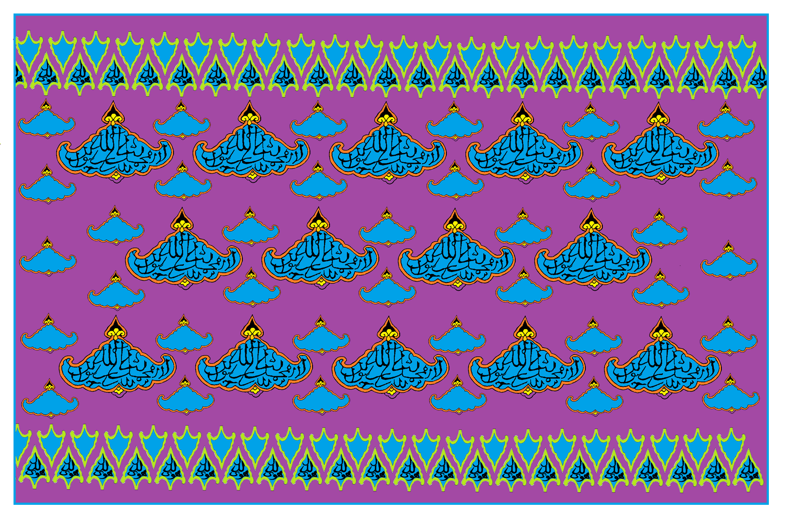
Figure 2. Batik Motif Flower of Syahadah
(Herwandi’s Design, 2017)

- The Motif of The Sentence of Achehnese Flower (Kalimah Bungong Aceh)

This motif is the combination of the Achenese flowers and the sentence of laillaha illa Allah, as the figure below.
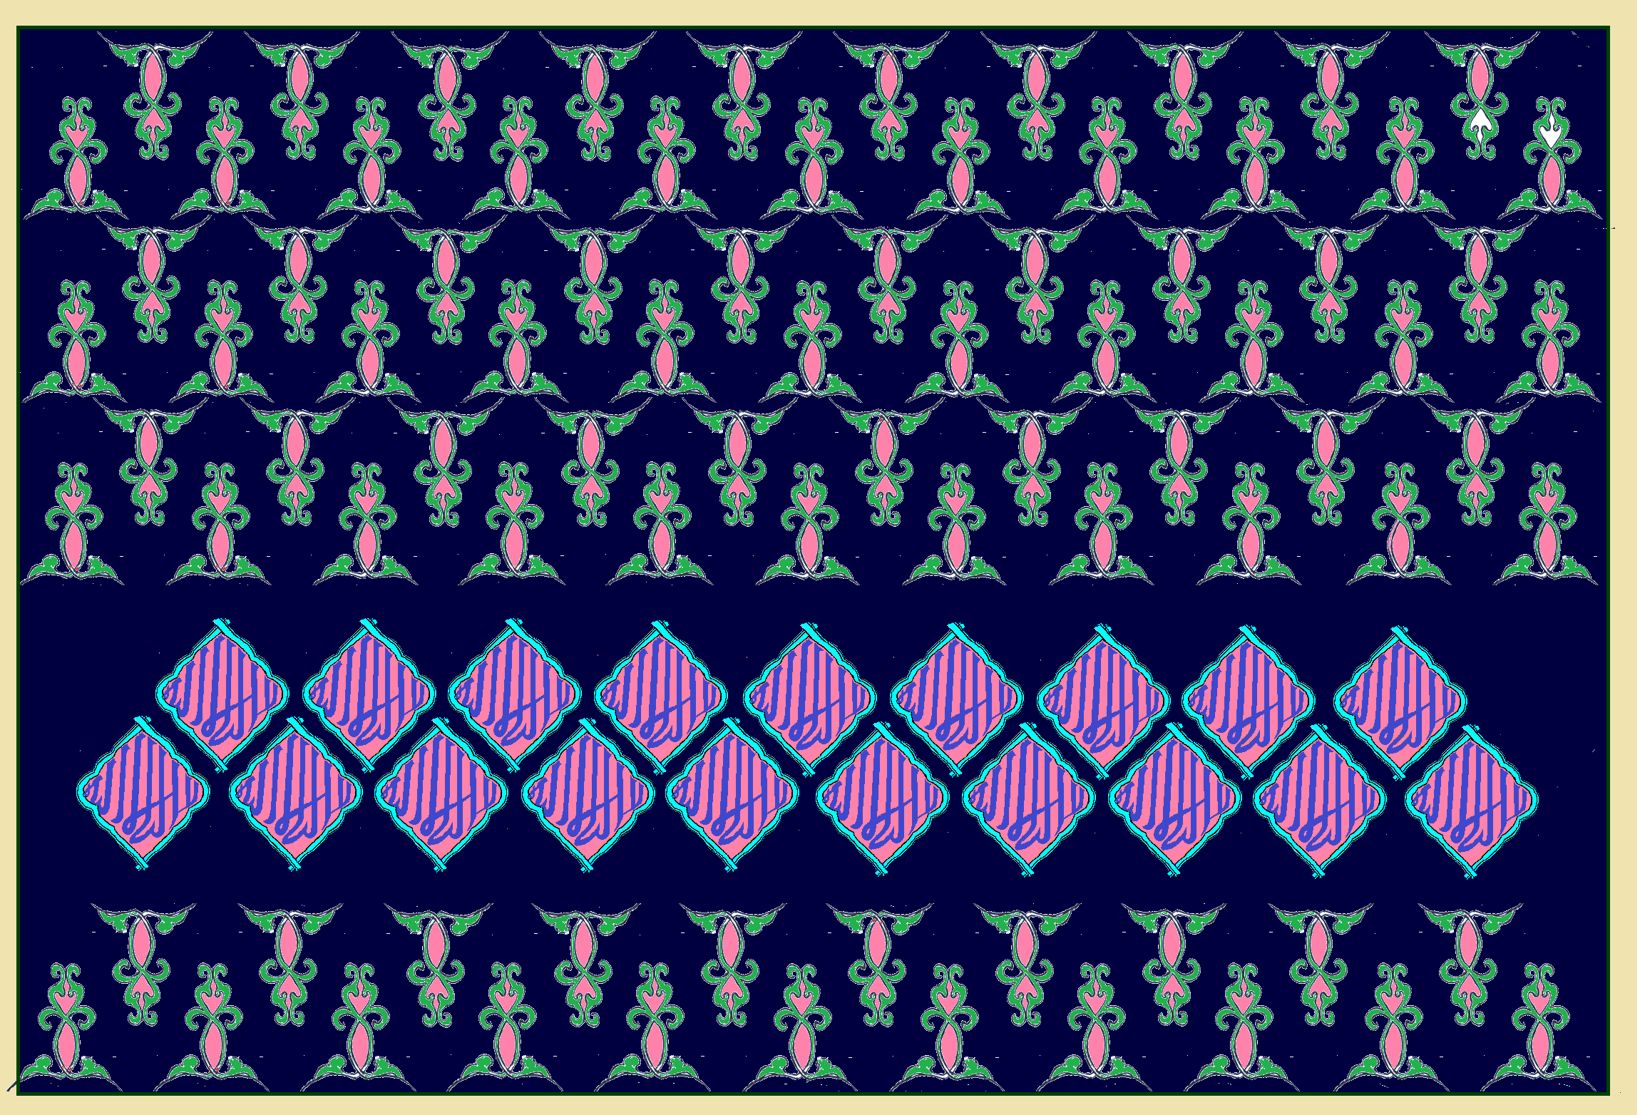
Figure 3 Batik Motif of Kalimah Bungong Aceh
(Herwandi’s Design, 2017)
Such batik motifs are also already registered to the Property Rights (Hak Cipta-HaKI) The Minister of Justice and Human Rights of Republic of Indonesia, and has already acquired the Letter of Property Rights Registration from the Minister of Justice and Human Right of the RI. Each of the Letter of Property Rights Registration can be seen below.
- Registration Letter of Property Rights Art of Batik Motif ”Kalimah Bingkai Kaca (Registration No. Property Rights, EC00201704603, 18 October 2017);
- Registration Letter of Property Rights Art of Batik Motif ”Bungong Syahadah” (Registration No. Property Rights: EC00201704602, 18 October 2017);
- Registration Letter of Property Rights Art of Batik Motif ”Kalimah Bungong Aceh” (Registration No. Property Rights: EC00201704600, 18 October 2017);

E. Closing
The Achenese area can be said that it has a lot of artistic artifacts. Those could be a quite valuable inheritance and become the historical witnesses and evidences preserving invaluable historical and artistic data. Thousands artistic artifacts in form of tom-stones called the Achenese Stone spreading out not only surrounding Aceh but also at the some places in the Archipelago.
The grave of Teungku Di Anjong is also historical evidence and at the same time is the source of history. This grave has decorated jirat and tomb-stone and is an artistic artifact having hidden cultural values and artistic value of high philosophy. The decoration on this grave proves that it has a great potency to develop so that it becomes the source of inspiration in promoting the spirit of creative industry in Acheh. The decorations on the Teungku Di Anjong’s grave could be revitalized in to new motifs, mainly, in producing the new batik motifs in Acheh. Then, the decorations found on the other tomb-stones could also be revitalized to support both the art and creative industry in Aceh at the moment and the coming future.

Publications Consulted

Hurgronje, Snough (1906). Achehnese. Leyden: E.J. Brill.
Herwandi, (2002) ”Kaligrafi Islam Pada makam-Makam di Aceh Darussalam: Telaah Sejarah Seni (Abad ke-16 – 18 M)” Dissertation Doctor at Program Arkeologi Pascasarjana Univ. Indonesia.
Herwandi, (2003) Bungong Kulimah: Kaligrafi Islam dalam Balutan Tasawuf Aceh. Padang: Unand Press.
Herwandi, Husaini Ibrahim, M. Yusdi (2017).“Karakter Lokal Pada Artefak Seni Makam Berhias di Nanggroe Aceh Darussalam (Abad 13-18 M)”,Paper presented at Internasional Seminar Penguatan Kebudayaan Lokal held by Ikatan Dosen Budaya Daerah Indonesia (IKADBUDI), Unhas, Makasar, 17 – 19 Sepetember 2017.

Ibrahim, Husaini (2006), Peninggalan Sjarah dan Kesadaran Sejarah Di Aceh: Suatu Tantangan Masa Depan”, paper presented at Konferensi Nasional Sejarah VIII , 13-16 November 2006 at Jakarta.
Nurdin (2017). “Sejarah Mesjid Teungku Di Anjong dan Cikal Bakal Julukan Serambi Mekkah” dalam http://portalsatu.com/read/travel/-28592
Yatim, Othman Mohd. (1986) Batu Aceh Early Islamic Gravestones in Peninsular Malaysia. Kuala Lumpur: United Selangor Press. Sdn. Bhd.
Dahlia (2014). “Makna Ornamen Secara Hermenutik Pada Makam Kandang XII”, in ARABESK: Seri Informasi Kepubakalaan No. 2 Edisi XIV (Juli-Desember). Banda Aceh: Balai Pelestarian Cagar Budaya (BPCB) Banda Aceh.. 54-69
Dewi, Cut (2015). “Iconic Architectural Heritage in Banda Aceh: Remembering and Conservation in Post-­‐Disaster Contexts”. A Thesis Submitted For The Degree of Doctor of Philosophy at The Australian National University.
O'Neill, H. (1994). “South-East Asia”. In M. Frishman & H.-U. Khan (Eds.), The Mosque: History, Architectural Development, and Regional Diversity. London, UK: Thames and Hudson.

Mardira, Salaman (2017). “Riwayat Masjid Teungku di Anjong dan Asal Mula Aceh Berjuluk Serambi Makkah” https://news.okezone.com/read/ 2017/05/31/340/ 1704080

This paper is the result of the "Social, Humanities and Education" scheme of The Ministry of Research and Technology-Higher Education of the Republic of Indonesia 2018. (Assignment contract. No. 050/SP2H/LT/DRPM/2018).

