EFFECTIVENESS OF PHYSICS LEARNING USING PROBLEM BASED LEARNING ASSISTED BY PhET VIRTUAL LABORATORY
NOFRINA MAULANI^{1)*} SUHARTO LINUWIH²⁾ SULHADI³⁾
UNNES Postgraduate Campus, North Kelud III Semarang, 50237
nofrinamaulani@students.unnes.ac.id
08993992737
Abstract
This research is motivated by the lack of digital literacy and the complexity of students in the process of teaching and learning activities. In the learning process during PPKM (Enforcement of Community Activity Restrictions) students do online learning at home, often students who are not active are found. In this case, the teacher's role changes from the main role of providing information to being a facilitator in thinking, reflecting and collaborating findings. The use of PhET virtual laboratory media can help improve technological literacy. The purpose of this study was to analyze the effectiveness of the Problem Based Leaning model assisted by the PhET virtual laboratory on student learning outcomes. PhET simulation is an interactive animation that is accessed online and offline using Java and Flash software. The method used is quantitative research with a one-shot case study design. Class X MIPA 7 was used as the experimental class and class X MIPA 8 was used as the control class. The effectiveness of the Problem Based Leaning model assisted by the PhET virtual laboratory in the experimental class obtained a classical completeness score of 83%, while the control class was far below the classical completeness value of 55%.
Keywords: Effectiveness, PhET, Problem Based Learning

Introduction
Physics is a branch of science which is a discipline that studies important concepts. The concept really needs to be understood by students in order to be able to solve problems (Elisa et al., 2017). Physics problem solving emphasizes understanding concepts which are very important to build students' thinking processes (Kusumawati et al., 2016). Problem solving ability is a 21st century skill that must be prepared by students for the future (Baran, 2016). In dealing with its role in the future, problem solving skills are part of thinking skills that must be developed (Fathiah et al., 2015).
This is in accordance with the Partnership for 21st Century Skill Event research in 2015 which revealed that problem-solving skills are one of the skills needed by students to compete in the industrial revolution 4.0 which is marked by the emergence of new literacy, namely data literacy, technological literacy, and human literacy. Curriculum applies scientific method-based learning with indicators of problem-solving abilities. According to Piaget's theory, human thinking abilities develop with age. The level of thinking ability of these students affects the problem solving process (Rosa, 2017; Destiana, 2019; Wiyono et al., 2019).
One of the problem-solving strategies is to involve students to communicate openly about their ideas about phenomena or problems in everyday life (Octor et al, 2015; Sucipto, 2017). This is supported by assessment in international studies such as Thrends International Mathematics Science Study (TIMSS) which are international studies to identify and measure mathematics and science achievement in students. Based on the results of TIMMS 2018 for science, the average score of Indonesian students reached 389 with an OECD (Organization for Economic Co-operation and Development) average score of 489. This means that Indonesian students scores are still far below average of OECD (TIMSS, 2018). In order to improve the problem-solving ability, a learning model with a scientific approach is needed, namely Problem Based Learning (PBL).
PBL is one of the learning models with a scientific approach recommended by the 2013 curriculum (Permendikbud No.105, 2014). PBL can effectively develop relevant skills such as communication, collaboration, interdisciplinary, innovation, independence and responsibility (Du et al., 2013). PBL is learning the teacher checks prerequisite knowledge, provides numeracy skills, and provides open-ended questions so that students have good problem solving skills (Hartanto et al., 2019). PBL use activities and scientific thinking processes to be logical, orderly, and thorough which has an impact on student problem solving. The results of research by (Argaw et al., 2017) and Rusydi (2017) show that PBL can improve student learning achievement. PBL is a learning model that presents contextual problems so as to stimulate students to learn. In this case the role of the teacher changes from the main role of providing information to being a facilitator in thinking, reflect and collaborate on findings. Problem solving is done by collecting and analyzing information in order to find solutions (Indhira et al., 2019). The Problem Based Leaning learning model according to Permendikbud (2017) provides opportunities for students to find solutions by processing information, so that students can gain new knowledge they have acquired to solve appropriate problems. According to the Ministry of Education and Culture (Kemendikbud, 2017) the stages of learning the PBL model that will be applied in this study there are: (1) Orienting students to the problem is to focus students on observing the problem that is the object of learning. (2) Organizing learning activities is one of the activities where students ask questions about the problems being studied. (3) Guiding independent and group investigations at this stage students collect information / conduct experiments to obtain data in order to answer or solve the problem under study. (4) Develop and present the students associate data found from experiments with various other data from various sources. (5) Analysis and evaluation of the problem solving process to get answers to existing problems, then they are analyzed and evaluated.

Method
The type of research used in this research is a combination research (mix method) which emphasizes the collection of quantitative and qualitative data with explanatory sequential type. According to Creswell (2017) grouping four types of research designs commonly used in the pre-experimental design method, namely one-shot case study, one-group pretest-posttest design, post-test only with nonequivalent group and alternative treatment post-test only with nonequivalent group designs. This study uses a one group pretest-posttest design. Interviews were conducted twice, namely before learning and after using the PhET virtual laboratory.
Results and Discussion
The normality test is a test to find out whether the empirical data obtained from the field is in accordance with a certain theoretical distribution.

Table 1. Tests of Normality
 | Kolmogorov-Smirnova |  |  | Shapiro-Wilk
 | Statistics | df | Sig. | Statistics | df | Sig.
A7 | 0.083 | 30 | 0.200 | 0.969 | 30 | 0.525
A8 | 0.158 | 30 | 0.054 | 0.917 | 30 | 0.022

The results of the Test of Normality in Table 1. output in the Kolmogorov-Smirnov column obtained a sig value of 0.200 in the experimental class and 0.054 in the control class. The data obtained sig value> 5%, then accept H₀ accepted, which means that the experimental class and the control class are normally distributed.
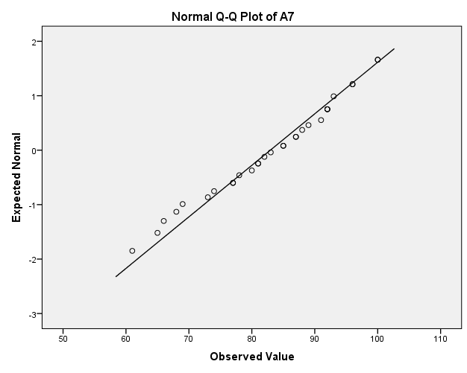
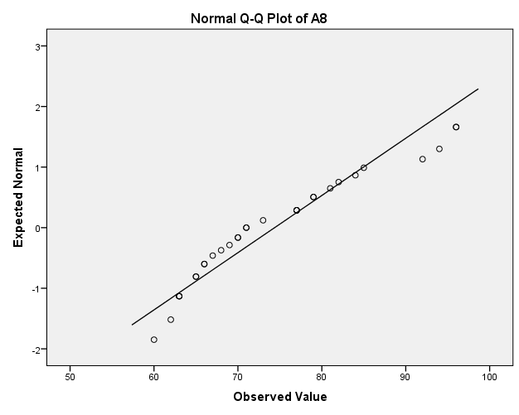

Figure 1. Normally plot

According to figure 1. the results of the normal plot shown by the two images are normally distributed because the normal line is close to the test results points in the two classes.

Homogeneity test is a test of whether or not the variances of two or more distributions are equal. Homogeneity of variance test is very necessary before comparing two or more groups, so that the differences are not caused by differences in the basic data (inhomogeneity of the compared groups.

Table 2. Test of Homogeneity of Variances
Levene Statistics | df1 | df2 | Sig.
0.027 | 1 | 76 | 0.871

Based on the output of Test of Homogeneity of Variances in Table.2, sig value is 0.871 > 0.05, meaning H₀ is accepted because the variance is homogeneous.

Sample test is used to test the average value of a sample. In the one-sample T-test there are assumptions that must be met before entering the analysis, namely the sample data is normally distributed.

Table 3. One Sample T-Test
 | Test Value = 70
 | t | df | Sig. (2-tailed) | Mean Difference | 95% Confidence Interval of the Difference
 |  |  |  |  | Lower | Upper
A7 | 6.704 | 29 | 0.000 | 12.933 | 8.99 | 16.88
A8 | 2.283 | 32 | 0.029 | 4030 | 0.43 | 7.63

From the output in Table 3 obtained sig value of 0.000 and 0.029 <0.05 then H₀ is accepted so that the learning average is not better than 70.

Binomial test is used to test the hypothesis if the population consists of two class groups, the data is on a nominal scale, and the sample is small. The probability parameter for both groups or called classical completeness is 75%. The proportion of observations is determined by the number of cases of a dichotomous variable or the number of cases limited by a cut point of 70 in accordance with the Minimum Completeness Criteria set by the school.
Table 4. Binomial Test
 |  |  |  | Category |  |  | N |  |  | Observed Prop. |  |  | Test Prop. |  |  | Exact Sig. (1-tailed)
A7 | Group 1 |  | <= 70 |  |  | 5 |  |  | 0.17 |  |  | 0.75 |  |  | 0.000a
 | Group 2 |  | > 70 |  |  | 25 |  |  | 0.83
 | Total |  |  |  |  | 30 |  |  | 1.00
A8 | Group 1 |  | <= 70 |  |  | 15 |  |  | 0.45 |  |  | 0.75 |  |  | 0.000a
 | Group 2 |  | > 70 |  |  | 18 |  |  | 0.55
 | Total |  |  |  |  | 33 |  |  | 1.00
In the experimental class, it was found that as 25 students or 83% of students exceeded the cut score and exceeded the classical completeness score of 75%. In the control class, it was found that as 18 students or 55% of students exceeded the cut point score, and did not exceed the classical completeness score of 75%.
Table 5. Group Statistics
 | CLASS | N |  |  | Mean |  |  | Std. Deviation |  |  | Std. Error Mean
DATA | 1 | 45 |  |  | 83.11 |  |  | 9.895 |  |  | 1.475
 | 2 | 33 |  |  | 74.03 |  |  | 10.141 |  |  | 1.765

Comparative test of two samples between the two samples are independent. This means that the two samples do not have the same number of sample members. In order to be able to distinguish whether the experimental results of the new method are better than the previous method (conventional method), then another equal group is taken and subjected to the conventional learning.
 | Table 6. Independent Samples Test
 |  |  |  |  | Levene's Test for Equality of Variances |  |  | t-test for Equality of Means
 |  |  |  |  | F |  | Sig. | T |  | df | Sig. (2-tailed) |  | Mean Difference | Std. Error Difference |  | 95% Confidence Interval of the Difference
 |  |  |  |  |  |  |  |  |  |  |  |  |  |  |  | Lower | Upper
 | DATA | Equal variances assumed |  |  | 0.027 |  | 0.871 | 3.962 |  | 76 | 0.000 |  | 9.081 | 2.292 |  | 4.516 | 13.645
 |  | Equal variances not assumed |  |  |  |  |  | 3.947 |  | 68.13 | 0.000 |  | 9.081 | 2.301 |  | 4.490 | 13.671
According Table 7. Independent Sample Test obtained a sig value of 0.871 > 0.05, then H₀ is accepted. This means that both groups have the same variance (homogeneous). While the test criteria obtained sig value 0.000 <0.05, which means H₀ is rejected.

Table 8. One-Sample Test
 |  |  | Test Value = 70
 |  |  | T | df |  | Sig. (2-tailed) |  |  | Mean Difference |  |  | 95% Confidence Interval of the Difference
 |  |  |  |  |  |  |  |  |  |  |  | Lower |  |  | Upper
A7 |  |  | 6.704 | 29 |  | 0.000 |  |  | 12.933 |  |  | 8.99 |  |  | 16.88

According Table 8. One Sample Test a sig value of 0.000 < 0.05, then H₀ is accepted. So the average learning outcomes of the experimental group are not the same as the average learning outcomes of the control group. From research and interviews that have been carried out by researchers, the effectiveness of PBL using PhET virtual laboratory include: students can do practical work virtually from home, encourage students to have problem solving skills, students will get used to applying experimental methods because there is a possibility of a problem that must be solved by students through experiments, scientific activities occur even though students study from home, phet is very helpful in learning. The weakness of students in solving physical problems is a common phenomenon. Teacher checks prerequisite knowledge, provides numeracy skills, and provides open-ended questions so that students have good problem solving skills. Because a person is considered to have become a good problem solver when he is able to overcome a problem without causing another problem (Ince, 2018).
The results showed that the most important difficulties faced by students in solving problems were due to a lack of understanding to analyze problems, identify words, and not use strategic steps that were definitely not well organized and resulted in failure to reach solutions. The final result of the one sample test is shown in Table 8. sig (2-tailed) 0.000 which shows that the research conducted in class XA7 showed that physics learning using problem based learning assisted by PhET virtual laboratory to improve student learning outcomes.

Conclusion
The learning outcomes of the experimental class using Problem Based Learning assisted by PhET virtual laboratory are more effective than the control class that does not use Problem Based Learning assisted by PhET virtual laboratory.

Reference
Argaw, A. S., Haile, B. B., Ayalew, B. T., & Kuma, S. G. (2017). The Effect Of Problem Based Learning (PBL) Instruction On Students Motivation And Problem Solving Skills Of Physics. Eurasia Journal Of Mathematics, Science And Technology Education, 13(3), 857-871.
Baran, M. (2016).An Analysis On High School Students’ Perceptions Of Physics Courses In Terms Of Gender (A Sample From Turkey). Journal Of Educational And Training Studies, 4(3), 150-160.
Creswell, J. W. (2017). Research Design: Pendekatan Kualitatif, Kuantitatif, dan Campuran. Yogyakarta: Pustaka Pelajar
Destiana. (2019). Pengaruh Teknologi Informasi Berbasis Android (Smartphone) Dalam Pendidikan Industri 4.0. Prosiding Seminar Nasional Program Pascasarjana PGRI Palembang, 190-197.
Du, X., Su, K., & Liu, J. (2013). Developing Sustainability Curricula Using The PBL Method In A Chinese Context. Journal Of Cleaner Production, 6(1), 80-88.
Elisa, M. A., & Ariaji, R. (2017). Peningkatan Pemahaman Konsep Fisika dan Aktivitas Mahasiswa Melalui PhET Simulation. Peteka (Jurnal Penelitian Tindakan Kelas Dan Pengembangan Pembelajaran), 1(1), 15-20.
Fathiah, Kaniawati, I. & Utari, S. (2015). Analisis Didaktik Pembelajaran Yang Dapat Meningkatkan Korelasi Antara Pemahaman Konsep Dan Kemampuan Pemecahan Masalah Siswa SMA Pada Materi Fluida Dinamis. Jurnal Penelitian & Pengembangan Pendidikan Fisika, 1(1):111-118.
Hartanto, F. D., & Mariani, Sc. (2019). "An Analysis of Mathematical Problem Solving Ability in Terms of Student's Cognitive Style in Learning PBL Includes Ethnomatematics". Unnes Journal of Mathematics Education Research, 8(1): 65-71
Ince, E. (2018). An Overview of Problem Solving Studies in Physics Education. Journal of Education and Learning, 7(4), 191-200.
Indhira, A. V. Y., Alamsyah, T. P., & Halimatusa'diah D. (2019). "Penerapan Strategi Pembelajaran Problem Based Learning untuk Meningkatkan Kemampuan Pemecahan Masalah Matematis Siswa Kelas IV SD". Jurnal Matematika Kreatif-Inovatif. 10(2): 146-152.
Kusumawati, A. D., & Sumardi, Y. (2016). Peranan Perangkat Pembelajaran Fisika Berbasis Elaboration Learning Untuk Siswa SMA. Unnes Physics Education Journal, 5(2), 42-53.
Rosa, F. O. (2017). Eksplorasi Kemampuan Kognitif Siswa Terhadap Kemampuan Memprediksi, Mengobservasi Dan Menjelaskan Ditinjau Dari Gender. Jurnal Pendidikan Fisika, 5(2):111-118.
Octor, J. L., Strand, N.E., Mestre, J. P. & Ross, B. H. (2015). Conceptual Problem Solving In High School Physics. Physical Review Special Topics- Physics Education Research, 11(2), 1-13.
Peraturan Menteri Pendidikan dan Kebudayaan Republik Indonesia Nomor 105 Tahun 2014 tentang Pendampingan Pelaksanaan Kurikulum 2013 pada Pendidikan Dasar dan Pendidikan Menengah. (2014). Jakarta: Kemendikbud.
Rusydi, R. (2017). Pembelajaran Berbasis Masalah (PBM) Pada Materi Termodinamika Untuk Meningkatkan Kemampuan Kognitif Dan Kemampuan Kreatif (Kreativitas) Mahasiswa FTK UIN Ar-Raniry Banda Aceh. Jurnal IPA & Pembelajaran IPA, 1(2), 192-202.
Sucipto, S. (2017). Pengembangan Ketrampilan Berpikir Tingkat Tinggi Dengan Menggunakan Strategi Metakognitive Model Pembelajaran Problem Based Learning. Jurnal Pendidikan (Teori Dna Praktik), 2(1), 63-71.
TIMSS. (2018). “Highlights from TIMSS and TIMSS Advanced 2018”. Washington. Institute of Education Sciences.
Wiyono, K., & Zakiyah, S. (2019). Pendidikan Fisika Pada Era Revolusi Industri 4.0 di Indonesia. Seminar Nasional Pendidikan Prodi Fisika FKIP ULM, 1-13.

