Model Development Of Industrial Dressmaking

In Fashion Techonogy Vocational School

Nadya Karlina¹ ᵃ⁾, Uswatun Hasanah² ᵇ⁾, Shinta Doriza³ ᶜ⁾
Universitas Negeri Jakarta¹,²,³
nadyazie@gmail.comᵃ⁾, uswatun-hasanah@unj.ac.id ᵇ⁾, shintadoriza@unj.ac.id ᶜ⁾

Abstract: The purpose of the research is to develop a project-based independent learning model in Vocational School of Fashion. The research and development method uses 10 steps from Borg and Gall. The results of the development Project Based Independent Learning (PBIL) models are accompanied by PBIL learning manuals for educators. The steps of implementing the PBIL model, namely determining the fundamental questions, compiling project planning, preparing a schedule, monitoring students and project progress, analyzing project results and evaluating experience. Learning activities consist of face-to-face, independent learning by Android-based learning media and monitoring by social media. Effectiveness test results indicate , learning by PBIL models, students easier to learn lessons (97%); students helped in solving problems (91%); increase students’ courage to share opinions (85%); support students to work in a team(94%); motivate students to reach achievement (97%); students able to solve post test questions easier than before (97%); motivating students to complete tasks (97%); learning by PBIL model, students is closer to their teacher (97%).

Keywords:learning models, independent learning, industrial dressmaking

INTRODUCTION

The regulation of the Minister Education and Culture of the Republic of Indonesia Number 34 of 2018 concerning National Standards of Vocational High School / Madrasah Aliyah Vocational Education that one of the National Standards of Vocational Education / MAK is the standard of the learning process. SMK / MAK learning process standards, learning process standard is the minimum criteria regarding learning planning, learning implementation, learning assessment, and learning supervision in vocational secondary education units to achieve graduate competence (Kemdikbud, 2018). The article "Concepts of Learning and Learning" explained, learning is interpreted as the interaction between students and educators and also learning resources in a learning environment (Hanafy, 2014). Thus, the effectiveness of a learning is determined by the interaction between the three components. The learning process can be carried out if there is continuity between planning, implementation, assessment and supervision continously.
Based on government regulation No. 19/2005 about National Education Standards, that Vocational Secondary Education is education at the secondary education level which is prioritized to develop students' abilities for certain types of work. Thus the need for continuity between projects produced by industry and those produced by schools. As mentioned by Nurjannah (2018), "the SMK curriculum must be able to anticipate the needs of the workforce, so that graduates have the ability to fulfill the needs of the industry". Through appropriate stimulation to students in the learning process, it is expected to improve the results of practical learning in vocational schools, so that in their implementation students also understand the urgency of the skills demanded by the industry.
The organization of learning theory and practice also leads to specific, functional knowledge, development of reproductive skills, physically skilled in preparation for work (Sudira, 2013). Overall competence in the curriculum becomes the main target and must be mastered by students during the learning time at the Vocational School (PSMK, 2008). Thus the limitations of practical learning facilities in schools need to be overcome by utilizing the World of Work facilities that are school partners. Educators are required to be able to get around the implementation of learning in order to continue to achieve the target. Basic competencies that cannot be learned when students implement Internship are still attempted even though there is no learning process in the classroom.
The whole learning process will be a learning model. Based on research "Development of Teaching-Learning Model with Project-Based Learning Using Smart Learning Contents Authoring Tool" conducted in 2015, it was concluded that in general the development of project-based learning models on the implementation of learning by smart devices can provide more satisfaction to students (Bae & Lee, 2015). The activity is carried out by teachers and students with all the facilities used in the learning process both directly and indirectly.
The application of curriculum in vocational high schools uses the 2013 curriculum. The use of the 2013 curriculum is expected to produce graduates who are productive, creative, innovative and effective according to the strengthening of integrated attitudes, skills and knowledge. The research "Implementation Of Project Based Learning Model In Mechanical Machining Skills Package Of Vocational High School" conducted in 2016 generally concluded that one of the most appropriate learning models for vocational schools based on the 2013 curriculum learning standard process was the use of project-based learning models (Sudjimat, 2016). However, it remains one weakness that lies in the project used, because it is generated by an analysis of the basic competencies of the subjects only.
The obstacles in conveying learning by teachers to students, and the lack of opportunities for students to practice accompanied by the teacher is the urgency of the need for new innovations in education. Innovations are needed not only in learning resources, but also the whole learning process, namely the learning model. According to Joice & Weil in Isjoni (2013) the learning model is a pattern or plan that has been planned in such a way and is used to arrange the curriculum, arrange subject matter, and give instructions to the instructors in their class. Istarani (2011) said that the learning model is a whole series of presentation of teaching material covering all aspects before, being and after learning by the Educator and all related facilities that are used in the learning process direct or indirectly.
One of the learning models in the 2013 Curriculum is Project Based Learning. Project Based Learning (PBL) is a methods of learning that leads to the training process based on real problems that are carried out by themselves through certain activities (projects). The emphasis of real problems are carried out in a project activity as a learning process is the most important thing (Moerdiyanto, 2012). PBL emphasizes project-based learning, experiential-based learning, and authentic learning that is based on real-life problems.
This research develops a product of learning model in flow charts form on the competence of industrial fashion expertise. The learning model is a development of the PBL which is developed based on the needs of students in the Industrial Clothing expertise competency at the Fashion Management Vocational School. The development of this learning model is needed by Educators and students as an effort to improve student learning outcomes.
The learning model developed is Project-Based Independent Learning (PBIL). The development project-based learning into Project-based independent learning is tested on learning industrial fashion with the material to create men's shirts, which is carried out simultaneously with the implementation of Internship. So the theory of constructivism becomes thicker. Students will develop the ability to learn independently because learning is not fully implemented in the classroom.
This development research procedure basically has two main objectives. The first objective is to develop project-based learning model products for SMK. Whereas the second objective is to test the feasibility of the product through actual field trials. This model of study is completed with a learning resources that can access information that is needed while in the process of learning (Doriza & Sunawar, 2015). The study material from this research is a study guidebook for teachers, the media used is android and textbook.
The PBL approach is a learning approach (Nurohman, 2015) that has syntax: (1) Starts with the Essential Question, (2) Design a Plan for the Project, (3) Creates a Schedule, (4) Monitor the Students and the Progress of the Project, (5 ) Assess the Outcome, (6) Evaluate the Experiences.
METHOD
This research method uses 10 steps based on Research and Development (R & D) from Borg & Gall (2003) the stages as following: (1) preliminary research; (2) product development planning; (3) creation of initial products; (4) initial field testing; (5) initial product revision;(6) main field testing; (7) revision of operational products; (8) operational field testing; (9) revision of the final product; and (10) dissemination and distribution.
The object of this research were 57 students of SMK Negeri 4 Kab. Tangerang together with 2 supporting teachers, the subject is Making Industrial Clothing. The trial was conducted on 11th grade students, namely Clothing Class A for the small group test and Clothing Class B class for the large group test.
Data collection is carried out to collect field data, trial data, and trial result data. Data collection techniques carried out by observation, literature review, learning outcomes and questionnaire techniques. The variables in this study are PBIL models that get validation from learning experts and users, learning media that get validation from media experts and teaching materials as well as content compatibility that gets validation from material experts and users.
Data collected, (1) material decisions from selected subjects to be tested with the learning model developed; (2) design decisions for developing learning models; (3) the results of product assessment conducted by 3 experts (learning experts, media experts and material experts) to conduct product assessments from the learning aspects, media and materials; (4) the results of the product evaluation are carried out to determine the product's suitability based on aspects of learning, media and material; and (5) test the effectiveness of the learning model.
Learning tools are validated by experts and practitioners. Practicality is determined by the response of students and teachers. The effectiveness of the product was tested, students' perceptions of the learning model with a user questionnaire percentage. Analysis of pre-test and post-test data with paired T test. Data analysis was also tested for normality and homogeneity as a prerequisite of paired T test for students' knowledge ability. Mastery test is used to analyze the mastery of students' knowledge ability by SPSS.
RESULTS AND DISCUSSION
Based on the analysis of curriculum needs, it is known that the goal of learning ccouldn’t be reach well. Results of analysis show the student at SMK N 4 Kab. Tangerang, only 9% of students can name the work order for making shirts according to design well. Furthermore, only 9% of students can analyze the procedure of making shirts well, the quality of the results of shirt products completed by students after a good quality learning process is only 4%. In delivering the material, the teacher needs to provide a solution for students to solve the problem by 6%.
Based on the analysis of the needs of aspects of the characteristics of students, it is known that only 27% of students have a high interest in the competence of fashion expertise since the beginning of learning. As many as 15% of students stated, their interest has increased after and during the learning process of the fashion industry. and only 21% of students stated that from the beginning they entered SMK Dressmaking already had a talent for sewing, while 33% others stated that they did not have sewing talent but could improve their competency after studying at SMK Dressmaking.
But students get enough motivation from both families and teachers who support specialization subjects. It is known that 45% of students get positive motivation from their families, even students get positive motivation from capable teachers up to 85%. School facilities also support learning. it can be seen from the results of a questionnaire which states that 91% of students are given the opportunity to practice sewing at school using school facilities. Students also have the opportunity to practice at home with their personal facilities at 67%.
Based on the firts ability analysis, students who have very good grades in the basic competencies of sewing technology by 45%, 70% of students have good grades in the basic competencies of industrial clothing, such as home clothing and children's clothing.
The analysis of the learning environment was conducted to the students, it was found that 85% of students stated that they had good interactions with the teacher in the classroom and also outside the classroom. The interaction between students in the class is also quite high,almost 94%. and the interaction between students outside the classroom is 88%. But this is not followed by learning resources needed by students. From the results of the analysis, it is known that 6% of students stated that schools provide industrial clothing books. And 0% of students said that the industrial fashion learning media is available at school. However, schools provide complete sewing technology facilities, this is stated by 97% of students. 88% of students also have a sewing facility at home. Another statement from students that 97% of them have an android and 94% have the opportunity to access the internet on their androids.
Based on the potentials and problems, a literature research is done. The learning model was developed based on KI, KD, KD Analysis, and the Fashion Vocational School Syllabus. Researchers develop learning model that is suitable with PBIL learning models, ranging from lesson plans to cognitive, psychomotor and affective assessment instruments. PBIL learning model is equipped with PBIL Learning Guidebook, Android-Based Learning Media that supports the learning process indirectly and Shirt Making Teaching Book.
Project-Based Independent Learning (PBIL) is a learning model developed based on Project Based Learning (PBL). In its implementation, the PBIL model teaches students to be master in skills, both the process and its application in daily life so the learning process will be more meaningful. To make it happen, students are involved in activities to solve problems and other meaningful tasks, provide opportunities for students to work autonomously, construct their own learning, and ultimately produce tangible products that are valuable and realistic.
At the validation stage the instruments used in this study were carried out with the help of 2 instrument expert lecturers, the results of the instrument can be directly used. Furthermore, in the validation phase of the learning model design by the teaching expert Dr. Uwes Anis Chaeruman, the result is a guidebook and learning device has a very decent title (A), which is 93%. Media validation by expert instructional media instructor Aeng Muhidin, M.Pd., The result is that learning media used in the PBIL learning model has a very decent predicate (A), which is 92%. Material validation by material expert lecturer Dra. Melly Prabawati, M.Pd., the results of the material in textbooks and instructional media have a very decent prediction (A) that is equal to 100%. The experts give advice as follow.

TABLE 1. Learning Experts Suggestions
No. | Suggestions and feedback | Repair
1. | A guidebook to be completed with examples | Include real examples in the implementation of PBIL in SMK
2. | Use illustrations to visualize ideas, ideas and explanations. Such as tables, graphs, diagrams, pictures, icons, symbols that are relevant, consistent and interesting. | Add graphs of PBIL learning steps, add illustrated images of teacher and student activities both in the classroom and when students use learning media independently

TABLE 2. Expert Material Suggestions
No. | Suggestions and Feedback | Repair
1. | Teaching materials to be equipped with a bibliography | Complete teaching materials related sources
2. | Each title in the pattern image. Write down the scale size | Include the scale used in the textbook
3. | Example picture: don't cut off the head, make the same size picture, try to have a line frame | Revise the picture and give a black frame to the image contained in the teaching material
4. | For questions form, draw front and back side shirt. | Drawing front and backside shirt

In the small trial phase, the results were obtained that the PBIL learning model was very feasible. Practicality is determined by the response of students and teachers. To get responses from students and teachers, a questionnaire was used after learning. From the results of the questionnaire on the small group test it was known that PBIL learning model according to students had a very decent (A) rating of 95%. The teacher also gave his response through a questionnaire with a worthy predicate, it was 82%.
The results of data analysis were obtained from the pre-test and post-test results given to students in small group tests. The data is tested for normality and homogeneity. Based on SPSS output, it is known that the significance value Asiymp. Sig (2-tailed) of 0.200 > 0.05, it can be concluded that the data are normally distributed. SPSS Homogenity test results, it is known that the significance value (sig) Based on Mean is 0.478 > 0.05, so it can be concluded that the group variance of the pre-test and post-test results is the same or homogeneous.
After the two preconditions above are known, the paired T test can be performed. The result is that there is a difference between before and after treatment. Judging from the p value of the paired T test, the result is 0,000 <0.05 (95% confidence). In cognitive learning students experience significant changes (p <0.05, p = 0.003). Student learning outcomes have increased the mean value from 33.57 to 80.71.
After the small group test was completed, there was input from the teacher , the use of evaluation in Google classroom experienced a few obstacles. Many students have difficulties accessing Google classroom to conduct quizzes through learning media. The researcher then revised the learning media and was retested on a broad scale test. At this stage practicality is also determined by the response of teachers and students using a questionnaire. From the results of the questionnaire on a large scale test it was found that PBIL learning model according to students had a very decent (A) rating of 97%. The teacher also gave his response through a questionnaire with a very decent predicate, which is 88%.
The results of the analysis of large-scale test data were also obtained from pre-test and post-test data given to students. The data is tested for normality and homogeneity. Based on SPSS output, it is known that the significance value Asiymp. Sig (2-tailed) of 0.012> 0.05, it can be concluded that the data are normally distributed. SPSS homogenity test results on a large scale test, it is known that the significance value (sig) Based of Mean is 0.036> 0.05, so it can be concluded that the variance of pre-test and post-test data on large-scale tests is the same or homogeneous.
T test results paired that there is a difference between before and after treatment. Judging from the p value of the paired T test, the result is 0,000 <0.05 (95% confidence). In cognitive learning students experience is not significant changes (p >0.05, p = 0.587). However the post test results of students experienced an increase in the mean value from 39.09 to 81.52.

TABLE 3. Paired Samples Correlations
 |  | N | Correlation | Sig.
Pair 1 | Pre-test & Post-test | 33 | ,098 | ,587

TABLE 4. Paired Samples Statistics
 |  | Mean | N | Std. Deviation | Std. Error Mean
Pair 1 | Pre-test | 39,09 | 33 | 8,790 | 1,530
Pair 1 | Post-test | 81,52 | 33 | 12,530 | 2,181

Significance of Product Content

The existence of PBIL (project-based independent learning) is an effort to embody the principle of national development, which is to carry out life long learning, by prioritizing independent education and experiential learning.
Independence in PBIL implements indirect learning which in its implementation consists of face-to-face learning at the beginning of learning then subsequently there is no face-to-face learning. In addition, the PBIL model also invites students to complete their projects based on their own experiences, either through friends or more expert people.

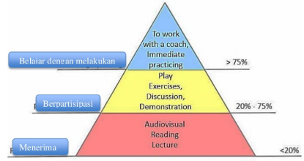
FIGURE 1. Retention of Learning

The application of the PBIL model begins with a face-to-face meeting at the first meeting. Furthermore PBIL model facilitates indirect / independent learning followed by monitoring learning through social media. The initial activity is carried out in the classroom, with the stages of giving basic questions to students and conducting pre-tests, conveying themes later with students preparing project plans and determining the schedule of activities to complete the project. The next step is independent learning by facilitating students with Android-based learning media and textbooks. At this stage the teacher monitors the students and the progress of the project that the students do independently or collaboratively, then analyzes the results of the students' products and evaluates the experience through cognitive tests / post tests.
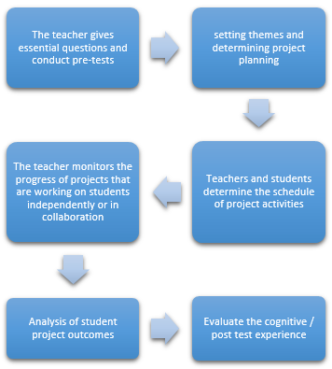
FIGURE 2. Steps in the PBIL Model
Learning manuals explain more about PBIL, learning guides, implementing learning with media and textbooks. This book is intended for teachers. The steps of the PBIL model are developed from the PBL model which consists of 6 phases, including: (1) determining the fundamental questions by the teacher; (2) developing project plans that are carried out collaboratively between teachers and students; (3) compile a schedule of activities in completing the project; (4) monitor students and project progress through social media, students work on projects independently; (5) product analysis of project results; (6) evaluation of experience.
The use of instructional media is a process of independent learning for students outside of school and also for teachers. ICT integrated learning media that can be used on PBIL models include android-based learning media.
The main page contains features that function to access the desired page. The features on the main page include Competencies, Materials, Videos, Evaluations, and Profiles. Android-based learning media is recommended in the learning model because it has a user interface that is easy for students to understand (Doriza, Irzal, Muhidin, & Sari, 2019) and is used in most cellphone as a means of support for students (Anohah, Oyelere, & Suhonen, 2017; Cavus, 2011; Traxler, 2010) according to the results of the analysis.
Students are also equipped with learning resources in the form of textbooks. The textbook contains indicators of competency achievement, learning objectives, subject matter and supporting material for basic competency in shirt making. Textbooks contain pictures of the steps of making shirts. Student monitoring by the teacher is done through social media Whats app and zoom.

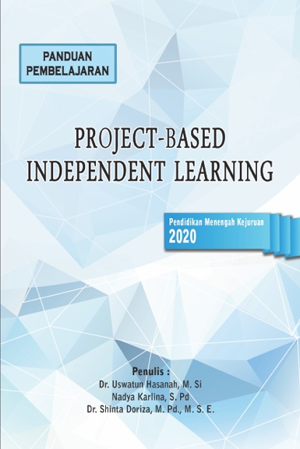

FIGURE 3. Front Cover of the Learning Guide Book

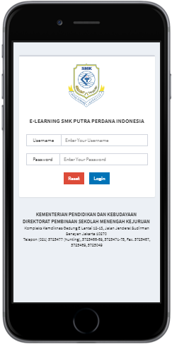
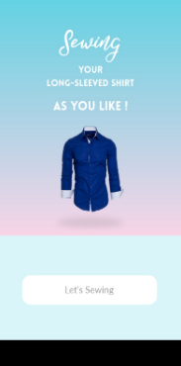
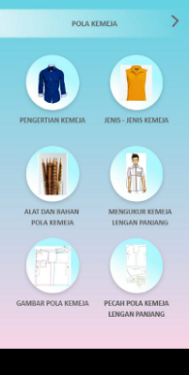

FIGURE 4. Display Android-based Learning Media
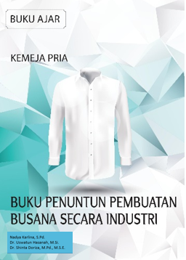

FIGURE 5. Front Cover of the Textbook

PBIL models provide opportunities for students to produce interesting and meaningful learning experiences especially for students who are ready to enter the workforce. In its application, students are required to carry out scientific projects independently with the guidance of teachers through social media. The process will be more meaningful because students are given the opportunity to plan scientific projects. The indirect learning process gives students many opportunities to learn more by themselves and develop creativity in solving problems. The pattern of independent learning is scientific learning according to Curriculum 2013 (K13) integrated ICT.
CONCLUSION
The results of the development of the learning model Project-Based Independent Learning. PBIL learning model development was developed based on the 10 steps of Borg & Gall, resulting in the design of PBIL learning models, Project-Based Independent Learning guidebooks, android-based learning media, textbooks and equipped with cognitive, psychomotor and affective assessment instruments. The product has been validated by learning experts, media experts, material experts and users. Learning model as a new reference for teachers in implementing the learning process. Learning handbooks, provide knowledge and concrete examples for teachers in implementing PBIL learning models. Learning media is a source of learning for students in completing projects independently, equipped with material buttons, work steps and video tutorials. Textbooks are also learning resources for students that are used as a guide to making shirts.
The learning model of the effectiveness test results shows that, by PBIL learning model, students find it easier to learn the subject of shirt making material (97%); students helped in solving problems (91%); increasing the courage of students to share opinions (85%); support students to be able to work with their friends (94%); motivating students to get achievement (97%); students feel it is easier to solve post test questions (97%); motivate students to disregard tasks (97%); learners feel that by the PBIL learning model, relations with teachers become closer (97%).
The use of PBIL models by teachers as a combination of direct learning / face-to-face and independent / indirect learning. The PBIL model can be applied to students of the Vocational School of Fashion who implement the Internship. Other conditions that support teachers to apply the PBIL model to students, including when teachers implement external services.
Compared with other models, PBIL is able to improve the quality of student learning in certain materials and make students able to apply a certain knowledge in a particular product / context. Students must be cognitively involved in the project for a certain amount of time. Involvement in complex assignments is an important component of learning because we assume that students will be motivated to test their ideas and the depth of understanding when facing authentic problems. PBIL can increase enthusiasm for learning between students and teachers, because the implementation is not monotonous in the classroom. Also brings up many skills (such as time management, collaborating and problem solving). Learners also learn to adapt the material to their own abilities in learning.
REFERENCES

Anohah, E., Oyelere, S. S., & Suhonen, J. (2017). Trends of mobile learning in computing education from 2006 to 2014: A systematic review of research publications. International Journal of Mobile and Blended Learning, 9(1), 16–33. https://doi.org/10.4018/IJMBL.2017010102
Bae, J.-H., & Lee, H. (2015). Development of Teaching-Learning Model with Project-Based Learning Using Smart Learning Contents Authoring Tool. Springer-Verlag Berlin Heidelberg, 1031–1036. https://doi.org/10.1007/978-3-662-45402-2_146
Borg, & Gall. (2003). Education Research. New York: Allyn and Bacon.
Cavus, N. (2011). Investigating mobile devices and LMS integration in higher education: Student perspectives. Procedia Computer Science, 3, 1469–1474.
Doriza, S, Irzal, M., Muhidin, A., & Sari, D. K. (2019). Implication of the use of Android-based App Pie application on children counseling subject. Journal of Physics: Conference Series, 1402, 066091. https://doi.org/10.1088/1742-6596/1402/6/066091
Doriza, Shinta, & Sunawar, A. (2015). Pengembangan Sumber Belajar Ekonomi Keluarga Berbasis CD Interaktif. Jurnal Ilmu Pendidikan Universitas Negeri Malang, 21(1), 64–70. Retrieved from https://www.neliti.com/id/publications/103278/pengembangan-sumber-belajar-ekonomi-keluarga-berbasis-cd-interaktif
Hanafy, M. S. (2014). Konsep Belajar dan Pembelajaran. Lentera Pendidikan, 17, 66–79.
Isjoni. (2013). Cooperative Learning (Efektifitas Pembelajaran Kelompok). Bandung: Alfabeta.
Istarani. (2011). Model Pembelajaran Inovatif (Referensi Guru Dalam Menentukan Model Pembelajaran). Medan: Media Persada.
Kemdikbud. (2018). Peraturan Menteri Pendidikan Dan Kebudayaan Nomor 34 Tahun 2018 Tentang Standar Nasional Pendidikan Sekolah Menengah Kejuruan/Madrasah Aliyah Kejuruan. Kemdikbud. Retrieved from Https//jdih.kemdikbud.go.id
Moerdiyanto. (2012). Perluasan Implementasi Pendidikan Kewirausahaan Model Project Based Learning bagi Remaja Putus Sekolah Korban Gempa. Jurnal Economia, 8, 78–96.
Nurjannah. (2018). Analisa Kebutuhan Sebagai Konsep Dasar Dalam Pengembangan Kurikulum Bahasa Arab di MAN Curup. Jurnal Bahasa Arab, 2, 50–72. https://doi.org/DOI: 10.29240/jba.v2i1.409
Nurohman, S. (2015). Pendekatan Project Based Learning Sebagai Upaya Internalisasi Scientific Method Bagi Mahasiswa Calon Guru Fisika. In Semnas UNY (pp. 1–20). yoyakarta: UNY. Retrieved from http://staff.uny.ac.id/
PSMK, D. (2008). Pelaksanaan Prakerin Direktorat Pembinaan Sekolah Menengah Kejuruan Direktorat Jendral Manajemen Pendidikan Dasar dan Menengah. Depdiknas. Retrieved from https://www.academia.edu/5247952/i_Pelaksanaan_Prakerin_Direktorat_Pembinaan_Sekolah_Menengah_Kejuruan_Direktorat_Jenderal_Manajemen_Pendidikan_Dasar_Dan_Menegah
Sudira, P. (2013). Praksis Pendidikan Kejuruan Indonesia diantara Mahzab John Dewey dan Charles Prosser. In Praksis Pendidikan Kejuruan Indonesia diantara Mahzab John Dewey dan Charles Prosser (pp. 1–13). Yogyakarta: Makalah Seminar Pendidikan Vokasi sebagai Disiplin Keilmuan-FT UNY.
Sudjimat, D. A. (2016). Implementation of project based learning model in mechanical machining skills package of vocational high school. Proceedings of the International Mechanical Engineering and Engineering Education Conferences, 030024, 1–7. https://doi.org/10.1063/1.4965758
Traxler, J. (2010). Will Student Devices Deliver Innovation, Inclusion, and Transformation? Journal of The Research Center for Educational Technology, 6(1). Retrieved from https://www.researchgate.net/publication/50590465_Will_Student_Devices_Deliver_Innovation_Inclusion_and_Transformation

