Education Building Maintenance Priority Strategy Consider Safety Condition Using Analytical Hierarchy Process (AHP)
Muhammad Faizal Ardhiansyah Arifin^{1, a)} , Yoga Aditya^{1, b)} , Agung Budiwirawan^{1, c)}, Agung Sutarto^{1, d)} , Arie Taverianto ^{1,e)}
¹ Department of Civil Engineering, Faculty of Engineering, Universitas Negeri Semarang
Kampus Sekaran Gunungpati 50229, Semarang, Indonesia
^{a)}Corresponding author: faizal.arifin@mail.unnes.ac.id
^{b)}yogaaditya318@students.unnes.ac.id
^{c)}agungbudi@mail.unnes.ac.id
^{d)}agung.sutarto@mail.unnes.ac.id
^{e)}arietaveriyanto@mail.unnes.ac.id
Abstract. Building with their components degradation known as a general problem for every building agency globally. The components in the building are so numerous that makes it difficult for building agencies to handle them at the same time. It was not accounted that the building agency not only handles one building but sometimes they need to handle many building. These problems have become more complex with the limited financial condition of the building agencies for maintaining the building. Based on building maintenance complex problems this study attempt to provide a visible solution to manage the building maintenance strategy. A comprehensive method to assess the building condition is presented by applying Analytical Hierarchy Process (AHP). This method developed in this study is applied to define the building condition and followed by determining the building priority to be maintained. The building component in this study is specified into three specific components, namely interior, exterior, and building utility. To complete this method, a three-level priority factor is determined with consideration from the safety factor follow by the functionality factor, dan the last is an esthetic factor. The developed model shows a proper and reliable solution related to the degradation of building components and their functionalities.
Keywords: building, maintenance, sustainability, Analytical Hierarchy Process (AHP)

INTRODUCTION
(Use the Microsoft Word template style: Heading 1)
In the last few years, building maintenance related to building deterioration becomes a great issue because the number of deteriorated buildings is increasing [1]. This issue becomes essential because the number of aging buildings globally brings an environmental issue related to the building dilapidation condition and low building energy performance [2]. Moreover, numerous components in the building with different functions have different degradation characteristics making aging buildings difficult to maintain) [3]. Especially, the old components of the aging building have a greater risk of sudden failing to be a function. Therefore, during the building operation phase, there will need a necessity of huge operation and maintenance costs in order to ensure the building’s serviceability [4]. Such a situation makes building maintenance more challenging for every building agency globally. A regular inspection is needed to assess the building's condition for ensuring the building’s functionality. The building functionality is a very important aspect of the building industry, because when the building cannot provide a good service then the building occupant will feel uncomfortable and slowly will leave the building. Furthermore, the safety aspect of the building condition becomes the most important aspect, since the safety of building occupants is the major priority on the building service list) [5]. However, to assess the building condition need proper judgment from building experts in order to obtain a real reflection of the building condition. The real reflection of building conditions from reliable building inspection can assist the building stakeholder intake a proper decision to pressure the building deterioration condition as well as ensure the building’s sustainability [6].
When the building assessor is able to record and report the building condition properly in detail a good building maintenance strategy can easily establish [7]. In order to assess the building condition properly usually, the building assessor will define the building into several specific components [8]. In general, the buildings component can divide become into four major components encompasses structure, architecture, mechanical, and electrical. Since mechanical and electrical components have the main function to provide electricity and water then these two major components can be united as utility components. Each major components have many specific sub-components with different function and characteristics. The structure is a major component with the main function as a frame to embed the other major components. Therefore, the structure is a major part to ensure the safety of the building and having powerful strength with the longer lifetime design. The other major components, such as architecture, mechanical, and electrical have less strength and less service lifetime. Considering the vulnerability of architecture, mechanical, and electrical components usually most building maintenance strategy is focused on these components. Even though these three major components are components that have various and numerous types of sub-components it makes the general building maintenance strategy more difficult. Furthermore, sometimes sub-component of mechanical or electrical will have a relationship, if one sub-component is broken will lead to degradation faster to the other sub-component. Thus, such as of this condition is need fast response maintenance action to prevent a greater risk of malfunction and greater maintenance cost.
Besides the difficulties factor of the short service life of the architecture, electrical, and mechanical components, and the various as well as numerous numbers difficulties factor of the sub-components, another problem arises when the maintenance budget is not sufficient compared with the maintenance cost [9]. A smart maintenance strategy needs to be taken, this strategy considers which sub-components need to maintain first before the other sub-components that should be tailored to the available maintenance budget. Thus, the building agencies need to take a priorities policy to take proper maintenance action at the proper sub-component. To conduct a priority maintenance strategy an identification condition of sub-components needs to be taken care of carefully to make proper priority classification. This priority policy in building maintenance strategy is already well-known as a reliable approach to solving financial limitation issues [10]. However, deciding which sub-components more priority to maintain always becomes a great issue to discuss among building industry practitioners. Since one building industry practitioner and the other building industry practitioner have different opinions regarding the classification of safety factors, functionality factors, and esthetic factors to rank the priority level. These three classification factors are the common thinking of building industry practitioner because it refers to the main function of the building to serve building users and building occupants. Refers to the building functions the priority level in building maintenance strategy should be considered the safety factors as the major consideration to conduct maintenance action because the safety of the building occupants is the major priority in building service guidelines [11]. More specific the main reason to place safety factors as the major consideration is to prevent accidents for anyone inside or near the building.
Therefore this study is attracted to enriching the knowledge of building maintenance strategy, especially in the classification of building sub-component priority levels. This study hopes to contribute a new idea of priority level in building maintenance strategy and guides towards the same perception of priority level for building practitioners globally. The focus of the maintenance strategy in this study is to classify building maintenance priority by assessing the architecture condition and utility (mechanical and electrical components) condition as the general major components in building maintenance. To conduct an intensive building condition inspection the architecture sub-components in this study will be divided into two major sub-components including exterior sub-components and interior sub-components.
The method to specify the priority level of which sub-component to be taken care of in this study is by utilizing Analytical Hierarchy Process (AHP). AHP is well-known as a dependable method to solve intricate and complex problems in decision support systems. The main concept of AHP is to segregate multi-factor problems to become a hierarchy structure [12]. The Newtonian and Cartesian concepts of thinking are inspired AHP to solve complex problems into smaller parts many times until reached an exact and scalable level [13]. This method requires an expert's judgment to compare assessments opinions among similar criteria to conduct a priority classification alternative by putting a necessary consideration factor related to the facing problems [14]. This statement is aligned with the requirement of this study to assess the building condition, the required assessor that assessed the building must have experience. Since the building consists of many components and some components are integrated to become one system. Furthermore, the building system not only has a single system but can be consist of several different systems. Therefore an expert building assessor becomes an absolute requirement
Already many previous studies utilized AHP to solve maintenance problems in the building industry, a similar study in building maintenance that utilized AHP was performed by Kutut et al. in a historic building to specify which building needs a priority to be maintained. Kutut et al. [15] utilized AHP to assess priority alternatives maintenance types to preserve the historic building in Lithuania. Figuerido et al. [13]proposed a building maintenance strategy to determine the priority ranking of some alternative maintenance actions by utilizing AHP combined with fuzzy theory. Another study utilizing AHP to develop a building maintenance strategy is proposed by Adreolli et al. Adreolli et al. [16] proposed the AHP model for multiple-criteria prioritization that focused on building seismic retrofit solutions for industrial buildings.
Since most building agencies handle only one building, this study not only limited the focus to one single building. The developed maintenance strategy based on AHP in this study is utilized to classify several buildings with the same function as an educational building. By viewing from this point of view the developed maintenance strategy in this study can rank properly which building needs to be taken care of first a which building needs to be taken care of later.

METHODOLOGY
This study was conducted at Engineering Faculty Universitas Negeri Semarang, located in the Sekaran Gunungpati district. The object of this study is to consist of 13 education buildings with a similar function. All of these buildings are 3 story buildings consisting of a classroom, laboratory, and office of different ages. The focus of observation of all these buildings is on the architecture components and utility components. Especially for the architectural components to direct the observation properly, this component is divided become exterior and interior components. The detail of the interior and exterior sub-components observed in this study are outlined in Table 1 below. Besides interior and exterior sub-components, Table 1 also shows the detail of utility sub-components observed.
TABLE 1. Interior, exterior, and utility components observed
Interior | Exterior | Utility
Wall | Roof cover | Plumbing
Tile | Roof Structure | Electricity installations
Door | Wall | Toilet
Window | - | -
Ventilation | - | -
Ceiling | - | -

According to the AHP concept, the members of the three groups building components above are observed in more detail to build a hierarchy structure. Consequently, the Interior has six specific members, the exterior has three specific members, and the utility has three specific members. The scheme of hierarchy structure according to the AHP concept for establishing a building maintenance strategy in this study is illustrated in Figure 1. As an example, the ceiling sub-component in the interior group is outlined based on the sub-components compiler. The compiler ceiling sub-component is consist of the ceiling frame, ceiling cover, ceiling list, and ceiling paint. The next step after defining the member of sub-components is to compare each other member’s sub-components and follow by comparing each other sub-components in order to obtain the weighted value of AHP. To assist in obtaining the weighted index, this study applies the priority classification that includes safety, functionality, and esthetic.

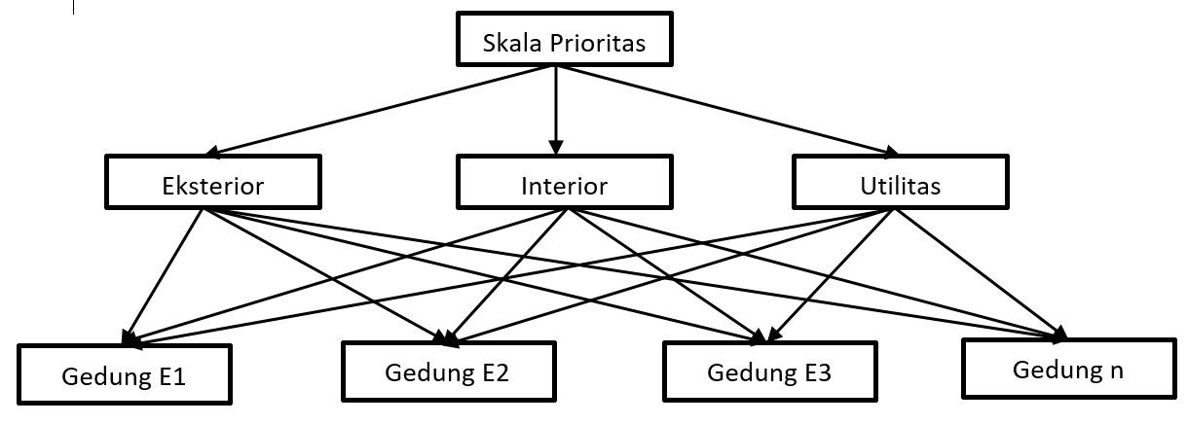
Figure 1. AHP structure for establishing building maintenance strategy

Each of the compiler sub-components in Table 1 then is assessed the condition with a specific classification from failed condition to excellent condition. Failed condition is defined when the condition of the member of sub-components is totally broken and needs to replace with the new one. Excellent condition is specified when the condition of the member sub-components is totally brand new and can work as specified as well as no maintenance action is necessary. Before obtaining the condition description, firstly a number condition indexing is applied to assist the building condition assessment process. The detailed value of condition indexing and respected description condition was taken referred to Liu et al. [17] and shown in Table 2.

TABLE 2. Building condition index and respected condition description
Building Condition Index | Condition Description | Maintenance Recommendation
100 – 85 ≥ | Excellent | No maintenance action
84,99 – 70 ≥ | Good | Service
69,99 – 55 ≥ | Satisfied | Minor repair
54,99 – 40 ≥ | Fair | Minor repair
39,99 – 25 ≥ | Poor | Major repair
24,99 – 10 ≥ | Very poor | Major repair
9,99 - 0 | Failed | Rehabilitation

Furthermore, the detailed process of this study in assessing the building condition based on AHP concepts is depicted in Figure 2. The process depicted in Figure 2 is started with put building as a major object of this study. The next process is to decipher the building into components and subcomponents. Therefore the process depicted in Figure 2 is associated with how to build a structure of hierarchy that is based on the building components and sub-components. Along with the hierarchy process a weighted factor of the associated members of sub-components and associated sub-components of the major building components is calculated. Thus, the assessment of building conditions in this study is performed based on the building components and sub-components conditions. By conducting in this way the building condition assessment can be performed in detail and very well measure. After integration, all the members of sub-components become one single building then an assessment to find the global building condition index can be established. If this process is applied to all 13 object buildings in this study we can determine the priority to perform which building needs to be maintained first.

Building Object
Define the major component
Define the sub-component of major component
Condition Classification
Define the member components of sub-component
Condition Assessment of member components
Weighted Value

Figure 2. AHP process building condition assessment

RESULT AND DISCUSSION
Based on the building components classification and building condition classification, the building assessment was performed on thirteen building objects and the assessment result will be discussed in this section. To help a better understanding for the readers this section will be started to present a visualization of the object of the building. The visualization of exterior and interior conditions of the thirteen buildings is represented by 3 buildings that are taken by considering the worst condition to the best condition. Overall the exterior condition of those 13 buildings from the wall component and roof components reflects a satisfying condition to excellent condition. However, the interior condition needs intensive maintenance to retain the good or even excellent condition. The detailed visualization of those 3 buildings is shown in Figure 3.
The 3 buildings represent building objects in Figure 3 showing Building E3, Building E7, and Building E12. The represented interior picture for Building E3 is showing one of the door sub-component that is already in the worst condition and needs to replace with a new one. Moreover, the represented interior visualization for Building E7 is depicting the condition of the wall in the laboratory room that needs renewal with repeat painting. The different picture of sub-components for representing the interior of Building E12 is represented by showing the ceiling condition. The ceiling condition of Building 12 is shown in the worst condition and looks almost collapsed which can bring fatal accidents to the building occupants. Actually, besides the interior condition shown in Figure 3 below, there are still many interior conditions in those 3 buildings that need to be assessed. The interior picture sample shown in Figure 3 can bring an image of visualization to understand how to assess the building condition. According to this visualization, we can imagine how many sub-components are necessary to be identified in performing the building assessment.

 | 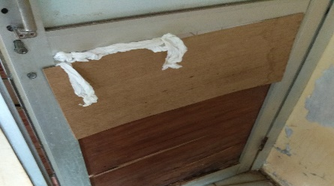
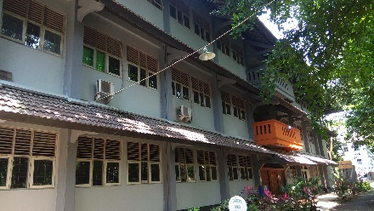 | 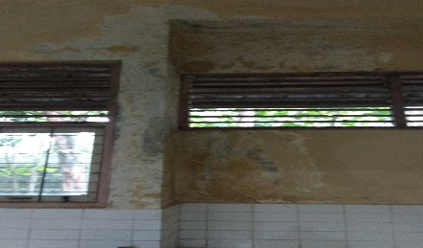
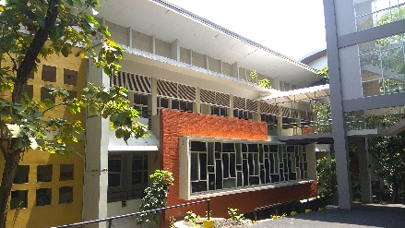 | 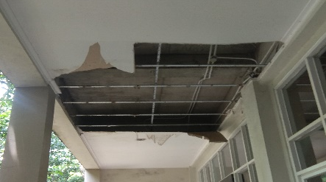

Figure 3. Photo exterior and the interior condition of 3 represents building (Top: Building E3, Middle: Building E7, Bottom: Building E12)

After assessing the building condition which refers to the building condition index in Table 2, then the next process is to determine the important criteria of those sub-components and find the weighted index components as well as the weighted index sub-components. Microsoft Excel is utilized in this study to calculate the weighted index for every component and sub-components to one single building. The first step to calculating the weighted index of the building components is by determining the important criteria of the sub-components. The further process is to construct the comparison pairwise matrix. The result of the comparison among the building components is shown in Table 3.
TABLE 3. Result of components comparison
Components\Components | Interior | Utility | Exterior
Interior | 1,000 | 3,000 | 5,000
Utility | 0,333 | 1,000 | 3,000
Exterior | 0,200 | 0,333 | 1,000
Total | 1,533 | 4,333 | 9,000

After comparing the building component, the next process is to find the criteria matrix of the component as shown in Table 4. The consideration to determine the important criteria depends on the sub-component condition if the condition of the sub-component has a greater risk that endangers the occupant’s life then is determined as the most important. The next process is to clarify the building assessment result and the obtained weighted index of the building components and sub-components. The result of the weighted index of building components and sub-components is shown in Table 5.
TABLE 4. Matrix of Criteria Value
Components\Components | Interior | Utility | Exterior
Interior | 0,65 | 0,69 | 0,56
Utility | 0,22 | 0,23 | 0,33
Exterior | 0,13 | 0,08 | 0,11
Total | 1,00 | 1,00 | 1,00

The sum in the column that represents a single component of the Criteria Value Matrix must show value 1. The biggest value in the Criteria Value Matrix table for each component is put as a value to determine the priority value in the weighted index list below. The process to calculate criteria values to find the weighted index is also applied to the sub-component as shown in the weighted list below also. Among the components and sub-components, there will be a priority level is determined from the result of the weighted index.

TABLE 5. List of Weighted Index
Components | Weighted Component | Sub-Component | Weighted Sub-Component
 |  | Roof cover | 0,630
Exterior | 0.11 | Roof structure | 0,260
 |  | Wall | 0,110
Interior | 0,63 | Wall | 0,133
Interior | 0,63 | Tile | 0,333
Interior | 0,63 | Door | 0,162
Interior | 0,63 | Window | 0,162
Interior | 0,63 | Ventilation | 0,126
Interior | 0,63 | Ceiling | 0,046
 |  | Plumbing | 0,333
Utility | 0,26 | Electrical | 0,333
 |  | Sanitary | 0,333

Since the interior has many sub-components, the result of the weighted index shows that the interior is the most priority among the three major building components. Furthermore, tile is the most important sub-component of the interior component. Roof cover becomes the most important sub-component of the exterior component. Since plumbing, electrical, and sanitary in the utility component consider to have the same level of importance to support the building service, then the same weighted index value sub-component is found in the utility component. This result has a meaning if all of the three utility sub-component have the same priority.
Based on the table component and sub-component weighted index above and the result of the building assessment that refers to the building condition index then a calculation to find a global building condition index that represents the real single building can be obtained. The general equation to find the global building condition index for a single building based on the building component is represented in Equation 1 below. A tiered equation process from the sub-components members followed by sub-component and component is performed to obtain the global condition index in Equation 1.

BCI of Building E1 = (BCI_{exterior} x weighted index_{exterior}) + (BCI_{interior} x weighted index_{interior}) (1)
+ (BCI_{utility} x weighted index_{utility})

Referring to Equation 1, a repeated process for all the 13 building objects in this study can be calculated to find the global BCI. Based on the result of the global BCI for all 13 buildings then the order of maintenance priority that needs to be performed can be established. The building with the smallest value indicates that the building condition is worst. Thus, buildings with the worst condition of BCI global will be listed at the top and followed by the other buildings. That means the building in the worst condition needs immediately to be maintained to prevent occurring severity damage. The order of building maintenance priority is shown in Table 6.
According to the AHP value result in Table 6 the priority order is started from Building E10, where this building has the smallest AHP value and indicates that Building E10 has the worst condition among 13 buildings in this object study. When the AHP value result is validated according to Building E10 condition shows if the AHP value result is correct. However, building with similar conditions sometimes makes building agencies difficult in choose which building has more priority than the other building. Such kind of ambiguous situation in this study is shown in Building E08 and Building E03, Building E04 and Building E07, Building E06 and Building E01, as well as Building E09 and Building E13. Those pairwise buildings example mentioned has a similar AHP value, and it means that the actual building condition of those pairwise buildings is not much different. Therefore, this study is shown able to solve intricate problems in making decisions of building priority in building maintenance management.

TABLE 6. Result of building priority order based on AHP
Priority Number | Building Name | AHP Value
1 | E.10 | 58,633
2 | E.08 | 65,030
3 | E.03 | 65,462
4 | E.04 | 66,057
5 | E.07 | 66,221
6 | E.02 | 69,415
7 | E.06 | 70,673
8 | E.01 | 70,993
9 | E.09 | 71,032
10 | E.13 | 71,766
11 | E.12 | 72,214
12 | E.11 | 72,939
13 | E.5 | 74,381

Referring to building names, actually building E01 is the oldest building among the 13 buildings. However, as the oldest building, building E01 is not in the worst condition. Conversely Building E10 that younger than Building E01 becomes the worst building. The condition of Building E10 is reflected that the AHP priority value is valid. Since the actual condition of Building E10, there are many members of the sub-component found in broken condition. This result is an anomaly because commonly the old building has a greater deterioration rate than the younger building.

CONCLUSION
The developed AHP model for establishing a good and reliable building maintenance strategy in this study has been performed very well. The indications of well perform performance of the developed model are shown from the result of the AHP priority indexing value. By applying the AHP priority indexing value the building agencies can choose which building needs to be maintained first before the other building. Building with the lowest condition level that considers the building safety and serviceability is suggested to be maintained first, which means the result of this study shows if able to provide a reliable option for building agencies.
Furthermore, the priority order developed in this AHP model not only works for a single whole building as an integration of many components and systems at the same time also can suggest priority at the lower level. Therefore, the priority building maintenance strategy developed in this study can provide information on which component or sub-components condition and suggest which component or the sub-component needs to be maintained first. According to this, a proper maintenance action can be performed. Overall the result of this study is aligned with the building maintenance concept and able to provide a new perspective for improving a better building maintenance strategy under a budget limitation.
However, since there is a limitation to accessing the difficult location of the building, this study cannot provide complete information on building sub-components conditions. Further study needs to consider applying a building surveyor to inspect the building components and sub-components that are located at a difficult location. Moreover, besides safety, functionality, and esthetic consideration factors to determine the weighted index, there is also necessary to put maintenance cost as a consideration factor also.

References
[1] N. Kwon, K. Song, Y. Ahn, M. Park, and Y. Jang, “Maintenance cost prediction for aging residential buildings based on case-based reasoning and genetic algorithm,” J. Build. Eng., vol. 28, no. August 2019, p. 101006, 2020, doi: 10.1016/j.jobe.2019.101006.
[2] I. El-Darwish and M. Gomaa, “Retrofitting strategy for building envelopes to achieve energy efficiency,” Alexandria Eng. J., vol. 56, no. 4, pp. 579–589, 2017, doi: 10.1016/j.aej.2017.05.011.
[3] J. C. P. Cheng, W. Chen, K. Chen, and Q. Wang, “Data-driven predictive maintenance planning framework for MEP components based on BIM and IoT using machine learning algorithms,” Autom. Constr., vol. 112, no. August 2018, p. 103087, 2020, doi: 10.1016/j.autcon.2020.103087.
[4] A. Hauashdh, J. Jailani, I. A. Rahman, and N. AL-fadhali, “Structural equation model for assessing factors affecting building maintenance success,” J. Build. Eng., vol. 44, no. March, p. 102680, 2021, doi: 10.1016/j.jobe.2021.102680.
[5] A. Silva and J. de Brito, “Do we need a buildings’ inspection, diagnosis and service life prediction software?,” J. Build. Eng., vol. 22, no. August 2018, pp. 335–348, 2019, doi: 10.1016/j.jobe.2018.12.019.
[6] R. Matos, F. Rodrigues, H. Rodrigues, and A. Costa, “Building condition assessment supported by Building Information Modelling,” J. Build. Eng., vol. 38, no. December 2020, p. 102186, 2021, doi: 10.1016/j.jobe.2021.102186.
[7] J. Barrelas, Q. Ren, and C. Pereira, “Implications of climate change in the implementation of maintenance planning and use of building inspection systems,” J. Build. Eng., vol. 40, no. March, p. 102777, 2021, doi: 10.1016/j.jobe.2021.102777.
[8] C. Nägeli, A. Farahani, M. Österbring, J. O. Dalenbäck, and H. Wallbaum, “A service-life cycle approach to maintenance and energy retrofit planning for building portfolios,” Build. Environ., vol. 160, no. March, p. 106212, 2019, doi: 10.1016/j.buildenv.2019.106212.
[9] J. Kim, S. Han, and C. Hyun, “Minimizing Fluctuation of the Maintenance, Repair, and Rehabilitation Cost Profile of a Building,” J. Perform. Constr. Facil., vol. 30, no. 3, p. 04015034, 2016, doi: 10.1061/(asce)cf.1943-5509.0000775.
[10] V. W. Y. Tam, I. W. H. Fung, and R. C. M. Choi, “Maintenance Priority Setting for Private Residential Buildings in Hong Kong,” J. Perform. Constr. Facil., vol. 31, no. 3, p. 04016115, 2017, doi: 10.1061/(asce)cf.1943-5509.0000988.
[11] J. Cuadrado, M. Zubizarreta, E. Rojí, H. García, and M. Larrauri, “Sustainability-Related Decision Making in Industrial Buildings: An AHP Analysis,” Math. Probl. Eng., vol. 2015, no. Mcdm, 2015, doi: 10.1155/2015/157129.
[12] A. Supriadi, A. Rustandi, D. H. L. Komarlina, and G. T. Ardiani, Analytical Hierarchy Process (AHP) Teknik Penentuan Strategi Daya Saing Kerajinan Bordir. 2018.
[13] K. Figueiredo, R. Pierott, A. W. A. Hammad, and A. Haddad, “Sustainable material choice for construction projects: A Life Cycle Sustainability Assessment framework based on BIM and Fuzzy-AHP,” Build. Environ., vol. 196, no. November 2020, p. 107805, 2021, doi: 10.1016/j.buildenv.2021.107805.
[14] M. Mathew, R. K. Chakrabortty, and M. J. Ryan, “A novel approach integrating AHP and TOPSIS under spherical fuzzy sets for advanced manufacturing system selection,” Eng. Appl. Artif. Intell., vol. 96, no. October, p. 103988, 2020, doi: 10.1016/j.engappai.2020.103988.
[15] V. Kutut, E. K. Zavadskas, and M. Lazauskas, “Assessment of priority alternatives for preservation of historic buildings using model based on ARAS and AHP methods,” Arch. Civ. Mech. Eng., vol. 14, no. 2, pp. 287–294, 2014, doi: 10.1016/j.acme.2013.10.007.
[16] F. Andreolli, P. Bragolusi, C. D’Alpaos, F. Faleschini, and M. A. Zanini, “An AHP model for multiple-criteria prioritization of seismic retrofit solutions in gravity-designed industrial buildings,” J. Build. Eng., vol. 45, no. October 2021, p. 103493, 2022, doi: 10.1016/j.jobe.2021.103493.
[17] S. S. Liu and M. F. A. Arifin, “Preventive maintenance model for national school buildings in indonesia using a constraint programming approach,” Sustain., vol. 13, no. 4, pp. 1–25, 2021, doi: 10.3390/su13041874.

