ATTACHMENTS

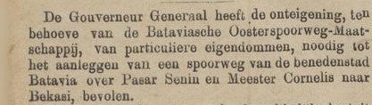
Attachment 1 concerning the Construction of the Batavia – Bekasi Railway which was published in the Java-bode Newspaper: nieuws, handels- en advertentieblad voor Nederlandsch-Indie, May 9, 1885 edition.

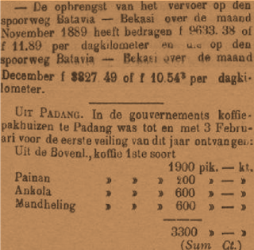
Attachment 2 on the Advantages of the Batavia – Bekasi Railway which was published in the newspaper De locomotief : Samarangsch handels en advertentie blad February 11, 1890 edition.

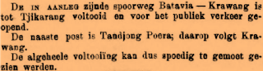
Attachment 3 concerning the Extension of the Bekasi – Karawang Railway which was published in the Bataviaasch Nieuwsblad Newspaper, July 5, 1890 edition.
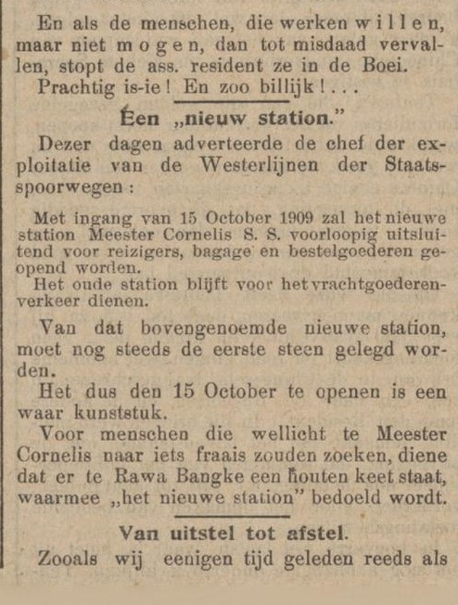
Attachment 4 on the construction of the new Meester Cornelis Station published in the 11 October 1909 edition of the Het nieuws van den dag voor Nederlandsch-Indië newspaper.

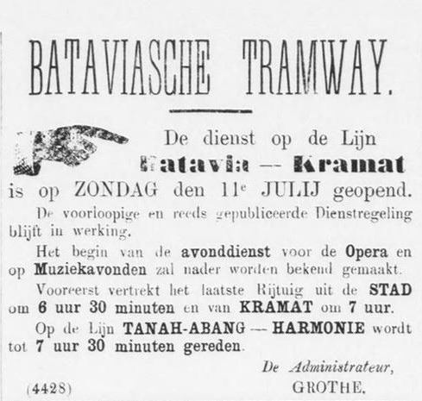
Attachment 5 regarding the opening of the loaded BTM Horse Tram
in the newspaper Batavia Handelsblad July 12, 1869 edition.

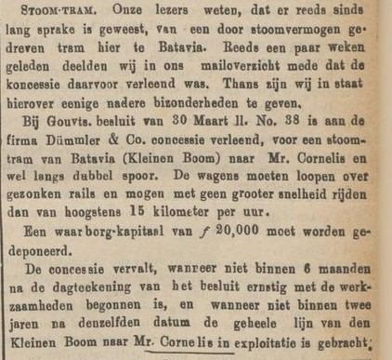
Attachment 6 regarding the Takeover of the BTM Horse Tram Service published in the Java-bode Newspaper: nieuws, handels- en advertentieblad voor Nederlandsch-Indie April 27, 1881 edition.

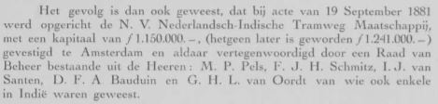
Attachment 7 concerning the Initial Capital of the NITM Steam Tram Company as quoted from the Nederlandsch-Indische Tramweg Maatschappij Report Book Year 1881-1921.

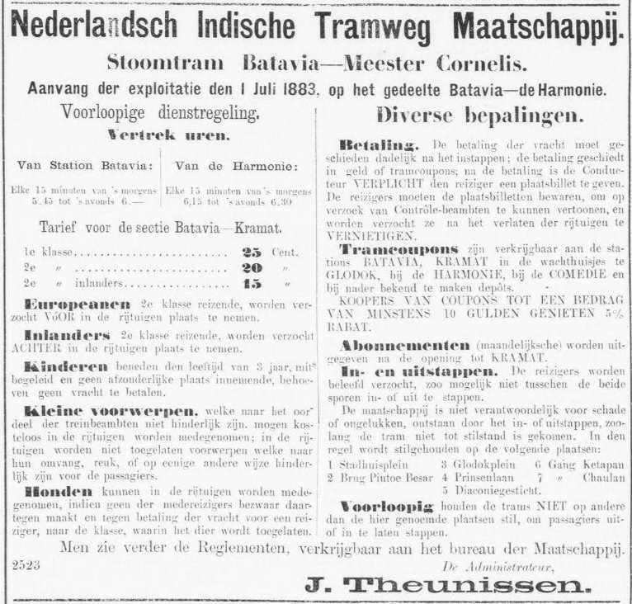
Attachment 8 concerning the Opening and Schedule of the NITM Steam Tram Service which was published in the Batavia Handelsblad Newspaper 30 June 1883 edition.

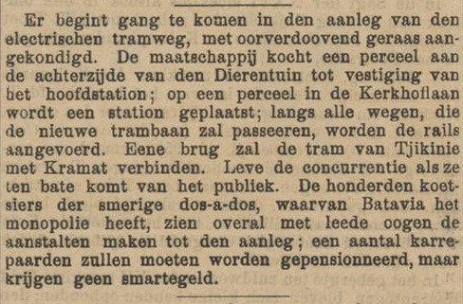
Attachment 9 concerning the Construction of the Electric Tram, which was published in the Java-bode Newspaper: nieuws, handels- en advertentieblad voor Nederlandsch-Indie, December 14, 1897 edition.

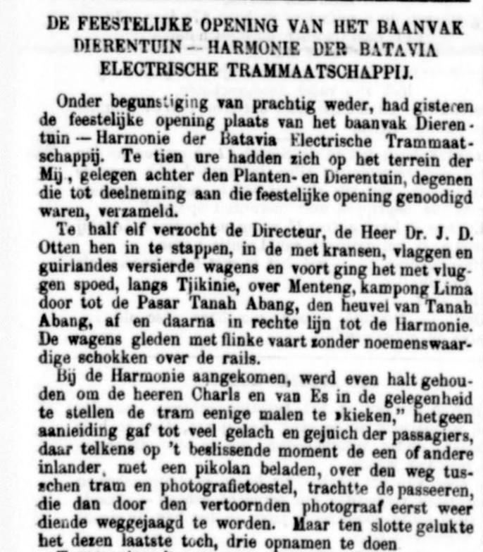
Attachment 10 concerning the Opening of the BETM Electric Tram Service which was published in the Bataviaasch Nieuwsblad Newspaper, April 10, 1899 edition.
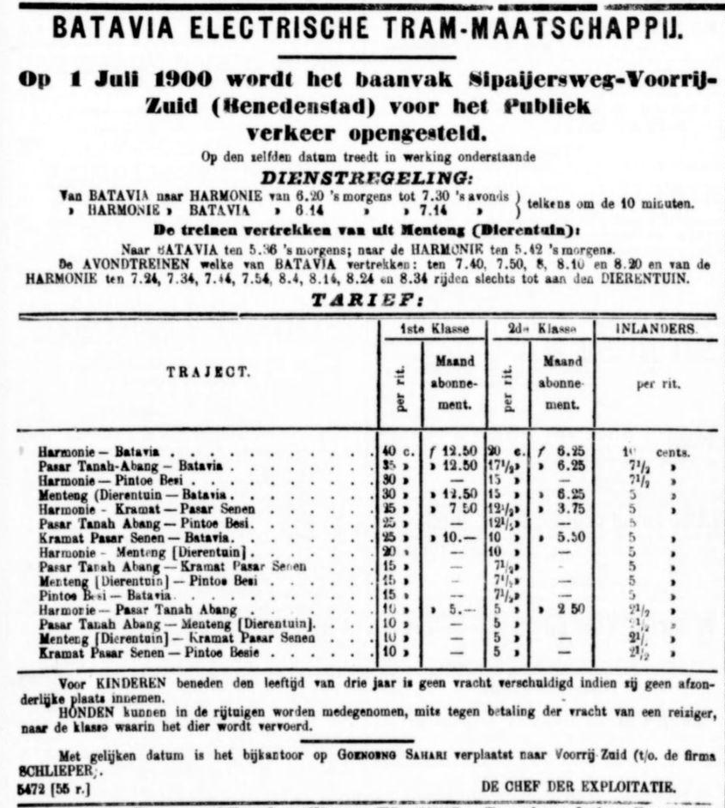
Attachment 11 regarding the BETM Electric Tram Service Schedule published in the Bataviaasch nieuwsblad newspaper, 30 June 1900 edition.
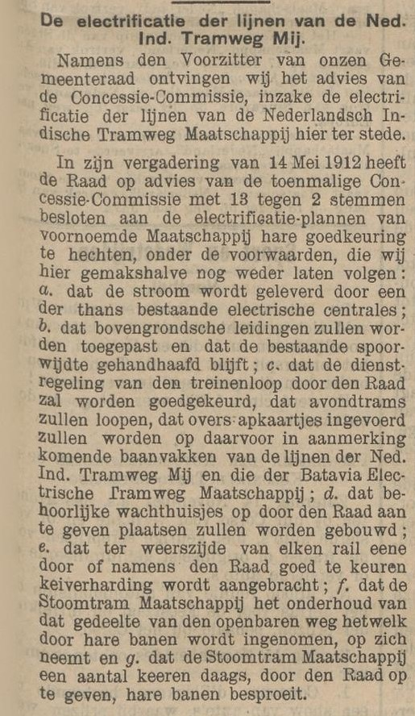
Attachment 12 on the Colonial Government's Demand to NITM to electrify its Tram service was published in the 19 October 1914 edition of the Het nieuws van den dag voor newspaper.
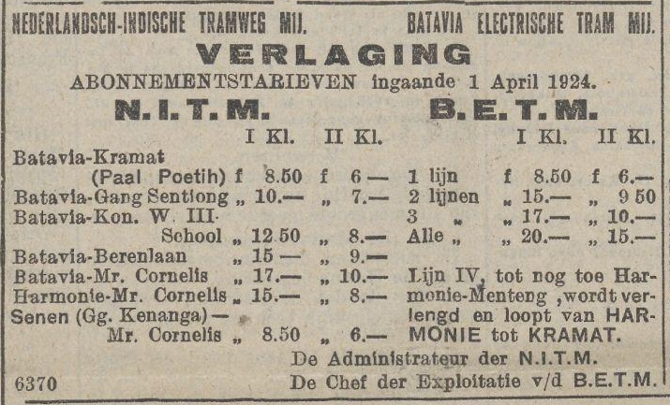
Attachment 13 on the joint advertisement of NITM and BETM that allows switching from one service to another published in the Het nieuws van den dag voor newspaper Nederlandsch-Indië 27 March 1924 edition.

