Article Title (max. 15 words)
Full Name of First Author^{1*}, Second Author², Third Author³, Fourth Author⁴

¹ Affiliation of Author 1 (Department, Faculty, University, Postal Code, Country)
² Affiliation of Author 2 (Department, Faculty, University, Postal Code, Country)
³ Affiliation of Author 3 (Department, Faculty, University, Postal Code, Country)
⁴ Affiliation of Author 4 (Department, Faculty, University, Postal Code, Country)

*Corresponding Author:

Article Title
Abstract
Abstract should be written in English, ranging between 250–300 words. The title of the abstract should be written in the center of the field using regular font 9 pt bold. The space between the title of the abstract and the name of the institution is one single space 10 pt. The space between the text of the abstract and the title is one single space 10 pt. The abstract is written using regular font 9 pt in a single column format. Keywords are written below the text of the abstract, arranged alphabetically and separated by comma.

Keywords: use 8 pt; lower case; italic; Times; write alphabetically in 5-6 words; separate each keyword by using comma
INTRODUCTION
Content of the article should be written left aligned with the left margin 1”, right margin 1”, bottom margin 1” and top margin 1“..The article should be written using MS Word using Times New Roman using 12 pt font, 1.5 space and in a single column format. Each article should be at least have 15 pages (including figures and tables) justified.
Article should be written in A4 paper. The article should be composed as follows: Abstract, INTRODUCTION, METHOD, RESULT AND DISCUSSION, CONCLUSION, ACKNOWLEDGEMENT (Compulsory to acknowledge the Grant), List of Notation (if any), and REFERENCES.
  - SUB SECTION
Sub Section should be written in bold letter using UPPER CASE format, aligned to the left, and numbered. Sub sub heading should be written using bold letter, aligned left without number and underline.
Sub Heading
Sub Heading should be written in bold letter using UPPER CASE format, aligned to the left, and numbered. Sub sub heading should be written using bold letter, aligned left without number and underline.
Figures and Tables
Figures 1 and Tables 1 placed in a text with description. Pictures and tables is followed by the title of the picture placed just below the picture and the title of the table placed above the table. The title of the table and picture should be numbered. The picture should be able to be clearly printed. Pictures or diagrams/ schemes placed in the text or if the picture is too big, it can be placed in the middle of the page. The picture should not be framed. For coloured pictures/ graphics, it should have at list a 300 dpi image quality. The displayed tables are without vertical line, whereas horizontal lines can only display 3 main horizontal lines which are 2 horizontal lines for column title and closing line from the bottom line.

Table 1. Description of units used in the equation
No | Description | Units
1 | Temperature | K
2 | Pressure | bar

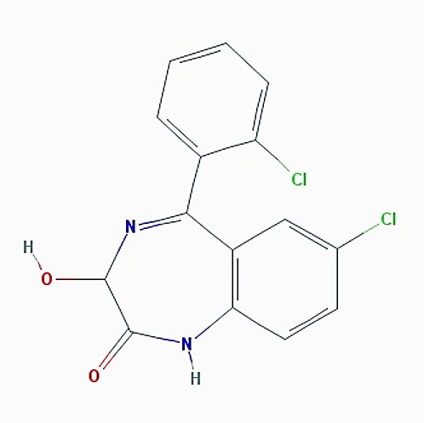
Figure 1. Molecul structure
Equation
Equation should be written center aligned and numbered in the brackets. The numbers placed at the end of the right margin of the column. Author may use table for the guidance as shown in the Equation (1).
$$A+B \underset{→}{k_{1}}C+D$$ | (1)

List of Notation
If any list of Notation arranged alphabetically. Notation of latin alphabet should be written first followed by Arabic alphabet.
Citation
Citation format of an article should be written using APA citation system. The source is written in the description consists of the name of the author and the year of publication.
Example: Lignocellulosic hydrolysis can be carried out by using enzymes or chemicals (Euler, 2018 for on author, Knudson and Weber, 2019 for two authors; Reynolds et al., 2020 for three or more authors).
Article Submission
Article should be submitted online to our website, and the article should be written in English. https://journal.unnes.ac.id/nju/index.php/rekayasa
Reviewing process will be conducted by the Board of Editor and Reviewers of Rekayasa. Any correspondence will be addressed to the e-mail used for correspondence. The author should revise the article according to the reviewer advice. The Board of Editor are entitled to reject any articles which are not relevant to subject of the application of technology, not up to date, or have been published in any other scientific publication.

References
Journal
Tom, A. P., Pawels, R. & Haridas, A. (2016). Biodrying Process: A Sustainable Technology for Treatment of Municipal Solid Waste with High Moisture Content. Waste Management. 49(1), 64-72.
Proceeding
Chaerul, M. (2020). Performance of Bioplant for Municipal Solid Waste at Jatinangor Campus of Institut Teknologi Bandung. E3S Web of Conferences. 148, 02009.

