 | CATHARSIS 8 (4) 2019 410 - 418  Catharsis: Journal of Arts Education  http://journal.unnes.ac.id/sju/index.php/catharsis |  |  | 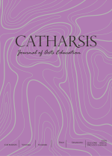
Wayang Gaga as a Media of Creativity Education for Students at Nongkosawit 02 Elementary School Semarang

Heny Setyaningrum , Jazuli, Triyanto

Universitas Negeri Semarang, Indonesia

Article Info  ________________  Article History:  Received 26 May 2019  Accepted 20 November 2019  Published 23 December 2019  ________________  Keywords:  Wayang Gaga, Educational Media, Creativity |  | Abstract  _________________________________________________________________  Wayang Gaga is a contemporary puppet made from grass. Wayang Gaga is staged with a simple story and triggers communication between the players and the audience. Wayang Gaga can be used as a medium for creativity education for children through the process of creating and appreciating. This study aims to examine Wayang Gaga as a medium for creativity education for elementary school children. Research location in Nongkosawit Public Elementary School 02, Jl. Randusari, RT.06/RW.02, Nongkosawit, Gunungpati District, Semarang City. Data collection techniques use observation, interviews, and documentation. The data validation technique uses source triangulation. Data analysis techniques refer to Miles and Huberman with data reduction procedures, data presentation and conclusion drawing. The results showed that Wayang Gaga can be used as a medium for creativity education for elementary school children through the process of making puppets (creations) to short performances by students (appreciation). Weaving skills, the breadth of thinking and the flexibility of speaking in public when being a puppeteer is one of the characteristics of creativity that results from learning activities using the Wayang Gaga media. Specific creativity can be seen from the personalities of students involved in a series of creative processes namely Wayang Gaga workshops and performances, supported by internal and external driving factors, so as to produce a creative product in the form of Wayang Gaga and its performances. This research is expected to bring up new educational media based on local wisdom, so that in addition to developing creativity students can also recognize and love the arts in their own area.  © 2019 Universitas Negeri Semarang  © 2019 Universitas Negeri Semarang
Correspondence Address:  Kelud Utara 3 kampus pascasarjana UNNES, Sampangan, Semarang, Indonesia, Indonesia  E-mail: setyaningrum_heny@.com |  |  | p-ISSN 2252-6900  e-ISSN 2502-4531

INTRODUCTION

Forming creative and innovative people is one of the goals of education (Budiarti, 2015: 65). Creativity according to (Munandar, 2009: 25) is a general ability to create something new, as the ability to provide ideas that can be applied in problem solving. With creativity, humans will be able to develop creativity so that innovations will emerge to advance the life of the nation.

However, the current state of education in Indonesia still emphasizes intellectuality which only prioritizes numerical results as a measure of success (Nurseto, 2015: 116). This is very contrary to the purpose of education itself so that it will have an impact on quality. Educational activities are directed to improve the quality of Indonesian people through heart and mind in order to have competitiveness in facing global challenges. (Ahmadi, 2012: 2). In facing these global challenges, it is necessary to provide a provision of children's creativity through the educational process.

Creativity can be pursued through educational activities. Education has a very decisive role for the development and realization of individual self, especially for the development of the nation and state (Saparahayuningsih, 2010: 3). Creativity education can be applied early on in elementary school age children. Primary school-age children are those who have 6-12 years of age, and have been able to think rationally, such as reasoning to solve concrete problems (Ibda, 2015: 27). Elementary school age children is a golden period in creative expression that is very high (Suhaya, 2016: 7). Therefore it is appropriate if creativity education starts to be implemented in those days, namely by using an arts education approach. Creative abilities can also be fostered and developed with educational media (Kusumastuti, 2010: 2). The function of the media is as a tool in the learning process, as a guide in learning, arousing the attention and motivation of children and improve the results of the learning process (Rusman, 2010: 162). The media is very useful to help stimulate children in understanding concepts and knowing concretely the object of learning material. In addition, the use of educational media can overcome passivity in students so that they become active and creative.

The Indonesian education system states that school curricula must incorporate local wisdom in their subjects as an effort to explore the potential of local resources for cultural objects that can be used as objects or materials for the learning process (Muhammad, 2017: 110). With reference to this, it is necessary to have an art-based learning media based on local wisdom. One of the media that has the potential to be a medium for creativity education for elementary school children is Wayang Gaga art from Semarang.

Wayang Gaga is a contemporary wayang created by the Semarang Wayang Gaga Community. Puppet Gaga is made of grass, its shape is unique and not riveted like ordinary shadow puppets. The story that is played comes from everyday life and is presented simply, using Javanese so that it is easily understood by children. The story that is delivered is also educational because it contains moral messages and contains values ​​in life.

Wayang Gaga can be a learning medium for children, especially elementary school children. Wayang Gaga is an educational strategy for elementary school children because it can be an interesting learning medium and stimulate children's creativity. Wayang Gaga is also full of traditional and cultural values ​​so that children can get to know the arts and culture that exists in their own area. In addition to making children able to think creatively, and love their culture, Wayang Gaga also provides entertainment that contains moral messages, which can be responded to directly by actively interacting. The formulation of the problem in this research is how Wayang Gaga can be a medium of creativity education in art education for elementary school children.

METHODS

The method used in this research is qualitative. The location of this research is located at Nongkosawit Public Elementary School 02, Jl. Randusari, RT 06 / RW 02, Nongkosawit, Gunungpati District, Semarang City. The research targets were students in grades IV and V. Data collection techniques use observation, interviews, and documentation. Observations were carried out along with interviews and documentation. In-depth interviews were conducted to strengthen the data, including with Pambuko Septiardi as the founder of the Wayang Gaga Community, community members, cultural figures, class IV and V students, teachers and also the Principal of Nongkosawit 02 Elementary School Semarang.

The data obtained in the form of primary and secondary data. Primary data were obtained from observations and interviews with resource persons, while secondary data were obtained from photos, videos, documentation and some news articles in print and electronic media about workshops on the creation and performance of Wayang Gaga. Data validation uses source triangulation, which is checking data with data from other relevant sources. The data analysis technique used in this study refers to Miles and Huberman (in Rohidi, 2011: 233) which divides the steps in analyzing data by data reduction, data presentation and drawing conclusions.

RESULTS AND ANALYSIS

The discussion of the research will explain about Wayang Gaga which is used as a medium for creativity education in elementary school children in Nongkosawit 02 Elementary School Semarang by using the theory of creativity by Rhodes namely Four P’s of Creativity (Person, Process, Press, and Product).

Wayang Gaga as Creativity Education Media for Elementary School Children

Creativity is always associated with all forms or activities of art, not least in the field of art education. Art education at school is an effort to develop children's intelligence and creativity. Creative ability itself can be fostered and developed one of them through educational media (Kusumastuti, 2010: 1). In this context, art is used as a medium in the delivery of knowledge, knowledge and values ​​in a beautiful and interesting way.

Art education is a means for children's mental growth and creativity. Besides art is also a vehicle for interacting, socializing, developing interests and talents, and fostering sensitivity (Azzahrah, 2017: 46). Art is a learning medium that can be applied to formal education or public schools as a counterweight to children's thinking abilities. The implementation of arts education must be different from the lessons in general. Learning art in public schools according to (Jazuli, 2010: 68) needs to consider three principles, namely the freedom of students to cultivate their creative potential, communication of students with their environment and must be done in a fun way (joyful learning). Art can facilitate everyone to pour or pour out all creativity based on their own desires (Suhaya, 2016: 2). Art as a means of education in schools (general / formal) at least reflects that it has certain functions or benefits in shaping the personality of the students as a whole who have social sensitivity or awareness as members of the community who uphold and respect the cultural values ​​of their communities (Triyanto, 2014: 37). One way to appreciate the cultural value of the community is by introducing local art products to students so that love is embedded in their own culture. Puppet Gaga is a type of contemporary puppet art in the city of Semarang, Central Java. Wayang Gaga Art was born from an art community called Semarang Wayang Gaga Community. Wayang Gaga comes from the words wayang and gaga / Kebun. Wayang Gaga is different from wayang kulit in general. The concept carried by Wayang Gaga is puppet toys made from natural materials. Wayang Gaga is made from (suket: Javanese language) or grass. In its development, Wayang Gaga can also be made from tree branches, tree roots, rice, to leaves. Wayang Gaga is made by weaving and braiding. The shape of the puppet is not standard and can be created in accordance with the wishes of the maker.

Wayang Gaga is played by several puppeteers and a bayan (a prominent figure in a village) as the narrator or who leads the way in the performance. The Wayang Gaga performance is accompanied by live keroncong music. Puppet Gaga can be performed in all events both formal and informal, both in small to large scale events. Wayang Gaga serves as a medium of entertainment and educational facilities for its audience, both children, young people, and adults. But in its mission, Wayang Gaga concentrates more on young children, that is, for the media to plant children's characters today.

Art activities by the Semarang Wayang Gaga Community have a lot of "creative" content so that they can be used as media for creativity education in children. These activities consist of training or workshops for making Wayang Gaga and Wayang Gaga performances. These activities are usually done in parallel in one day so that children can feel making and playing puppets directly. This refers to aspects of art that are creation and appreciation. In these activities children are not only able to make Wayang Gaga, but children can demonstrate the show and appreciate the values ​​of the show. Training or workshops and performances of Wayang Gaga are usually carried out in villages to schools, especially in elementary schools. Elementary school was chosen as a target because at elementary school age, children are in their heyday with pure creativity abilities, so that children are able to express themselves spontaneously and innocently. Courage to speak, the breadth of thinking and the ability to respond to a problem are strategies to increase creativity in this activity. In this way, the community hopes to stimulate children's intelligence and creativity and at the same time be able to instill love in their own culture. Wayang Gaga training and performance activities make children more active and creative. Therefore Wayang Gaga is very interesting if it is used as an educational medium especially for arts education.

As a media, wayang always develops from time to time, undergoes a transformation of form, in accordance with the socio-cultural conditions (Rohidi, 2014: 7). Wayang Gaga is a cultural product of a community place that has the potential to be used as an educational medium, especially to form creativity in children. Through the media, children can imagine and innovate so as to bring up initiatives and thought processes in an effort to solve the problems they face (Sari, 2017: 2).

In this study Wayang Gaga was piloted for local culture-based creativity education media for students in grades VI and V at SD Negeri Nongkosawit 02 Semarang. The Wayang Gaga community came to the school and held a workshop on making puppets from grass called Wayang Gaga. Researchers are responsible for the implementation of these activities. Community members then gave workshops on how to make Wayang Gaga from grass obtained from the environment around the school. Students join the activities with pleasure because they think the activity is more fun than theoretical learning activities in the classroom.

Then if the puppets made by the child are ready, the tutor will select several students who have the potential to become puppeteers. The puppeteer consists of several students, because the Wayang Gaga performance itself requires many puppeteers to occupy various roles according to the number of plays.. In the search for children as a puppeteer, the tutor then found 4 children who were considered potential because they had the following characteristics: 1) Dare to express opinions, 2) Active, both asking and trying to weave, 3) Responsive and critical in asking questions, 4) Cheerful, 5) Not shy, and 6) Having the breadth of thinking, the flexibility of speaking spontaneously in public.

In accordance with the theoretical basis presented, researchers used theory of 4P strategy, creativity approach “four P’s of Creativity” from Rhodes to analyze the creativity that occurs in Wayang Gaga training or workshop activities and performances by elementary school children in Nongkosawit 02 Elementary School Semarang. Rhodes in (Munandar, 2002: 26) mentioned the four definitions of creativity, i.e. “Four P’s of Creativity, they are: Person, Process, Press, Product”. Person, means that creativity is an expression of the uniqueness of the individual in interaction with the environment. Process, means that the importance of stimulating students to involve themselves in various creative activities. Press, means that realizing creative talent requires encouragement and support from the environment (external motivation) in the form of appreciation, support, giving awards, praise, and encouragement from within (internal motivation). Product, means that we should appreciate the product of creativity.

These four P are interrelated, where the creative (Person) involves himself in the creative (Process), then with encouragement or support from the environment (Press), will produce a creative product (Product). Kreativitas adalah ungkapan dari keunikan individu dalam interaksi dengan lingkungan (Munandar, 2002: 68).

Person

The individuals who are the subject of creativity in this study are the children of class IV and class V at SD Negeri Nongkosawit 02 Semarang. The number of grade IV students is 8 students consisting of 3 girls and 5 boys. While class V has 14 students consisting of 6 girls and 8 boys. Students come from families who have middle to lower economic conditions, and are in an environment not far from the location of the school.

Creative personalities tend to be attracted to things that are difficult, complicated and mysterious. This makes children not give up quickly and have more energy for their activities.

As in the activities of making Wayang Gaga, while still weaving puppets, some students said that he felt difficulty in making puppets, but he wanted to keep on completing the puppets and was curious about how to make it. Children feel happy even though some people find it difficult and some people find it easy to make it so that they complete the puppets faster than their friends. This shows that children's skills are different from one another. But the willingness to keep trying is also one of the characteristics of a creative child.

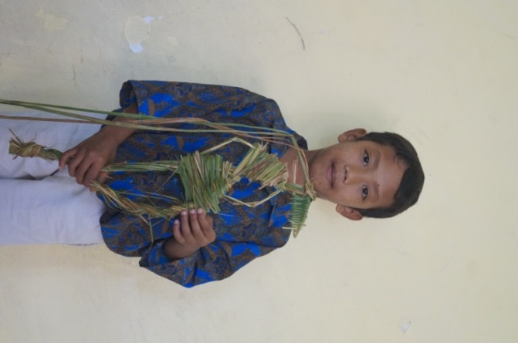

Figure 1: Yovan, the fastest student in completing the puppet

Everyone is a different person. Likewise, students at Nongkosawit 02 Public Elementary School are, in fact, schools in the village. Their creativity level is not the same. Some children show their courage and creative power, but some do not respond to the stimulus provided by the tutor. Some students who are creative are those who have the courage to ask questions and communicate with tutors. They are also able to modify their puppets with interesting accents such as making different hairstyles on the puppets and inserting flowers in the puppet's hair. Besides that, creative people are also seen in children who are enthusiastic and always want to know about what, why, and how Wayang Gaga is.

Process

Process activities according to (Munandar, 2002: 69) are activities for the development of children's creativity. Meanwhile the creative process according to (Arisianto, 2019: 113) is the process of how a work of art is created through physiological and psychological processes. In the process activities, children as research subjects need to be given time to busy themselves creatively and complete their work. The process is covering what happens in the activities carried out to achieve results. In the process of making puppets there is interaction between the child and the tutor, then in that way they get closer and make the child feel awkward to ask. The questions they ask are evidence of children's critical and creative thinking.

In addition to making Wayang Gaga, in this process activity children are also trained to be able to play Wayang Gaga which will be staged simply. Before being trained, the children are indirectly selected by the tutor, and gathered to be invited to discuss on what themes they will raise for the story in the show. Children are given the opportunity to deliver their ideas and think of what kind of flow will be shared with their friends. Then in this activity it was formulated by the children that they would display Wayang Gaga with the play or the title "Plankton Stealing the Secret Recipe for Krabby Patty". The story is the imagination of students who then insert some moral messages to be known to children, both as players and as spectators. After the story is formulated, the tutor trains how to hold the Wayang Gaga. In these activities the children practice bringing various characters to be staged and negotiating the story line that will be performed. Children learn to determine the right story along with the problems and solutions to be presented. Then in the show they spontaneously dialogue with each other's characters. This shows the process of creativity in children.

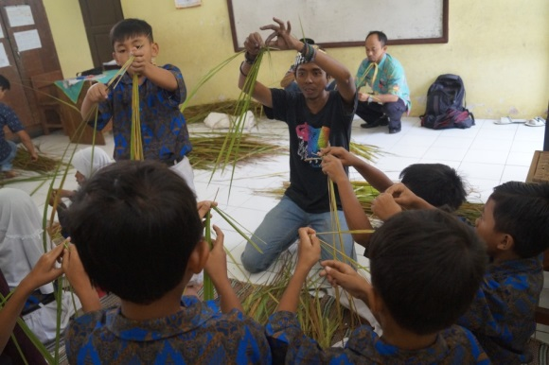

Figure 2: Student training in making Wayang Gaga

Press

Press, means that realizing creative talent requires encouragement and support from the environment. This drive can also be called motivation. Motivation can be divided into internal and external motivation. Internal motivation is motivation from within which is obtained from the personal mental process itself. While external motivation is the encouragement from outside the self such as the support of the people closest, appreciation, giving awards, praise, etc.. In this study visible internal and external motivation in children.

Internal motivation is shown by the seriousness and enthusiasm of children to make Wayang Gaga. They are very excited and trying to be able to realize their own puppets. Even among them often ask the tutor about their curiosity about Wayang Gaga. While external motivation was found by people in the workshop such as tutors, teachers, and their own friends. They encourage children to not give up easily in making puppets. Providing motivation is very important to stimulate a child's enthusiasm for thinking and acting.

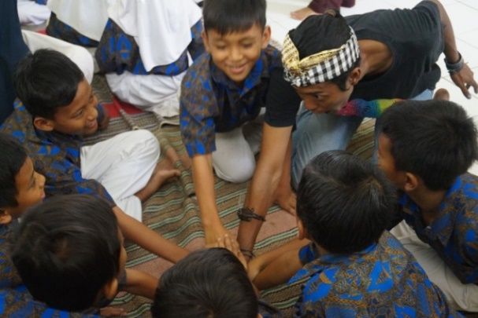

Figure 3: external motivation of the tutor

Product

Product means the result of creativity activities that occur. The products in this study are the puppets made by children and the wayang gaga performances by children. The puppets made by children can then be owned by themselves and can be used as decorative ornaments and toys. Of course, having Puppet Gaga makes children happy and proud to be able to make and own that puppet.

Creativity can also be seen from the different forms of puppets, according to their wishes and imagination. Furthermore, another creativity product is a show that shows directly the active and creative response of the puppeteers. They boldly and spontaneously play Wayang Gaga with direct conversations whose words come out of the mouths of children without using text.

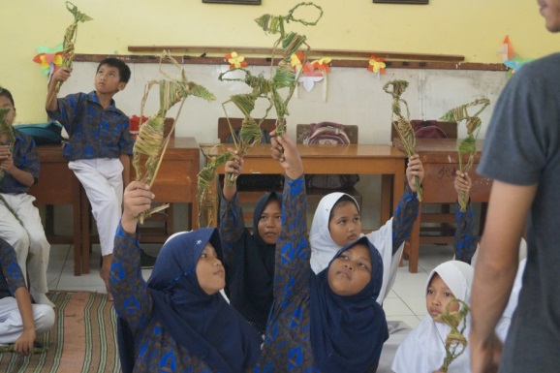

Figure 4: students show the results of theirown puppets

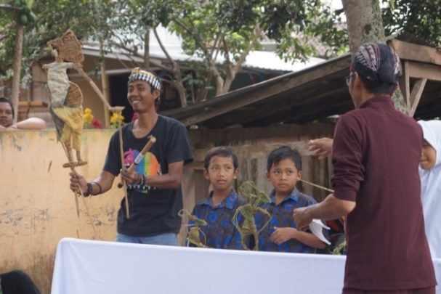

Figure 5: students playing the Wayang Gaga performance in front of their friends and teachers

Specific findings in this study are the interrelationship of several components including Person, Process, Press and Product. Creative person involves himself in a creative process, then with the support or encouragement from oneself and the environment can produce a creative product. The following is a summary chart of the results of the problem analysis with the theory of creativity development by Rhodes:

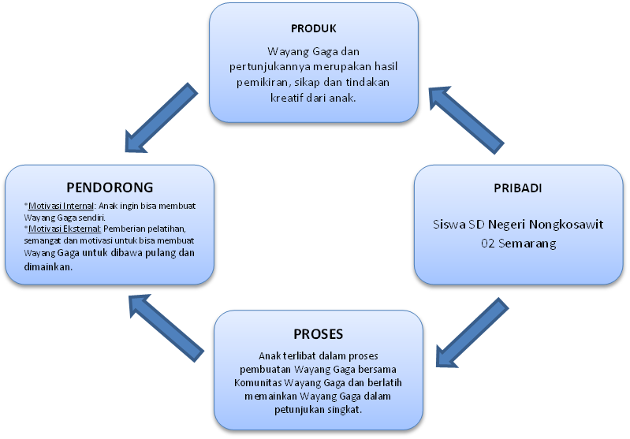

Chart 1: The flow of the creativity education process that occurs in Wayang Gaga training and performances at Nongkosawit 02 Elementary School in Semarang

The creativity process starts from the personalities of Nongkosawit 02 Semarang Elementary School students involved in a series of creative processes namely Wayang Gaga workshops and performances with the Wayang Gaga Community, supported by the presence of driving factors including internal and external motivation, so as to produce a creative product in the form of Puppet Gaga and the show.

CONCLUSION

Creativity is an important aspect that must be realized through education. Creativity can be formed through fun learning activities, one of which is by using media in the form of own art products or based on local wisdom namely Wayang Gaga. Learning is not only fixed in the classroom, but can also be done outside the classroom with fun practice methods. With this method the child will feel directly making puppets out of grass and playing it in a short performance. Through this process children are stimulated to think creatively, responsively, actively and critically. In addition, the use of media in the form of local arts or culture products, Wayang Gaga can introduce children to the culture that is around their homes, so that children can love their own culture more.

ACKNOWLEDGMENTS

Thank you to the advisors who hve directed the writer to produce good research. Thank you also to the Semarang Wayang Gaga Community and all the extended family of SD Negeri Nongkosawit 02 Semarang for allowing and providing data for research.

REFFERENCES

Ahmadi. (2012). "Pengembangan Media Pembelajaran Inovatif Kooperatif Musik Ritmis Berbasis Multimedia di SMA Negeri 3 Pati". Catharsis: Journal of Art Education, 1(2). https://journal.unnes.ac.id/sju/index.php/catharsis/article/view/858

Arisianto. (2019). "The Art Creative Process of Indonesian Children In The Student’s National Collective Painting Competition In 2018". Catharsis: Journal of Art Education, 8(2).https://journal.unnes.ac.id/sju/index.php/catharsis/article/view/32816

Azzahrah, F. (2017). "Revitalisasi Tari Sigeh Pengunten Melalui Pendidikan Seni Budaya di SMO Negeri 1 Tanjung Raya Kabupaten Mesuji". Catharsis: Journal of Art Education, 6(1). https://journal.unnes.ac.id/sju/index.php/catharsis/article/view/17030

Budiarti, Y. (2015). "Pengembangan Kemampuan Kreativitas dalam Pembelajaran IPS". PROMOSI: Jurnal Program Studi Pendidikan Ekonomi, 3(1). http://ojs.fkip.ummetro.ac.id/index.php/ekonomi/article/view/143

Ibda, F. (2015). "Perkembangan Kognitif: Teori Jean Piaget". Intelektualita, 3(1).https://jurnal.arraniry.ac.id/index.php/intel/article/view/197

Jazuli, M. (2010). "Model Pembelajaran Tari Pendidikan Pada Siswa Sd / Mi Semarang". Harmonia, 10(2), 1–18. https://doi.org/10.2307/1308780

Kusumastuti, E. (2010). "Pendidikan Seni Tari Melalui Ekspresi Bebas, Disiplin Ilmu, Dan Multikultural Sebagai Upaya Peningkatan Kreativitas Siswa". HARMONIA - Jurnal Pengetahuan Dan Pemikiran Seni, 10(2). https://journal.unnes.ac.id/nju/index.php/harmonia/article/view/61

Muhammad, F. N. N. (2017). "Extracurricular Learning of Dance with Local Wisdom Basis". Catharsis: Journal of Art Education, 6(2).https://journal.unnes.ac.id/sju/index.php/catharsis/article/view/19284

Munandar, U. (2002). Kreativitas dan Keberbakatan: Strategi Mewujudkan Potensi Kreatif dan Bakat"(1st ed.). Jakarta: PT Gramedia Pustaka Utama.

Munandar, U. (2009). Pengembangan Kreativitas Anak Berbakat. Jakarta: Rineka Cipta.

Nurseto, G. dkk. (2015). "Pembelajaran Seni Tari: Aktif, Inovatif dan Kreatif". Catharsis: Journal of Art Education, 4(2), 115–122. https://journal.unnes.ac.id/sju/index.php/catharsis/article/view/10285

Rohidi, T. R. (2011). Metodologi Penelitian Seni. Semarang: Cipta Prima Nusantara.

Rohidi, T. R. (2014). "Pengembangan Media Pembelajaran Pendidikan Seni Budaya Berbasis Kearifan Lokal (Wayang Sebagai Sumber Gagasan)". Jurnal Imajinasi, 8(1). https://journal.unnes.ac.id/nju/index.php/imajinasi/article/view/7284

Rusman. (2010). Model-Model Pembelajaran Mengembangkan Profesionalisme Guru. Jakarta: PT. Rajagrafindo Persada.

Saparahayuningsih, S. (2010). "Peningkatan Kecerdasan dan Kreativitas Siswa". KREATIF Jurnal Kependidikan Dasar, 1(1).https://journal.unnes.ac.id/nju/index.php/kreatif/article/view/1665

Sari, H. Y. dkk. (2017). Media dan Pengembangan Kreativitas Anak Usia DIni, (1).

Suhaya. (2016)."Pendidikan Seni sebagai Penunjang Kreatifitas". Pendidikan Dan Kajian Seni, 1(1). http://jurnal.untirta.ac.id/index.php/JPKS/article/view/837

Triyanto. (2014). Pendidikan seni Berbasis Budaya. Imajinasi, 8(I). https://journal.unnes.ac.id/nju/index.php/imajinasi/article/view/8879

